National Science Olympiad
Astronomy C Division Event
16 May 2009
Augusta State University
Augusta, GA
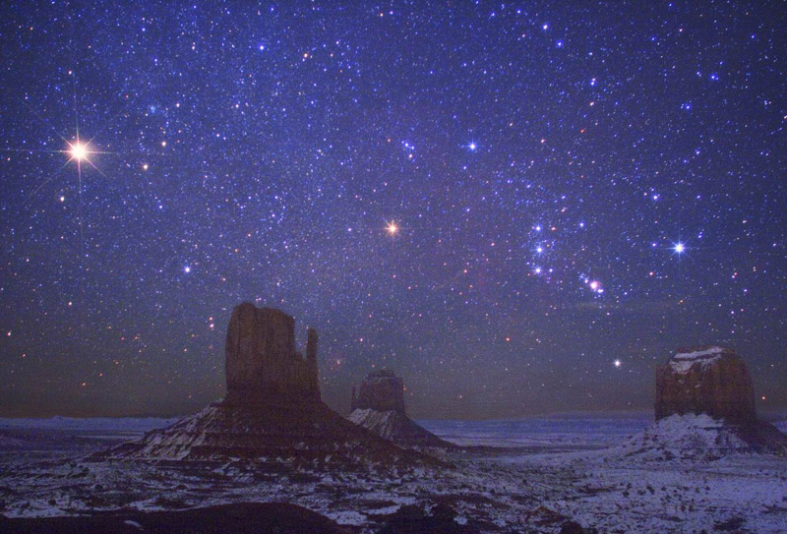

TEAM NUMBER: ________________

TEAM NAME: ___________________________________________

INSTRUCTIONS:

1) Please turn in ALL MATERIALS at the end of this event.

2) Do not forget to put your TEAM NAME and TEAM NUMBER at
the top of all Answer Pages.

3) This event and the answer key will be available on the Wright Center website:
http://www.tufts.edu/as/wright_center/products/sci_olympiad/sci_olympiad_astro.html

4) Good Luck! And May the Stars be With You!

Page 1

Team Number: ____________ Team Name: ________________________________

Section A: Use Image Set A to answer the questions in this section.

- Image I contains a large reddish object in the lower left hand corner.
  - What is the name of this object?
  - What type of variability does this object exhibit?
  - Which image shows a close-up of the surface of this object?
  - Which image shows a light curve that represents the eventual catastrophic collapse of this object?
  - This object is 1400 light-years from Earth. At maximum outburst, how bright will it appear in the sky compared to the brightness of the sun? Give your answer in absolute magnitude.
- RS Ophiuchi is a recurrent nova variable star.
  - Which image contains a light curve produced by RS Ophiuchi?
  - What type of system produces this type of variability?
  - This system is comprised of what specific types of objects?
  - Which image illustrates this type of system?
  - Which image contains a light curve that shows a possible end result for the denser object in this system?

- Image O contains a star that is the prototype for a specific type of variable.
  - What is the scientific name of the star and the type of variable?
  - This system contains the same two types of objects as in 2c above. What is the major difference between the two systems?
  - Which image shows the behavior of this star? What is the period?
  - What objects will remain after the final collapse of this star?
  - Which image shows the result of this star ploughing through the ISM at ~130 km/s?

- Image A is one example of the type of system that includes Z Andromedae.
  - To what specific type of system does Z Andromedae belong?
  - What are the three main components of this type of system?
  - Which image shows the light curve of Z Andromedae?
  - Why is the variability of Z Andromedae much less than the extreme outbursts seen in the light curve in image T?
  - What is the final evolutionary stage for the densest component?

- A white dwarf was the progenitor of the object in one of the images.
  - Which image contains the object?
  - What is the name of this object? What type of object is it?
  - How does this object differ from image N?
  - What type of progenitor formed the object in image N?
  - What types of objects remain in the core of b) and d)?

Page 2

Team Number: ____________ Team Name: ________________________________

- The Cepheid variable in image F is RS Puppis, unique in that it is surrounded by a nebulosity, and light echoes within the nebulosity were used as another method to calculate and reaffirm its distance of ~6500 light years.
a) From the light curve in image Z, determine the absolute magnitude of
RS Pup.
b) Besides Cepheids, what other type of variable is used to determine
cosmological distances? Which light curve represents the behavior of
this type of variable?
- Which type of variable is younger, Cepheids or the answer to part b?
- Where are the variables in part b located?
- What relationship enables these variables to be used to measure cosmological distances?

- Image J is a winter constellation.
  - What is the name of the fifth brightest star in this constellation?
  - Which image shows the light curve for this eclipsing binary?
  - From the graph calculate the total time for the eclipse of the primary.
  - Why is this portion of the 29-year eclipse cycle flat at minimum?
  - The primary is 15 solar masses, and the secondary is 13.7 solar masses. What is the separation of these two objects?

- Image D is an illustration of the complex Circinus X-1 system 31,000 light years away in the southern hemisphere constellation Circinus the compass.

  - Which image shows the light curve for this object?
  - What type of system is Cir X-1?
  - What are the components of this system?
  - What is the period for this system?
  - Bursting in this system is extremely luminous because the radiation pressure is sufficient to overcome the gravitational potential of the object. What is happening within the system when these maximum outbursts occur?

Page 3

Team Number: ____________ Team Name: ________________________________

Section B: Use Image Set B to answer the questions in this section.

On March 11, 2000, NASA's Chandra X-ray Observatory captured a spectacular image of G292.0+1.8, a young, oxygen-rich supernova remnant with a pulsar at its center surrounded by outflowing material. How long ago did this supernova occur?

PLEASE NOTE: Many approximations are made in these calculations so you will only be able to estimate the order of magnitude of the age of G292.0+1.8. Keep two significant figures in your calculations until the end to minimize round-off errors.

  - The distance to G292.0 +1.8 is estimated to be 4.8 kpc (Saken et al. 1992). Using information from figure 2, find the radius in meters of G292.0+1.8.

  - Although the initial explosion ejects the outer layers of the star, most of the gas in the remnant is not from the star itself. As the ejected material expands outwards, it encounters and intermingles with the interstellar medium and propels it outward, building up the outer shock wave. In a typical interstellar region, the density is about one atom per cm³ or one million/m³. Assuming a hydrogen atom mass for each atom of 1.7 x 10⁻²⁷ kg, what is the total mass that has been swept up by the remnant? Treat G292.0+1.8 as a spherical shell.

  - The average amount of energy released in a supernova explosion is ~10⁴⁴ Joules, and approximately one quarter of this energy drives the expansion of the remnant. Find the average expansion velocity of G292.0+1.8.

  - Calculate the estimated order of magnitude of the age of G292.0+1.8 in years.

  - In figures 1 and 3, an arrow points to the suspected pulsar or remaining core of the collapsed star. Using the information from figures 2 and 3, find the displacement in meters of the pulsar from the center of the remnant.

  - Assume a typical mass of 1.4 times that of the Sun for the pulsar. If the Sun radiates about 3.8 x 10²⁶ joules/s, how many years must the Sun radiate to release the amount of energy required to move the pulsar from the center of the remnant to its present location?

Page 4

Team Number: ____________ Team Name: ________________________________

Section C: Use your resources and knowledge of variable stars to answer the following questions as accurately as you can.

- Star A is 10 parsecs away and is observed to have an apparent magnitude of + 5.0. What is its Absolute Magnitude?

- The apparent magnitude of Star B is plotted below as a function of time. How far away is it from the observer? (in pcs)

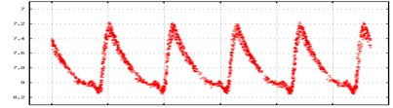

- The apparent magnitude of Star C is plotted below as a function of time. How far away is it from the observer? (in pcs)

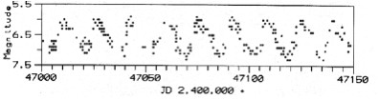

- Star D is a main sequence star and has an apparent magnitude of + 20. The visible absorption spectrum for Star D is shown below. How far away is it from the observer? (in pcs)


Page 5

Team Number: ____________ Team Name: ________________________________

- As Star E evolved, its surface temperature dropped from 8,000 K to 6,000 K. By how much did its wavelength of peak radiation increase? (in nm)

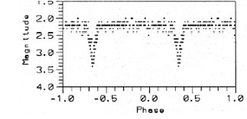
- Star F and Star G make up an eclipsing binary star system. The apparent magnitude of the system is plotted below as a function of time. Assume that Star F and is completely eclipsed by Star G. What is the apparent magnitude of Star G?

- Star H is 1 pc away from earth. What would you expect to measure as its observed parallax? (in arc seconds)

- Star I has an apparent magnitude of + 5.0 and is 250 pcs away. What is the luminosity of Star I? (in solar luminosities)

- The light curve for Star J is shown in the figure below. What is the surface temperature of Star J? (in K)

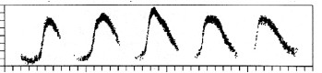

- Star K is 10 pcs away, has an apparent magnitude of +3.0, and radiates the most energy at 290 nm. What is the radius of Star K? (in solar radii)

- Star L is a main sequence star. The visible absorption spectrum for Star L is shown below. What is the mass of Star L? (in solar masses)



Page 6

Team Number: ____________ Team Name: ________________________________

- Star M was observed to be a Type 1a Supernova with a peak apparent magnitude of +10.0. What is the distance to M? (in ly)

- Star N and Star O are both main sequence stars. Star N is of spectral class A0 and Star O is of spectral class K5. They have the same apparent magnitude as observed from earth. If an observer were able to move 10 pcs closer to both stars, which star will appear brighter from the new observation point?

- Star P is a pulsating variable star. As it pulses, the apparent magnitude of Star P changes by 5 magnitudes. Assuming that its temperature remains constant as it pulses, what is the ratio of Star P’s maximum and minimum radius?

- The O – C diagram for the period of Star Q is shown below. How many days longer was the observed period for Cycle 60 than Cycle 20? (in days)

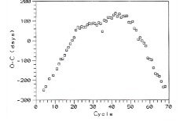

- Star R and Star S are members of an orbiting binary star system. Initially, Star R had a mass of 3 solar masses, Star S had a mass of 1 solar, mass and the system had a period of T₁. After a mass transfer event, Star R had a mass of 2 solar masses, Star S had a mass of 2 solar masses, and the system had a period of T₂. If the separation between stars remained unchanged, what is the ratio of T₁ to T₂?

- Star T has a positive recessional velocity. The wavelengths of two spectral lines L1 and L2 are measured for Star T. L1 lies in the radio portion of the electromagnetic spectrum and L2 lies in the optical portion of the spectrum. For which line will there be a greater difference between the observed and laboratory wavelength values.

Page 7

Team Number: ____________ Team Name: ________________________________

- The laboratory wavelength for the H-alpha line in the Balmer Series is 656.3 nm. Star U and Star V are members of an orbiting binary star system. The maximum and minimum values measured for the H-alpha lines in the system’s spectrum are 656.4 nm and 656.2 nm respectively. What is the orbital velocity of Star U? (in km/s)

- Initially, Star W had an absolute magnitude of + 5 and Star X had an absolute magnitude of – 4. Later, the absolute magnitude of Star W decreased to +9 and the absolute magnitude of Star X decreased to -5. For which star was the change in luminosity greater?

- Star Y and Star Z have the same maximum apparent magnitude. Their light curves are shown below. Which star is farther away?

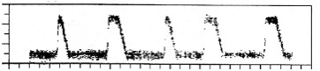
Star Y

x

Star Z

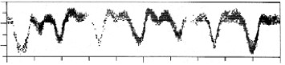

Page 8

