SHOCK VALUE TEST

1. 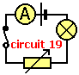Circuit 19 shows a switch closed, battery, bulb and a variable resistor wired in a complete series circuit. Which statement about the operation of the circuit is **TRUE**?
   1. ? if the resistance is increased less current flows and the bulb is dimmer
   2. ? if the resistance is decreased, less current flows and the bulb is brighter
   3. ? the variable resistor cannot be used as a switch
   4. ? if the cell or battery connections are swapped around, the bulb goes out

2.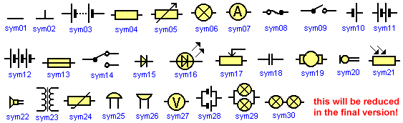  
Which of the circuit symbols means a '**two way switch**'?

* 1. ? sym18
  2. ? sym23
  3. ? sym14
  4. ? sym02

3.  
Which of the following symbols means a '**fuse**'? [7j-28]

* 1. ? sym21
  2. ? sym04
  3. ? sym05
  4. ? sym13

4.  
Which of the circuit symbols means a '**meter for measuring potential difference**'? [7j-2]

* 1. ? sym27
  2. ? sym07
  3. ? sym19
  4. ? sym06

5.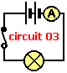space.gif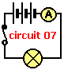space.gif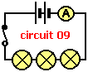space.gif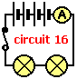From the four circuits shown, which will have '**the brightest lit lamp or lamps**'? Note that the bulbs are identical and the batteries identical. [7j-17]

* 1. ? circuit 09
  2. ? circuit 07
  3. ? circuit 16
  4. ? circuit 03

6.fuse1.gifThe ratings for four typical domestic appliance fuses are 3A, 5A, 8A and 13A. Which **fuse wires will melt** if a **current of 4A** is passed through them? [7j-69]

* 1. ? **3A only** fuse2.gif
  2. ? **3A, 5A, 8A and 13A** fuse2.gif
  3. ? **3A and 5A only** fuse2.gif
  4. ? **3A, 5A and 8A only** fuse2.gif

7.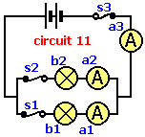space.gif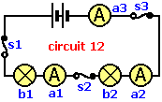Which of the following is **TRUE** when comparing the two circuits 11 and 12? Note that the bulbs are identical and the batteries identical. [7j-29]

* 1. ? the bulbs are dimmer in circuit 11 than the bulbs in circuit 12
  2. ? the bulbs are brighter in circuit 12 than the bulbs in circuit 11
  3. ? in circuit 11 the bulbs are wired in parallel, but not so in circuit 12
  4. ? if switch s2 is opened in both circuits, all the bulbs go out

8.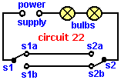The **Circuit 22** shows two, two way switches, s1 and s2, connected to a power supply and lamp. Which conditions ensure the **lamp is OFF** in **Circuit 22**? [7j-74]

* 1. ? **s1a open** (down) and **s2b closed** (down)
  2. ? **s1b open** (up) and **s2a closed** (up)
  3. ? **s1b open** (up) and **s2a open** (down)
  4. ? **s1a closed** (up) and **s2b open** (up)

9.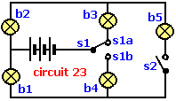The **Circuit 23** shows a two way switch s1 and a simple switch s2, connected to a power supply and five lamps (b1 to b5). Which **lamps will be ON when switches s1b and s2 are closed**? [7j-80]

* 1. ? b1, b2, b4 and b5
  2. ? b1 and b4
  3. ? b2 and b3
  4. ? b1, b2, b3 and b5

10.fuse1.gifThe ratings for four typical domestic appliance fuses are given below. Which is the **safest fuse** to use for an appliance with a normal **operating current of 6A**? [7j-67]

* 1. ? **5A** fuse2.gif
  2. ? **3A** fuse2.gif
  3. ? **13A** fuse2.gif
  4. ? **8A** fuse2.gif

11.  
Which of the circuit symbols means '**two cells or batteries in series**'? [7j-4]

* 1. ? sym14
  2. ? sym18
  3. ? sym10
  4. ? sym11

1. The **Circuit 22** shows two, two way switches, s1 and s2, connected to a power supply and lamp. Which conditions ensure the **lamp is ON** in **Circuit 22**? [7j-73]
   1. ? **s1b open** (up) and **s2a open** (down)
   2. ? **s1a open** (down) and **s2a closed** (up)
   3. ? **s1b closed** (down) and **s2b open** (up)
   4. ? **s1a closed** (up) and **s2b open** (up)