Made by fantasyfan
- Name 4 functions of the respiratory system:
a.

b.

c.

d.

- Match the process to its definition
1. Pulmonary Ventilation __ a. transport of oxygen from the lungs to the tissues and transport of carbon dioxide from the tissues to the lungs
2. External Respiration __ b. movement of air into the lungs and movement of air out of the lungs
3. Transport of Respiratory Gases__ c. movement of oxygen from the lungs to the blood and movement of carbon dioxide from the blood to the lungs
4. Internal Respiration __ d. Movement of oxygen from blood to the tissue cells and movement of carbon dioxide from tissue cells to blood
Label the diagram:
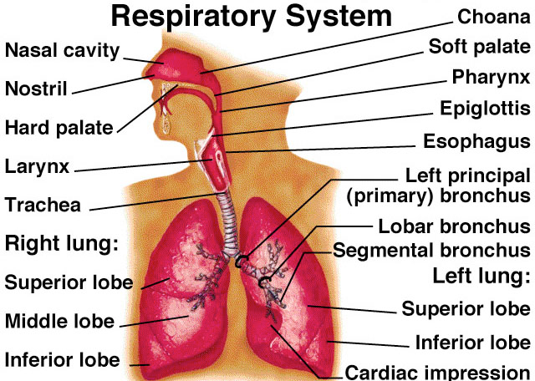
3

4
5
6
9
10
8
7

11

12. Where in the brain are the respiratory control centers found
a. Hippocampus b. Frontal Lobe
c. Pons c. Hypothalamus
13. This type of cell creates surfactant
a. Type I alveolar cells b. Type II alveolar cells
c. Dust cells d. Jail cells
14. This is the medical term for the Adam’s apple
a. Thyroid Cartilage b. popcorn
c. Epiglottis d. Hyoid cartilage

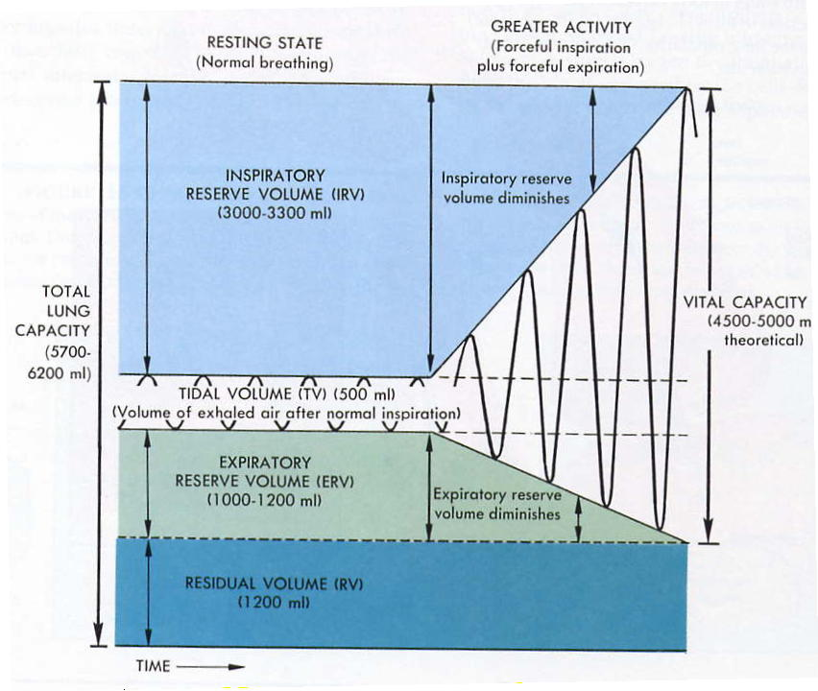
21. Why can’t Q.17’s volume be measured on a spirometer?
18
17
15
16
19
20
_____________________________________________________________________________________________________________________________________________

22. Match the terms with the definitions:
- Apnea __ a. permanent cessation of breathing
- Dyspnea __ b. increased pulmonary ventilation in excess of metabolic demand
- Eupnea __ c. reduced pulmonary ventilation
- Hyperpnea __ d. labored, gasping breathing
- Hyperventilation __ e. temporary cessation of breathing
- Hypoventilation __ f. accelerated respiration
- Orthopnea __ g. increased rate and depth of breathing
- Respiratory Arrest __ h. normal, relaxed, quiet breathing
- Tachypnea __ j. Dyspnea that occurs when a person is lying down

23. COPD’s is 2 different diseases. Name them.
1.__________________
2.__________________
24. Name 2 acute disorders of the respiratory system
1.__________________
2.__________________
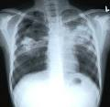
25. Diagnose this patient:
He/She has___________

