STATION 2

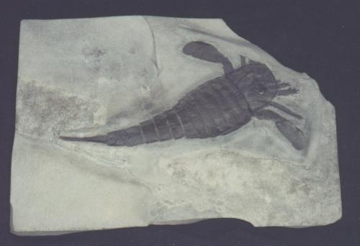

STATION 9

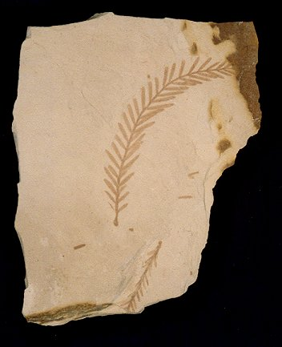
A
STATION 10

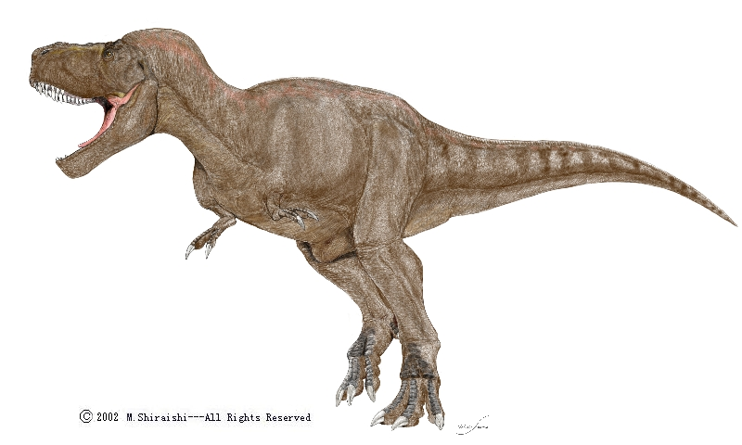
A.
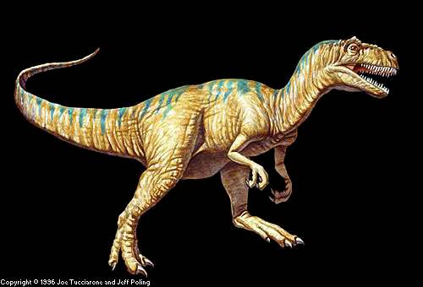
B

B

Illustrations more or less to scale with
C
each other.
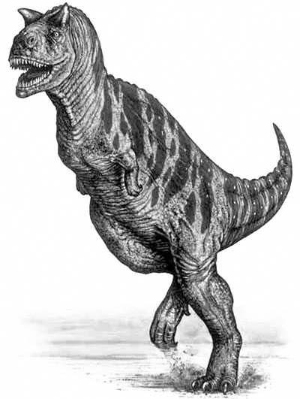
STATION 15 Dinosaur footprint
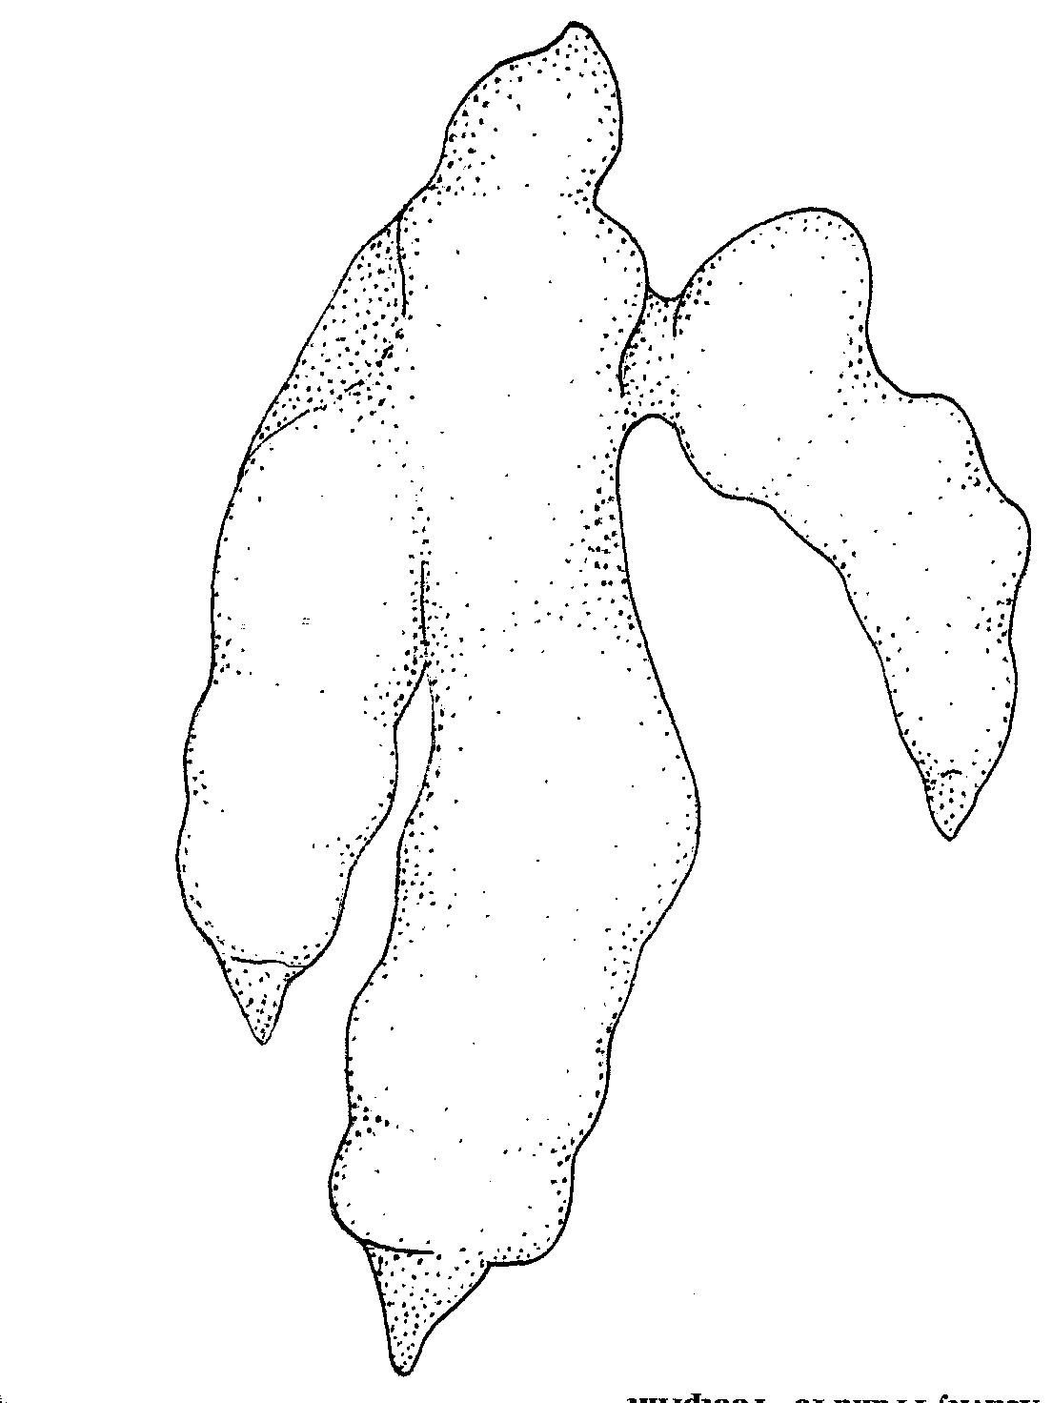

STATION 17

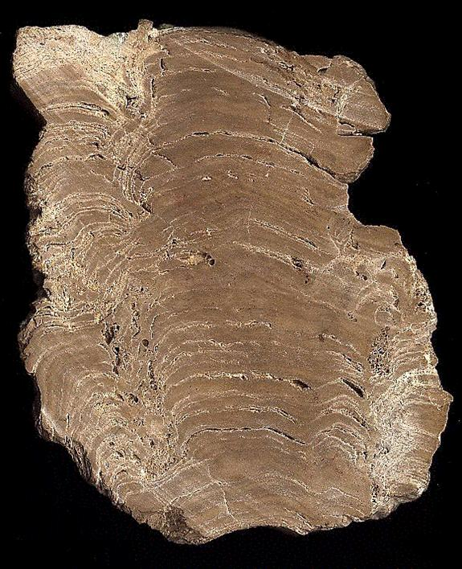

STATION 19

A.

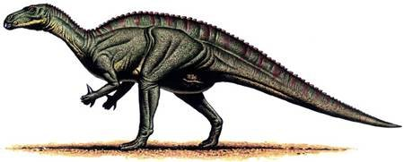

B.

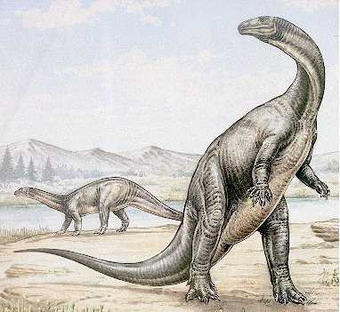

STATION 20 FOSSIL SLABS (from same rock layer in Ohio)

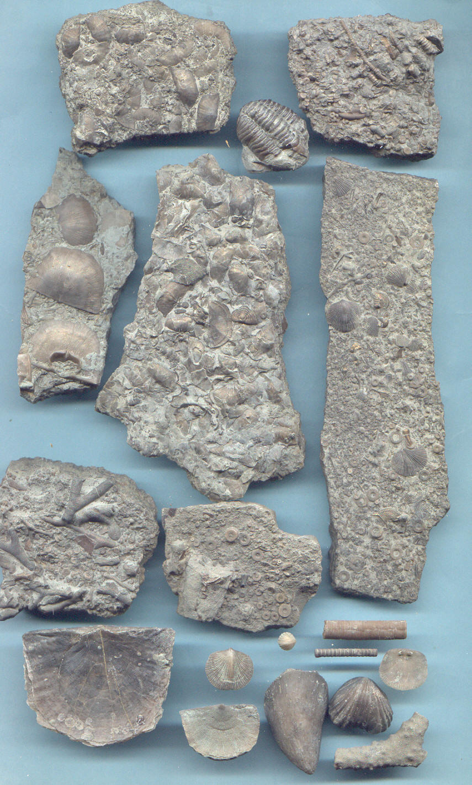

Paleozoic

Ordovician limestone

Bryozoa, crinoids, 2 trilobites (Cryptolithus head, Flexicalymene tail)

Paleozoic
Ordovician (Cryptolithis is an index fossil)

Limestone

STATION 21 Relative/Absolute Age

