Science Olympiad Rocks and Minerals Test
2008 State Exam

- Your Challenge: Without performing scratch tests on the minerals, put them in order of increasing hardness. Use other properties, like cleavage, crystal habit, etc. (Moh’s Hardness scale)
3 Calcite
4 Fluorite
5 Apatite
7 Quartz
8 Topaz
9 Corundum
10 Diamond
- Identify each mineral specimen and place them in the correct position of the Bowen’s Reaction Series diagram below:
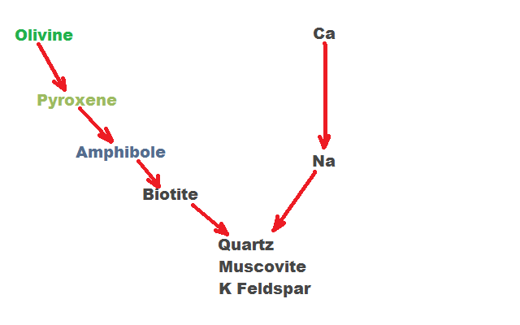
A Albite
B Orthoclase Group
C Microcline/Amazonite
- Identify each mineral specimen, their crystal system and chemical formula.
Both are Pyrite, Isometric/Sulfides, FeS₂ (one is a cube, the other is a pyritohedron)
- Identify the mineral specimen. What do they have in common compositionally?
- Magnetite
- Hematite
- Limonite Conglomerate
All have Fe
- Identify the rock. What is its environment of deposition?
Pebble Conglomerate
Fluvial system, debris flow, glacial deposit, storm waves
- Identify each mineral specimen, its chemical formula and the type of twinning present in the sample.
- Aragonite, CaCO₃, Cyclic Twinning
- Calcite, CaCO_{3,} elbow twins/penetration twin
- Identify the red mineral and name the rock. What type of rock is it (igneous, metamorphic, or sedimentary)?
Garnet, Garnet Biotite Schist, Metamorphic
- Identify the mineral specimens and name its mineral group.
a. Quartz → Silicate
b. Halite → Halide
c. Selenite Gypsum → Sulfate
d. Calcite → Carbonate
- Identify the mineral specimens. What do they have in common?
- Jasper
- Agate/Chalcedony
Both are quartz, cryptocrystalline, Silica dioxide
- Identify the two minerals. What is the economic importance of the purple mineral?
Pink: Tourmaline
Purple: Lepidote → Source of Lithium
- Identify the mineral specimens and state their individual economic importance.
- Galena → Lead Ore
- Hematite → Iron ore
- Identify the minerals. What metal is common in all three minerals?
- Malachite
- Azurite
- Bornite
Cu is common in all three
- Identify the minerals.
- Ulexite
- Satin spar gypsum.
- Name each rock and place them on the diagram below in the environment in which they were deposited.
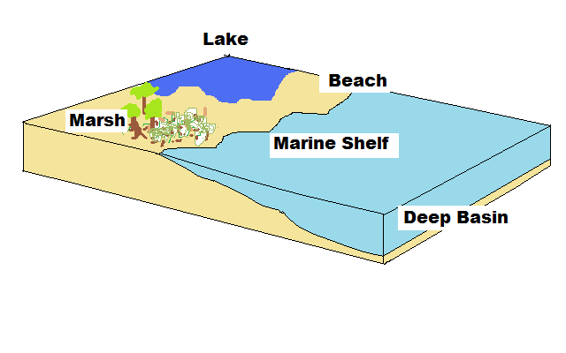
A Siltstone/Shale
B Coal (anthracite)
C Sandstone
D Fossiliferous LS
E Shale
- Identify the mineral specimens. What is an original use for each mineral?
- Biotite → Electrical insulation
- Muscovite → Windows
- Identify the rocks and name their parent rock. (For example, this type of rock was formed from a _________ rock).
 | A | B | C
Sample | Quartzite | Marble | Slate
Parent Rock | Sandstone | Limestone | Shale

- Identify the green minerals in each rock. What do they all have in common?
- Epidote
- Tourmaline
- Hornblende
All are green, silicates, have approx. same hardness
- Identify the mineral specimens, their crystal family, and their economic uses.
- Beryl → Cyclosilicate, gemstone
- Corundum → Silicate, gemstone
- Name each rock sample, and place them in the correct environment of formation on the diagram below.

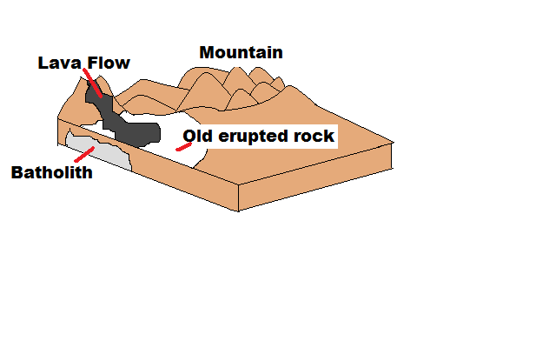
A: Obsidian
B: Schist
D: Granite
C: Rhyolite
- Name the five characteristics of a mineral (in other words, what is the definition of a mineral?).
Naturally occurring
Solid
Long range crystalline order
Inorganic
Specific Chemical Formula

