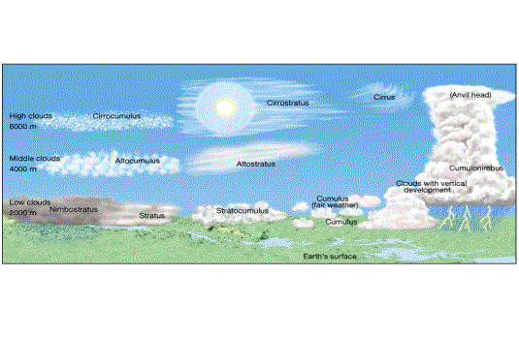
Using temperature as the basis, the atmosphere is divided into four layers. The temperature decrease in the troposphere, the bottom layer in which we live, is called the "environmental lapse rate." Its average value is 6.5°C per kilometer, a figure known as the "normal lapse rate." A temperature "inversion," in which temperatures increase with height, is sometimes observed in shallow layers in the troposphere. The thickness of the troposphere is generally greater in the tropics than in polar regions. Essentially all important weather phenomena occur in the troposphere. Beyond the troposphere lies the stratosphere; the boundary between the troposphere and stratosphere is known as the tropopause. In the stratosphere, the temperature at first remains constant to a height of about 20 kilometers (12 miles) before it begins a sharp increase due to the absorption of ultraviolet radiation from the Sun by ozone. The temperatures continue to increase until the stratopause is encountered at a height of about 50 kilometers (30 miles).In the mesosphere, the third layer, temperatures again decrease with height until the mesopause, some 80 kilometers (50 miles) above the surface.The fourth layer, the thermosphere, with no well-defined upper limit, consists of extremely rarefied air. Temperatures here increase with an increase in altitude.Besides layers defined by vertical variations in temperature, the atmosphere is often divided into two layers based on composition. The homosphere (zone of homogeneous composition), from Earth’s surface to an altitude of about 80 kilometers (50 miles), consists of air that is uniform in terms of the proportions of its component gases. Above 80 kilometers, the heterosphere (zone of heterogenous composition) consists of gases arranged into four roughly spherical shells, each with a distinctive composition. The stratified nature of the gases in the heterosphere varies according to their weights.Occurring in the altitude range between 80 and 400 kilometers (50 and 250 miles) is an electrically charged layer known as the ionosphere. Here, molecules of nitrogen and atoms of oxygen are readily ionized as they absorb high-energy, shortwave solar energy. Three layers of varying ion density make up the ionosphere. Auroras (the aurora borealis, northern lights, and its Southern Hemisphere counterpart the aurora australis, southern lights) occur within the ionosphere. Auroras form as clouds of protons and electrons ejected from the Sun during solar-flare activity enter the atmosphere near Earth’s magnetic poles and energize the atoms of oxygen and molecules of nitrogen, causing them to emit light—the glow of the auroras. Heat budget: Approximately 50 percent of the solar energy that strikes the top of the atmosphere reaches Earth’s surface. About 30 percent is reflected back to space. The remaining 20 percent of the energy is absorbed by clouds and the atmosphere’s gases. The wavelength of the energy being transmitted, as well as the size and nature of the absorbing or reflecting substance, determine whether solar radiation will be scattered, reflected back to space, or absorbed. The fraction of radiation reflected by a surface is called its albedo.Radiant energy that is absorbed heats Earth and eventually is reradiated skyward. Because the atmospheric gases, primarily water vapor and carbon dioxide, are more efficient absorbers of terrestrial (longwave) radiation, the atmosphere is heated from the ground up. The transmission of shortwave solar radiation by the atmosphere, coupled with the selective absorption of Earth radiation by atmospheric gases that results in the warming of the atmosphere, is referred to as the greenhouse effect. Because of the annual balance that exists between incoming and outgoing radiation, called the heat budget, Earth’s average temperature remains relatively constant despite seasonal cold spells and heat waves. Although the balance of incoming and outgoing radiation holds for the entire planet, it is not maintained at each latitude. Averaged over the entire year, a zone around Earth between 38°N and 38°S receives more solar radiation than is lost to space. The opposite is true for higher latitudes, where more heat is lost through outgoing longwave radiation than is received. It is this energy imbalance between the low and high latitudes that drives the global winds and ocean currents, which in turn transfer surplus heat from the tropics poleward. Furthermore, the radiation balance of a given place fluctuates with changes in cloud cover, atmospheric composition, and most important, Sun angle and length of daylight. Thus, areas of radiation surplus and deficit migrate seasonally as the Sun angle and length of daylight change. Winds: Mountain and valley breezes develop as air along mountain slopes is heated more intensely than air at the same elevation over the valley floor. Chinooks are warm, dry winds that sometimes move down the east slopes of the Rockies. In the Alps, winds similar to chinooks are called foehns. Katabatic (fall) winds originate when cold air, situated over a highland area such as the ice sheets of Greenland or Antarctica, is set in motion under the influence of gravity. Country breezes are associated with large urban areas where the circulation pattern is characterized by a light wind blowing into the city from the surrounding countryside. Panhandle hook: Low pressure systems that originate in the panhandle region of Texas and Oklahoma which initially move east and then "hook" or recurve more northeast toward the upper Midwest or Great Lakes region. In winter, these systems usually deposit heavy snows north of their surface track. Thunderstorms may be found south of the track. Santa Ana Wind: In southern California, a weather condition in which strong, hot, dust-bearing winds descend to the Pacific Coast around Los Angeles from inland desert regions. Alberta Clippers: A fast moving low pressure system that moves southeast out of Canadian Province of Alberta (southwest Canada) through the Plains, Midwest, and Great Lakes region usually during the winter. This low pressure area is usually accompanied by light snow, strong winds, and colder temperatures. Another variation of the same system is called a "Saskatchewan Screamer". Air masses: cA: origin examples: Artic basin and the Greenland ice cap. Very very cold, very dense, very little moisture, stable. cP: origin examples: Interior Canada and Alaska. Very cold, dense, dry and stable. mP: origin examples: North Pacific and Northwestern Atlantic. Cool and humid entire year or cold and humid in winter and cool and humid in summer, somewhat dense, a lot of moisture, unstable in winter and stable in summer. cT: origin example: Northern interior Mexico. Hot and dry, not dense, dry, unstable. mT: origin examples: Gulf of Mexico, Caribbean Sea, western Atlantic, subtropical Pacific. Warm and humid entire year, not dense/dense in subtropical Pacific, unstable entire year/ stable entire year in subtropical Pacific. Clouds: High clouds are not generally precipitation makers. Middle clouds may give light snow or dirzzle. Low clouds’ precipitation is generally light to moderate but of long duration and widespread. Cumulus seldom produce appreciable precipitation. Cumulonimbus produce heavy precipitation and thunder and lightning and occasionally hail.
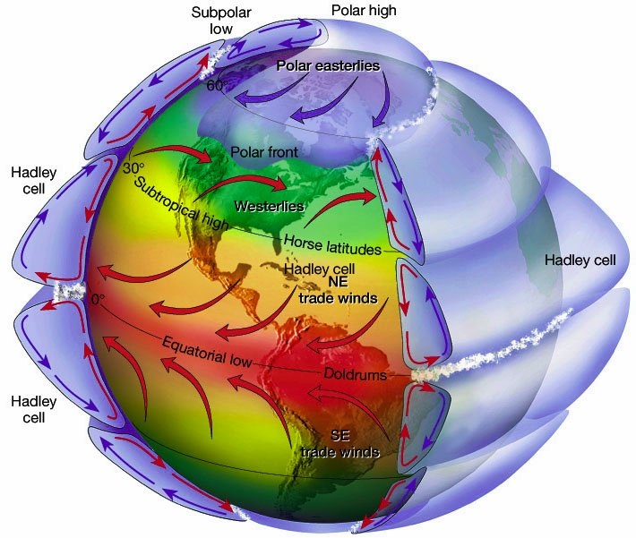

Around 80% of the mass of Earth’s atmosphere is within the closest 18km to its surface. Atmospheric pressure is normally measured in units called millibars (mb). One millibar is equal to 1 gram per centimeter squared (1g/cm2). At sea level, the average air pressure is 1,013mb. At the top of Mt. Everest the air pressure can get as low as 300mb. (Isotherms are lines of constant temperature)
Cold front identification | Before Passing | While Passing | After Passing
Winds | south-southwest | gusty; shifting | west-northwest
Temperature | warm | sudden drop | steadily dropping
Pressure | falling steadily | minimum, then sharp rise | rising steadily
Clouds | increasing: Ci, Cs and Cb | Cb | Cu
Precipitation | short period of showers | heavy rains, sometimes with hail, thunder and lightning | showers then clearing
Visibility | fair to poor in haze | poor, followed by improving | good, except in showers
Dew Point | high; remains steady | sharp drop | lowering
Occluded fronts are fronts where the cold front overtakes the warm front in a cyclone. They can be warm or cold, depending on the temperature of the air mass in front of it. Winds before blow southeast, then after passing they blow southwest.
Warm front idenfication | Before Passing | While Passing | After Passing
Winds | south-southeast | variable | south-southwest
Temperature | cool-cold; gradually warming | steady rise | warmer, then steady
Pressure | usually falling | leveling off | Slight rise, then fall
Clouds | in this order: Ci, Cs, As, Ns, St, and fog; occasionally Cb in summer | stratus-type | clearing with scattered Sc; occasionally Cb in summer
Precipitation | Light-to-moderate rain, snow, sleet or Drizzle | drizzle or none | usually none, sometimes light rain or showers
Visibility | poor | poor, but improving | fair in haze
Dew Point | steady rise | steady | rise, then steady
Dry lines are fronts of drier air. The air mass in front of a dry line is typically more humid than air that has been passed by the front. Dry lines may affect the wind direction or temperature of an air mass it passes through. Similar to cold fronts, dry lines lift moist air above the incoming dry air and can produce thunderstorms, including supercell clouds. Warm advection at 850 millibars is often indicative of rising temperatures at the surface, while cold advection at this level often precedes falling temperatures.
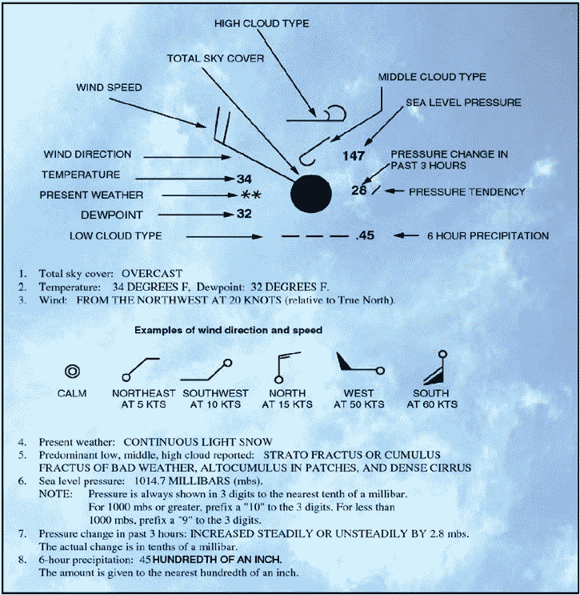
Vorticity is the localized rotation of the air. Air that rotates counterclockwise, such as in cyclones and troughs, is said to have positive vorticity. Clockwise rotating air, such as in high pressure systems and ridges, has negative vorticity.
Dew Point temperature is the temperature that will allow dew to form because of moisture. The relative humidity of a place is the ratio of the vapor density associated with the dew point temperature to vapor density associated with the current temperature.
Convergence is when two bodies of air rush into the same low pressure area and are pushed upward.
The Law of Reflection states That the angle of incidence (incoming Ray) is equal to the angle of reflection (outgoing ray)
Sundogs are formed by plate-shaped hexagonal ice crystals in high and cold cirrus clouds or, during very cold weather, by ice crystals called diamond dust drifting in the air at low levels. These crystals act as prisms, bending the light rays passing through them by 22°.
virga is an observable streak or shaft of precipitation that falls from a cloud but evaporates before reaching the ground.
Crepuscular rays are rays of sunlight that appear to radiate from a single point in the sky.
These rays, which stream through gaps in clouds or between other objects, are columns of sunlit air separated by darker cloud-shadowed regions.
The reason for a green flash lies in refraction of light (as in a prism) in the atmosphere: light moves more slowly in the lower, denser air than in the thinner air above, so sunlight rays follow paths that curve slightly, in the same direction as the curvature of the Earth. Higher frequency light (green/blue) curves more than lower frequency light (red/orange), so green/blue rays from the upper limb of the setting sun remain visible after the red rays are obstructed by the curvature of the earth.

