Part IV: Data Interpretation

1. Diabetes is becoming more common in the United States. From 1980 through 2006, the number of Americans with diabetes tripled (from 5.6 million to 16.8 million).
Number (in Millions) of Civilian/Noninstitutionalized Persons with Diagnosed Diabetes, United States, 1980–2006
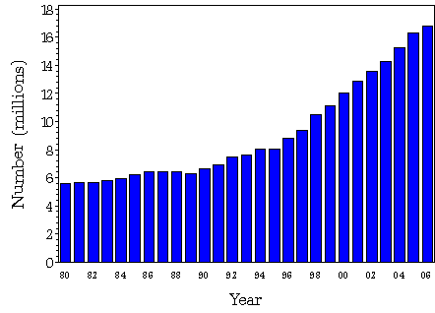
Give three possible reasons for the trend seen in the above graph (15pts)(tiebreaker question).

2. CDC is collaborating with public health officials in multiple states across the United States and with the U.S. Food and Drug Administration (FDA) to investigate a multi-state outbreak of Salmonella Litchfield infections. An investigation that used interviews comparing foods eaten by ill and well persons is showing that cantaloupe from Honduras is the likely source of the illnesses.
As of April 2, 2008, state health departments identified 51 ill persons in 16 states infected with Salmonella Litchfield with the same genetic fingerprint. Ill persons with the outbreak strain have been reported from Arizona (1 person), California (10), Colorado (1), Georgia (2), Illinois (1), Missouri (1), New Jersey (2), New Mexico (1), New York (5), Ohio (1), Oklahoma (2), Oregon (5), Tennessee (1), Utah (5), Washington (10), and Wisconsin (3). Onset dates, which are known for 50 patients, ranged from January 10 to March 10, 2008. Their ages range from <1 to 93 years; 59% are female. At least 16 persons have been hospitalized. No deaths have been reported. In addition, 9 ill persons with the outbreak strain have been reported in Canada.

Most persons infected with Salmonella developed diarrhea, fever, and abdominal cramps 12–72 hours after infection. Infection was diagnosed by culture of a stool sample. The illness usually lasted 4 – 7 days.

Persons infected with the outbreak strain of Salmonella Litchfield, United States, by state, January 1 to April 2, 2008.
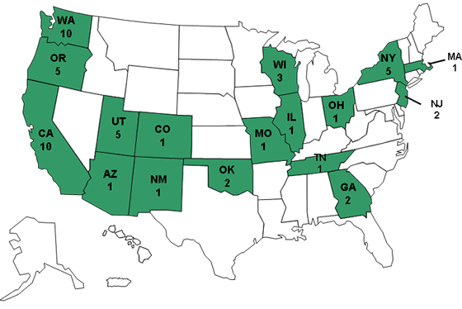
Develop a case definition for the above scenario. (12pts)

