- Draw the symbol that represents each cloud that you might find on a Station ball: (2 pts each)
- Altostratus: b. Cumulonimbus:

- Cirrus: d. Nimbostratus

- Stratocumulus f. Cirrocumulus

- Fill in the answers based on the station ball: (1 pt. each)
59
57
130
Cloud coverage: ________
Wind spd: _______knots
Wind direction: (coming from) ______
Temp: _____
Weather: _______
Dewpoint: ___
Low cloud: ________
Medium cloud: _________
High cloud: __________
Sea Level Preasure: _______

``````

- Draw a 3 cell model, labeling the following: (1 pt. each)
Hadley cell, Farell cell, Polar high, Equator, Tropic of Capricorn, Tropic of Cancer. Draw the cells and which way they rotate.

- List the 3 most common gasses in the atmosphere and how much of the atmosphere they make up as percentages: (1 pt. for each gas, 2 pts for correct percentages, 3pts for both)
  - _________________________________________________________
  - _________________________________________________________
  - __________________________________________________________

- Match the following Koppen classifications with the weather it is associated with: (2 pts each)
- Af ___ A. Humid with severe, dry winter
- BWh ___ B. Mild with no dry season, cool summer
- Cfc ___ C. Cool deserts with a temperature lower than 18C
- Dwa ___ D. Polar tundra, no true summer
- ET ___ E. Tropical wet climate, no true summer

6. You are standing outside, and the large tree in your front yard is swaying! You walk towards it and find that walking isn’t quite as easy as usual. Based on the information above, what is the wind speed, in MPH and Knots, what is the Beaufort number (based on the beaufort scale), and what is the Seaman’s term? (1 pt each)
____ MPH, ____ Knots, The Beaufort number is ____, and the seaman’s term is _________.
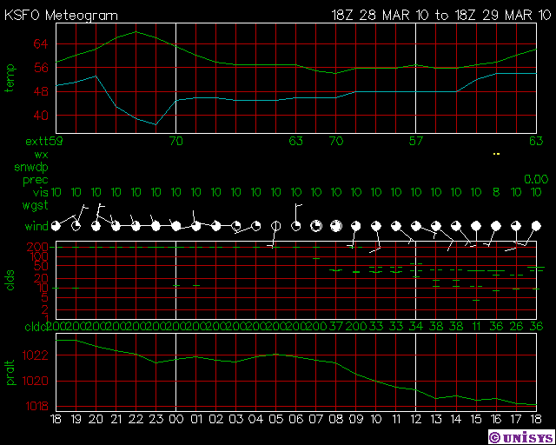
Answer questions 7-10 using the meteogram below:
7. BONUS (Tie breaker): In what state was this meteogram recorded?
8. At what time in this 24 hour period was the relative humidity at it’s lowest? (2 pts)

9. What type of front might have moved in over the night? (2 pts)(Warm, Cold, Occulated, or Stationary)
10. Write the METAR code as it would have appeared at 9:00AM. (Tie breaker)

