Meteorology Practice Test
Fill in the Blank
- A ______ _______ is defined as the transition zone where a cold air mass is replacing a warmer air mass.
- A ______ ______ is defined as the transition zone where a warm air mass is replacing a cold air mass.
- ____________ is the evaporation of water from plants into the atmosphere.
- ______ shear is the change of winds due to height.
- A ____________ is a downdraft less than 2.5 miles in diameter (severe storms)
- Meteors or rock fragments burn up in the ____________.
Mutiple Choice
- What percent of the Earth’s water is located in the oceans?
- About 5%
- About 50%
- About 25%
- About 97 %
- Which layer of earth’s atmosphere does weather occur?
- Troposphere
- Stratosphere
- Mesosphere
- Thermosphere
- Exosphere
- Ozone, located in the stratosphere, protects us from
- harmful UV radiation
- sunlight
- infrared radiation
- What is a temperature inversion?
- Cold air under warm air
- Warm air under cold air
- A front that is NOT moving is called a….
- Warm front
- Occluded front
- Stationary front
- Dry line
- When a cold front overtakes a warm front, it is called a(n)
- Cold front
- Stationary front
- Occluded front
- Impossible to detect
- What is an air mass?
- A large body of air that has similar characteristics throughout it
- Pressure exerted by a mass of air at a given point
- A boundary that separates a warm air mass from a dry air mass
- The bending of light as it passes from one medium to another is called
- Reflection
- Refraction
- Diffraction
- Scattering

- What is responsible for producing blue skies on a clear day?
- Mie scattering
- Selective scattering
- Rayleigh scattering
- Both B and C
- Winds flow (clockwise, counterclockwise) around a high in the northern hemisphere and (clockwise, counterclockwise) around a high in the southern hemisphere.
- What are also known as anti-cyclones?
- High pressure center
- Low pressure center
- Dry line
- What is the highest wind speed ever to be recorded in the United States?
- 231 mph in Mount Washington
- 159 mph in Miami
- 334 mph in New York City
- 372 mph in Mount Washington
Matching
- A line representing points of equal depth under water
- Isotherm
- Isobar
- Isobaths
- Isohyets
- Isostere
- isopleths
- isopor
- A line connecting points of equal pressure
- A line representing points of equal precipitation
- A line connecting points of equal temperature
- A line representing points of equal atmospheric density
- A line representing points of equal annual change in magnetic declination
- A line representing points of equal numerical value, such as population

Clouds
Identify the Clouds


_____________

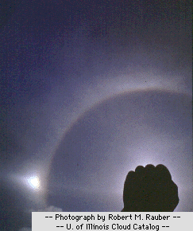

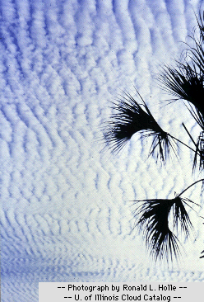

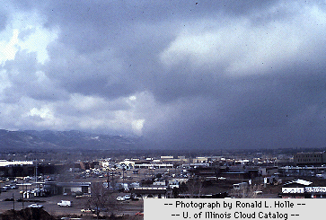

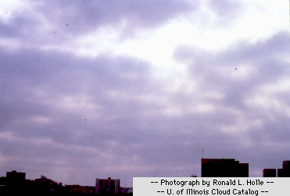

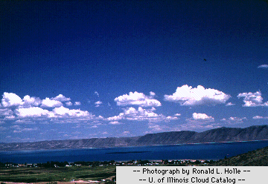

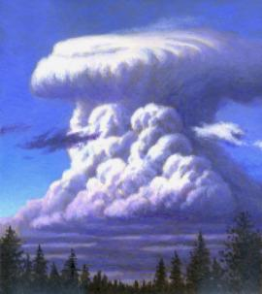

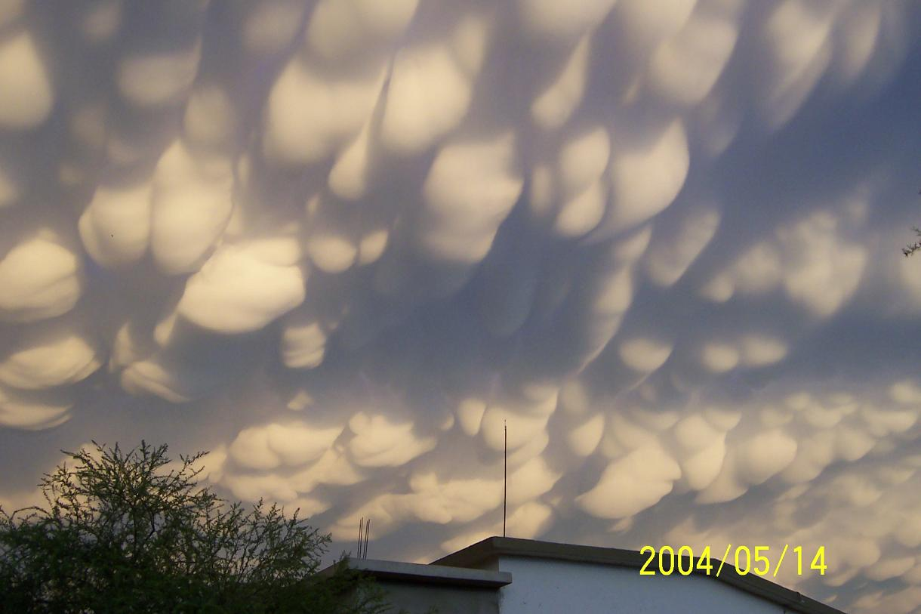

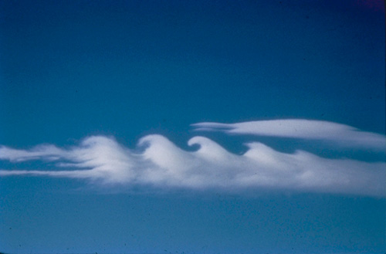
Short Answer
- What does the Beaufort Scale measure?
- What is a virga?

- What are contrails?

- List some of the effects of El Nino.

- What is the pressure gradient force?

- What is a macroburst? (can be in general)

- Define dew point temperature.

- What are the four layers of the atmosphere?

- What is diffraction?

