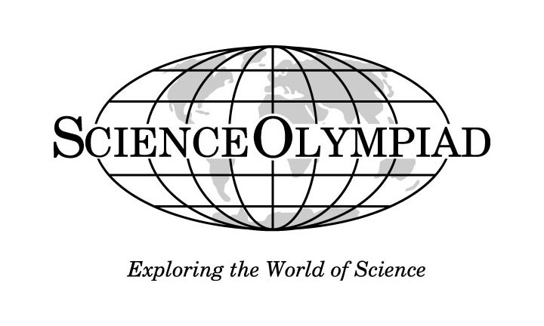**Comprehensive Assessment**

**Anatomy (B)**

**Answer Key**

***Each Question Worth: 1.282 points***

*This test was created by LaRoyce Covington Jr, and is to be used for no other purpose but as a practice test for Science Olympiad competitions. Those administering the test may not edit, change, or revise the test in any way.*

*Copyright © LaRoyce Covington 2012*

***Respiratory System***

**INSTRUCTION: Simply fill in the blanks to these sentences and/or questions**

1. **Name the functions of the Respiratory System.**

**Ventilation, Respiration, Regulation of Blood pH, and Speech**

2. There are two main breathing patterns: **Quiet Breathing** and **Forced Breathing**.

3. The upper respiratory system consists of the organs from the **nostrils** to the **pharynx**, in order of where the air passes. The lower respiratory system stretches from the top of the **trachea** to the **diaphragm**.

4. Air is taken in through the **nose**.

5. The **nostrils** are one of two places where air enters and exits respiratory system. It has hair to trap dirt, dust particles, and bacteria.

6. Air passes through the **pharynx** on its way to the lungs.

7. The **trachea** is a tube that runs from the larynx to just above the lungs.

8. The **lungs** are large paired organs within the chest cavity on either side of the heart. They are protected by the **rib** **cage**.

9. The **diaphragm** is a dome-shaped muscle separating the thoracic (chest) cavity from the abdominal (belly area) cavity.

10. Name two diseases that can be detected using a spirometer:

**Chronic Obstructive Pulmonary Disease (COPD)** and **Asthma**

***Digestive System***

**INSTRUCTION: In this portion of the test fill in the blanks in the paragraphs.**

***CORRECTED VERSION:***

The digestive tract is about 8 meters, or 28 feet long. It can take from 15 to 72 hours for food to pass from the mouth to the anus.

The mouth is where the digestion of food starts. The mouth is a good example of mechanical digestion and chemical digestion at work. The teeth chomp, chew, and tear food down into smaller pieces (mechanical digestion). The molecular structure of the food does not change in mechanical digestion. Then, the salivary glands secrete saliva into the mouth, breaking down starches into dextrin and maltose (chemical digestion). Saliva is a form of chemical digestion because it changes the molecular structure of the food. These digestive processes create food boluses.

After food boluses are developed in the mouth, they go down the pharynx. The pharynx is a shared connection between the nasal cavities, the mouth, the air tract, and the esophagus. Therefore, there must be a structure to prevent the boluses from entering the trachea (passage to the lungs). This is why we have an epiglottis. The epiglottis is a small flap which can open and close the entrance to the trachea. When food boluses travel through the pharynx, the epiglottis folds down to protect the airway. However, in instances like when you talk and eat, the epiglottis can get confused. In order to talk, the epiglottis must be open. In order to swallow, the epiglottis must be closed. Therefore the epiglottis might malfunction and you could choke. This is why you shouldn't talk with food in your mouth.

After the pharynx, food bolus is transported to the stomach via the esophagus/oesophagus. The esophagus is a muscle-walled tube that goes from the throat to the lower digestive tract. To help food get down, muscular contractions called peristalsis push food down towards the stomach. To demonstrate peristalsis motions, imagine a sphere in a rubber tube. the diameter of the sphere is a little more then the diameter of the tube. If you wanted to get the ball out, you would squeeze the tube from one end, and slowly move your hand towards the ball while squeezing to push it out. The reason peristalsis is important is when we are working against gravity. For example, when you eat upside down, the food bolus is still able to move to the stomach because of peristalsis contractions.

Next in the digestive tract comes the stomach. When we think of digestion, the first thing that comes to mind is the stomach. It acts like a waiting room for food bolus. While the food boluses are waiting, the stomach breaks the food down into a liquid-like mixture by churning the food (mechanical digestion) and secreting gastric acid (chemical digestion). Gastric acid also kills bacteria that may be in the food.

When food boluses are ready to be further digested, they transfer to the duodenum by contractions of the stomach walls. The duodenum is the first part of the small intestine and is about 25 cm in length. The duodenum is stationary, and is fixed behind sheets of connective tissue called peritoneum. Glands in the duodenum secrete a thick alkaline fluid that counteract the acidic nature of the chemicals the food bile has absorbed. The gall bladder also secretes pancreatic juice and bile into the duodenum.

The liver is a very important part of the digestive system, even though food does not directly pass through it. The liver produces bile (a greenish fluid which aids in the digestion of fats), which is stored in the gall bladder. When bile is needed, it joins with secretions from the pancreas and goes through the common bile duct into the duodenum.

After the duodenum comes the two other parts of the small intestine, the jejunum and the ileum. These are what make up the bulk of the small intestine. The jejunum is the first part while the ileum is the second part.

After passing through the duodenum, jejunum, and the ileum (the small intestine), food bolus makes its way through the large intestine. The large intestine is actually shorter than the small intestine, but larger in diameter. Water and electrolytes are removed in the large intestine. Also, microbes such as bacteria aid in further digestion. Finally, food bolus comes out of the anus as feces.