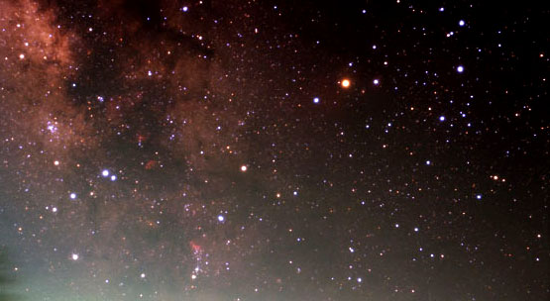

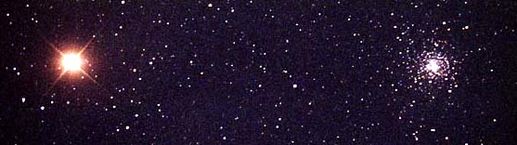
This photo contains the constellation of __(1)__. The inset shows the large reddish star __(2)__. Identify the object to the right of the large reddish star. __(3)__ What type of object is it? __(4)__

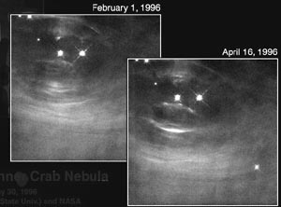
Within this object are several RR Lyrae variable stars. All RR Lyrae stars have an absolute visual magnitude of 0.75. One of these variables, Star #42, has an apparent magnitude of 13.5. How many light years away is this object? __(5)__ Look at the Image Sheet. Which HR diagram most accurately shows this object? __(6)__ This object appears in one of the images on the Image Sheet. Which image? __(7)__ What is the name of the other object(s) in this image? __(8)__

The image to the right is located at the center of M1. What is the name of this object? __(9)__ If the scale for the ruler in the upper right-hand corner of the image is 10,000 AU’s, how many AU’s has the white-line “wave” moved between

February 1st and April 16th, 1996? __(10)__
What is the approximate speed of this “wave” in km/s? __(11)__ At what fraction of the speed of light is the “wave” moving? __(12)__ Which image on the Image Sheet is a composite of the X-ray, optical, radio and infrared parts of the spectrum for M1? __(13)__ Which type of radiation is revealing events with the highest energy? __(14)__ The lowest energy? __(15)__ The optical image contains an oval-shaped distribution of gas and a chaotic network of filaments. Which of these regions produces a continuous spectrum? __(16)__ which region produces an emission spectrum? __(17)__ On the Image Sheet locate the first recorded observation of this object. __(18)__ The expansion rate of this object is 0.23 arcsec/yr, and its apparent size is 4 x 6 arcmin. How long will it be until the long axis of this object has the same apparent size as the full moon (angular diameter of 0.5 degrees)? __(19)__

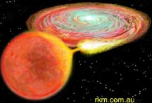
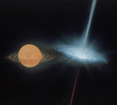
The binary system illustration (below left) consists of two stars in different stages of evolution. The reddish star is a __(20)__ and the other one is a __(21)__. If this system becomes highly unstable, it may lead to what type of event? __(22)__ ~How many solar masses did the progenitor star for the object with the accretion disk have? __(23)__

On the Image Sheet, select the image that shows the previous evolutionary stage of the object on the right. __(24)__ what is this stage called? __(25)__

The illustration (right) depicts a rare type of system. What is the name of this system? __(26)__ What type of system is it? __(27)__ On the Image Sheet find the image of the object that contains this system. __(28)__ What is the name of this object? __(29)__ What is the evolutionary stage of the object on the left? __(30)__ The object on the right? __(31)__ The system has an orbital period is 16.5 days, ~5 solar masses, and an eccentricity of 0.7. What is the distance between the two objects at periastron and apastron in kilometers? __(32)__

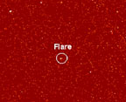
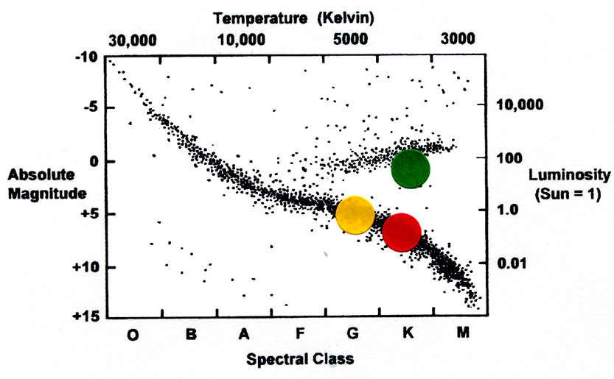
The name of the object in this image is __(33)__. What type of object is it? __(34)__ Which image on the Image Sheet shows normal core activity for this type of object? __(35)__ Unexpected flare activity has been discovered for other types of objects as well. On the Image Sheet, which image shows objects with flare activity? __(36)__ These objects are in what stage of evolution? __(37)__ These objects are contained within one of the other images on the Image Sheet – which one is it? __(38)__ On the HR-diagram to the right, the Sun is represented by the yellow circle. Prior to its arrival in its current position on the diagram, the Sun evolved through two stages. What was the Sun called when it was in the position of the red circle? __(39)__ The green circle? __(40)__ When stars at the stage represented by the green circle or earlier stages form, they often produce areas of luminosity called __(41)__. Which image on the Image Sheet shows these areas? __(42)__ At one stage during its birth, the proto-sun had a luminosity of 1000 solar luminosities (L) and a surface temperature of ~1000K compared to its present temperature of ~5800K. How much larger was the radius of the proto-sun than the Sun’s radius today? __(43)__

NGC 2244 is what type of object? __(44)__ On the Image Sheet locate this object __(45)__ and the image of the larger object that contains this object. __(46)__ This larger object is shown as a composite image of what two wavelengths? __(47)__
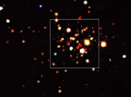

The close-up of the object to the left contains several x-ray binary systems. What is the name of this object? __(48)__ One of the images on the Image Sheet is a close-up of this object, which shows several end products of stellar evolution. Which image is it? __(49)__ Another close-up of this object on the Image Sheet contains objects that are younger than the age of the object itself. Which image is it? __(50)__ What are these objects called? __(51)__ Which HR diagram on the Image Sheet shows these objects? __(52)__ What type of object is shown in the image to the left above? __(53)__ On the Image Sheet there is another image of this same type of object. Which one is it? __(54)__ What is the name of this object? __(55)__ This object is located within one of the other images on the Image Sheet. Which one is it? __(56)__ What is the name of the object in this image? __(57)__
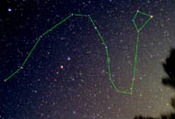

One of the images on the Image Sheet is located in the northern circumpolar constellation shown on the right. What is the name of this constellation? __(58)__ Which two images on the Image Sheet shows the object located in this constellation? __(59)__ What is the name of this object? __(60)__ Which image on the Image Sheet shows the X-ray image of the center of this object? __(61)__ What do scientists suspect is located in the center of this object? __(62)__ This object is 3000 LY away, 1000 years old, and is 400 times larger than the Solar System (Sun-Pluto distance 39.5 AU) What is the average rate of expansion for this object in km/s? __(63)__

Look at the four panels of stellar spectra on the left-hand side of the Spectra and Image Sheet. The lines at about 4340 and 4860 angstroms are critical lines for classifying stars. These are two of the Balmer lines of hydrogen, in which the atom is making a transition up from the second energy level. List the four panels in order from strongest to weakest Balmer lines. __(64)__ List the four panels in order from hottest to coolest. __(65)__ What is the temperature of the spectra at which the Balmer lines are strongest? __(66)__ What happens to the Balmer lines at higher temperatures? __(67)__ At lower temperatures? __(68)__

Indicate the position on the HR diagram below of all the images (69 – 86) located on the Spectra and Image Sheet. Place all responses in the response section.

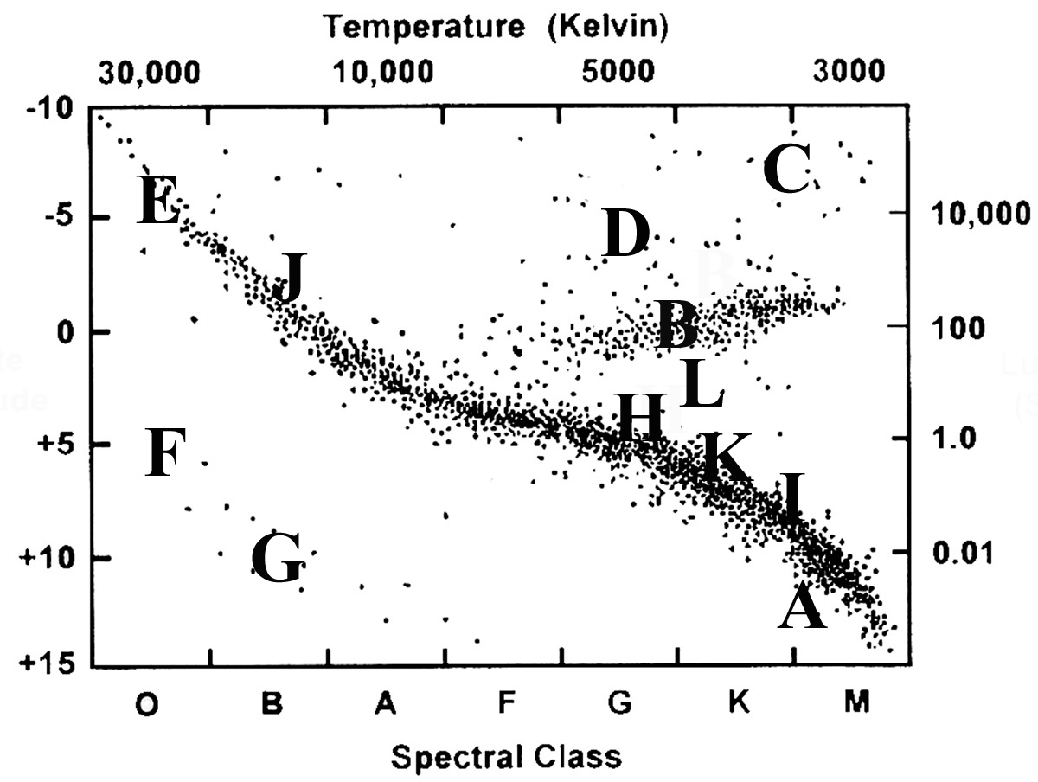

TEAM #_________ TEAM NAME___________________________________

Response Sheet

- _________________________________________________________________

- _________________________________________________________________

- _________________________________________________________________

- _________________________________________________________________

- _________________________________________________________________

- _________________________________________________________________

- _________________________________________________________________

- _________________________________________________________________

- _________________________________________________________________

- _________________________________________________________________

- _________________________________________________________________

- _________________________________________________________________

- _________________________________________________________________

- _________________________________________________________________

- _________________________________________________________________

- _________________________________________________________________

- _________________________________________________________________

- _________________________________________________________________

- _________________________________________________________________

- _________________________________________________________________

- _________________________________________________________________

- _________________________________________________________________

- _________________________________________________________________

- _________________________________________________________________

- _________________________________________________________________

- _________________________________________________________________

- _________________________________________________________________

- _________________________________________________________________

- _________________________________________________________________

- _________________________________________________________________

- _________________________________________________________________

- _________________________________________________________________

- _________________________________________________________________

- _________________________________________________________________

- _________________________________________________________________

- _________________________________________________________________

- _________________________________________________________________

- _________________________________________________________________

- _________________________________________________________________

- _________________________________________________________________

- _________________________________________________________________

- _________________________________________________________________

- _________________________________________________________________

- _________________________________________________________________

- _________________________________________________________________

- _________________________________________________________________

- _________________________________________________________________

- _________________________________________________________________

- _________________________________________________________________

- _________________________________________________________________

- _________________________________________________________________

- _________________________________________________________________

- _________________________________________________________________

- _________________________________________________________________

- _________________________________________________________________

- _________________________________________________________________

- _________________________________________________________________

- _________________________________________________________________

- _________________________________________________________________

- _________________________________________________________________

- _________________________________________________________________

- _________________________________________________________________

- _________________________________________________________________

- _________________________________________________________________

- __________________________________________________________________

- __________________________________________________________________

- __________________________________________________________________

- __________________________________________________________________

- __________________________________________________________________

- __________________________________________________________________

- __________________________________________________________________

- __________________________________________________________________

- __________________________________________________________________

- __________________________________________________________________

- __________________________________________________________________

- __________________________________________________________________

- __________________________________________________________________

- __________________________________________________________________

- __________________________________________________________________

- __________________________________________________________________

- __________________________________________________________________

- __________________________________________________________________

- __________________________________________________________________

- __________________________________________________________________

- __________________________________________________________________

- __________________________________________________________________

