### Mnstrviola’s Anatomy Practice Test- v 2.0

**Section I: Multiple Choice- worth 1 point each. ¼ point penalty for each wrong answer**

1. Which is NOT a function of the respiratory system?
   1. Olfaction
   2. Voice production
   3. Regulation of blood pH
   4. Production of carbon dioxide
2. Which is NOT a part of the lower respiratory tract?
   1. Bronchi
   2. Lungs
   3. Pharynx
   4. Larynx
3. The nostrils...
   1. are also known as the nasal septum
   2. are the external openings of the nose
   3. are the site of gas exchange
   4. are the openings into the pharynx
4. How many conchae are located in the nasal cavity?
   1. 0
   2. 1
   3. 2
   4. 3
5. Which of these is NOT a region of the pharynx?
   1. Oropharynx
   2. Nasopharynx
   3. Gastropharynx
   4. Laryngopharynx
6. Which of these is NOT a part of the larynx?
   1. Hyoid cartilage
   2. Thyroid cartilage
   3. Cuneiform cartilage
   4. Cricoid cartilage
7. The uvula...
   1. is located in the lungs
   2. is part of the soft palate
   3. is microscopic
   4. is located in the laryngopharynx
8. The alveoli...
   1. are the site of gas exchange
   2. are larger than the bronchi
   3. are located in the bronchus
   4. are covered in cartilage
9. The visceral pleura...
   1. lines the walls of the thorax
   2. is a cartilage covering the diaphragm
   3. is larger than the parietal pleura
   4. covers the surface of the lung
10. The diaphragm...
    1. is made of smooth muscle
    2. is not necessary for respiration
    3. is controlled by the phrenic nerve
    4. is the only muscle associated with respiration
11. Which is NOT a function of the digestive system?
    1. Elimination of urine
    2. Breaking down food
    3. Providing nutrients
    4. Taking in food
12. What is mastication?
    1. chewing
    2. swallowing
    3. digestion
    4. absorption
13. How many teeth are in the normal adult mouth?
    1. 20
    2. 16
    3. 32
    4. 24
14. Which of these is NOT a salivary gland?
    1. subpharyngeal
    2. submandibular
    3. parotid
    4. sublingual
15. During deglutition...
    1. the stomach breaks down carbohydrates
    2. the cardiac sphincter closes
    3. saliva is secreted into the mouth
    4. food bolus is transported from the mouth
16. What is chyme?
    1. the wall of the stomach
    2. the folds of the stomach
    3. bolus that has been digest further
    4. the hormone which activates pepsinogen
17. Which is NOT a part of the small intestine?
    1. ileum
    2. caecum
    3. jejunum
    4. duodenum
18. What produces bile?
    1. duodenum
    2. stomach
    3. liver
    4. pancreas
19. Which is NOT part of the large intestine?
    1. Ascending colon
    2. Transverse colon
    3. Descending colon
    4. Arytenoid colon
20. The large intestine absorbs...
    1. proteins
    2. water
    3. carbohydrates
    4. sugars

**Section II: Fill in the Blanks- worth two points for each blank. No penalty for wrong answer**

1. Food is prevented from entering the trachea by the epiglottis and the _____________.
2. The ____________ vibrate to produce sounds when air flows through the larynx.
3. During forceful inspiration, the diaphragm ____________ and the external intercostals ___________ the rib cage, increasing the volume of the thoracic cavity.
4. Inspiration is usually a(n) ____________ process, while expiration is usually a(n) ____________ process.
5. The lungs do not normally collapse because ____________ reduces the surface tension of the fluid lining the alveoli, and pleural pressure is __________ than alveolar pressure.
6. The right lung has ___________ lobes while the left lung has ____________ lobes.
7. Oxygen and carbon dioxide pass from the alveoli to the capillary by the process of ___________.
8. ___________ is the process of measuring volumes of air that move throughout the respiratory system.
9. The diaphragm is located __________ the lungs.
10. The Hering-Breuer reflex limits the extent of ___________.
11. The body wall of the abdominal cavity and the abdominal organs are covered with ____________.
12. The appendix is a(n) ____________ organ, its function was probably lost through evolution.
13. The oral vestibule is the space between the teeth and the ___________.
14. The large folds on the inner stomach walls are called ___________.
15. Approximately ______ liters of gastric secretions is produced in a day.
16. The ___________ valve allows materials to move from the ileum to the large intestine, but not back.
17. Mucus is produced by __________ cells.
18. The three longitudal **strips** of muscle that are on the outer walls of the colon are called ___________.
19. The large intestine is the main site of __________ absorption.
20. It takes food about _________ hours to travel through the alimentary canal.

**Section III: Short Answer (1-3 sentences)- worth three points each. No penalty for wrong answer**

- Be as specific as you can!

1. Describe the advantages and/or disadvantages of breathing through your mouth.
2. Which bronchus is a foreign object most likely to be lodged in? Why?
3. Explain the purpose of villi and microvilli.
4. What are effects of exercise on the respiratory system?
5. Describe the components of the palate.
6. Describe the differences between a carbohydrate, lipid, and protein in relation to the digestive system.
7. Describe the function of the large intestine.
8. What are long and short-term effects of exercise on the digestive system?
9. Is the “sinus” the same thing as the “nasal cavity”? Explain.

**Section IV: Digestive Secretion Chart- fill in the blanks. 1 point for each blank. No penalties**

- Be as specific as you can!

|  |  |  |  |
| --- | --- | --- | --- |
| Name | Function | Production Site | Secretion Site |
| Peptidases | Digests polypeptides |  |  |
|  | Digests Lipids | Salivary Glands | Mouth |
| Hydrochloric Acid |  |  |  |
|  | Digests Protein | Gastric Glands |  |
| Nuclease | Digests Nucleic Acids |  |  |
|  | Digests Sucrose |  | Small Intestine |
| Lactase |  |  |  |
| Bile |  |  |  |
|  | Stimulates Bicarbonate Secretion To Counter Acidity | Duodenum | Duodenum |
| Salivary Amylase |  |  |  |
| Maltase |  |  |  |
|  | Protects from stomach acid | Duodenum  (Goblet Cells) | Duodenum |

Section V: Pulmonary Volumes and Capacities- 2 points for each question, no penalties

Average pulmonary volumes for young adult male

1. TV- _____mL
2. IRV- _____mL
3. ERV- _____mL
4. RV- _____mL

Pulmonary Capacity equations (not all blanks will be used for some)

1. Functional Residual Capacity= _________ + __________ + ________ + _______
2. Inspiratory Capacity= _________ + ___________ + ________ + __________
3. Vital Capacity= __________ + ____________ + _________ + __________
4. Total Lung Capacity= ____________ + ____________ + __________ + _________

**Section VI: Labeling Diagrams- worth 2 points each. No penalty for wrong answer.**

- Be as specific as you can!

Diagram I: Fill In the Blank

1. ___________________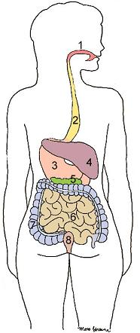
2. ___________________
3. ___________________
4. ___________________
5. ___________________
6. ___________________
7. ___________________
8. ___________________

Diagram II: Use words from the word list

Word List

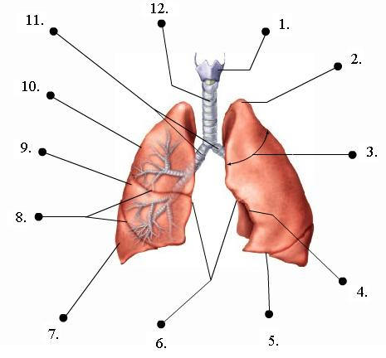

1.____________ a. Trachea

2.____________ b. Primary Bronchi

3.____________ c. Superior Lobe

4.____________ d. Middle Lobe

5.____________ e. Inferior Lobe

6.____________ f. Larynx

7.____________ g. Apex

8.____________ h. Base

9.____________ i. Mediastinal Surfaces

10.____________ j. Costal Surfaces

11.____________ k. Fissures

12. ____________ l. Cardiac Impression

**Section VII: Diseases Identification- 10 points each**

You’re a doctor in this section. Diagnose each patient with the most specific and most likely condition(s), and identify ways the patient could treat his/her symptoms or disease(s). Be as descriptive as you can.

1. Mike Garcia is an avid golfer and an avid smoker. He has labored breathing. Using a spirometer, you see he has an expiratory reserve volume of 600mL. His chest is also larger than usual, and his lungs are less elastic.
2. Dave Jones has been feeling nauseous and has no appetite. He refuses to eat even his favorite food, macaroni and cheese. He also started to vomit. He came to you because he felt pain in his lower right abdomen. You apply pressure to his McBurney’s point and it is tender.
3. Ellen Chin loves to go scuba diving. She also loves spending time with her pet Spots, the dog. One day, she has a convulsion, faints, and is rushed to the hospital. When she wakes up, she experiences pain in her eye and when she breathes.
4. Thomas Green is a 50 year old man who’s favorite dinner is pizza and milk. However, whenever his wife makes him pizza and milk for dinner he has a stomach ache. He describes it as having “a burning sensation in my stomach that lasts for an hour or so”. He has recently traveled to Paris. Also, he often takes aspirin to help relieve stress from work. He says that he does not experience much flatulence or diarrhea.
5. Patricia Gomez is back to your office. You have diagnosed her with hepatitis before. She says she experiences pain on the right side of her abdomen and has diarrhea. She also has pain around her joints. You notice her skin is yellower than usual, but she says that it’s just a tan. Patricia also looks skinnier than usual. Looking at her past medical history, you notice she had a low weight at birth and was also diagnosed with cirrhosis before. Her parents and grandparents were diagnosed with Crohn’s disease. You touch her forehead and it’s hotter than usual.

(Hint: There are two diseases)

Section VIII: Digestive Layers- Label the diagram, and describe each layer. 4 points each

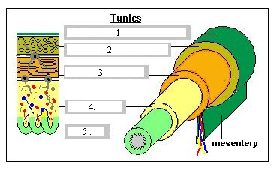

1.___________________________________________________________________________________________________________________________________________________

2.________________________________________________________________________

__________________________________________________________________________

3.____________________________________________________________________________________________________________________________________________________

4._________________________________________________________________________

___________________________________________________________________________

5.____________________________________________________________________________________________________________________________________________________