Virginia
Regional Science Olympiad

Astronomy C Division Event
2009

Team Number __________________

Team Name __________________________________________

Instructions:

Please turn in all materials at the end of this event.

Do not forget to put you Team Name and Team Number at the
Top of all Answer Pages.

Questions adapted from Foundations of Astronomy Edition 8 Michael A Seeds
2005

Astronomy Event 2009
Part A Each question correct is one point.

1. The remaining 48 ancient constellations that we still recognize today are located
a. along the ecliptic.
b. along the celestial equator.
c. near the south celestial pole.
d. at mid and northern celestial latitudes.
e. uniformly around the celestial sphere

2. Which statement below most accurately describes modern constellations?
a. They are 88 well defined regions on the celestial sphere.
b. They are 88 connect-the-dot mythological sky figures.
c. They are 13 connect-the-dot mythological sky figures along the ecliptic.
d. They are 13 well defined sky regions along the ecliptic.
e. They are 88 groups of stars with members of each constellation physically close together in space

3. What is the most likely Greek letter name of the second brightest star in the constellation Lyra?
a. alpha Lyrae.
b. beta Lyrae.
c. gamma Lyrae.
d. delta Lyrae.
e. epsilon Lyrae

4. The apparent visual magnitudes of four stars are listed below. Of these four stars which one appears dimmest in the sky?
a. - 0.5
b. +2.8
c. -1.2
d. +0.7
e. It cannot be determined from the given information

5. Which pair of apparent visual magnitudes listed below indicates that we receive about 16 times as much visible light from star W than from star X?
a. mv star W = 16, and mv star X = 1
b. mv star W = 1, and mv star X = 16
c. mv star W = 1, and mv star X = 6
d. mv star W = 5, and mv star X = 2
e. mv star W = 2, and mv star X = 5

6. The apparent visual magnitude of star A is 2 and the apparent visual magnitude of star B is 1. Based on this information which statement below must be true?
a. Star A emits more light than star B.
b. Star B emits more light than star A.
c. Star A is closer than star B.
d. Star B is closer than star A.
e. Light output and distance cannot be determined from a star's apparent visual magnitude alone.

7. If the apparent visual magnitude of the Sun is -26.5 and that of the full moon is -12.5, what is the light intensity ratio of sunlight to moonlight received at Earth on the day of the full moon?
a. 40
b. 100
c. 4000
d. 10,000
e. 400,000

8. When you observe a star on the celestial equator for a period of a few hours, you notice that it
a. moves from north to south relative to the horizon.
b. moves from south to north relative to the horizon.
c. moves from east to west relative to the horizon.
d. moves from west to east relative to the horizon.
e. does not move relative to the horizon.

9. If you could see the Sun and stars during the daytime for several weeks you would notice that the Sun
a. never moves relative to the stars.
b. moves slowly westward relative to the stars.
c. moves slowly eastward relative to the stars.
d. sometimes moves westward and at other times eastward relative to the stars.
e. rises in the west and sets in the east.

10. The five naked-eye planets and three telescopic planets that wander among the stars in the sky are always near the
a. horizon.
b. celestial equator.
c. ecliptic.
d. Moon.
e. Sun

11. Which of Kepler's laws of planetary motion is a consequence of the conservation of angular momentum?
a. The planets orbit the Sun in elliptical paths with the Sun at one focus.
b. A planet-Sun line sweeps out equal areas in equal intervals of time.
c. The orbital period of a planet squared is proportional to its semimajor axis cubed.
d. Both b and c above.
12. Suppose that Planet Q exists such that it is identical to planet Earth yet orbits the Sun at a distance of 5 AU. How does the amount of gravitational force on Planet Q by the Sun compare to the amount of gravitational force on Earth by the Sun?
a. The amount of the two forces is the same.
b. The amount of force on Planet Q is one-fifth the force on Earth.
c. The amount of force on Planet Q is 5 times the force on Earth.
d. The amount of force on Planet Q is one twenty-fifth the force on Earth.
e. The amount of force on Planet Q is 25 times the force on Earth.

13. Newton's form of Kepler's law can be written as: (Msun + Mplanet) Py2 = aAU3, where the masses of the Sun and planet are in units of solar masses, the period is in units of years, and the semimajor axis in astronomical units. Why is Kepler's form of his third law nearly identical to Newton's form?
a. Both forms are very similar in that they have periods and semimajor axes in units of years and astronomical units respectively.
b. The mass of the Sun plus the mass of a planet is nearly one.
c. The mass of each planet is very large.
d. Both b and c above.
e. All of the above.

14. How does the orbital speed of an asteroid in a circular solar orbit with a radius of 4.0 AU compare to a circular solar orbit with a radius of 1.0 AU?
a. The two orbital speeds are the same.
b. The circular orbital speed at 4.0 AU is four times that at 1.0 AU.
c. The circular orbital speed at 4.0 AU is twice that at 1.0 AU.
d. The circular orbital speed at 4.0 AU is one-half that at 1.0 AU.
e. The circular orbital speed at 4.0 AU is one-fourth that at 1.0 AU.

15. Who first proposed that gravity is the bending of space-time due to the presence of matter?
a. Tycho Brahe (1546 - 1601)
b. Johannes Kepler (1571 - 1630)
c. Galileo Galilei (1564 - 1642)
d. Isaac Newton (1642 - 1727)
e. Albert Einstein (1879 - 1955)

16. Of the following, which color represents the lowest surface temperature star?
a. Yellow.
b. Blue.
c. Orange.
d. Red.
e. White.

17. The amount of electromagnetic energy radiated from every square meter of the surface of a blackbody each second is
a. proportional to temperature.
b. inversely proportional to temperature.
c. proportional to temperature to the fourth power.
d. inversely proportional to temperature to the fourth power.
e. Both a and c above

18. The B - V color index of a star indicates its
a. density.
b. total mass.
c. radius.
d. chemical composition.
e. surface temperature

19. If a star appears brighter through a B filter than it does through a V filter, its B - V color index is
a. negative.
b. zero.
c. positive.
d. greater than or equal to zero.
e. less than or equal to zero.

20. Where is the location of the cooler low-density gas that yields the dark (absorption) line stellar spectra that were studied by Annie Jump Cannon?
a. In the interior of the star.
b. In the star's lower atmosphere.
c. In Earth's atmosphere.
d. Both a and b above.
e. Both b and c above

21. What does the presence of molecular bands in the spectrum of a star indicate?
a. The star has a low surface temperature.
b. The star has a high surface temperature.
c. The star is about to go supernova.
d. The star is spectral type G
e. The star is spectral type TiO

22. Of the following spectral types, which one represents a star with the highest surface temperature?
a. A
b. B
c. F
d. K
e. G
23. All stars are composed of mostly hydrogen and helium, yet many stars have no lines for hydrogen or helium in their spectrum. What causes this apparent contradiction?
a. Spectral lines are created in the lower atmospheres of stars, and for many stars hydrogen and helium are hidden below the atmosphere.
b. The upper layers of a star contain hot low-density gases that produce bright lines at precisely the same wavelengths as the dark lines, thus making them invisible.
c. Hot hydrogen and helium gas in the interstellar medium produces bright lines to fill in the dark lines.
d. The resolution of many spectrographs is too poor to show the extremely thin spectral lines for hydrogen and helium.
e. The surface temperature is such that the electrons are not at the proper energy levels to produce spectral lines at visible wavelengths.

24. You research the star Sirius and find that its spectral lines are blue shifted. What does this tell you about Sirius?
a. Its surface temperature is higher than that of the Sun.
b. It has a transverse velocity that is away from us.
c. It has a transverse velocity that is toward us.
d. It has a radial velocity that is away from us.
e. It has a radial velocity that is toward us.

25. Suppose that you take the spectrum of several stars and identify the 656-nanometer line of hydrogen. You then measure against the reference spectrum on the same image and find that some of the 656-nm lines are shifted due to the Doppler Effect. Of the following shifted locations of this line, which one signals a star that is moving away from us at the highest speed?
a. Star A @ 655 nm.
b. Star B @ 657 nm.
c. Star C @ 658 nm.
d. Star E @ 659 nm.
e. Star D @ 654 nm.

26. What property of a star can broaden the width of its spectral lines?
a. Rapid rotation of the star.
b. High-density atmosphere.
c. High-temperature atmosphere
e. All of the above

27. What is the distance to a star that has a parallax angle of 0.5 arc seconds?
a. Half a parsec.
b. One parsec.
c. Two parsecs.
d. Five parsecs.
e. Ten parsecs

28. At what distance must a star be to have its apparent magnitude equal to its absolute magnitude?
a. One AU.
b. Ten AU.
c. One parsec.
d. Ten parsecs.
e. One Megaparsec

29. What is the distance to a star that has an apparent visual magnitude of 3.5 and an absolute visual magnitude of -1.5?
a. 100 parsecs.
b. 50 parsecs.
c. 25 parsecs.
d. 10 parsecs.
e. 5 parsecs.

30. A star has one-half the surface temperature of the Sun, and is four times larger than the Sun in radius. What is the star's luminosity?
a. 64 solar luminosities.
b. 16 solar luminosities.
c. 4 solar luminosities.
d. 2 solar luminosities.
e. 1 solar luminosity.

31. The Sun's spectral type is G2. What is the Sun's luminosity class?
a. Bright Supergiant (Ia)
b. Supergiant (Ib)
c. Bright Giant (II)
d. Giant (III)
e. Main Sequence (V)

32. In addition to the H-R diagram, what other information is needed to find the distance to a star whose parallax angle is not measurable?
a. The star's spectral type.
b. The star's luminosity class.
c. The star's surface activity.
d. Both a and b above.
e. All of the above.

33. For a particular binary star system the ratio of the mass of star A to star B is 4 to 1. The semimajor axis of the system is 10 AU and the period of the orbits is 10 years. What are the individual masses of star A and star B?
a. Star A is 1 solar mass and star B is 4 solar masses.
b. Star A is 4 solar masses and star B is 1 solar mass.
c. Star A is 2 solar masses and star B is 8 solar masses.
d. Star A is 8 solar masses and star B is 2 solar masses.
34. In a given volume of space the Red Dwarf (or lower main sequence) stars are the most abundant, however, on many
H-R diagrams very few of these stars are plotted. Why?
a. Photographic film and CCDs both have low sensitivity to low-energy red photons.
b. They are so very distant that parallax angles cannot be measured, thus distances and absolute magnitudes are difficult to determine precisely.
c. They have so many molecular bands in their spectra that they are often mistaken for higher temperature spectral types.
d. They have very low luminosity and are difficult to detect, even when nearby.
e. Most of them have merged to form upper main sequence stars.

35. Which of the following is evidence that the spaces between the stars are not totally empty?
a. The interstellar extinction of starlight.
b. The presence of absorption lines of singly-ionized calcium in the spectra of hot stars.
c. Absorption lines in stellar spectra that are much thinner than the other spectral lines.
d. Some stars appear redder than they should, based on their spectral types.
e. All of the above.

36. Which wavelengths of starlight ionize the cool hydrogen atoms in the interstellar medium?
a. Ultraviolet.
b. Visible light.
c. Infrared.
d. Microwave.
e. Radio.

37. The abundances of chemical elements in the interstellar medium, based on absorption lines, are the same as that of the Sun for hydrogen, carbon, and oxygen. However, calcium and iron have a lower abundance in the interstellar medium than on the Sun. Why?
a. The Sun is producing calcium and iron.
b. The Sun is consuming hydrogen, carbon, and oxygen.
c. The heavier elements on the Sun have settled toward its center.
d. The absorption lines of calcium and iron are difficult to detect
e. Calcium and iron are in dust grains of the interstellar medium.

38. The abundances of chemical elements in the interstellar medium, based on absorption lines, are the same as that of the Sun for hydrogen, carbon, and oxygen. However, calcium and iron have a lower abundance in the interstellar medium than on the Sun. Why?
a. The Sun is producing calcium and iron.
b. The Sun is consuming hydrogen, carbon, and oxygen.
c. The heavier elements on the Sun have settled toward its center.
d. The absorption lines of calcium and iron are difficult to detect at low temperature.
e. Calcium and iron are in dust grains of the interstellar medium.
39. What does the infrared cirrus that was discovered by IRAS tell us about the interstellar medium?
a. Dust is distributed in patches along the galactic plane.
b. Dust is distributed uniformly along the galactic plane.
c. The interstellar medium is turbulent.
d. Both a and c above.
e. Both b and c above.
.
40. What effect does a supernova event have on the interstellar medium?
a. Such events are the sources of the hot coronal gas.
b. Material is injected into the interstellar medium.
c. They create low-density expanding bubbles in the interstellar medium.
d. Both a and c above.
e. All of the above.

41. In which component of the interstellar medium do new stars form?
a. In the HI clouds.
b. In the HII intercloud medium.
c. In the hot coronal gas.
d. In molecular clouds.
e. Both a and d above.

42 What is the source of a shock wave that passes through a molecular cloud and triggers star formation?
a. A supernova explosion.
b. The ignition of hot stars within the cloud.
c. A collision of molecular clouds.
d. A spiral wave pattern within a galaxy.
e. All of the above.

43. What eventually halts the slow contraction of a newly forming star?
a. A second shock wave.
b. Electrostatic repulsion.
c. The Coulomb barrier.
d. Nuclear fusion.
e. Gravity.

44. What evidence do we have that the Orion region is actively forming stars?
a. Protostars are seen here at infrared wavelengths inside their cocoons.
b. Some stars here are between the birth line and the main sequence.
c. Some visible stars in the Orion region have disks.
d. Some short-lived stars are located in this region.
e. All of the above.

45. Where in the Sun is the law of hydrostatic equilibrium at work?
a. At the visible surface.
b. At the outer boundary of the energy-generating core.
c. At the convective zone/radiative zone boundary.
d. About halfway between the center and visible surface.
e. At every point inside the Sun.

46. Why is there an upper mass limit for main sequence stars of about 100 solar masses?
a. Giant molecular clouds do not contain enough material.
b. General relativity does not allow such massive objects to exist.
c. The rotation rate is so high that such an object splits into a pair of stars.
d. Objects above this mass fuse hydrogen too rapidly and cannot stay together.
e. Objects above this mass do form in molecular clouds; however, they emit no light and are not considered stars.

47. Which of the following observable properties of a main sequence star is a direct indication of the rate at which energy is produced inside that star?
a. Surface temperature.
b. Luminosity.
c. Diameter.
d. Distance.
e. Age.

48. Why are lower-mass stars unable to ignite more massive nuclear fuels such as carbon?
a. They never get hot enough.
b. They did not accumulate enough carbon when they formed.
c. Beryllium is highly unstable.
d. Carbon has too many neutrons in its nucleus.
e. Both a and d above

49. How do star clusters confirm that stars are evolving?
a. The H-R diagram of a star cluster is missing the upper part of the main sequence.
b. The H-R diagram of a star cluster is missing the lower part of the main sequence.
c. The relative motion of stars in a cluster can be estimated by their Doppler shifts.
d. Pulsating variable stars in globular clusters display a period-luminosity relationship.
e. Star clusters occasionally lose members

50. What is the general trend in the ages of the two types of star clusters?
a. Globular clusters are young and open clusters are old.
b. Globular clusters are old, and open clusters are both young and old.
c. All star clusters are very young
d. All star clusters are very old.
e. The two types of star clusters have both very young and very old members.

51. What event marks the end of every star's main sequence life?
a. The end of hydrogen fusion in the core.
b. The beginning of the CNO cycle.
c. The beginning of the triple-alpha process.
d. The formation of a planetary nebula.
e. Both a and c above

52. Why can't the lowest-mass stars become giants?
a. They never get hot enough for the triple-alpha process.
b. Their gravity is too weak to stop them from expanding beyond the giant phase.
c. They live so long that none has ever left the main sequence.
d. The rate of hydrogen-shell fusion is too slow to cause the star to expand.
e. They are fully connective, and never develop a hydrogen shell fusion zone.

53. What type of spectrum does the gas in a planetary nebula produce?
a. A continuous spectrum.
b. An emission line spectrum.
c. An absorption line spectrum.
d. An emission line spectrum superimposed on a continuous spectrum.
e. All of the above.

54. Why have no black dwarfs yet been observed in our galaxy?
a. They can only be detected by their gravitational influence on a binary companion.
b. They are too dim for our present-day telescopes to detect.
c. Astronomers are not motivated to search for such objects.
d. They are all too distant (in theory) to be detected.
e. Our galaxy is too young for any to have formed.

55. Which stars have high rates of mass loss due to intense stellar winds?

a. High-mass stars.
b. Newly forming stars.
c. Stars approaching death.
d. Both a and b above.
e. All of the above

56. What happens to a star when it becomes a giant if it has a close binary companion?
a. Radiation from the giant's surface can ionize the companion's gases.
b. Radiation from the companion's surface can vaporize the giant.
c. Matter can be transferred from the companion to the giant
d. Matter can be transferred from the giant to the companion.
e. The giant can explode as a nova or supernova.

57. Which type of supernova leaves NO core remnant?
a. Type Ia supernovae.
b. Type Ib supernovae.
c. Type II supernovae.
d. Both a and b above.
e. All of the above.

58. Why do old supernova remnants emit X-rays?
a. Electrons accelerated by magnetic fields produce synchrotron radiation.
b. The expanding hot gas collides with the interstellar medium.
c. Short-lived unstable isotopes of nickel and cobalt emit X-rays.
d. The remnant gas is excited by the neutrino burst.
e. Radiation from the central black hole excites the gas

59. What was the most important contribution of Tycho Brahe to modern astronomy?
a. The invention of the optical telescope.
b. The discovery of four moons orbiting Jupiter.
c. A model of the universe that was part Aristotelian and part Copernican.
d. The study of the Supernova of 1572.
e. Twenty years of accurate measurements of planetary positions.

60. If the semimajor axis of a planet is 4 AU, what is its orbital period?
a. 4 years.
b. 8 years.
c. 16 years.
d. 64 years.
e. It cannot be determined from the given information.

Astronomy
Part B Reference Figures

I.

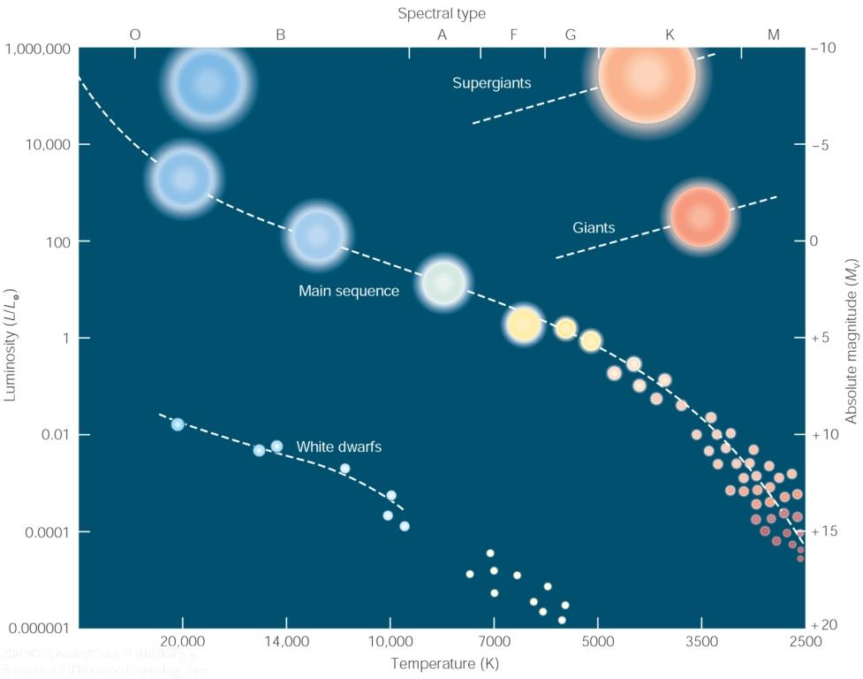

II.

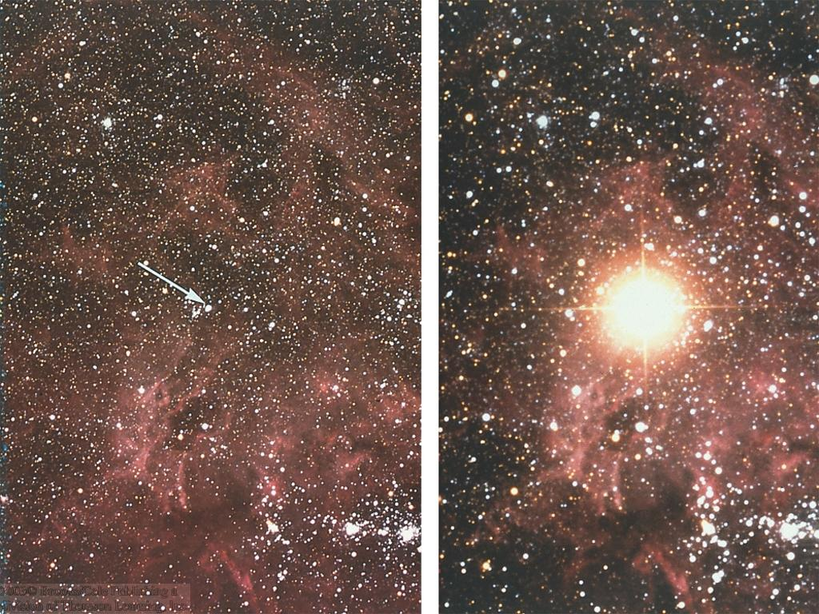
III.

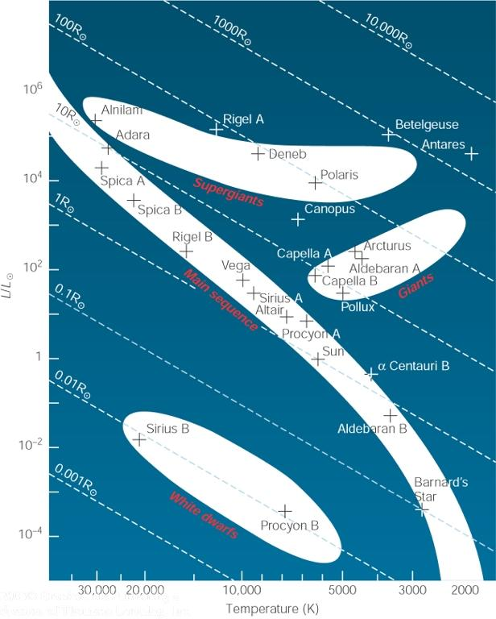
IV.

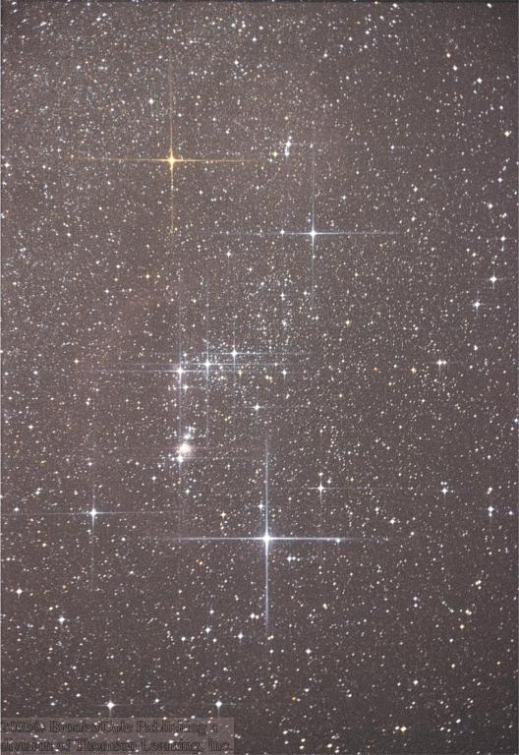
V.

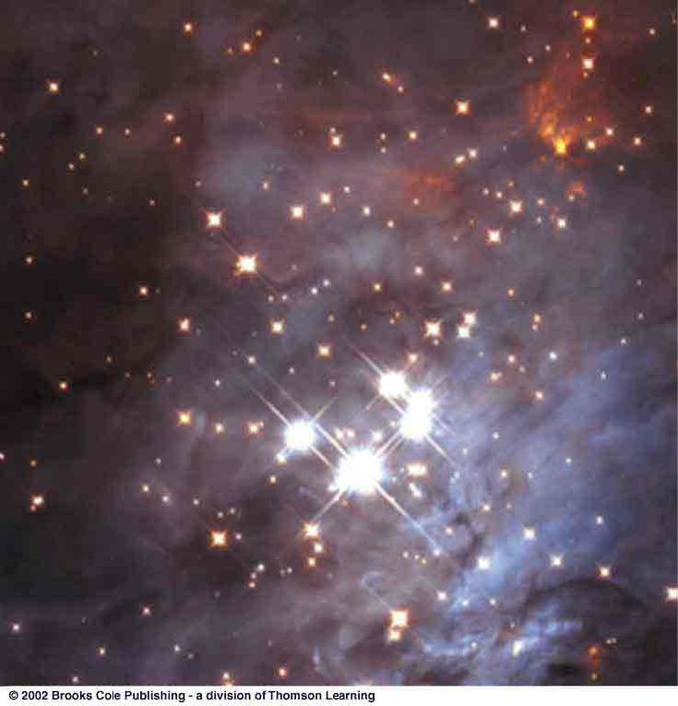

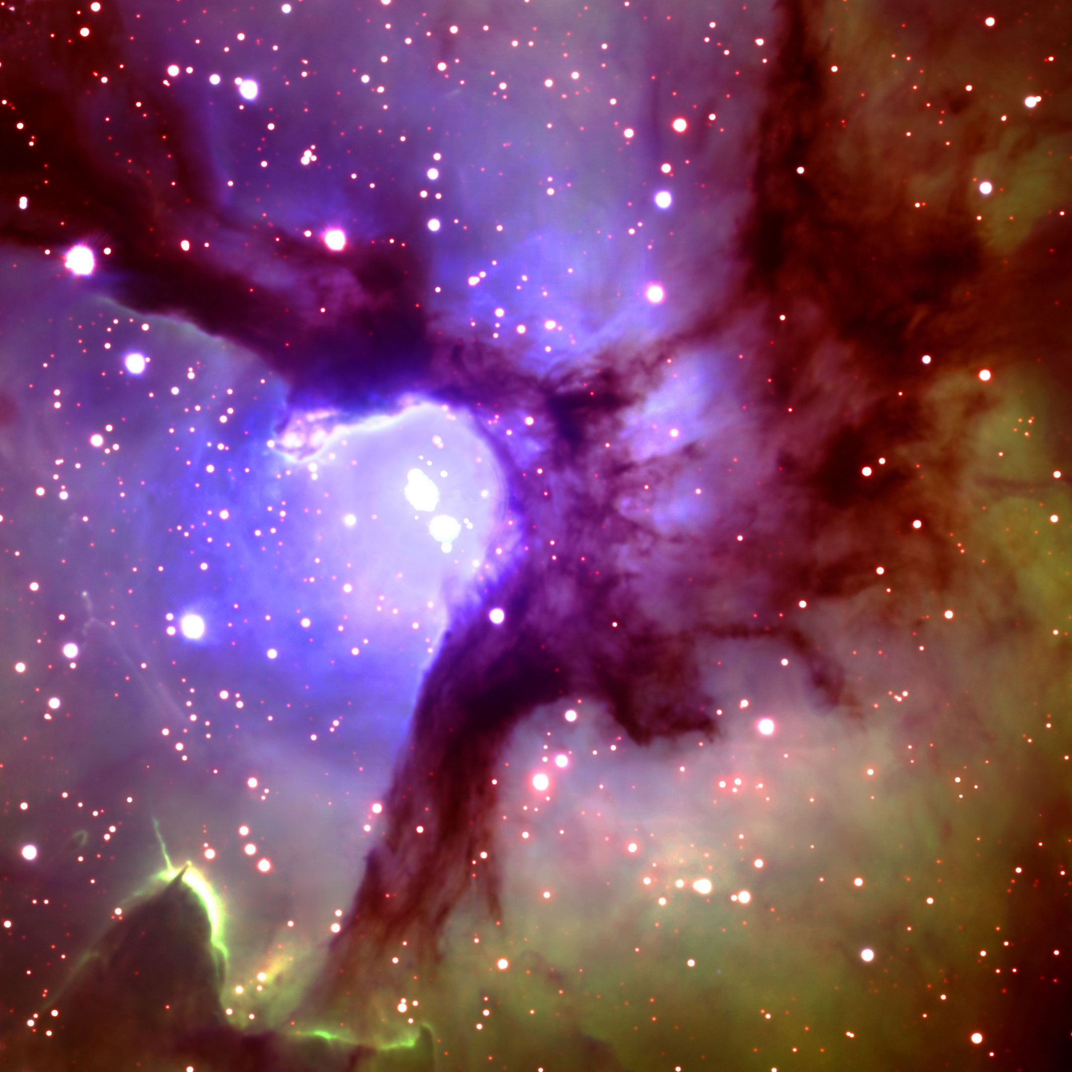
VI.

VII.

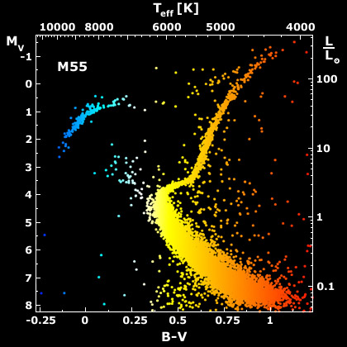
VIII.

IX.

X.

Part C. Short Answer Each answer is 3 points with partial credit given.

1. Describe and identify Figure I.

2. In Figure II, what do each of the letters identify?

3. From Figure III, what has most likely occurred?

4. What does Figure IV display?

5. Explain Figure V.

6. In Figure VI, what might be occurring at point A?

7. What is it that is producing this area which is emitting light?

8. Describe what Figure VIII displays happening.

9. Which letter in Figure IX places our Sun correctly, and how can this be identified?

10. Identify Figure X.

Astronomy C Division TEAM NUMBER _____________
Virginia Regional Event TEAM NAME

_____________________________

Part A Multiple Choice

1. ______ 21. ______ 41. ______

2. ______ 22. ______ 42.

3. ______ 23. ______ 43. ______

4. ______ 24. ______ 44. ______

5. ______ 25. ______ 45. ______

6. ______ 26. ______ 46. ______

7. ______ 27. ______ 47. ______

8. ______ 28. ______ 48. ______

9. ______ 29. ______ 49. ______

10. ______ 30. ______ 50. ______

11. ______ 31. ______ 51. ______

12. ______ 32. ______ 52. ______

13. ______ 33. ______ 53. ______

14. ______ 34. ______ 54. ______

15. ______ 35. ______ 55. ______

16. ______ 36. ______ 56. ______

17. ______ 37. ______ 57. ______

18. ______ 38. ______ 58. ______

19. ______ 39. ______ 59. ______

20. ______ 40. ______ 60. ______
Astronomy C Division TEAM NUMBER _____________
Virginia Regional Event TEAM NAME

_____________________________

Part B: Short Answer

1. _____________________________________________________________

_____________________________________________________________

_____________________________________________________________

2. __________________________________________________________________

_______________________________________________________________

_______________________________________________________________

_______________________________________________________________

3. __________________________________________________________________

_______________________________________________________________

_______________________________________________________________

_______________________________________________________________

4. __________________________________________________________________

_______________________________________________________________

_______________________________________________________________

_______________________________________________________________

5. __________________________________________________________________

_______________________________________________________________

_______________________________________________________________

_______________________________________________________________

Astronomy C Division TEAM NUMBER _____________
Virginia Regional Event TEAM NAME

_____________________________

6. __________________________________________________________________

_______________________________________________________________

_______________________________________________________________

_______________________________________________________________

7. __________________________________________________________________

_______________________________________________________________

_______________________________________________________________

_______________________________________________________________

8. __________________________________________________________________

_______________________________________________________________

_______________________________________________________________

_______________________________________________________________

9. __________________________________________________________________

_______________________________________________________________

_______________________________________________________________

_______________________________________________________________

10. __________________________________________________________________

_______________________________________________________________

_______________________________________________________________

_______________________________________________________________

Astronomy C Division Each correct answer is one point.
Virginia Regional Event

Part A Multiple Choice

1. ___D___ 21. __A____ 41. ___D___

2. ___A___ 22. ___B___ 42. __E____

3. ___B___ 23. ___E___ 43. ___D___

4. ___B___ 24. ___E___ 44. ___E___

5. __E___ 25. ___D___ 45. ___E___

6. __E____ 26. ___E___ 46. __D___

7. ___E___ 27. ___C___ 47. ___B___

8. __C____ 28. ___D___ 48. ___A___

9. ___C___ 29. ___A___ 49. ____A__

10. __C____ 30. ___E___ 50. ___B___

11. ____B__ 31. ___E___ 51. ___A___

12. __D____ 32. ___D___ 52. ___E___

13. __B____ 33. ___D___ 53. ___B___

14. __D____ 34. ___D___ 54. ___E___

15. ___E___ 35. ___E___ 55. ___E___

16. __D____ 36. ___A___ 56. __D____

17. __C____ 37. ____E__ 57. ___A___

18. __E____ 38. ____D__ 58. ___B___

19. __A___ 39. ____D__ 59. __E____

20. ___E___ 40. ___E___ 60. __B____
Astronomy C Division Questions are worth 3 points each, partial credit
Possible.
Virginia Regional Event

Part B: Short Answer

1 Nebula NGC 6751 “ It is a dying star surrounded by the expanding shell of
gas it ejected a few thousand years ago.” P. 124 Foundations of Astronomy
Michael A Seeds

2. A represents Super Giants, B represents Giants and C represents white dwarfs.

3. Supernova of Feb. 1987 in Large Magellanic Cloud. SN1987A

4. The diagram represents the radii of stars in a Hertzsprung-Russell Diagram.

5. Bright interstellar gas cloud (nebula) in the Orion Nebula.

6. A displays Globules that are sites where stars are being born.

7. These are excited clouds of gas producing a pink color from the ionized
Hydrogen.

8. . This is the HR Diagram of Star Cluster M55. “A” displays high mass stars
evolved onto Giant band. “ B “ Displays “turn off Point” and “C” displays
low mass stars still on main sequence.

9. B represents where our sun should be placed in this HR diagram as it is in the
Main Sequence of “hot luminous stars to cool faint stars”. (page 178
Foundations of Astronomy Michael A Seeds)

10. These are the “hot massive star cluster of 30 Doradus”. ( page 219, Foundations of Astronomy Michael A Seeds

Questions adapted from Foundations of Astronomy Edition 8 Michael A Seeds
2005

