**Tejal Patel**

**Disease Detective Practice Test**

**Troy Science Olympiad Tryouts**

(Questions 1-5), Use the passage below from from an article on the CDC website Morbidity and Mortality Weekly Report published on September 9, 2017.

*Notes from the Field*: *Clostridium perfringens* Outbreak at a Catered Lunch — Connecticut, September 2016 *Weekly* / September 8, 2017 / 66(35);940–941

Vivian H. Leung, MD1,2; Quyen Phan, MPH2; Cynthia E. Costa2; Christina Nishimura, MPH2; Kelly Pung3; Liz Horn3; Lynn Sosa, MD2

In September 2016, the Connecticut Department of Public Health was notified of a cluster of gastrointestinal illnesses among persons who shared a catered lunch. Information about symptoms and foods eaten was gathered using an online survey. A case was defined as the onset of abdominal pain or diarrhea in a lunch attendee <24 hours after the lunch. Risk ratios (RRs), 95% confidence intervals (CIs), and Fisher’s exact p-values were calculated for all food consumed. Associations of food exposures with illness were considered statistically significant at p<0.05.

Among approximately 50 attendees, 30 (60%) completed the survey; 19 (63%) respondents met the case definition. The majority of commonly reported symptoms included diarrhea (17 of 18), abdominal pain (15 of 16), and headache (7 of 15). The median interval from lunch to illness onset was 5.3 hours (range = 0.4–15.5 hours) for any symptom and 7 hours (range = 2.5–13 hours) for diarrhea. Analysis of food exposures reported by 16 ill and 10 well respondents found illness to be associated with the beef dish 16 ill respondents reported eating the beef.

The caterer had begun preparing all dishes the day before the lunch. Meats were partially cooked and then marinated in the refrigerator overnight. In the morning, they were sautéed 2 hours before lunch. Inspection of the facility found the limited refrigerator space to be full of stacked containers that were completely filled with cooked food, disposable gloves that appeared to have been washed for reuse, and a porous wooden chopping block.

1. The first sentence refers to a cluster of gastrointestinal illness. What defines a cluster?

An aggregation of cases over a particular period closely grouped in time and space, regardless of whether the number is more than the expected number

2. What were three criteria met for establishing a case definition in this outbreak? PERSON—those who attended, PLACE—the catered lunch place, TIME--<24h, CLINICAL FEATURES —abdominal pain, diarrhea

3. The report states that 95% confidence intervals were calculated for each dish and the people who got sick. Explain what this number means.

If repeated samples were taken and the 95% confidence interval was computed for each sample, 95% of the intervals would contain the population mean (A 95% confidence interval has a 0.95 probability of containing the population mean.)

4. What is a likely reason that the investigators calculate Fishers exact p values instead of using a chi-squared test?

Small sample size

5. What factors in food preparation and storage may have played a role in a food borne illness developing?

Paragraph 3—food partially cooked day before, refrigerator cramped with overfilled containers, gloves washed for reuse, porous wooden chopping block

6. Clostridium perfringens was determined to be the etiology of the outbreak. Was the timeframe of onset of illness typical or atypical of this organism?

Typical (within 8-24 hours patients get diarrhea)

(QUESTIONS 7-10) What type of bias is described by the following situations? Each answer used only once.

1. Observer
2. Recall
3. Selection
4. Information

7. Doctors know which patients in a drug study are receiving the experimental drug itself and which are receiving placebo. (A)

8. A study pays college students $50 each to participate as a control (C)

9. More likely in a retrospective study of people who got ill eating at Chipotle (B)

10. Some patients in a study were incorrectly identified as being HIV+ (D)

11. What is the difference between non-differential and differential misclassification?

Non-differential is unrelated to exposure or disease; differential is related to exposure or disease

13. What is the best way to reduce random error in an epidemiological study? increase the sample size

(Questions 13-16) Use the table below

|  |  |  |  |
| --- | --- | --- | --- |
|  | **DISEASE** | **NO DISEASE** | **TOTAL** |
| **EXPOSED** | 135 | 65 | 200 |
| **UNEXPOSED** | 38 | 62 | 100 |

13. Calculate the relative risk?

Risk Ratio: (135/200)/(38/100)= 1.77

14. Is there a correlation between exposure and disease?

Yes (risk ratio >1)

15. In the above 2 x 2 table, what would the odds ratio be if 10% of the people who thought they were exposed were actually not exposed:

|  |  |  |  |
| --- | --- | --- | --- |
|  | DISEASE | NO DISEASE | TOTAL |
| EXPOSED | 135 | 45 | 180 |
| UNEXPOSED | 38 | 82 | 120 |

135.82 = 6.47

45.38

16. In the above 2 x 2 table, what would the odds ratio be if 20% of the people forgot that they were exposed:

|  |  |  |  |
| --- | --- | --- | --- |
|  | DISEASE | NO DISEASE | TOTAL |
| EXPOSED | 135 | 85 | 220 |
| UNEXPOSED | 38 | 42 | 80 |

135 X 42 = 1.76

85x 38

(Questions 17-24) Match the following adult patient interviews with the most likely offending food-borne illness organism (each choice will be used only once):

**Salmonella Rotavirus Listeria Giardia**

**Shigella Norovirus E. Coli Campylobacter**

17.“I’ve been having diarrhea, belching, and feel like I’ve been having greasy stools. I drank water from a mountain stream last weekend”

Giardia

18. “I got sick after eating grilled chicken at a barbecue 3 days ago”

Campylobacter

19. “I’ve been having bad cramping with my diarrhea which feels like lots of water coming out”

Shigella

20 “I started having bad diarrhea after playing with my pet snakes, frogs and turtles”

Salmonella

21. “I have a fever, muscle aches and a stiff neck.”

Listeria

22. “I have vomiting, diarrhea, and I lost my sense of taste for a few days”

Norovirus

23.“I’ve had severe stomach cramps and diarrhea that was at first watery but now bloody”

E. Coli

24.“I had only a mild diarrhea and stayed home from school for only two days” –

Rotavirus

(Questions 25-26) In evaluating a study for a new test that screens people for disease what terms define the following:

25. Having sick people incorrectly identified as healthy: False negative

26. Having healthy people incorrectly identified as sick: False positive

27.In a study of 100 patients, how many more people would be included as being within one standard deviation of the median versus within the interquartile range, assuming a normal distribution?

18

28. In a study of the number of people in Western India affected with cholera in 2017, the mean was determined to be 1345 with a standard error of the mean of 26. Assuming normal distribution, calculate the 95% confidence interval of the mean:

=1345 + or – (26*1.96)

29. How would a chi-squared test be used in an epidemiology analysis of a possible food borne illness outbreak?

to test the association between a disease and its possible cause or factor

30. Define null hypothesis and alternate hypothesis:

Null: There is no association between a risk factor and disease

Alternate: There is an association between a risk factor and disease

(QUESTION 31-34) Use the figure below to answer the question. Each answer is used only once.

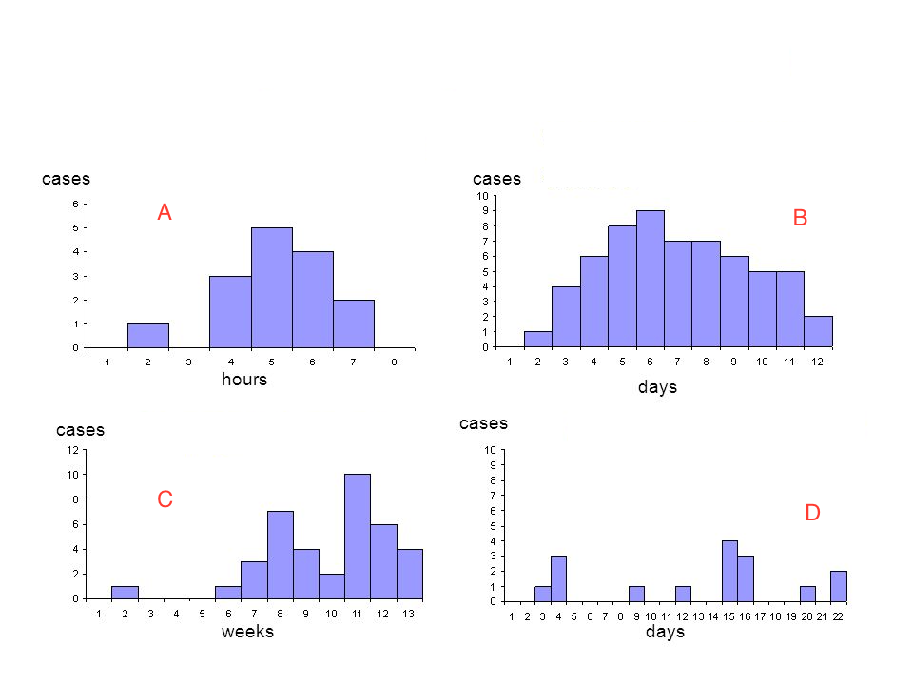

What type of outbreak is represented by each of the above epidemic curves?

31. A (Common point source)

32. B (Common persistent source)

33. C (Propagated source)

34 D (Common intermittent source)

A Common Point Source

B, Common Persistent Source

D. Propagated Source

E. Common Intermittent Source

(Questions 35-36) Use the table below

|  |  |
| --- | --- |
|  | **Control** |
| **Case** | |  |  |  | | --- | --- | --- | |  | Exposed | Not Exposed | | Exposed | 30 | 60 | | Not Exposed | 20 | 10 | |

35. Calculate the matched odds ratio:

3

36. Create a new 2 x 2 table with this information to calculate the unmatched odds ratio:

Case Control

Exposed 90 50

Not Exposed 30 70

Unmatched odds ratio: (4.0)

(Question 37-38) You are reading a report from a UN health report and come across the following excerpt regarding risk factors for a certain disease.

*…Below poverty line (AOR [95% CI] = 3.1 [1.19, 8.33]), large family size (AOR [95% CI] = 4.14 [4.13, 10.52]),  tapeworm infection (AOR [95% CI] = 2.72 [1.04, 7.25]), and  HIV infection (AOR [95% CI] = 5.75 [2.40, 13.69]) were independent predictors of disease.*

37. What do the two numbers within the square brackets [x,y] indicate?

upper and lower limits of odds ratio the 95% confidence interval

38. What does the reported adjusted odds ratio (AOR) account for that a regular odds ratio does not?

confounding variables

(Questions 39-40) You attend a conference reporting results of a new screening test. The investigators report there was a 97% probability that a person with negative test does not have the disease.

39. What statistical term is used to describe this finding?

Negative predictive value

40. They report that while their specificity was very high, their sensitivity was a bit lower. Is this a problem when considering implementing a new type of screening test? Why or why not?

Yes. You would miss a lot of patients with false negatives

(Questions 41-43) Indicate the best type of study design for the following scenarios.

41. Study the possible factors associated with developing Creutzfeldt-Jakob Disease

case-control

42. Study the rate of gastrointestinal illness after exposure to eating a rare and hard to find caviar

cohort

### 43. Study the prevalence of rotavirus in Fullerton primary schools

### cross-sectional

### (Questions 44-47) Indicate the type of prevention (primary, secondary, tertiary, quaternary) in the following scenarios.

### 44. Vaccination of people traveling to Africa on safari for hepatitis A primary

### 45. Teach people with a history of tapeworm infection how to cook and clean meat properly tertiary

### 44. Educate people in a remote village to not treat their cholera with herbs provided by the local nurse quartenary

### 45. Treating a patient diagnosed with Campylobacter infection with antibiotics secondary

### 46. In your study of lack of clean water supply and cholera, the mortality rate among those who had access to a clean water supply was 0.05 per 1,000 persons per year. The mortality rate among persons who did not have access to a clean water supply was 0.63 lung cancer deaths per 1,000 persons per year. Calculate the attributable proportion.

(0.63-0.05)/0.63*100=92.1%

(Questions 47- 51) Answer the following questions about cholera.

47. How would you diagnose cholera infection in the local population?

stool specimen

### 48. Which serogroup or subtype of cholera are you most concerned with?

### O1 or O139

### 49. Why is it important to diagnose cholera versus other types of watery diarrhea? high likelihood of an outbreak—high infectivity

### 50. What is the cornerstone of treatment for cholera?

### Rehydration (intravenous or oral fluids)

### 51. How is the cholera vaccine administered (intravenous, intramuscular, oral, rectal, intrathecal)?

### Oral

### 52. List three measures to help prevent future outbreaks of cholera:

### better sanitation, hand washing, public toilets, purifying water supply

### (Questions 53- 56) You have run a cholera test on a local population. Use the table below to answer the following question

|  |  |  |  |
| --- | --- | --- | --- |
| RESULTS | CHOLERA | NO CHOLERA | TOTAL |
| CULTURE TEST POSITIVE | 40 | 50 | 90 |
| CULTURE TEST NEGATIVE | 10 | 400 | 410 |
| TOTAL | 50 | 450 | 500 |

### 53.What is the sensitivity of the cholera test that you ran?

### TP/(TP+FN)= 40/(40+50)= 0.80

### 54. What is the specificity of the cholera test that you ran?

### TN/(TN+FP)= 400/(400+50)= 0.88

### 55.The precision of a particular test is influenced by (random or measurement) error?

### Random error

### 56. The accuracy of a particular test is influenced by (random or measurement) error?

### Measurement error

### (Questions 57-59) You are trying to determine if your new antibiotic to treat Giardia is effective. Here are the data

|  |  |  |  |
| --- | --- | --- | --- |
|  | #ill after treatment | #ill not after treatment | total |
| # ill prior to treatment | 200 | 238 | 438 |
| #not ill prior to treatment | 123 | 64 | 187 |
|  | 323 | 302 | 625 |

57.Calculate the McNear test statistic for your treatment:

X^2= ((238-123)^2)/(238+123)=36.6

58. Is there strong evidence to reject the null hypothesis of no treatment effect?

yes

59. Regarding epidemiological statistical analysis, is chi squared test or Fisher’s exact test more accurate when the sample size is small?

Fisher’s exact test

60. You have conducted a study looking at diabetes and the incidence of food borne illness in two different countries.

Diabetes and Incidence of Food borne illness by Country

|  |  |  |  |  |  |  |  |  |
| --- | --- | --- | --- | --- | --- | --- | --- | --- |
|  | **Country A** | | |  |  | **Country B** | | |
|  | Ill | Not ill | Total |  |  | Ill | Not ill | Total |
| Diabetes | 30 | 270 | 300 |  | Diabetes | 110 | 500 | 610 |
| No diabetes | 100 | 1300 | 1400 |  | No diabetes | 70 | 500 | 570 |
| Total | 130 | 1570 | 1700 |  | Total | 180 | 1000 | 1180 |

61. Calculate the Cochran-Mantel-Haenszel estimate for the odds ratio for this data:

=[((30)(1300)/1700)+((110)(500)/1180)]/[((270)(100)/1700)+((500)(70)/1180)]=1.53

(Questions 62-66) Match the organisms to the historical outbreak. Each answer can be used only onc

62. 1985 Jalisco Cheese (142 ill, 28 deaths) B (Listeria)

63. 2015 Chipotle Mexican Grill (55 ill, 0 deaths) E (E coli)

64. 2013 Foster Farm Chicken (634 ill, 0 deaths) D. (Salmonella)

65. 2015 Home Canned Potatoes (29 ill, 0 deaths) C. (C botulinum)

66. 2003 Chi Chi’s Salsa, Chile con Queso (55 ill, 0 deaths) A. (Hepatitis A)

A. Hepatitis A

B. Listeria

C. C botulinum

D. Salmonella

E. E. Coli

### (Questions 46-47)You are an epidemiologist who is tasked to studying diarrhea in a town in rural West Africa . Give an example of a survey question that would help you determine:

### 67. What two pieces of data would you need to gather to determine the prevalence of Hepatitis A in a town in rural West Aftrica in the last year?

Number of people who have tested positive for Hepatitis A in the last year

Number of people in the village

### 68. What two pieces of data would you need to determine the incidence of Heptitis A in the last month

Number of people who have tested positive for Hepatitis A in the last month

Number of people in the village

### 69. What two pieces of data would you need to determine the incidence proportion

Number of people who have tested positive for Hepatitis A in the last year

Number of people in the village at risk for Hepatitis A