FSA Invitational

12/11/10

Solar System

Directions: Put your school name, team name (if applicable for those schools with more than one team), your full name, at the top of the answer sheet. Read each question carefully and thoroughly before answering. Write all answers on the separate answer sheet. Only those answers written on the answer sheet will be accepted for grading. Upon completion of the exam, please turn in both the test and your answer sheet to the FSA official monitoring your exam.
Pam Walsh

Tie Breaker Questions (in order): 4c, 7a, 3e, 6e

Use the image sheet to answer the following questions:

1. a. Which image shows the most geologically active object in the solar system?
b. What is the name of this object?
c. What does this object orbit?
d. What geologic activity can you see in the photo?
e. What is causing this activity?
f. What compound causes the surface color of this object?

2. a. What is the name of the object in Image B?
b. What does this object orbit?
c. What geologic feature is the most prominent on the picture? (1pt for type of feature, 2pts for proper name)
d. What are the dark circles in the upper left quarter of the photo?
e. The atmosphere of this object is primarily composed of __________?

3. a. What is the name of the object in Image C?
b. What phenomena is occurring at the poles?
c. The dark cloud belts on this object are caused by a) upward welling warm gases
or b) downward sinking cool gases?
d. What gases make up the clouds on this planet?
a. ammonia ice b. H₂O ice c. Ammonium hydrosulfide ice d. all of these
e. The magnetic field of this object is caused by its ______ _______ and a layer of
_______ ______ _______ in its interior.

4. a. What is the name of the object in Image D?
b. How large is this object compared to the Earth?
c. A solar day on this object lasts approximately how many earth days?
a. 176 b. 1 c. 117 d. 243
d. A sidereal day on this object lasts approximately how many earth days?
a. 176 b. 1 c. 117 d. 243
e. List 2 unusual facts about the rotation of this object.

5. a. What is the name of the object in Image E?
b. What does this object orbit?
c. Name 3 other large satellites that also orbit the same object.

6. a. What is the name of the object in Image F?
b. This object orbits the sun at a distance of :
a. 30 AU b. 19 AU c. 39 AU d. 25 AU
c. The color of this object is caused by ________in the upper atmosphere.
d. The orbital period of this object is :
a.84 years b. 164 years c. 247 years d. none of these
e. Ring systems are caused by small moons breaking apart inside the ______
_____ due to tidal forces.

7. a. What is the name of the object in Image G?
b. What does this object orbit?
c. Name 3 earth like features that this object has.

8. a. What is the name of the object in Image H?
b. This object orbits the sun at a distance of 1 AU.
How far is an AU in miles and kilometers? ________
c. What are the 2 primary components of the atmosphere?
d. Is this object more or less dense than Venus?

9. a. What is the name of the object in Image I?
b. What does this object orbit?
c. The dark areas on the photo are called ________ and are caused by ______
________?
d. One orbit equals one rotation. This means that it is _____ ______ with its
parent object.

Questions 10 -14 Label the parts of a solar eclipse:
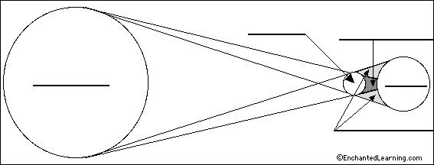

Questions 15 – 19 Label the parts of a comet:
