Image Set B - page 1

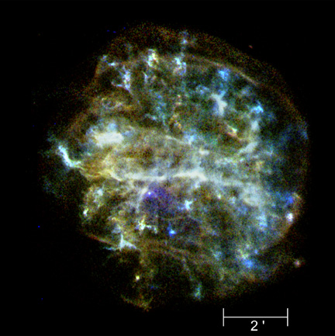

Figure 1. G292.0+1.8. Scale bar = 2 arcmin. Arrow marks the location of the suspected pulsar in the supernova remnant.
Image Set B - page 2

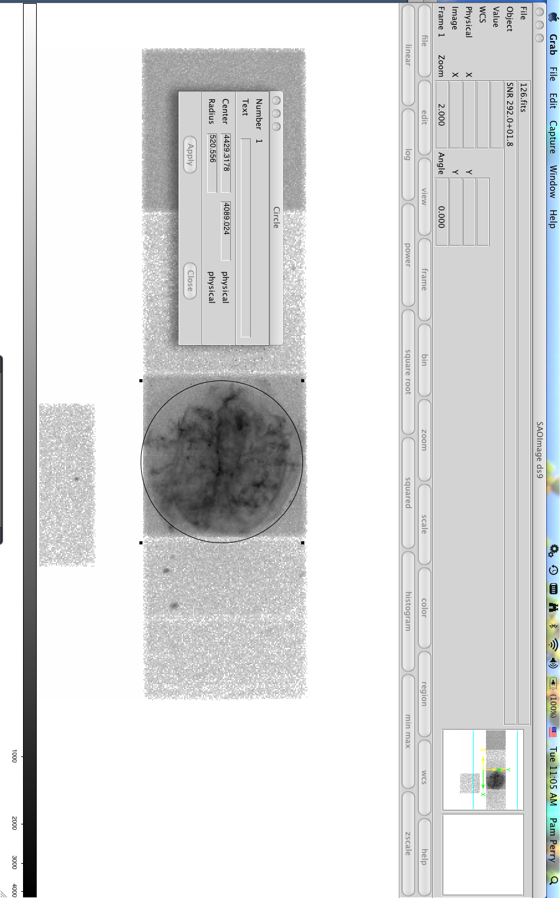

Figure 2. G292.0+1.8 in ds9 image analysis software. The radius of the circular region around the remnant is ~520 pixels. The coordinates of the center of the region are (4429, 4089). For Chandra images, 1 pixel = 0.5 arcsec.
Image Set B - page 3

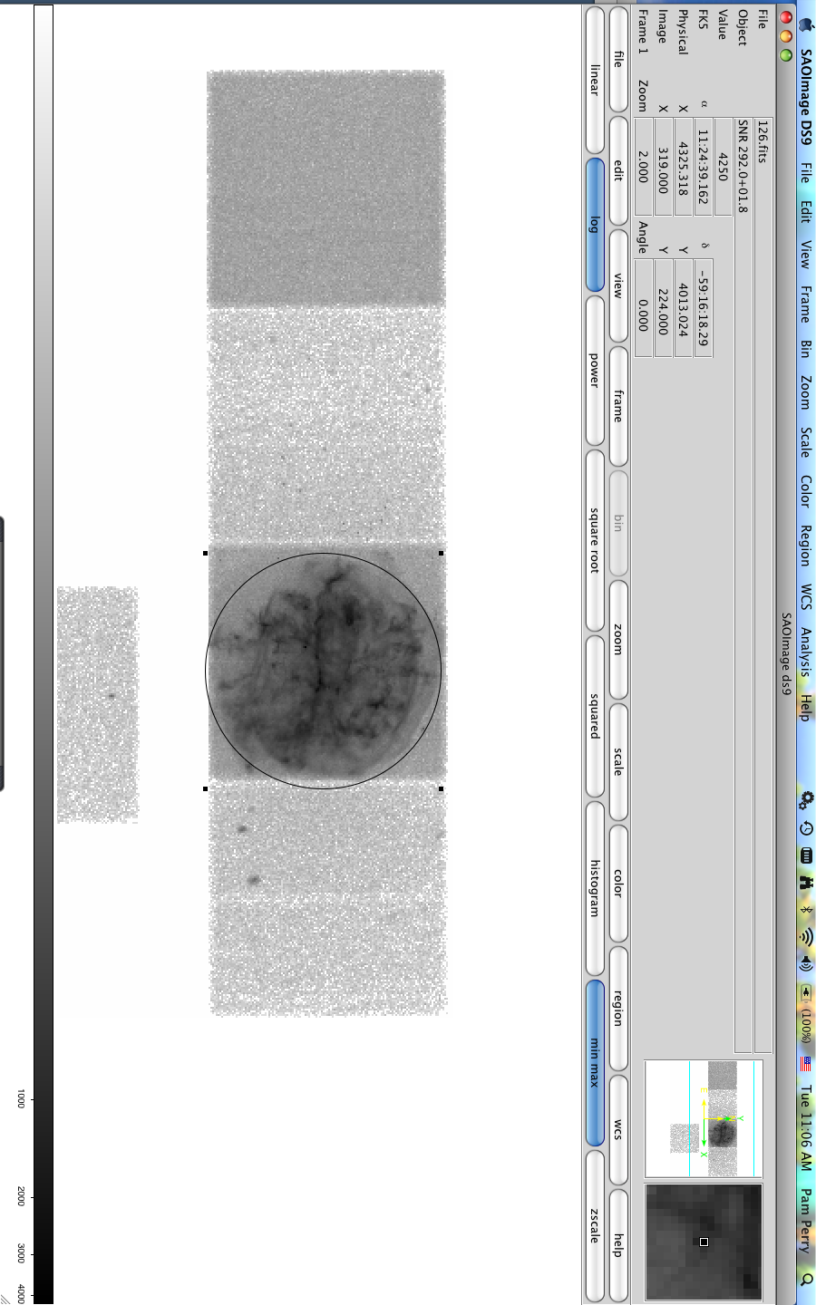

Figure 3. G292.0+1.8 in ds9 image analysis software. Arrows mark the location of the suspected pulsar in the supernova remnant (the small window in the corner is a zoom of the larger window). The physical coordinates of this suspected pulsar are (4235, 4013).

