Station 1

1-3) Using specimens A-C, identify the minerals and give its Moh’s hardness and chemical formula. Each component of the question (name, hardness, and formula) is worth 1/3 of a point.

4-8) Using specimens D-H, identify the minerals and rank each mineral by hardness from softest to hardest.
(#4 is softest, #8 is the hardest)

Station 2
9-19) Write the name(s) (NOT the letter) of the appropriate mineral(s) in each of the lines. Each specimen may be used once, more than once, or not at all.

- Which specimen occurs naturally in almost every color of the spectrum?
- Which specimen is nicknamed “TV Stone” due to its fiber optic capabilities?
- Which specimen is classified as a “mineraloid” due to it not being a crystalline solid?
- Which specimen is the main ore of lithium?
- Which specimen is used as an index mineral?
- Aquamarine is a variety of which specimen?
- Which specimen has a specific gravity of 1.95 and is a carbonate?
- Which three specimens have a hardness under 3?
- Which mineral is found mainly in granitic pegmatites?
- Which mineral forms in orthorhombic crystals and twins frequently, resembling a cross?
- Which two specimens exhibit cleavage with weak bonds in only one direction?

Station 3
20-29) Use the mineral samples provided to answer the questions. Fill in the blank when asked to identify the mineral and circle your answer for the multiple choice questions that follow. Both identifying the mineral and choosing the correct multiple choice answer are worth 1 point each.

20) Identify Mineral A.
21) Which statement about the mineral is correct?
a) Its chemical formula consists of only one element, earning the nickname “Fool’s Gold”
b) It will be scratched by Biotite but not by a pocket knife
c) Unlike its polymorph, it does not need to be heated for it to be magnetic
d) It will eventually oxidize (rust) over time if left exposed to air
e) None of the above

22) Identify Mineral B.
23) Which statement about the mineral is correct?
a) It can be extracted from dried up lakes and seas
b) It weighs approximately 3.6 times as much as water
c) It is the principle ore of manganese
d) It forms “Hopper crystals”
e) None of the above

24) Identify Mineral C.
25) Which statement about the mineral is correct?
a) It is commonly found in soil containing weathered igneous and metamorphic rocks
b) Its etymology is derived from German rather than Latin words
c) It exhibits basal cleavage, similar to mica
d) It can be found on the discontinuous branch of Bowen’s Reaction Series
e) None of the above

26) Identify Mineral D.
27) Which statement about the mineral is correct?
a) It is alternatively called “peridot” when of gem quality
b) Its calcium content varies with temperature
c) It is often observed to have a dendritic crystal habit
d) It cleaves, but doesn’t fracture
e) None of the above

28) Identify Mineral E.
29) Which statement about the mineral is correct?
a) It is technically considered to be an amphibole
b) Despite its appearance, it actually has an orthorhombic crystal system
c) It is a key constituent in meteorites
d) It is instrumental in understanding the conditions under which rocks form
e) None of the above

Station 4
Use the samples provided at the station to answer the questions.
30-32) Commonly prismatic in habitat, Mineral X occurs in marble and is a product of hydrothermal alteration, composing many igneous rocks.
- 30) Identify this mineral.
- 31) Which of the following elements are NOT present in this mineral? Choose all that apply. (Question is worth 3 points; -1/2 point for every incorrect answer; 0 point minimum)

- Phosphorus (P)
- Barium (Ba)
- Magnesium (Mg)
- Oxygen (O)
- Lead (Pb)
- Sodium (Na)
- Zinc (Zn)
- Aluminum (Al)
- Carbon (C)
- Nickel (Ni)

- 32) Which of the following properties do NOT apply to this mineral? Choose all that apply. (Question is worth 3 points; -1/2 point for every incorrect answer; 0 point minimum)
a. Monoclinic crystal system b. Greenish-black streak c. Specific Gravity is ~8.3
d. Hardness of 3-4 e. Adamantine luster f. Exhibits no striation
33-37) Mineral Y is the second-most abundant mineral on Earth. In addition, it is unique for its numerous varieties, the properties it exhibits, and its historical significance.
- 33) Identify the variety of this mineral.
- 34) Some varieties of this mineral can exhibit asterism. Define asterism.
- 35) If this is the second most abundant mineral, which mineral is the most abundant?
- 36) Many consider topaz to be the birthstone of November. However, one variety of Mineral Y is also considered to be a November birthstone. Name that variety.
- 37) All varieties of this mineral possess conchoidal fracture. Define conchoidal fracture.

Station 5
38-41) Using the image below, fill in the missing sections of Bowen’s Reaction Series.
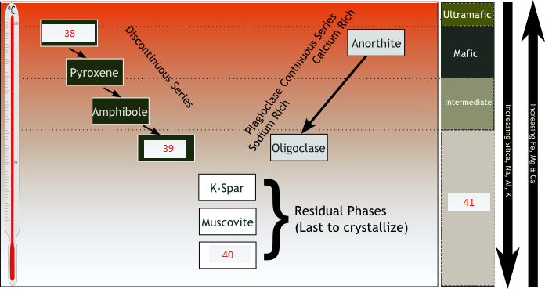
42-46) Answer the questions below.
42) Which is the first mineral to crystallize from the very high temperatures as magma first starts to cool?
43) Which is the most stable of the minerals in the Discontinuous Reaction Series?
44) True/False: Bowen’s reaction series shows that minerals with the highest melting temperatures crystallize from a cooling magma before those with lower melting points.
45) True/False: Bowen’s reaction series shows that calcium-rich minerals crystallize in the discontinuous series along with Pyroxene and Amphibole.
46) True/False: Bowen’s reaction series offers an explanation for the differentiation of silicic and mafic minerals in magma.

Station 6
Directions: Use Specimen A for questions 47 and 48, Specimen B for 49 and 50, and Specimen C for 51 and 52.

47) Carbonate rocks are a class of sedimentary rocks composed primarily of carbonate materials. Specimen A is the only metamorphic rock that is in this class. Identify Specimen A.
48) Which object listed below contains Specimen A?
a) Computer chips
b) Ancient sculptures and pottery
c) Coral reefs
d) Amber

49) Identify Specimen B. Is it metamorphic, sedimentary, or igneous?
50) Name one of the parent rocks of this specimen.

51) Identify Specimen C. Is it metamorphic, sedimentary, or igneous?
52) Which of the following about this rock is correct?
a) It is a homogeneous sedimentary rock derived from metamorphic shale-type rock
b) It is mainly composed of the minerals gypsum, chalcopyrite, and halite
c) It can be split along bedding planes
d) It is used as construction material in the form of cement

Station 7
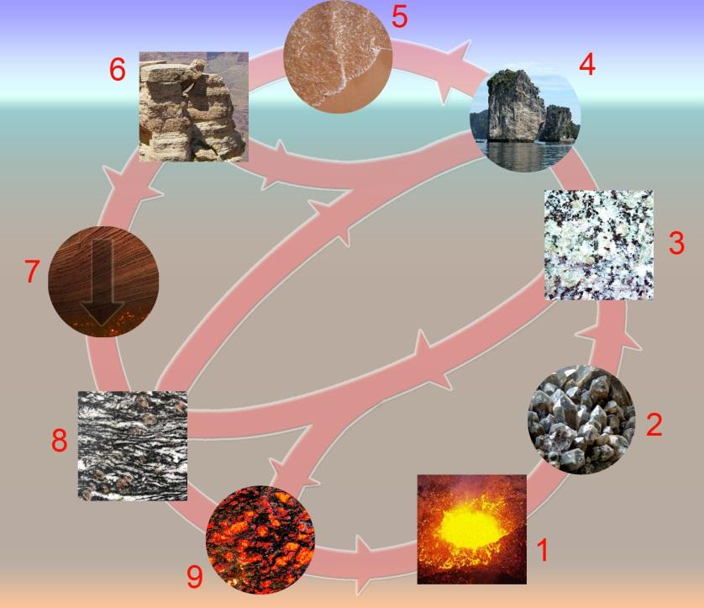

Directions: Match the following letters with the number in the picture above:

53) ____________ A) Sediments & sedimentary rocks
54) ____________ B) Melting
55) ____________ C) Crystallization
56) ____________ D) Igneous rocks
57) ____________ E) Sedimentation
58) ____________ F) Magma
59) ____________ G) Metamorphic rocks
60) ____________ H) Tectonic burial & metamorphism
61) ____________ I) Erosion

Station 8
Directions: Use Specimen A for questions 62 and 63 and use Specimens B and C for 64-67.

62) Identify Specimen A.
63) How is this rock classified?
- Pegmatitic
- Extrusive
- Mafic
- Pyroclastic

64) Identify Specimens B and C.
65) Specimen C is known for burning with what color?
66) Which specimen (B or C) is more commonly used in industry?
67) Specimen B is a(n) ____________ rock formed by __________________ compression.
- Igneous; Tectonic
- Sedimentary; Diagenetic
- Eroded; Acephalic
- Metamorphic; Ballistic

Station 9
Directions: Use Specimen A for questions 68-70, Specimen B for 71 and 72, and Specimen C for 73 and 74.
68) Identify Specimen A. Is it metamorphic, sedimentary, or igneous?
69) This specimen is often mined for use as a fertilizer because it has which element?
- Phosphorous (P)
- Potassium (K)
- Magnesium (Mg)
- Calcium (Ca)
- Sodium (Na)

70) Which statement about the specimen is FALSE?
- It is a limestone
- It is composed largely from calcite
- It dissolves in HCl (hydrochloric acid)
- It occurs near large bodies of water
- Its average particle size is slightly under 1 millimeter

71) Identify Specimen B. Is it metamorphic, sedimentary, or igneous?

72) Specimen B is known to have red colors due to the presence of which of the following minerals?
- Muscovite
- Rhodonite
- Hematite
- Chalcopyrite

73) Identify Specimen C. Is it metamorphic, sedimentary, or igneous?
74) The specimen’s holes or “bubbles” are formed through expansion of gas trapped inside the specimen prior to hardening. These “bubbles” are also known as:
- Convections
- Sockets
- Caps
- Vesicles

Station 10
Directions: Use Specimen A for questions 75 and 76, Specimen B for 77 and 78, and Specimen C for 79 and 80.
75) Identify Specimen A. Is it metamorphic, igneous, or sedimentary?
76) This specimen is highly reactive to acid rain due to its composition of
- NH₄PO₄
- CaCO₃
- Mg(NO₃)₂
- H₂SO₄

77) Identify Specimen B. Is it metamorphic, igneous, or sedimentary?
78) List two major minerals that compose it.

79) Identify Specimen C. Is it metamorphic, igneous, or sedimentary?
80) How is Specimen C characterized?
- Mafic plutonic
- Mafic aphanatic
- Felsic plutonic
- Felsic aphanatic

Station 11 (Tiebreaker Station)
Identify as many specimens as you can!
Be specific! (i.e. “milky quartz” instead of just “quartz”)

