Rocks and Minerals
Langley HS Invitational
December 15, 2013

ANSWER KEY
Format: 11 stations, 4.25 min. per station (46.75 min. = 46min, 45sec allotted)
- 5 mineral stations
- 5 rock stations
- 1 tiebreaker station

Uploader’s Note: This test was written by two high school students. For feedback, please contact fishman100 on the scioly.org forums. Pictures of the specimens are not included.

The high score when taken was roughly around 58% (if I remember correctly). During the test, Station 6 was omitted because of an issue with the specimens (not the questions).
Station 1
1-3) Using specimens A-C, identify the minerals and give its Moh’s hardness and chemical formula. Each component of the question (name, hardness, and formula) is worth 1/3 of a point.
1) Specimen A: Halite
Hardness: ~2-2.5
Chemical formula: NaCl

2) Specimen B: Azurite
Hardness: ~3.5-4
Chemical formula: Cu₃(CO₃)₂(OH)₂

3) Specimen C: Sulfur
Hardness: ~2.0
Chemical formula: S

4-8) Using specimens D-H, identify the minerals and rank each mineral by hardness from softest to hardest.
(Softest) Gypsum (E) < Calcite (H) < Goethite (F) < Amazonite (G) < Corundum (D) (hardest)

Point Distribution:
1-3) 1 point; name, hardness, and formula are each worth 1/3 point.
4-8) 1 point each; ½ point if the letter (not the name) of the mineral is given or if only “Feldspar” is given (instead of Amazonite)
Total points possible: 10
_____/10 points

Station 2
9-19) Write the name(s) (NOT the letter) of the appropriate mineral(s) in each of the lines. Each specimen may be used once, more than once, or not at all.
Provided specimens (in alphabetical order): Opal, Fluorite, Dolomite, Ulexite, Lepidolite, Staurolite, Hematite, Beryl, Talc, Biotite (italicized minerals are present at the station but unused in the questions)
- Which specimen occurs naturally in almost every color of the spectrum? Fluorite
- Which specimen is nicknamed “TV Stone” due to its fiber optic capabilities? Ulexite
- Which specimen is classified as a “mineraloid” due to it not being a crystalline solid? Opal
- Which specimen is the main ore of lithium? Lepidolite
- Which specimen is used as an index mineral? Staurolite
- Aquamarine is a variety of which specimen? Beryl
- Which specimen has a specific gravity of 1.95 and is a carbonate? Ulexite
- Which three specimens have a hardness under 3? Ulexite, Lepidolite, Talc (any order)
- Which mineral is found mainly in granitic pegmatites? Beryl
- Which mineral forms in orthorhombic crystals and twins frequently, resembling a cross? Staurolite
- Which two specimens exhibit cleavage with weak bonds in only one direction? Lepidolite, Biotite

Point distribution:
9-19) 1 point each; 18 and 21 are worth 3 and 2 points respectively
Total points possible: 14
_____/14 points

Station 3
20-29) Use the mineral samples provided to answer the questions. Fill in the blank when asked to identify the mineral and circle your answer for the multiple choice questions that follow. Both identifying the mineral and choosing the correct answer are worth 1 point each.
20) Identify Mineral A. Chalcopyrite
21) Which statement about the mineral is correct?
a) Its chemical formula consists of only one element, earning the nickname “Fool’s Gold”
b) It will be scratched by Biotite but not by a pocket knife
c) Unlike its polymorph, it does not need to be heated for it to be magnetic
d) It will eventually oxidize (rust) over time if left exposed to air
e) None of the above

22) Identify Mineral B. Rhodonite
23) Which statement about the mineral is correct?
a) It forms in a similar fashion as aragonite
b) It weighs approximately 3.6 times as much as water
c) It is the principle ore of manganese
d) It forms “Hopper crystals”
e) None of the above

24) Identify Mineral C. Kaolinite
25) Which statement about the mineral is correct?
a) It is commonly found in soil containing weathered igneous and metamorphic rocks
b) Its etymology is derived from German rather than Latin words
c) It exhibits basal cleavage, similar to mica
d) It can be found on the discontinuous branch of Bowen’s Reaction Series
e) None of the above

26) Identify Mineral D. Olivine
27) Which statement about the mineral is correct?
a) It is alternatively called “peridot” when of gem quality
b) Its calcium content varies with temperature
c) It is often observed to have a dendritic crystal habit
d) It cleaves, but doesn’t fracture
e) None of the above

28) Identify Mineral E. Magnetite
29) Which statement about the mineral is correct?
a) It is technically considered to be an amphibole
b) Despite its appearance, it actually has an orthorhombic crystal system
c) It is a key constituent in meteorites
d) It is instrumental in understanding the conditions under which rocks form
e) None of the above

Point Distribution:
20-29) 1 point for identifying the mineral correctly, 1 point for answering the multiple choice question correctly
Total points possible: 10
______/10 points

Station 4
Use the samples provided at the station to answer the questions.
30-32) Commonly prismatic in habitat, Mineral X occurs in marble and is a product of hydrothermal alteration, composing many igneous rocks.
- 30) Identify this mineral. Epidote
- 31) Which of the following elements are NOT present in this mineral? Choose all that apply. (Question is worth 3 points, -1/2 point for every incorrect answer; 0 point minimum)

- Phosphorus (P)
- Barium (Ba)
- Magnesium (Mg)
d) Oxygen (O)
- Lead (Pb)
- Sodium (Na)
- Zinc (Zn)
h) Aluminum (Al)
- Carbon (C)
- Nickel (Ni)

- 32) Which of the following properties do NOT apply to this mineral? Choose all that apply. (Question is worth 3 points; -1/2 point for every incorrect answer; 0 point minimum)
a. Monoclinic crystal system b. Greenish-black streak c. Specific Gravity is ~8.3
d. Hardness of 3-4 e. Adamantine luster f. Exhibits no striation
33-37) Mineral Y is the second-most abundant mineral on Earth. In addition, it is unique for its numerous varieties, the properties it exhibits, and its historical significance.
- 33) Identify the variety of this mineral. Smoky Quartz (specification needed for full points)
- 34) Some varieties of this mineral can exhibit asterism. Define asterism. An optical phenomenon where a mineral displays a star shape upon being cut into a cabochon.
- 35) If this is the second most abundant mineral, which mineral is the most abundant? Feldspar (Orthoclase and/or Albite are acceptable answers)
- 36) Many consider topaz to be the birthstone of November. However, one variety of Mineral Y is also considered to be a November birthstone. Name that variety. Citrine Quartz (MUST SPECIFY “Citrine” otherwise ½ credit)
37) All varieties of this mineral possess conchoidal fracture. Define conchoidal fracture. Rounded or shell-like fracture, similar to broken glass

Point Distribution:
30, 33-37) 1 point each, -1/2 point if not specific when answer requires specificity
31, 32) 3 points total; -1/2 pt. for each incorrect answer (minimum 0); all correct choices required for full credit
Total points possible: 12
_____/12 points
Station 5
38-41) Using the image below, fill in the missing sections of Bowen’s Reaction Series.
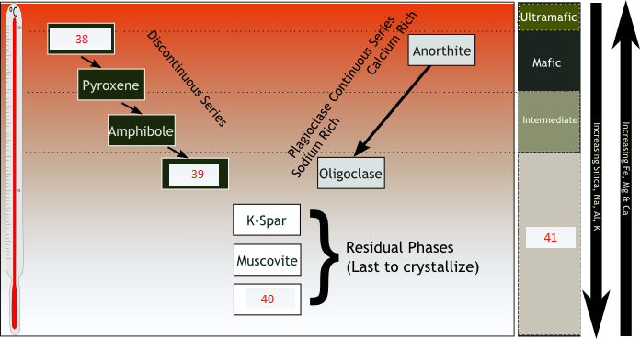
38) Olivine 39) Biotite 40) Quartz 41) Felsic
42-46) Answer the questions below.
42) Which is the first mineral to crystallize from the very high temperatures as magma first starts to cool? Olivine
43) Which is the most stable of the minerals in the Discontinuous Reaction Series? Biotite
44) True/False: Bowen’s reaction series shows that minerals with the highest melting temperatures crystallize from a cooling magma before those with lower melting points.
45) True/False: Bowen’s reaction series shows that calcium-rich minerals crystallize in the discontinuous series along with Pyroxene and Amphibole.
46) True/False: Bowen’s reaction series offers an explanation for the differentiation of silicic and mafic minerals in magma.
Point Distribution:
38-46) 1 point each
Total points possible: 9
_____/9 points
Station 6
Directions: Use Specimen A for questions 47 and 48, Specimen B for 49 and 50, and Specimen C for 51 and 52.

47) Carbonate rocks are a class of sedimentary rocks composed primarily of carbonate materials. Specimen A is the only metamorphic rock that is in this class. Identify Specimen A. Marble
48) Which object listed below contains Specimen A?
a) Computer chips
b) Ancient sculptures and pottery
c) Coral reefs
d) Amber

49) Identify Specimen B. Is it metamorphic, sedimentary, or igneous? Phyllite, metamorphic
50) Name one of the parent rocks of this specimen. Shale

51) Identify Specimen C. Is it metamorphic, sedimentary, or igneous? Slate, metamorphic
52) Which of the following about this rock is correct?
a) It is a homogeneous sedimentary rock derived from metamorphic shale-type rock
b) It is mainly composed of the minerals gypsum, chalcopyrite, and halite
c) It can be split along bedding planes
d) It is used as construction material in the form of cement
Point Distribution:
47-48) 1 point each
49) 2 points total; 1 point for every correct answer
50, 52) 1 point
51) 2 points total; 1 point for every correct answer
Total points possible: 8
_____/8 points
Station 7
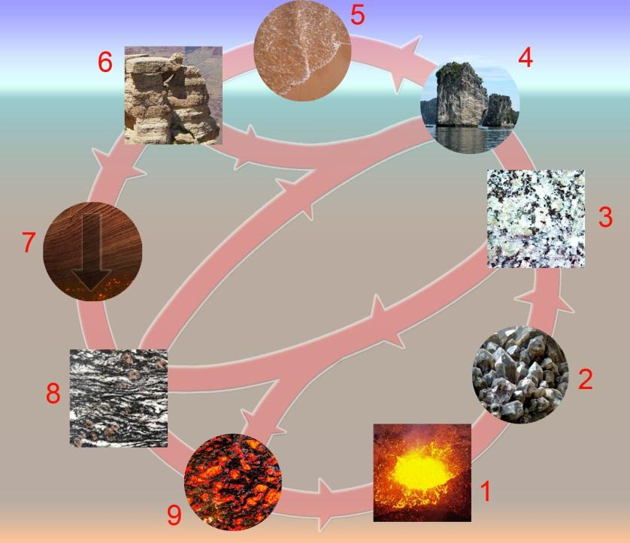
Directions: Match the following letters with the number in the picture above:
53) ______F______ A) Sediments & sedimentary rocks
54) ______C______ B) Melting
55) ______D______ C) Crystallization
56) ______I______ D) Igneous rocks
57) ______E______ E) Sedimentation
58) ______A______ F) Magma
59) ______H______ G) Metamorphic rocks
60) ______G______ H) Tectonic burial & metamorphism
61) ______B______ I) Erosion
Point Distribution:
53-61) 1 point each
Total points possible: 9
_____/9 points
Station 8
Directions: Use Specimen A for questions 62 and 63 and use Specimens B and C for 64-67.

62) Identify Specimen A. Basalt
63) How is this rock classified?
- Pegmatitic
- Extrusive
- Mafic
- Pyroclastic

64) Identify Specimens B and C.
B: Bituminous coal
C: Anthracite
65) Specimen C is known for burning with what color? Blue
66) Which specimen (B or C) is more commonly used in industry? C
67) Specimen B is a(n) ____________ rock formed by __________________ compression.
- Igneous; Tectonic
- Sedimentary; Diagenetic
- Eroded; Acephalic
- Metamorphic; Ballistic

Point Distribution:
62-63) 1 point each
64) 2 points total; 1 point for each correct answer
65-66) 1 point each
67) 2 points
Total points possible: 8
_____/8 points

Station 9
68) Identify Specimen A. Is it metamorphic, sedimentary, or igneous? Coquina; sedimentary
69) This specimen is often mined for use as a fertilizer because it has which element?
- Phosphorous (P)
- Potassium (K)
- Magnesium (Mg)
- Calcium (Ca)
- Sodium (Na)

70) Which statement about the specimen is FALSE?
- It is a limestone
- It is composed largely from calcite
- It dissolves in HCl (hydrochloric acid)
- It occurs near large bodies of water
- Its average particle size is slightly under 1 millimeter

71) Identify Specimen B. Is it metamorphic, sedimentary, or igneous? Sandstone; sedimentary

72) Specimen B is known to have red colors due to the presence of which of the following minerals?
- Muscovite
- Rhodonite
- Hematite
- Chalcopyrite

73) Identify Specimen C. Is it metamorphic, sedimentary, or igneous? Basalt; igneous
74) The specimen’s holes or “bubbles” are formed through expansion of gas trapped inside the specimen prior to hardening. These “bubbles” are also known as:
- Convections
- Sockets
- Caps
- Vesicles

Point Distribution:
68, 71, 73) 2 points total; 1 point for every correct answer
69, 70, 72, 74) 1 point each
Total points possible: 10
_____/10 points

Station 10
Directions: Use Specimen A for questions 75 and 76, Specimen B for 77 and 78, and Specimen C for 79 and 80.
75) Identify Specimen A. Is it metamorphic, igneous, or sedimentary? Limestone chalk; sedimentary
76) This specimen is highly reactive to acid rain due to its composition of
- NH₄PO₄
- CaCO₃
- Mg(NO₃)₂
- H₂SO₄

77) Identify Specimen B. Is it metamorphic, igneous, or sedimentary? Pegmatite; igneous
78) List two major minerals that compose it. Minerals could be mica, quartz, feldspar

79) Identify Specimen C. Is it metamorphic, igneous, or sedimentary? Gabbro; igneous
80) How is Specimen C characterized?
- Mafic plutonic
- Mafic aphanatic
- Felsic plutonic
- Felsic aphanatic

Point Distribution:
76) 1 point each
75, 77-79) 2 points total; 1 point for every correct answer
80) 1 point
Total points possible: 9
_____/9 points

Station 11 (Tiebreaker Station)
Identify as many specimens as you can!
Be specific!

Lignite Coal Almandine Diorite Beryl Graphite Pyrite Shale Arkose Fluorite
Chalk Amethyst Quartz Obsidian
Gneiss
Rose Quartz Albite
Scoria

Specimens can be written in any order.

Point Distribution:
1 point each for every correct answer, no deduction for an incorrect answer, no partial credit
- Must specify completely: ex. “Mica” is not an acceptable answer for “Muscovite Mica”

Total possible points for Station 13: 16

_____/16 points

