**MICROBE MISSION PRACTICE TEST (2010-2011)**

|  |  |  |  |
| --- | --- | --- | --- |
| **NAME 1:** |  | | |
| **NAME 2:** |  | | |
| **TEAM NUMBER:** |  | **SCHOOL:** |  |

**Note:** This is a practice test based on the **2010-2011** rules for Microbe Mission.

All answers will be written in the test. There is no answer sheet for this test.

The answer key is separated from this test and is not included in this file.

**STATION 1:** TYPES AND PARTS OF A MICROSCOPE

**1.** What is the source of illumination in a light compound microscope?

______________________________________________________________________________

**2.** What is the source of illumination in a confocal microscope?

______________________________________________________________________________

**3.** Name one type of microscope in which electron beams form the image of the specimen.

______________________________________________________________________________

**4.** Which part of a light compound microscope is used for controlling the amount of light that reaches the specimen?

______________________________________________________________________________

**5.** What is the purpose of the ocular in a light compound microscope?

______________________________________________________________________________

**STATION 2:** PRINCIPLES OF MICROSCOPY

**6.** How is the total magnification of a microscope determined?

______________________________________________________________________________

**7.** What happens to the size of the field of view when changing objectives from high power to low power?

______________________________________________________________________________

**8.** How many micrometers is 1.32 millimeters?

______________________________________________________________________________

**9.** If an organism viewed through a microscope appears to be moving , in which direction is it actually moving?

**A.**  **B.**  **C.**  **D.** 

**10.** What is the highest total magnification by a microscope equipped with a 12x ocular, and three objectives; 5x scanning, 10x low, and 43x high?

______________________________________________________________________________

**STATION 3:** MICROBIAL DISEASES

Name the type of microbe that causes each disease.

|  |  |
| --- | --- |
| **Disease** | **Microbe** |
| **11.** Histoplasmosis |  |
| **12.** Mad Cow Disease (bovine spongiform encephalopathy) |  |
| **13.** Anthrax |  |
| **14.** Rabies |  |
| **15.** Acquired immune deficiency syndrome (AIDS) |  |

**STATION 4:** PROKARYOTIC/EUKARYOTIC CELLS AND CELL PARTS

**16.** Give an example of a prokaryotic cell and a eukaryotic cell.

______________________________________________________________________________

**17.** Where does the final modification of proteins take place in a eukaryotic cell?

______________________________________________________________________________

**18.** What type of cell does not have membrane bound organelles (prokaryotic/eukaryotic)?

______________________________________________________________________________

**19.** What is the storage place in a eukaryotic cell called?

______________________________________________________________________________

**20.** What part of a plant cell is used for protection and support but not is found in an animal cell?

______________________________________________________________________________

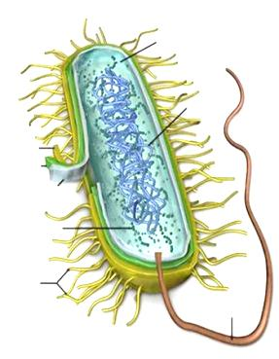

**21.** Is the microbe shown above right prokaryotic or eukaryotic?

______________________________________________________________________________

**STATION 5:** BACTERIA, ARCHAEA, VIRUSES, ALGAE, PROTOZOA, PRIONS, VIRUSES, ETC.

**22.** Name two types of prokaryotic microbes.

______________________________________________________________________________

**23.** How do algal blooms harm other organisms in the water such as fish?

______________________________________________________________________________

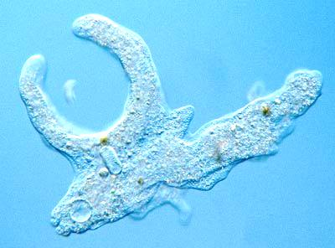

**24.** What type of microbe is in the picture shown above?

______________________________________________________________________________

**25.** Fungi are single-celled as _______________________ and are in multicellular clusters as _______________________ .

**26.** About how many cells of fungi are found in a teaspoon of topsoil?

**A.** 200,000 **B.** 6,000,000 **C.** 1800 **D.** 120,000

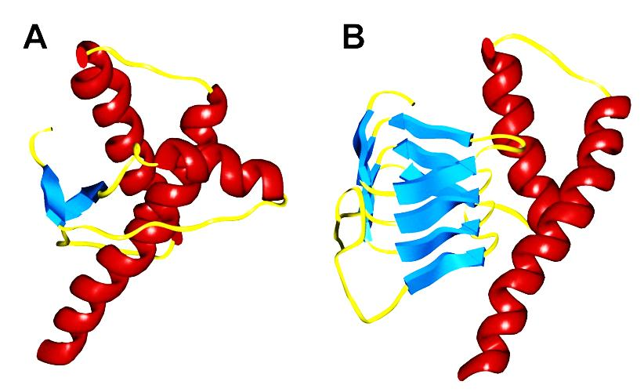

**27.** What type of microbe is the one shown above?

______________________________________________________________________________

**28.** Name one disease that it causes in humans.

______________________________________________________________________________

**29.** Name one disease that it causes in other animals.

______________________________________________________________________________

**STATION 6:** MICROBIAL GROWTH CURVE

**30.** In which phase is the number of nonviable cells increasing?

______________________________________________________________________________

**31.** In which phase is the number of viable cells increasing?

______________________________________________________________________________

**32.** What is happening during the stationary phase?

______________________________________________________________________________

**33.** What is the name for the phase in which there are few or no cells?

______________________________________________________________________________

**STATION 7:** DICHOTOMOUS KEY

|  |  |
| --- | --- |
| Identify each specimen using the dichotomous key on the next page. | |
| **34.** Specimen A |  |
| **35.** Specimen B |  |
| **36.** Specimen C |  |
| **37.** Specimen D |  |
| **38.** Specimen E |  |

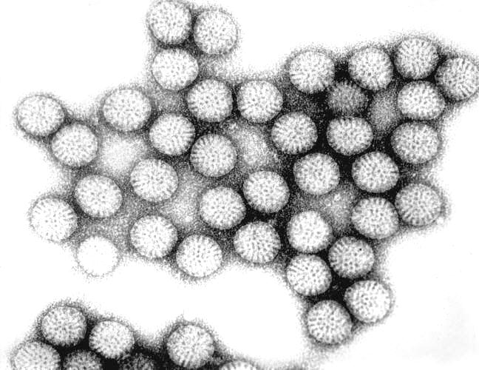

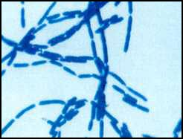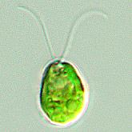**A > B > C >**

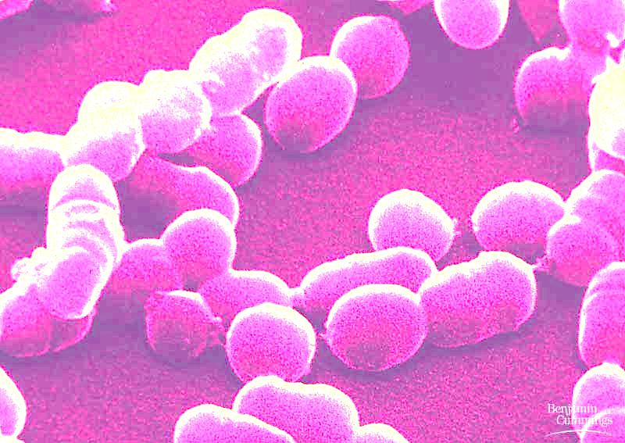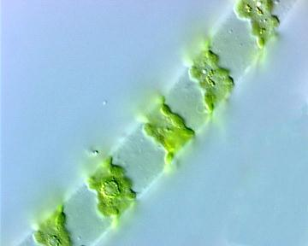**D > E >**

Photos are not to scale.

**DICHOTOMOUS KEY FOR STATION 7**

**1.** Is spherical or elliptical in shape . . . . . . . . . . . . . . . . . . . . . . . . . . . . . . . . . . . . **2**

**1.** Is not spherical or elliptical in shape . . . . . . . . . . . . . . . . . . . . . . . . . . . . . . . . . **3**

**2.** Rod-shaped . . . . . . . . . . . . . . . . . . . . . . . . . . . . . . . . . . . . . . . . . . . . . . . . . . bacillus bacteria

**2.** Spiral-shaped filaments . . . . . . . . . . . . . . . . . . . . . . . . . . . . . . . . . . . . . . . . . spirogyra

**3.** Has chlorophyll and flagella . . . . . . . . . . . . . . . . . . . . . . . . . . . . . . . . . . . . . Clamydomonas

**3.** Does not have chlorophyll . . . . . . . . . . . . . . . . . . . . . . . . . . . . . . . . . . . . . . . **4**

**4.** Long chain-like clusters . . . . . . . . . . . . . . . . . . . . . . . . . . . . . . . . . . . . . . . . . coccus bacteria

**4.** Non chain-like and irregularly shaped clusters . . . . . . . . . . . . . . . . . . . . . . . . rotavirus

**STATION 8:** MICROBES IN DAILY LIFE

**39.** What type of microbe causes mold?

______________________________________________________________________________

**40.** What type of microbe ferments milk into products such as yogurt?

______________________________________________________________________________

**41.** What is the name of the process in which food, usually a liquid such as milk, is heated to destroy disease-producing microbes?

______________________________________________________________________________