**Cell Biology Event Practice Exam**

Most of the information on this test can be found on <http://scioly.org/wiki/index.php/Cell_Biology>.

For questions 1-5, state whether the structures make up the primary structure, secondary structure, tertiary structure or quaternary structure of proteins.

1. Beta pleats and alpha helixes
2. Multiple polypeptide chains
3. Unique shape of protein
4. A sequence of amino acids
5. Interactions between side chains
6. What are four functions of enzymes?
7. Name three constituents of the cell membrane.
8. What is the function of cholesterol in the cell membrane?
9. Which of the following have a 9+2 arrangement?
   1. Ovum
   2. Cholesterol
   3. Cilia
   4. Enzymes
   5. Phospholipids
10. Which of the following maintains shape and prevents damage for the cell membrane?
    1. Integral proteins
    2. Peripheral proteins
    3. Cytoskeleton
    4. Amphipathic phospholipids
    5. Flagella
11. Which of the following is considered passive transport?
    1. Sodium-potassium pump
    2. Pinocytosis
    3. Phagocytosis
    4. Exocytosis
    5. Facilitated diffusion
12. The passive transport of water down its concentration gradient is
    1. Facilitated diffusion
    2. Pinocytosis
    3. Exocytosis
    4. Diffusion
    5. Osmosis
13. What is the ratio of potassium to sodium in a sodium-potassium pump?
    1. 1:1
    2. 1:2
    3. 2:1
    4. 3:2
    5. 2:3
14. When an animal is placed into a hypotonic environment, explain what happens to the cell.

Circle the best answer choices below:

1. A [ *plant cell / animal cell* ] becomes flaccid when it is placed in a(n) [  *hypertonic / isotonic / hypotonic* ] environment.
2. The ideal environment for a plant cell is [  *hypertonic / isotonic / hypotonic* ].
3. The pump that removes excess water from a plant is called the [ *osmotic pump / cytosolic pump / contractile vacuole* ].
4. Fill in the following diagram with the steps of the cell cycle in proper order. G1, G2, M, S.

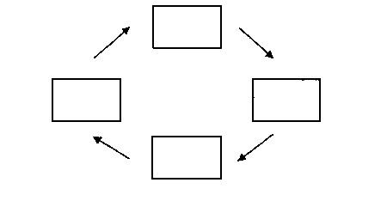

**M**

1. During which stage of the cell cycle does the DNA replicate?
2. What is the function of cyclins in the cell cycle?

The following images were drawn of a cell as it underwent mitosis. State the name of the phase represented in each photo.

1. __________________________________________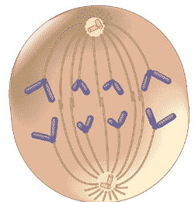
2. __________________________________________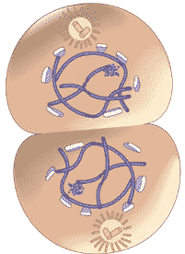
3. __________________________________________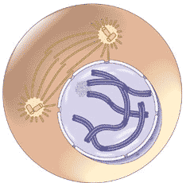
4. __________________________________________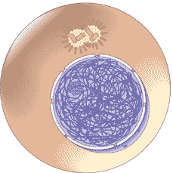
5. __________________________________________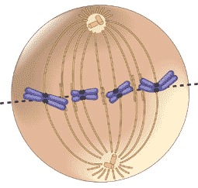
6. What is the correct sequence of photos above?
7. What is the name of the structure being formed in the cell below?
   1. Cleavage furrow
   2. Cell plate
   3. Cell wall
   4. Contractile ring
   5. Cell ring

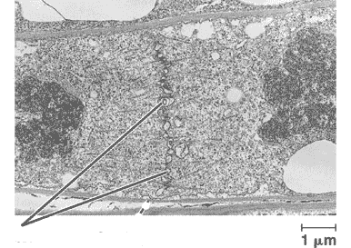

1. True/False: Pyrimidines contain a single ring structure.
2. Which two nitrogenous bases are considered to be purines?
3. If a strand of DNA contains 30% guanine, what is the percentage of cytosine present in the strand?
4. If a strand of DNA contains 22% adenine, what is the percentage of guanine present in the strand?
5. What is the function of histones in chromosomes?

For the following statements, write the organelle being described.

1. Ribosomes are produced here
2. Bound ribosomes are found here
3. Most cellular metabolism occurs here
4. Packaging of macromolecules for transport
5. Sac of hydrolytic enzymes necessary for cell digestion
6. Protects the cell from its production of hydrogen peroxide
7. Energy center
8. Site of protein synthesis
9. Stores nutrients and waste products, very large in plant cells
10. Rigid surrounding of a plant cell made of cellulose
11. Site of photosynthesis
12. Put into order from largest (1) to smallest (4) in diameter.

_______ Actin filaments

_______ Mitochondria

_______ Intermediate filaments

_______ Microtubules

1. Which of the following would you not find in a prokaryotic cell?
   1. Cell membrane
   2. Cell wall
   3. Cytoplasm
   4. Mitochondria
   5. Vacuole
2. Compare and contrast the DNA in a prokaryotic and eukaryotic cell.

47-50. Fill in the diagram below.

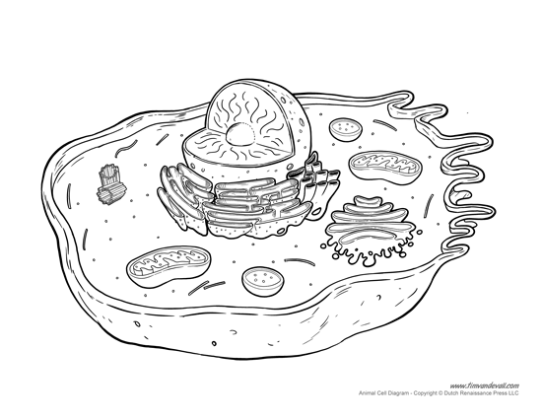

**50. ____________________**

**49. ____________________**

**48. ____________________**

**47. ____________________**

**When you are finished with this packet, answer the questions on the following links:   
This test was made as a refresher, and is probably much simpler than the actual event. The following links are made much harder than this exam: (Remember: Answer ALL questions).**

[**http://scioly.org/wiki/images/9/95/FIXED_reefownage_Cell_Biology_test.pdf**](http://scioly.org/wiki/images/9/95/FIXED_reefownage_Cell_Biology_test.pdf)

[**http://scioly.org/wiki/images/1/16/SSSS_Cell_Bio_Test_by_Maples6.pdf**](http://scioly.org/wiki/images/1/16/SSSS_Cell_Bio_Test_by_Maples6.pdf)

Answer Key

1. (1) Secondary
2. (1) Quaternary
3. (1) Tertiary
4. (1) Primary
5. (1) Tertiary
6. (3) NOT LIMITED TO THE ANSWERS PROVIDED  
   Provide energy to cells

Build new cells

Aid in digestion

Break down complex molecules (“substrate” = reactant)

Catalysts (speed up chemical reactions without being used up or altered)

1. (2) NOT LIMITED TO THE ANSWERS PROVIDED   
   Phospholipids, cholesterol, proteins (integral, peripheral), hydrocarbon tails, glycerol
2. (1) Temperature regulation
3. (1) C
4. (1) C
5. (1) E
6. (1) E
7. (1) E
8. (1) It will explode/lyse.
9. (1) Plant cell, isotonic
10. (1) Hypotonic
11. (1) Contractile vacuole
12. (1) M -> G1 (right) -> S (bottom) -> G2 (left)
13. (1) S
14. (1) NOT LIMITED TO ANSWERS PROVIDED There are enzymes in the cell called cyclin-dependent kinases that are present at all times but need a specific cyclin to bind to them before they become active. When they are activated by a cyclin they push the cell into the next phase of the cell cycle by modifying other enzymes. The cyclins are specific to different cell cycle checkpoints.
15. (1) anaphase
16. (1) telophase
17. (1) prophase
18. (1) interphase
19. (1) metaphase
20. (1) 24, 23, 25, 21, 22 OR interphase, prophase, metaphase, anaphase, telophase
21. (1) B
22. (1) true
23. (1) adenine and guanine (acceptable: A and G)
24. (1) 30
25. (1) 28
26. (1) keep chromosome shape
27. (1) nucleolus
28. (1) rough ER (ER accepted)
29. (1) cytosol OR cytoplasm
30. (1) golgi body
31. (1) lysosome
32. (1) peroxiosome
33. (1) mitochondria
34. (1) ribsome
35. (1) vacuole
36. (1) cell wall
37. (1) chloroplast
38. (1) actin filaments -> intermediate filaments -> microtubules -> mitochondria
39. (1) D
40. (1) ANSWERS NOT LIMITED TO THOSE LISTED   
    Prokaryote – one long ring structure, nucleoid region  
    Eukaryotic – many strands, nucleus
41. (1) ER, smooth ER, rough ER, bound ribosome OR ribosome
42. (1) plasma membrane, cell membrane, phospholipid, protein, etc.
43. (1) mitochondria, cristae, matrix, ribosome, free ribosome
44. (1) golgi body, trans face, cis face