MICROBE MISSION

PRACTICE TEST

SCIENCE OLYMPAID

TEAM NAME:

TEAM NUMBER:

SCORE: / 180

PART I – MICROSCOPES (38 points)

Questions 1-30 will be about microscopes and their functions.

For 1-14, label the parts of the microscope.

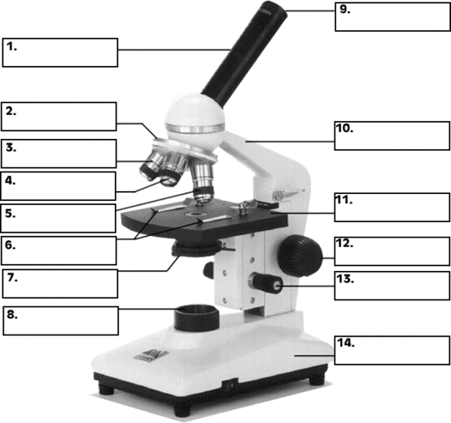

15.) Describe the function of number 6.

16.) Describe the function of number 13.

17.) Which part of the microscope controls the amount of light the specimen receives?

18.) What is the name of the microscope in the picture?

19.) What is the total magnification of a microscope whose ocular is 10x, and objectives are 10x, 40x, and 43x? SHOW YOUR WORK.

20.) What changes occur when you change the objectives from scanning power to lower power to high power?

21.) Which microscope creates an extremely detailed 3D view of all kinds of objects?

22.) Which microscope includes a UV radiation source and a filter that protects the viewer’s eyes?

23.) Under which microscope is the specimen contrasted against a gray background?

24.) Which microscope has a total magnification of up to 100,000X?

25.) Which microscope allows for detailed view of live, unstained specimens and produces an image that is colorful and three-dimensional?

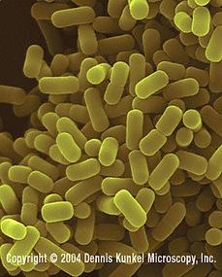

26.) Which microscope most likely produced this image?

27.) Which microscope most likely produced this image?

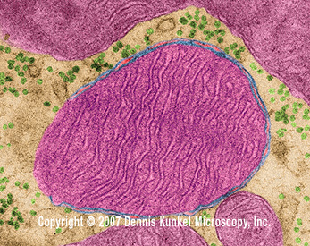

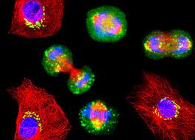28.) Which microscope most likely produced this image?

29.) Determine the field of view in micrometers.

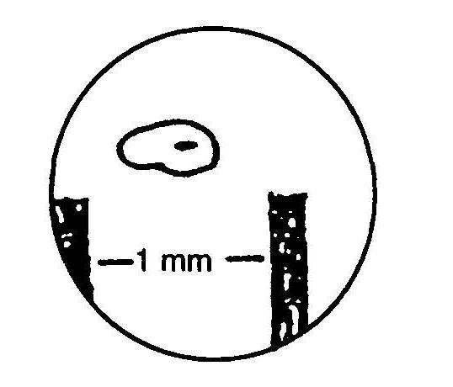

30.) What is the approximate length of the specimen in micrometers?

Part II – Microbe/Cell Questions (69 points)

Questions 31-70 are questions about microbes and cells.

31.) Small membrane bound sacs in the cytoplasm that store materials and moves materials into or out of the cell in bulk are called …

1. Cilia
2. DNA
3. Vesicles
4. Ribosomes

32.) The microbes that cause Mad Cow Disease are …

1. Fungi
2. Prions
3. Bacteria
4. Algae

33.) & are major decomposers in many ecosystems.

1. Viruses, Fungi
2. Bacteria, Prions
3. Prions, Algae
4. Bacteria, Fungi

34.) Some bacteria synthesize their own food using energy from chemical reactions. They are called…

1. Chemoautotrophic
2. Cyanobacteria
3. Photoautotrophic
4. Anaerobic

35.) Parasite worms are mostly…

1. prokaryotic
2. eukaryotic
3. fungi
4. prions

36.) Flagellum helps the cell …

1. Move C. Get energy
2. Eat D. See

For numbers 37-43, label the parts of the cell.

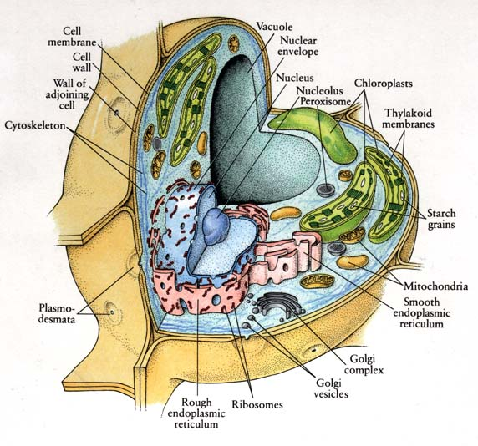

**38**

**37**

**39**

**40**

**41**

**42**

**43**

37.)

38.)

39.)

40.)

41.)

42.)

43.)

44.) What type of cell is this? Give two examples that support your conclusion.

For numbers 45-53, label the parts of the cell.

**45**

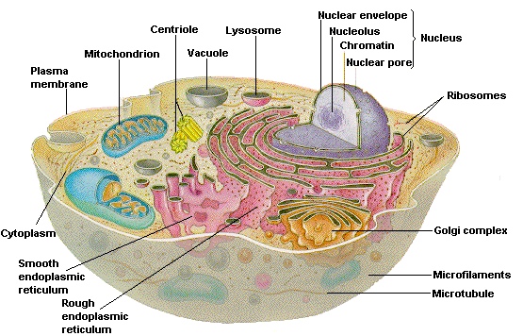

**53**

**52**

**48**

**50**

**49**

**47**

**46**

**51**

45.)

46.)

47.)

48.)

49.)

50.)

51.)

52.)

53.)

54.) What type of cell is this? Give two examples that support your conclusion.

55.) A virus reproduces through .

1. the lysogenic cycle
2. the lytic cycle
3. binary fission
4. sexual reproduction

56.) Every virus is basically some form of genetic material enclosed in …

1. a cell wall
2. a cell membrane
3. a protein coat
4. cytoplasm

57.) Which of the following foods can be made using bacteria?

1. cheese
2. sourdough bread
3. sauerkraut
4. all of the above

58.) Euglenoids cannot see, but they have that respond to light.

1. micronuclei
2. flagella
3. contractile vacuoles
4. eyespots

59.) What is the name of the photosynthetic organelle?

1. nucleus
2. chloroplast
3. vacuole
4. mitochondria

60.) Scientists have discovered a new type of microbe living beneath the ice in Antarctica. Which microbe is mostly likely the one they found?

1. Fungi
2. Protozoa
3. Archae
4. Algae

61.) Name the four groups parasite worms belong to.

62.) Draw a diagram depicting binary fission. Be sure to label each part of the process.

1. What divides through binary fission?

63.) Diseases caused by prions are characterized by …

a)

b)

c)

d)

e)

64.) What type of bacteria causes Botulism? Name three symptoms of Botulism.

65.) Describe how fungal diseases are treated.

For 66-68, tell where you would find the microbe and one of its features.

66.) Amoeba

67.) Paramecium

68.) Euglena

69.) What types of microbes are all of the above?

70.) Rinovirus causes what common communicable disease?

Part III – Microbial Growth (11 points)

Questions 71-80 will be about microbial growth.

For 71-74, label the Microbial Growth Curve.

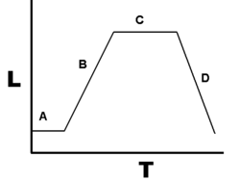

a)

b)

c)

d)

75.) In which phase (use letter) do the bacteria lose nutrients and die?

76.) In which phase (use letter) is there cell doubling and the number of bacteria increases?

77.) In which phase (use letter) do the bacteria adapt themselves to growth conditions?

78.) In which phase (use letter) is the rate of bacterial growth equal to the rate of bacterial death?

79.) Why do the bacteria start to die?

80.) About how many hours do microbes usually live?

1. 38-39 hours
2. 50-56 hours
3. 42-43 hours
4. 10-12 hours

Part IV – Microbial Diseases and their Treatment/Prevention (31 points)

Use the key to identify which microbe causes each disease.

**KEY**

**A.** Bacteria

**B.** Virus

**C.** Algae

**D.** Fungi

**E.** Prion

**F.** Archaea

**G.** Protozoa

**H.** Parasite Worm

81.) Giardiasis 84.) Malaria 87.) Thrush

82.) Trichinosis 85.) Dutch Elm Disease 88.) Chlamydia

83.) AIDS 86.) Cryptosporidiosis 89.) Small Pox

90.) Alpers syndrome

91.) Describe the symptoms of Paralytic Shellfish Poisoning. Then state the prevention and treatment of the disease.

92.) Describe the symptoms, prevention and treatment of Botulism.

Part V – Beneficial/Harmful Microbes (12 points)

Answer each of the questions regarding beneficial microbes.

93.) Which microbe(s) is (are) used to make….

1. petroleum?
2. medicine?
3. wine?
4. bread?

94.) How are microbes involved in wastewater microbiology?

95.) What are some ways that microbes can be harmful?

Part VI – Cellular Processes (19 points)

Answer questions 96-100 dealing with cellular processes.

96.) What is Phagocytosis?

97.) What is passive transport?

98.) What is active transport?

99.) Name the four stages of mitosis.

100.) What is meiosis?

Tie Breaker: Describe gram positive and gram negative staining.