**NY STATE SCIENCE OLYMPIAD**

**HYDROGEOLOGY**

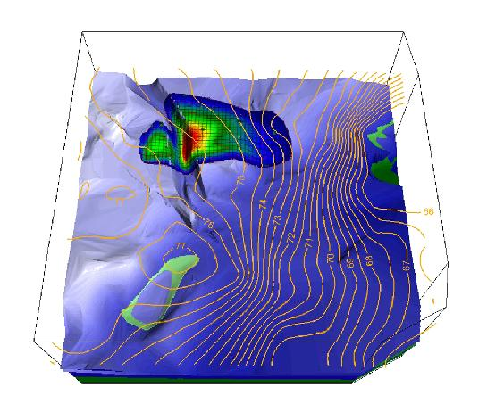

**2016 REGIONAL COMPETITION**

**TEST BOOKLET**

***All answers to Part I and III must be placed into the proper locations on your answer sheet. Part II will be submitted online. Please do not write on this test! If you need more room for calculations or explanation, use the spaces provided in your answer booklet.***

**PART I: WRITTEN TEST**

**SECTION A: VOCABULARY**

Write the word that best fits the definition on the provided line in your answer sheet. (1pt each)

___________________________ 1.) A combined measure of the water pressure and the elevation

at a point in an aquifer, and denotes the total energy of the water

___________________________ 2.) a geologic formation or layer that contains water and has

porosity, but has negligible permeability

___________________________ 3.) the interconnected porosity that contributes to groundwater

flow

___________________________ 4.) a layer of saturated soil or rock below which is an unsaturated

zone and another water table

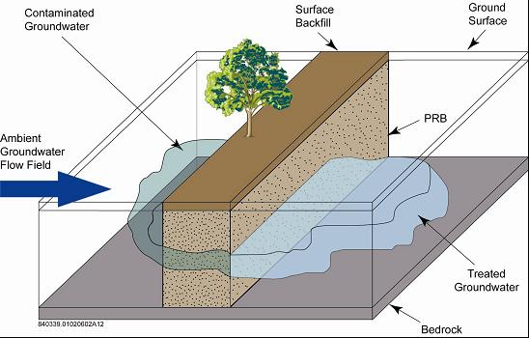

**SECTION B: MULTIPLE CHOICE**

Select the best answer for each question, and put it on the provided line in your answer sheet. (1 pt each)

_____ 1.) The diagram to the right shows groundwater that is trying to be treated with a PRB. What does PRB stand for?

a) Porosity-rich Blocker

b) Permeable Reactive Barrier

c) Pyrite-Redox Bromide

d) Passable Ridding Bridge

_____ 2.) Streams that gain water from groundwater are called ______ streams.

a) artesian b) discharge

c) effluent d) influent

_____ 3.) Which diagram to the right represents the soil with the greatest permeability?

_____ 4.) In what case of Darcy’s Law is the discharge not independent of the angle of sediment?

a) if the angle of sediment is greater than 90°

b) if the sediment’s permeability index is greater than 1.0

c) if the sediment’s potentiometric surface is above the ground’s surface

d) Darcy’s Law is always independent of the angle of sediment

Columns *A*, *B*, *C*, and *D* are partially filled with different sediments. Within each column, the sediment is uniform in size. A fine wire mesh screen covers the bottom of each column to prevent the sediment from falling out. The lower part of each column has just been placed in a beaker of water. Sediment sizes are not drawn to scale.



_____ 5.) In which sediment will capillary action cause the water from the beaker to rise *fastest* in the column?

a) medium sand b) large silt

c) small pebbles d) large sand

The diagram below shows normal conditions versus saltwater intrusion conditions. Use it to answer the next question.

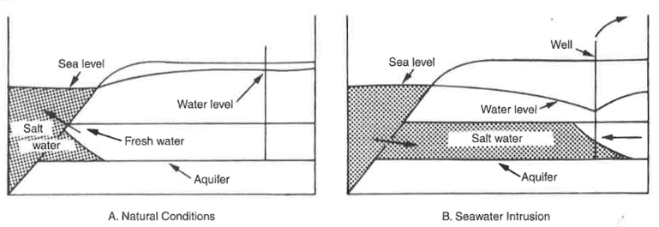

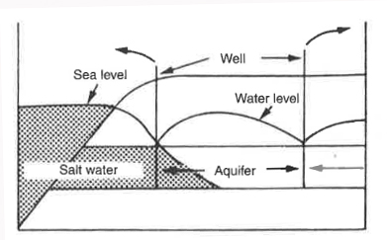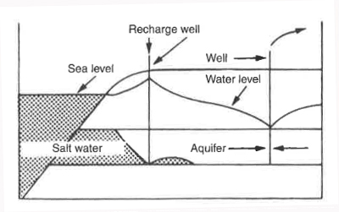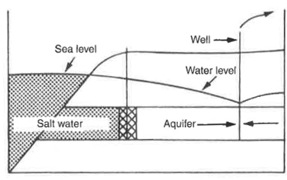_____ 6.) Which image below shows the saltwater intrusion prevention method known as the injection-ridge barrier?

A B C

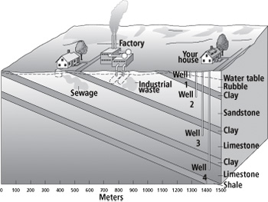_____ 7.) According to the figure to the right, where might pollution come from to contaminate Well 1?

a) a neighbor's sewage

b) factory

c) industrial waste

d) your sewage

_____ 8.) “As significant drawdown occurs to the potentiometric surface of a confined aquifer, water from the overlying confining aquifer will seep downward into the confined aquifer. The normal load exerted by the weight of the overlying rocks compacts this confining layer, which will decrease its thickness.” This description is explaining the mechanics of what serious groundwater issue?

a) baseflow recession b) steady-state seepage

c) land subsidence d) development of karst topography

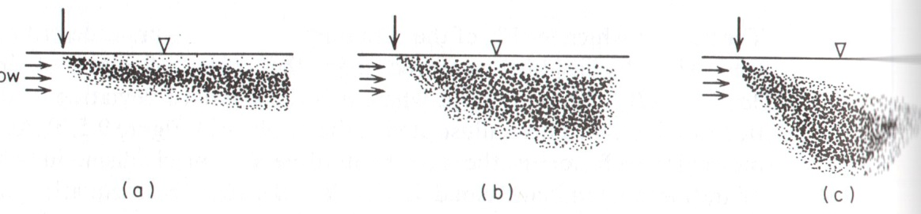

_____ 9.) The diagrams to the right show the migration of contaminant solution in a uniform flow field under different circumstances. The differences in the flow of the contaminant shown from diagrams a-c most likely due to differences in:

a) density of the solution b) permeability of the sediment

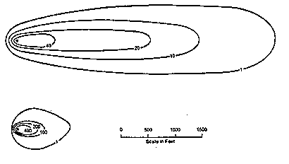c) pieziometric surface d) hydraulic gradient

_____ 10.) A solute is added to groundwater and undergoes the dispersive process. Which statement below best explains this process of mechanical dispersion?

a) is it anisotropic, with longitudinal dispersion > transverse dispersion

b) it is anisotropic, with transverse dispersion > longitudinal dispersion

c) is it isotropic, with longitudinal dispersion = transverse dispersion

d) it is bitropic, with longitudinal dispersion = transverse dispersion

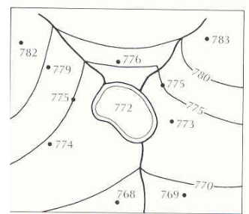

_____ 11.) The diagram to the right shows the construction of water table maps with an area of surface water. The unlabeled lines show rivers. Based on the map, which of the following statements is true?

a) the map shows two losing streams entering the lake and one gaining stream leaving the lake

b) the map shows two gaining streams leaving the lake and one losing stream entering the lake

c) the map shows two gaining streams entering the lake and one gaining stream leaving the lake

d) the map shows two gaining streams entering the lake and one losing stream leaving the lake

_____ 12.) Which statement below is true regarding the effect of topography on the development of groundwater systems?

a) if local topographic relief is small, regional groundwater systems will develop

b) if local topographic relief is small, only local groundwater systems develop

c) if local topographic relief is pronounced, regional groundwater systems will develop

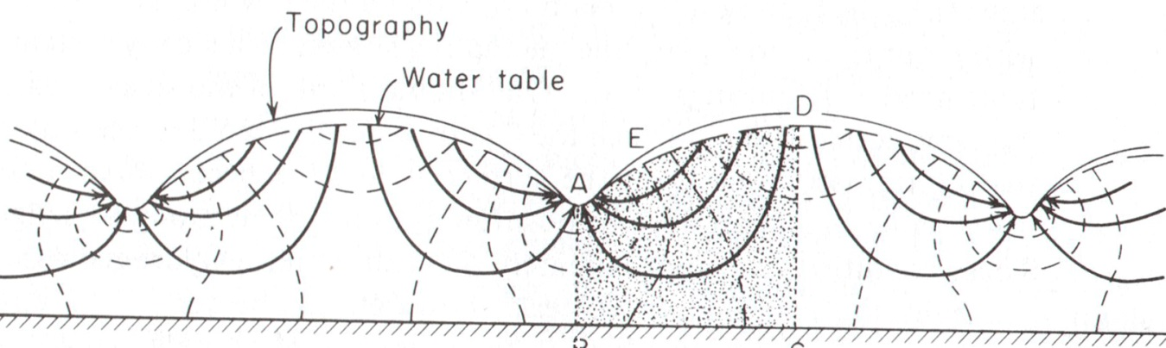d) if local topographic relief is pronounced, both regional and local groundwater systems develop

_____ 13.) Examine the diagram to the right showing a groundwater flow net cross section bounded on the bottom by an impermeable boundary. Between what two letters is there a recharge area?

a) AE b) ED

c) AB d) AD

C

B

_____ 14.) Which substance below has the *greatest* possible recommended concentration limit, in mg/L, for potable groundwater?

a) iron b) lead c) selenium d) chromium

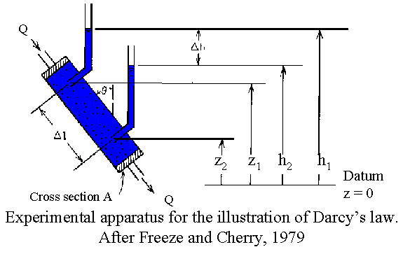

An image of Darcy’s experiment is located to the right. Use it to answer the next 2 questions.

_____ 15.) Darcy’s Law states that the ratio of Q to A is equivalent to:

a) hydraulic head

b) permeability

c) manometer

d) specific discharge

_____ 16.) The data table below shows hypothetical values for several of the variables in the diagram.

|  |  |
| --- | --- |
| **SYMBOL** | **VALUE** |
| θ | 20° |
| Δh | 10 m |
| Δl | 5 m |
| A | 25 m2 |

Based on the table, what is the hydraulic gradient?

a) 0.8°/meter b) 250 m3 c) 2 d) .5

_____ 17.) The Theis solution in estimating drawdown in an aquifer was a breakthrough in hydrogeology, but was only able to be utilized under a specific set of conditions. All of the following conditions must be true to use the Theis solution, EXCEPT:

a) there must be no source of recharge

b) the potentiometric surface must be horizontal prior to pumping

c) the aquifer must be bounded by an impermeable layer below and on top by the water table

d) the pumped well must be 100% efficient

**SECTION C: SHORT ANSWER**

Construct a detailed response to each question in the space given in your answer sheet. The number of points each question is worth is given in parenthesis next to each question.

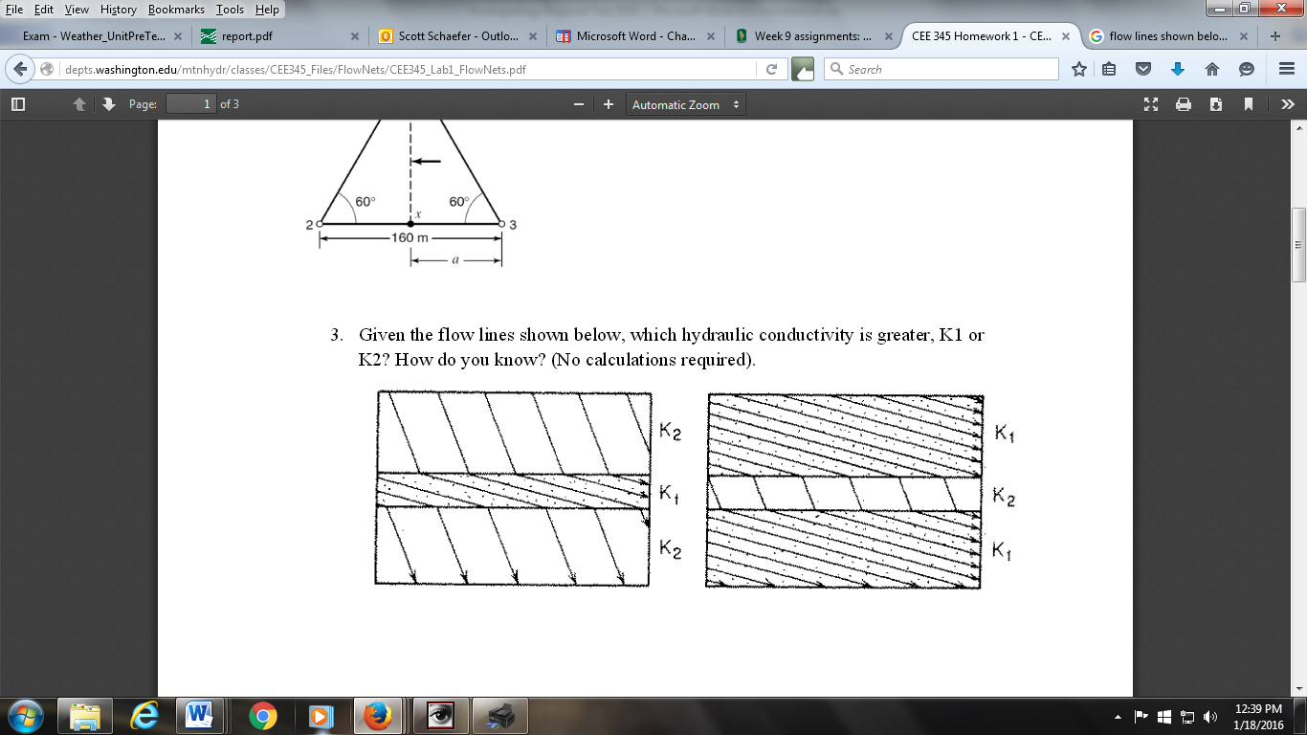1.) Based on the flow lines shown below, in which layer is hydraulic conductivity greater, K1 or K2? How do you know? (2)

2.) Fill in the chart below showing the layers of the ground (saturated zone, unsaturated zone, and water table) that correctly match the labeled values for pressure head ψ. (1)

|  |  |
| --- | --- |
| **Pressure Head Value** | **Subsurface Zone** |
| Ψ>0 |  |
| Ψ=0 |  |
| Ψ<0 |  |

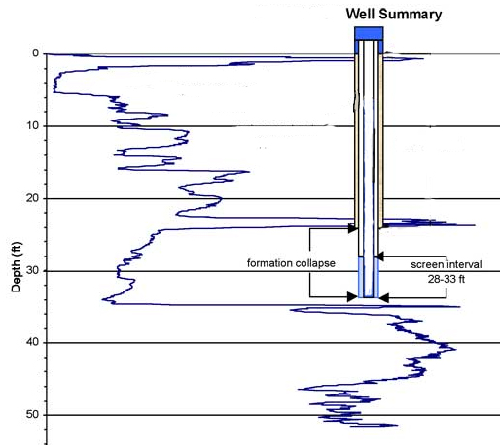Examine the graph and diagram to the right, showing an electrical conductivity log taken of a well in Kansas, showing electrical conductivity versus depth. Use it to answer the next two questions.

3.) At what depth is the water level and capillary fringe located? (1)

4.) How does the electrical conductivity data illustrate the below-ground layers of sediment? (2)

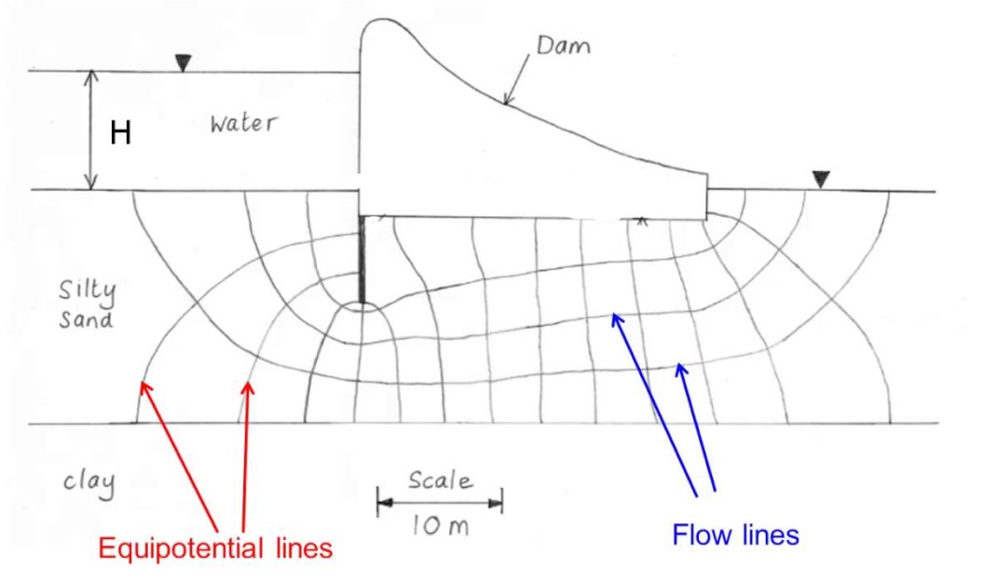5.) A dam is built on permeable sediment with an impermeable base, as seen in the picture to the right. The difference in height of the dam is 11 meters. There are 4 flow channels pictured, and 13 equipotenial lines. If the permeable sediment has a hydraulic conductivity (K) of 100 ft/day, determine the rate of flow or seepage under the dam, and round your answer to the nearest tenth. Show your work for partial credit. (4)