**Team and Team Number: Names:**

SSSS It’s About Time Division C Event  
By syo_astro 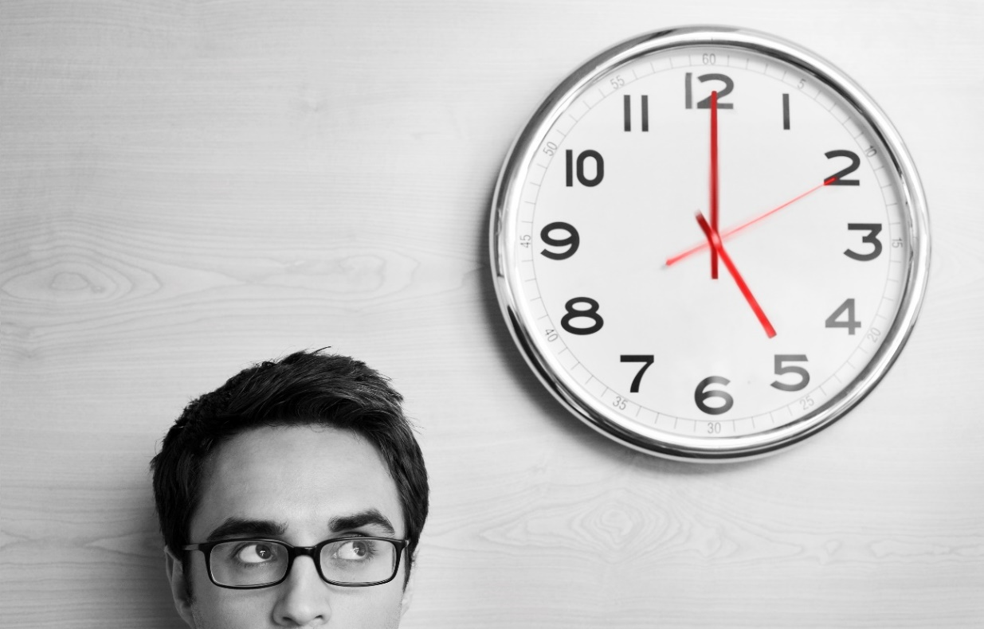

Directions

* **Each question is worth one point, where each part (ie. a, b, etc or i, ii, etc) is worth an additional point. Any question where the grading is different will be noted. The test is 45 points and 25 minutes.**

* **The test involves various types of questions relating to time, timekeeping, astronomy, physics, and/or mechanics.**

* **Within plus or minus 10% of a quantitative answer is considered correct. A quantitative answer that is numerically correct without necessary units and/or significant figures is given a ½ point.**

* **Don’t be afraid to guess (logically) for partial credit where possible, and have fun!**

* **Ties are broken by the larger sum from questions 6b, 8b, 9, 11b, 12a, 12e, 12f, 15a, 16, 20, 21, 21b. If this does not break the tie, then the sum from questions 4, 5, 6, 8a, 10a, 11c, 13a, 15, 18, 19, 22, 23 are used. If this does not break the tie, then the sum from questions 1, 8, 12, 12b, 24, 25 are used. Ties are to be broken AFTER checking various short answer questions and comparing them first.**

1. How many danda are in an olympiad?
2. What day of the month is Memorial Day in 2016 on the Gregorian calendar?
3. What day of the week is Independence Day in 2021 on the Gregorian calendar?
4. Arthur C. Clarke’s 2001: A Space Odyssey series ends with the final book in the year 3001. What day of the week would January 1st be in this year on the Gregorian calendar?
5. If the solar year is defined as the sidereal year, what does the lunisolar calendar show?
6. (1/2 point) Is the Gregorian calendar an arithmetic or astronomical calendar?
   1. (1/2 point) Can arithmetic calendars be complete?
   2. Why do arithmetic calendars that try to associate with seasons lose accuracy over time?
7. Why was incense useful to the Chinese and Japanese to keep time?
8. At what angle should one set the gnomon of a sundial?
   1. At what time during the day is the shadow cast by the gnomon the shortest?

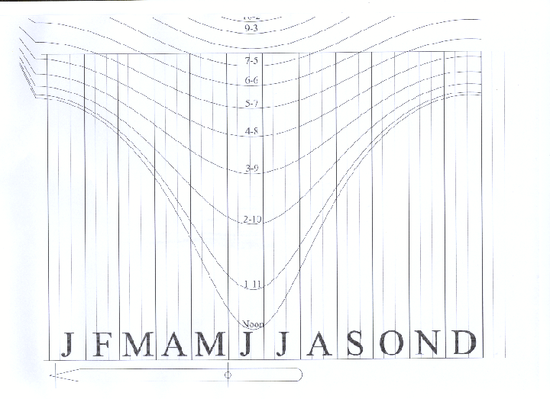

* 1. Are the hour lines for a shepherd’s dial as shown above made for use in the northern or southern hemisphere? Explain.

1. You find your latitude of 44.5° N the previous night by measuring the altitude of Polaris. You place a meter stick vertically at a height of 1.00 m. It casts a shadow of length 0.80 m at noon, which you measure. Calculate the declination angle of the Sun in °.
   1. With this, one could determine that you must have made this measurement on which two dates of the year (day and month, one point for each pair with error of one day)?
   2. If you kept the meter stick outside to measure time, would this time agree with the clock you have on your computer, phone, or common watches? Explain.
2. As you are busy working on an It’s About Time test for Science Olympiad, you hear a single ring of the bell on your striking clock. You are too busy to go up and check the time. This clock strikes once for each hour and once every half hour past the hour. What is the longest amount of time in minutes you have to wait before knowing what time it is?
   1. How many gear trains would be in this clock? Identify what each type is.
3. What is the traditional shape of weights on a cuckoo clock?
   1. Who created the world’s first cuckoo clock?
   2. This type of clock was made to measure time with water. While a water clock is emptying, why is it not useful to keep time with it?
   3. How did the creator from part (b) solve this?
4. Keeping the torsional constant of a balance wheel constant under temperature variations, you vary temperature in order to double its moment of inertia. What is the new period in seconds for one with an original period of 1.00 second and original moment of inertia of 10.0 kg*m2? Ignore frictional sources.
   1. Why is it unrealistic to state only moment of inertia would be affected?
   2. What invention first was used to solve this problem?
   3. Which of John Harrison’s marine chronometers used this invention?
   4. What was Galileo’s proposal for solving the longitude problem?
   5. Before mechanical marine chronometers became feasible, why would it be better to use a marine hourglass than a water clock based on effects of temperature?
   6. You go out on a long voyage across the ocean blue for 100. days and kept the temperature affected balance wheel (the one with double the moment of inertia) at its new period. When you arrive back, how many hours off would your balance wheel be compared to the 1.00 second balance wheel presuming you had references to measure with?

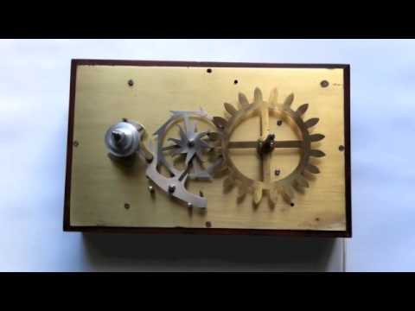

1. What type of escapement is shown above?
   1. What is the principle advantage of this escapement?
2. In 1969, what watch was used by NASA as the first brand used while on the moon?
3. While working in the Black Mesa facility in New Mexico, you realize you are late for a talk about science! You are stuck as you are, but you have been contacted to come out at a specific time. To find out what your time is, you decide to tune a simple radio to the WWVB signal at 60 kHz. You have a radio with a 1.0 nF capacitor. What is the inductance in Henrys of the inductor you need to find/make?
   1. You make the inductor and successfully tune to find what time it is. You receive the following signal (a “-“ means you can ignore that bit):

|  |  |  |  |  |  |  |  |  |  |  |  |  |  |  |  |  |  |  |  |  |  |  |  |  |
| --- | --- | --- | --- | --- | --- | --- | --- | --- | --- | --- | --- | --- | --- | --- | --- | --- | --- | --- | --- | --- | --- | --- | --- | --- |
| Bits | 00 | 01 | 02 | 03 | 04 | 05 | 06 | 70 | 08 | 09 | 10 | 11 | 12 | 13 | 14 | 15 | 16 | 17 | 18 | 19 | 20 | 21 | 22 | 23 |
| Binary | - | 0 | 1 | 0 | 0 | 1 | 1 | 0 | 0 | M | 0 | 1 | 0 | 0 | 0 | 1 | 1 | 0 | 0 | M | 1 | 1 | 1 | 0 |

|  |  |  |  |  |  |  |  |  |  |  |  |  |  |  |  |  |  |  |  |  |  |  |  |  |
| --- | --- | --- | --- | --- | --- | --- | --- | --- | --- | --- | --- | --- | --- | --- | --- | --- | --- | --- | --- | --- | --- | --- | --- | --- |
| Bits | 24 | 25 | 26 | 27 | 28 | 29 | 30 | 31 | 32 | 33 | 34 | 35 | 36 | 37 | 38 | 39 | 40 | 41 | 42 | 43 | 44 | 45 | 46 | 47 |
| Binary | 0 | 1 | 0 | 0 | 0 | M | 1 | 0 | 0 | 0 | 0 | 0 | 0 | 1 | 0 | M | 1 | 0 | 0 | 0 | 0 | 0 | 0 | 0 |

|  |  |  |  |  |  |  |  |  |  |  |  |  |
| --- | --- | --- | --- | --- | --- | --- | --- | --- | --- | --- | --- | --- |
| Bits | 48 | 49 | 50 | 51 | 52 | 53 | 54 | 55 | 56 | 57 | 58 | 59 |
| Binary | 0 | M | 0 | 1 | 0 | 0 | 0 | 1 | 0 | 0 | 0 | M |

What time is it (answer as UTC time hh:mm:sss, month day, year, DST or not)?

* 1. What bit tells you whether there will be a leap second at the end of the month?

1. What inherently creates error within clocks based on the duration of time during which a measurement is made?
2. During the Hafele-Keating Experiment, what oscillator was used to measure time?
3. You drive a spaceship off the Earth, a reference frame at rest relative to the Sun (holding other planetary motions, etc briefly ignorable). The ship goes at 0.5c for a distance of 0.5000 light years to the Oort cloud. During this, how much time in days would have passed on Earth according to a passenger on the ship?
4. You are curious how deep the water well you drilled is. To not waste rope on lowering a basket, you drop a rock and very carefully time the drop. You hear the drop after 4.50 seconds. Assuming the speed of sound in air is equal to a constant 343 m/s and g = 9.81 m/s2, then how deep is the well in meters?
5. The second law of thermodynamics is important to time because of entropy and its relationship with the arrow of time. Black holes were thought to be defined by the no-hair theorem, such that they could effectively lower entropy of objects thrown into them. How did Stephen Hawking show that they do in fact increase in entropy?

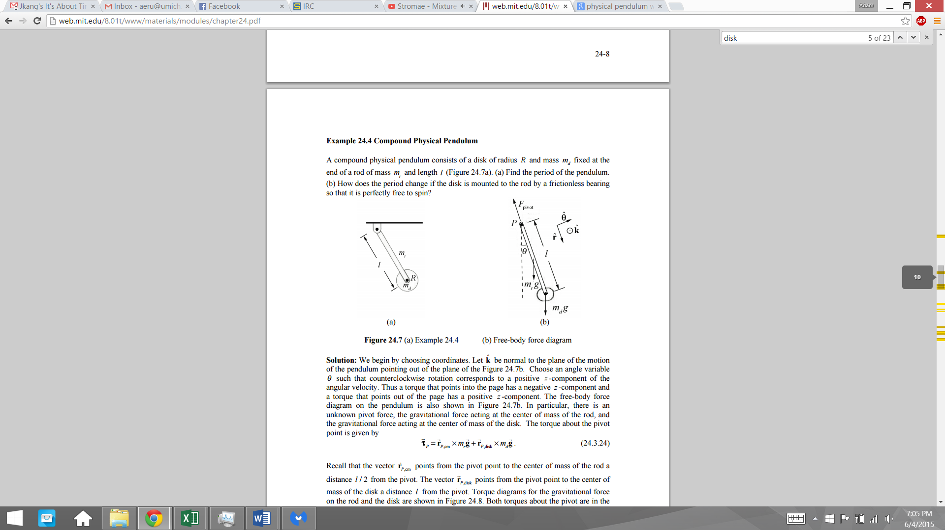

1. You are given the physical pendulum shown in the image above, with l = 1.0 m, mr = 0.50 kg, R = 0.20 m, and md = 2.0 kg. It is composed of the arm with a disk attached that may spin freely or not. Which case would have the shorter period? Explain using moment of inertia or energy to demonstrate why.
   1. For your choice, what is the period in seconds of that case?
   2. Would damping affect this period of this oscillator? Explain in the short-run and the long-run of letting the pendulum oscillate.
2. When does a driving force put an oscillating system into resonance?
3. You observe an asteroid within the asteroid belt orbiting the Sun at a semi-major axis of 3.200 AU. What is the orbital period in days of this body?

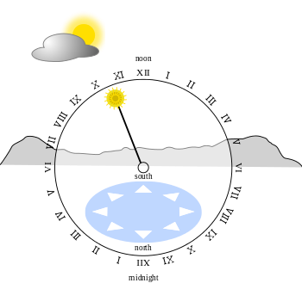

1. Given the astronomical clock shown above, you adjust the Sun on the clock to be pointed exactly midway between the II and III to match where the Sun is currently azimuthally. To check that your clock is calibrated to the Sun’s motion correctly, what would the azimuth of the Sun in degrees be clockwise from North?
2. You have a sample containing 1.51 * 1023 atoms. It initially decays at a rate of 8.63 * 1016 atoms per 300. minutes. What is the half-life of this sample in days?