Pirate Test Name o’ Lily-livered Landlubber:
Ahoy there, me hearty! Whut ye got? Be quick about it, I be shippin' out soon! (30 minutes)
#1-20: We found this skeleton lyin' on th' Davy Jones' Locker. Be a smart aleck an' show off t' yer crew by givin' each bone its scientific name.
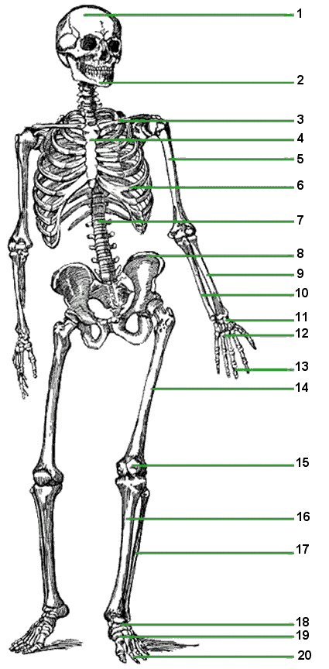
The captain be gettin' sea salt in his joints an' he finds that he canna move some o' them. #21-27: Name what kind o' joint each arrow points t' (be specific) an' next t' 't, write D, R, or A. (Diathrosis, Amphiarthrosis, Synarthrosis)
21.

22.

23.

24.

25.

26.

27.

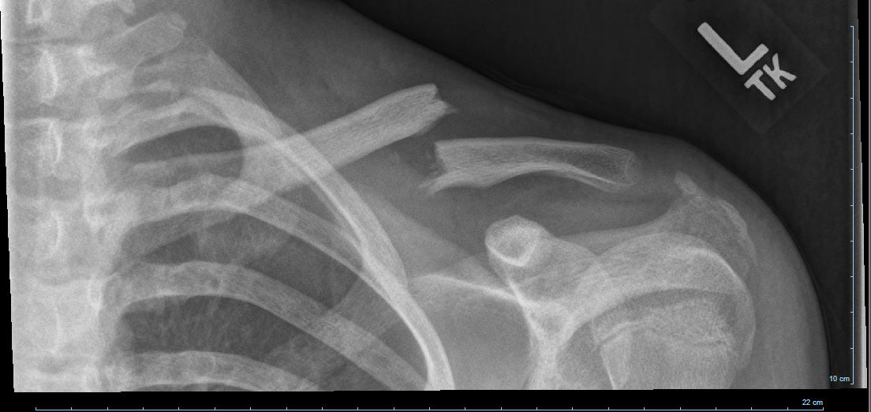

28. Common name o' th' broken bone?

29. Open? Compound? Closed? Simple?
(Pick th' two o' th' words tha’ apply).

30. This fracture here is:
a. impacted c. transverse
b. comminuted d. oblique

Asdfasdf

31. Each muscle begins at an ______, ends at an ______, an' contracts t' produce an ______.

(a). origin, insertion, action
(b). insertion, origin, action
(c). action, insertion, origin
(d). oigin, action, insertion
(e). None o' th' above

32. Muscle cells contain contractible units that be called:

(a). sarcoplasmic reticulum
(b). fascicles
(c). epymysium
(d). sarcomere
(e). None o' th' above

33. The cells that make up muscle tissue be highly specialized fer th' process o':

(a). atrophy
(b). contraction
(c). twitching
(d). all of the above
(e). none of the above

34. What kind o' muscle helps t' pump blood in arteries?________________
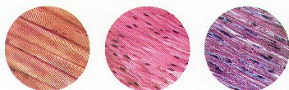
35.
Name th' kind o' muscle.
If 'tis striated, add an “S” next to it.
If 'tis voluntary, add a “V” next to it.
If ‘tis involuntary, add an “I”.

36. You`re fightin' off enemies on deck, slashin' this way an' that wi' yer sword. As ye leap away an' swiftly dodge the'r attacks, ye land on th' side o' yer foot. Ouch! Be this a sprain or a strain?

37. What did ye hurt?
(a). tendon
(b). muscle
(c). ligament
(d). bone
(e). your face ☹

38. How does hypertrophy an’ atrophy compare? What causes them t’ occur?

39. Explain th’ difference ‘tween adduction an’ abduction. (1-2 sentences be ‘nuff)

40. Rhomboids ___ a. large, superficial, moves scapula and supports arm
41. Pectoralis ___ b. connects the scapula and vertebrae; major and minor
42. Deltoids ___ c. three muscles that rotate hips
43. Gluteus ___ d. very prone to cramps, lower leg
44. Trapezius ___ e. upper body, anterior of body
45. Gastrocnemius___ f. shape of triangle; three distinct sets of fibers

What be these called?

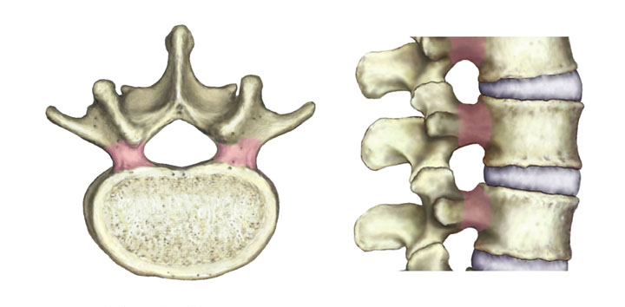
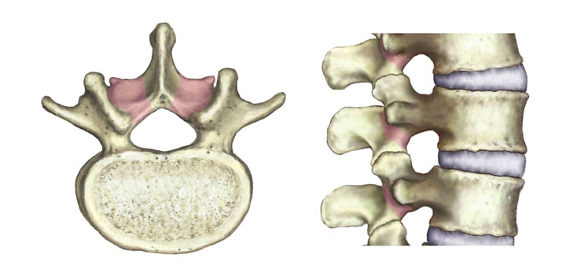
46. 47.

48. What type o' vertebrae be th' two pictures above? (hint: they be both th' same kind)

49. What is th’ difference ‘tween vertebral and intervertebral foramen?

50. The captain decided t' fire ye on accoun' o' gentleman o' fortune dasn't like words they canna understand an' ye keep usin' them anatomy terms. T' get revenge like a nasty seafarin' hearty does, ye yell "I hopes ye all get scurvy, ye horn swagglin’ bilge rats!” an' toss all the'r lemons overboard. They make ye keel haul th' plank but at th' last second, th' captain says: "If ye can accurately name an' spell three muscular dystrophy diseases, then we`ll let ye off th' hook"

Bone-us Kweshtun: Whut iz th’ swashbucklers’ name o’ th’ di-sea-se tha’ iz caused by th’ wear an’ tear o’ cartilage at th’ joints? (1 xtra dubloon fer ye!)

‘Tis th’ end, ye swabbie whut deserves the black spot!

