**SCIENCE OLYMPIAD TEST**

1. What best describes the energy production of the star at position 1?

***Figure 1***

* 1. 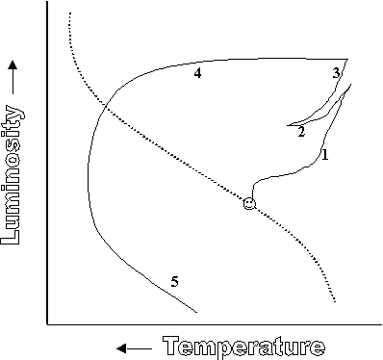Helium fusion in the core
  2. Helium fusion in the shell
  3. Hydrogen fusion in the core
  4. Hydrogen fusion in the shell

1. What happens to the stars temperature from position 1 to 2?
   1. It increases b. It decreases

c. It remains constant

1. What happens to the stars luminosity (energy output) from position 1 to 2?
   1. It increases b. It decreases

c. It remains constant

1. At which position (also called the “horizontal branch”) does the star have a helium-fusing core?

a. 1 b. 2

c. 3 d 4

e. 5

1. From Position 3 to 4 the star’s luminosity does not change despite its increase in temperature. Why?
   1. The star increases in size
   2. The star decreases in size
   3. The star increases in mass

1

A

C

D

B

* 1. The star decreases in mass

1. In what position might the star go supernova?

a. 2 b. 3

c. 4 d 5

e. This type of star can not go supernova

1. ***Figure 3*** shows a portion of the main sequence band. A star (like our Sun) is located at Position . To which position will it move over the next several billion years?

***Figure 3***

* 1. A b. B

c. C d. D

1. Which of the following is NOT true of the star (from the previous question) in its new position several billion years into the future?
   1. The star is slightly larger then its starting position
   2. The star is slightly more luminous then its starting position
   3. The star is slightly hotter then its starting position
   4. The star is slightly more massive then its starting position

**The star HD 20899 lies in the constellation Taurus (as part of the star cluster the Hyades) at a distance of 46 parsecs. A blackbody spectrum of the star is shown below.**

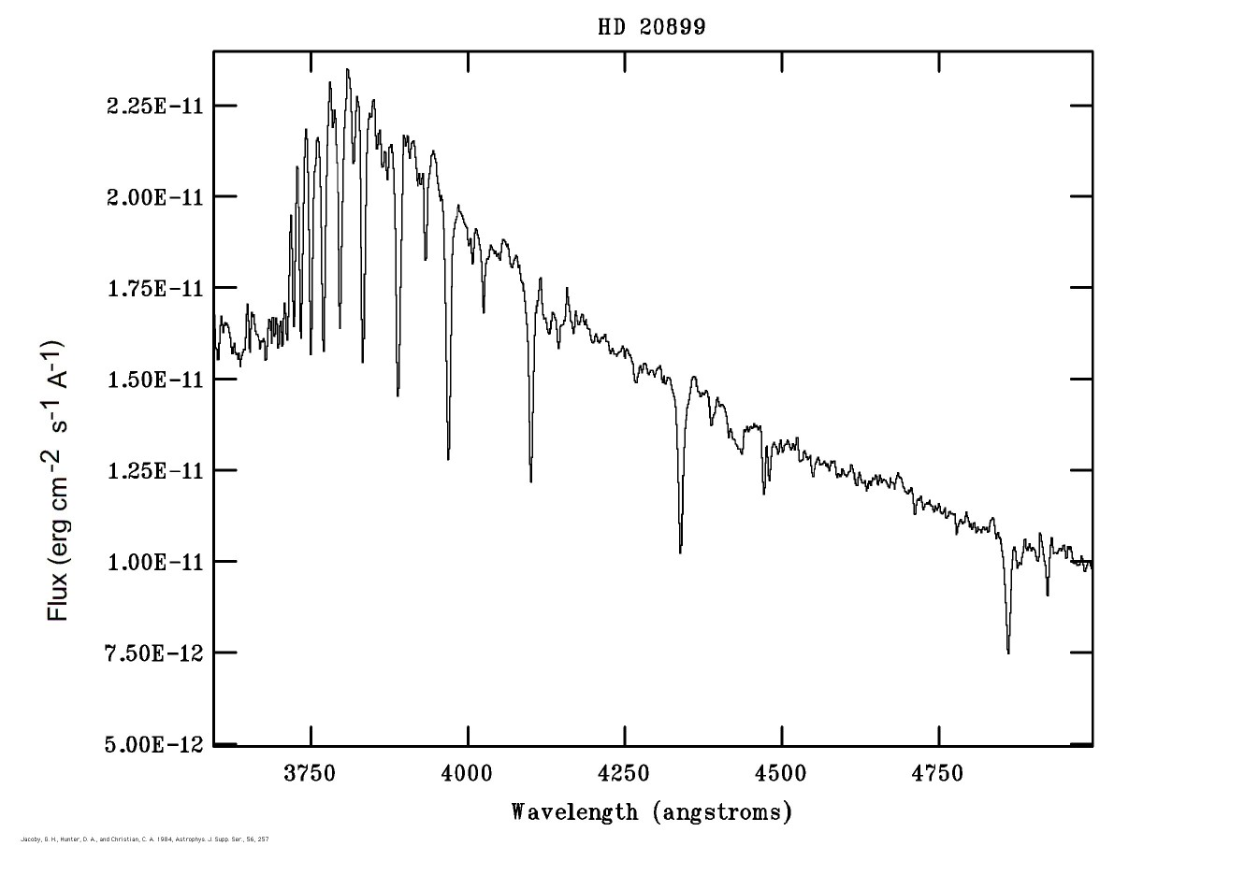

1. Based upon the blackbody curve of the star, what is its approximate surface temperature?
   1. 10,200 K
   2. 8,700 K
   3. 6,200 K

|  |  |
| --- | --- |
| **Spectral Type** | **Surface Temp (K)** |
| **O** | **> 30,000 K** |
| **B** | **10,000 – 30,000 K** |
| **A** | **7,500 – 10,000 K** |
| **F** | **6,000 – 7,500 K** |
| **G** | **5,000 – 6,000 K** |
| **K** | **3,500 – 5,000 K** |
| **M** | **< 3,500 K** |

* 1. 4,100 K
  2. 3,500 K

1. Repeat your answer to the previous question.
2. Given its approximate surface temperature, what spectral type is this star?
3. B9
4. A4
5. F8
6. K3
7. M0

**Use the distance modulus formula (below), Appendix I (attached) and the B-V graphs (attached) to solve questions on this page.**



1. An A5 V star has an apparent magnitude of +5. How far away is the star?

a. 10 pc b. 20 pc

c. 30 pc d. 40 pc

e. 50 pc

1. Repeat your answer to the previous question.
2. A star is measured to have an apparent visual magnitude, V, of 6.0 and an apparent blue magnitude, B, of 6.77. What is this star’s temperature?
   1. 12,000 K b. 9,600 K

c. 7,200 K d. 5,500 K

e. 3,600 K

1. What is this star’s distance?
2. 4 parsecs b. 15 parsecs

c. 55 parsecs d. 255 parsecs

e. 310 parsecs

1. Repeat your answer to the previous question.

**The light curves (apparent magnitude vs. Wavelength) for two stars are shown below. Use the mid-point of the band pass (450 nm for B and 650 nm for V) to answer the following questions.**

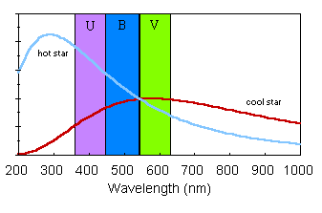

**1.8**

**2.0**

**2.2**

**2.4**

**2.6**

**2.8**

1. What is the B-V color index for the ‘hot’ star?
   1. 1.2
   2. 1.0
   3. 0.4

**m**

* 1. 0.0
  2. -0.2

1. What is the B-V color index for the ‘cool’ star?
2. -0.1
3. 0.05
4. 0.5
5. 1.1
6. 1.5
7. What is the approximate temperature of the ‘hot’ star?
8. 24,000 K
9. 17,000 K
10. 8,500 K
11. 4,200 K
12. 3,500 K

**The graph below shows the HR diagram (m vs. B-V) of an open cluster. An attached transparency graph shows the typical HR diagram for main sequence stars (M vs. B-V). Use a “main-sequence” fitting technique to answer the following question.**

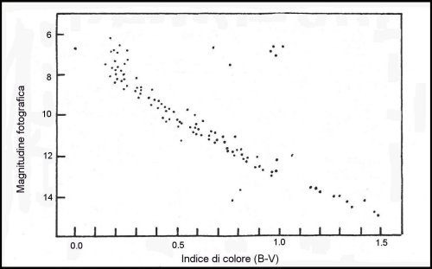

**m**

Color Index

1. How far away is this cluster (pc)?
2. 60
3. 120
4. 240
5. 480
6. 960
7. Repeat your answer to the previous question.
8. Again, repeat your answer to the previous question.
9. The circled region in the HR diagram of the Beehive lies off the main sequence. What type of stars are these?
10. Type Ia Supernovae
11. Main Sequence
12. White Dwarfs
13. Red Dwarfs
14. Red Giants

**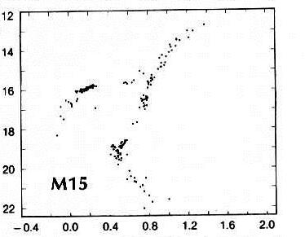 A HR diagram for the globular cluster is shown at right.**

1. What is the apparent magnitude of the RR-Lyrae gap?
2. 12.5 b. 15.8

c. 18.0 d. 0.4

e. 0.8

1. Assuming the average RR-Lyrae type star to have an Absolute Magnitude of 0.75, what is the distance to M15 (in parsecs)?
2. 1,800 pc b. 8,500 pc

c. 10,200 pc d. 18,600 pc

e. 24,100 parsecs

1. Repeat your answer to the previous question.

**A plot of 4 supernovae (brightness vs. wavelength) is shown below. Three graphs are those that show characteristics of Type Ia supernovae, while the other shows itself to be a Type II supernova.**

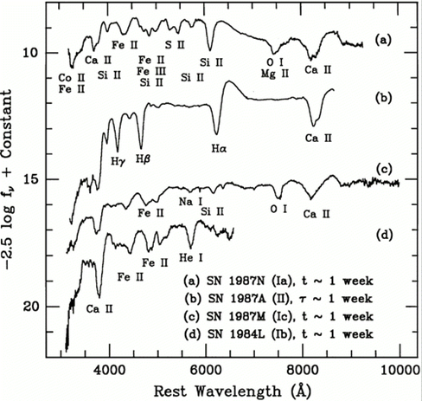

1. Which plot is that of a Type II supernova?
2. Because they share similar origins, The luminosities of all Type Ia supernovae are similar. If we assume an absolute visual magnitude of -19 for this type of supernova, how far away is the brightest Type 1a supernova shown at right?
   1. 160 million parsecs
   2. 80 million parsecs
   3. 16 million parsecs
   4. 4 million parsecs
   5. 1.2 million parsecs
3. Repeat your answer to the previous question.
4. Which of the following stars has a ***possibility*** to produce a Type 1a Supernova?
   1. Mira
   2. Sirius B
   3. U Scorpii
   4. RR-Lyrae
   5. NGC 2440
5. Which of the following best characterizes the nature of T Tauri stars?
   1. They are young, pre-main sequence stars.
   2. They are the core of a dead, low-mass star.
   3. Variable stars found on the horizontal branch of the HR Diagram.
   4. The ionized gas ejected from a low-mass star at the end of its life.
   5. They are x-ray binaries with one of the pair being a black hole candidate.
6. Although its true nature is the source of some uncertainty, which of the following may, in fact, be a T Tauri star?
   1. Mira
   2. BP Psc
   3. NGC 2440
   4. RX J086.3+1527
   5. Rosette Nebula
7. Which of the following best characterizes the nature of Planetary Nebula?
   1. They are young, pre-main sequence stars.
   2. They are the core of a dead, low-mass star.
   3. Variable stars found on the horizontal branch of the HR Diagram.
   4. The ionized gas ejected from a low-mass star at the end of its life.
   5. They are x-ray binaries with one of the pair being a black hole candidate.
8. Which of the following is a planetary nebula?
   1. M15
   2. Mira
   3. U Scorpii
   4. NGC 2440
   5. The Carina Nebula

**Use the Appendix II (color plate) to answer the following questions:**

1. Which image on the color plate is a planetary nebula? A
2. The Rosette Nebula (photo A) is which type of nebula?
   1. Diffuse
   2. Emission
   3. Planetary
   4. SNR
   5. Dark
3. Which image is the Carina Nebula? C

**The two images below were taken six months apart. A nearby bright star can be seen to have moved. Consider the background stars to be much more distant (not showing parallax).**

4-April-06 2-October-06

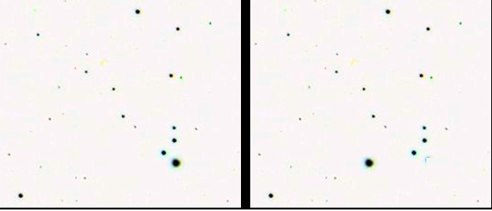

1 arc-sec

2

3

4

5

Visual Magnitudes

1. What is the 6 month shift (in millimeters) of the bright star in the images?
2. 49 b. 20.5

c. 10.5 d. 4.2 e. 1.8

1. What is the parallax (in arc-sec) of this star?
2. 0.75 b. 0.46

c. 0.21 d. 0.08 e. 0.005

1. What is the distance (in parsecs) to this star?
2. 15.6 b. 9.3

c. 7.1 d. 4.8 e. 2.4

1. What is this star’s visual magnitude?
2. 5.5 b. 4.5

c. 3.5 d. 2.5 e. 1.5

1. What is the star’s spectral class?
2. B5 b. A0

c. A5 d. F0 e. F5

**Appendix I**

### Absolute Magnitude Versus Spectral Type

(from C.W. Allen, Astrophysical Quantities, The Athlone Press, London, 1973)

##### **Main Sequence Stars, Luminosity Class V**

**Giants, Luminosity Class III**

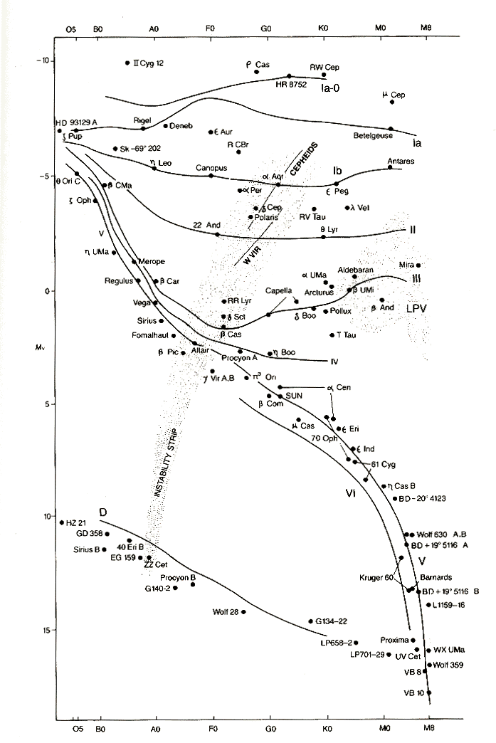appen2_sm

appen2a_sm

##### **Supergiants, Luminosity Class I**

appen2b_sm

**Appendix II**

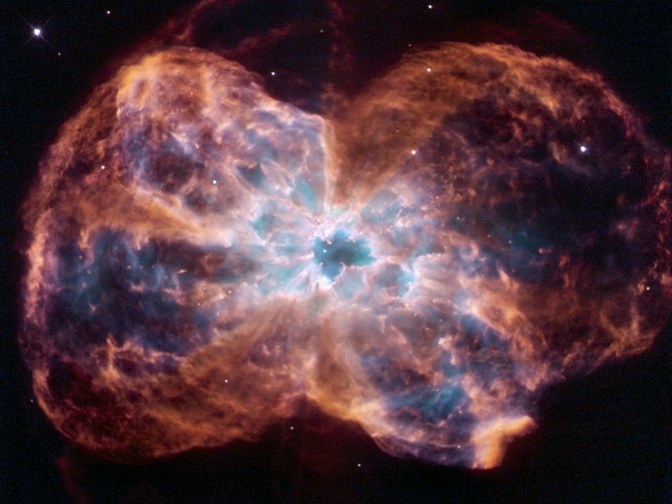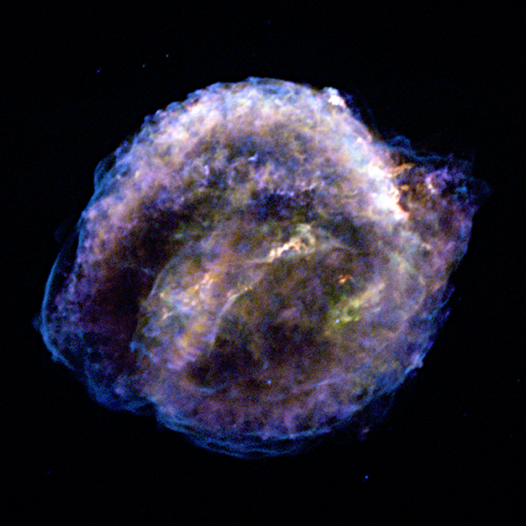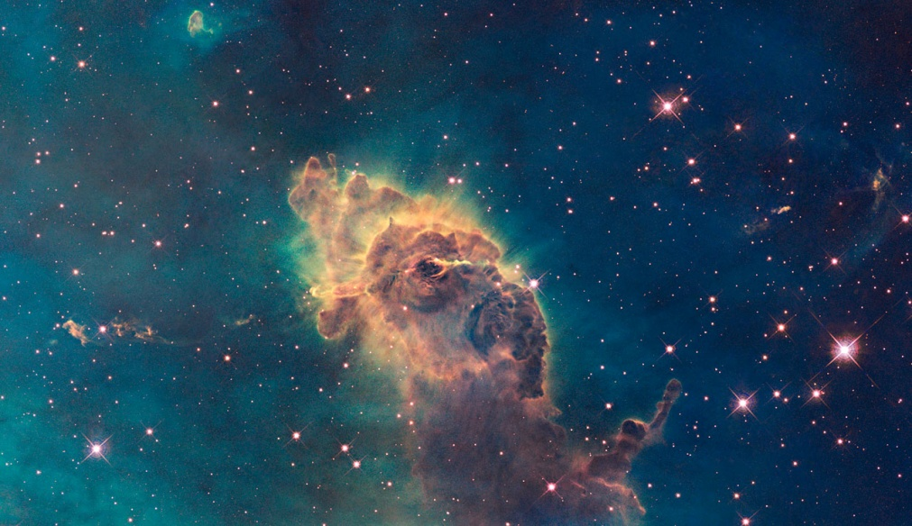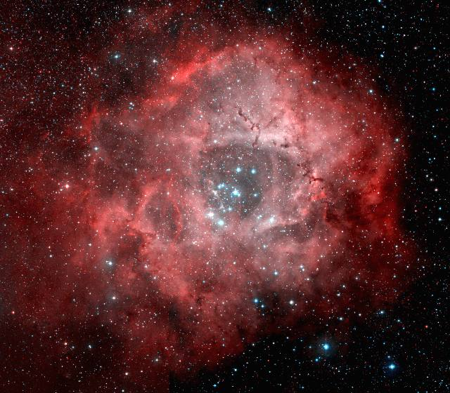

**D**

**A**

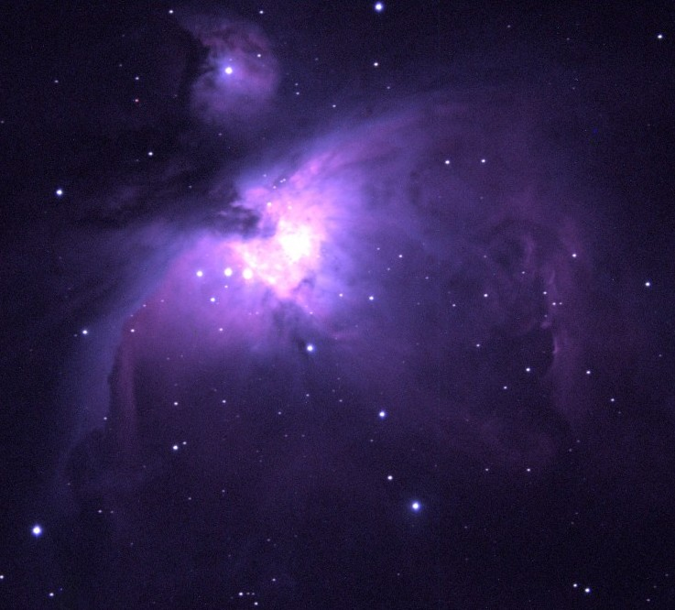

**E**

**C**

**B**

**10 pc**

**10 cm**

**1 m**

**10 m**

**100 m**

**6.6 AU**

**66 AU**

**660 AU**

**6,600 AU**

**1,000,000 km**

**10,000,000 km**

**100,000,000 km**

**1 km**

**10 km**

**100 km**

**1,000 km**

**10,000 km**

**100,000 km**

**1 LY**

**10 LY**

**100 LY**

**1,000 LY**

**10,000 LY**

**100,000 LY**

**1 MLY**

**10 MLY**

**100 MLY**

**1,000 MLY**

**10,000 MLY**

**100,000 MLY**

**Distance**

**1 mm**

**1 cm**

**30**

**20**

**25**

**15**

**5**

**10**

**0**

**-5**

**-10**

**-30**

**-20**

**-25**

**-15**

**Absolute magnitude**

**Apparent magnitude**

**-30**

**-20**

**-25**

**-15**

**-5**

**-10**

**0**

**5**

**10**

**30**

**20**

**25**

**15**

**35**

**40**

**45**

**50**

**65**

**55**

**60**

**70**

**80**

**75**

**85**

**90**

**DISTANCE-BRIGHTNESS NOMOGRAM** (Distances are approximate)

**1 M pc**

**100,000 pc**

**10,000 pc**

**1,000 pc**

**100 pc**

## 

The distance line is a log-scale; each heavy line is 10 times the previous line (going up the scale). The example to the right illustrates the 10 km to 100 km section. It becomes more difficult to read the upper end of these scales. Estimate as best as you can when solving problems.

**100 km**

**80 km**

**60 km**

**40 km**

**20 km**

**10 km**



**Mm**

**2**

**6**

**10**

**8**

**4**



**M**

**2**

**6**

**10**

**8**

**4**