New York State Invitational Tournament 2009

FOSSILS

STATION 1 1. Name the phylum that these fossils belong to.

2. A – D

- Identify the fossils to major subgroup of the phylum for each specimen.

- Indicate the type of preservation for each specimen in the space provided.

Choose from the following:

cast internal mold external mold actual remains

mineral replacement petrifaction carbonization

STATION 2 3. Name the type of arthropods that these fossils represent.

4. Which term best describes the life habit of these animals?
a. benthic c. planktonic
b. pelagic d. predator

5. a. Identify Specimen A

b. Which geologic period is indicated by Specimen A?

6. What adaptation is indicated by the position of Specimen B, and give an explanation.

7. Specimens C and D are the same animal. Name the genus.

8. Which part of the animal is represented in C & D?

Name the type of preservation of C & D

STATION 3 9. What is the common name for sample A?

10. Name the genus for Sample B.

11. How are these types of fossils different?
a. A is made of calcite; B is made of quartz
b. A is related to jellyfish; B is related to sponges
c. A is a single individual; B is a colony
d. A is free moving; B is attached to the ocean floor

12. The environment that these organisms lived was
a. nonmarine c. deep ocean
b. shallow marine d. terrestrial

13. Members of this phylum have a unique method of feeding. Explain.

STATION 4 14. Name the phylum.

15. A – C
- Identify the subgroup of the phylum that each specimen belongs.

- Indicate the method of feeding for each. Choose from the following terms:

predator grazer (feeds on algae) filter feeder

deposit feeder (gets organic matter from mud) parasite

STATION 5 16. Name the phylum

17. A – E. Identify the genus that each specimen represents.

18. Give two ways how sample D is different from all of the others (not including size)?

19. Which specimen is the best index fossil for the Ordovician?

20. Which terms best describe how & where these organisms lived?

a. benthic (bottom-dwelling) & sessile (attached to sea floor)
b. benthic (bottom-dwelling) & vagrant (free moving)
c. planktonic (floating) & sessile (attached to sea floor)
d. nektonic (swimmer) & vagrant (free moving)

STATION 6 21. Which subgroup (class) of mollusks do these specimens belong?

a. Bivalves b. Gastropods c. Cephalopods d. Clams e. snails.

22. A – D
Identify the order (type) that each specimen belongs to (give the most detailed name you can).

23. Which living organisms are these most similar to?
a. snails & slugs c. squids and octopus
b. oysters & clams d. starfish

- a. Describe the environment that these lived in.

b. How did these animals move in the water?

c. How did these animals obtain food?

25. How is sample D different than the other 3?

STATION 7 26. Give the common name of these specimens.

27. What rock are these fossils preserved in?

28. How are these fossils preserved?

29. Why is this group often used as an Index Fossil for the Ordovician?

30. What was their mode of life?
a. lived attached to the sea bottom c. lived on land
b. floated in the ocean d. swam in the ocean

STATION 8 31. Name the Phylum.

32. A – B
Identify sample A and B to Genus.

33. How did these organisms feed?

34. Which term best applies to this group.

a. solitary b. pelagic c. colonial d. vagrant (free moving)

35. Sample C contains a number of fossils. What type of rock are they preserved in?

STATION 9 36. A –B Identify the type of fish represented by each fossil.

37. Why are other parts of the skeleton of Specimen B rarely preserved?

38. Which geologic period did this group of Fish (Specimen B) first appear?

39. Sample A is from the Green River Formation in Wyoming, which is
believed to have been a lake 25 million years ago.

List two conditions that must have existed for Sample A to be so well
preserved?

STATION 10 All the fossils are parts of different types of vertebrates.

40. A – C Identify the major group (class) that each fossil vertebrate tooth belongs.

41. Specimen A is part of a jaw of which type of sea animal?
a. shark b. dinosaur c. bony fish d. mososaur

42. Specimen A was among the largest marine predators of
a. Paleozoic seas c. Cenozoic seas
b. Mesozoic seas d. Paleozoic – Cenozoic seas

- Which best describes the feeding habits of Specimen B?
a. carnivore (meat eating) c.. herbivore (plant eating)
b. insectivore (insect eating) d. omnivore (at plants and animals)

- What is unique about the teeth of the group of animals represented by Specimen B?

  - all the teeth in the jaw were the same form
  - they had teeth that constantly replaced old teeth as they wore out
  - the teeth in the jaw are different and serve different functions when eating
  - the teeth wore down easily into flat surfaces

- What mineral are all vertebrate teeth and bones made of?
a. apatite (calcium phosphate) c. calcite (calcium carbonate)
b. quartz (silicon dioxide) d. chitin ( carbon compound)

STATION 11 The specimens all are remains of dinosaurs. Specimens B & C are teeth from
different types of dinosaurs.

- Briefly describe how Specimen A was preserved.

47. This type of preservation is called
a. recrystallization b. cast c. permineralization d. carbon trace

48. Which term best describes the animals that these fossils belonged to
a. marine b. terrestrial c. aquatic d. benthic

49. Identify which dinosaur models, Albertosaurus and Maiasaurus, best
match teeth B & C.

50. Explain why the shape of each tooth is different in each dinosaur.

STATION 12 51. Name the dinosaurs A & B.

52. Identify the geologic period in which these animals lived.

- Describe one adaptation (or behavior) that Specimen A had for protection.

- Describe one adaptation (or behavior) that Specimen A had for protection feeding.

55. Which group do these dinosaurs belong to?
a. ornithiscia b. therapsid c. saurischia d. synapsid

- Explain some evidence that supports the idea that dinosaurs may have been warm blooded and very energetic animals.

57. Describe two theories that explain why dinosaurs became extinct.

STATION 13 58. Identify Specimens A – D.

59. What do all of these fossils have in common?
a. they all lived in terrestrial environments.
b. they are all plants
c. they all are producers
d. they all lived in aquatic environments

60. Which method of reproduction do specimens C & D have in common?
a. they produce spores
b. they reproduce by budding
c. they have flowers that produce pollen
d. they produce seeds

61. Specimen A is from Carboniferous age rocks in Pennsylvania.
How did the carboniferous get its name?

62. Specimen B has a long fossil record that goes back to the Precambrian.
They were one of the most common organisms on earth during the last half of the Precambrian and the beginning of the Paleozoic.

What critical change on earth was caused by these organisms?

a. they were the first land plants during the Ordovician

b. they released oxygen, which helped change the composition of the atmosphere during the Precambrian

c. they served as food for grazing animals during the Paleozoic

d. they enabled animals to have hard parts at the beginning of the Cambrian

STATION 14

Use the cross section through earth’s crust and the index fossils indicated to answer the questions. Layers R & Q are igneous intrusions. Layers A, B, C, and D are sedimentary rocks.
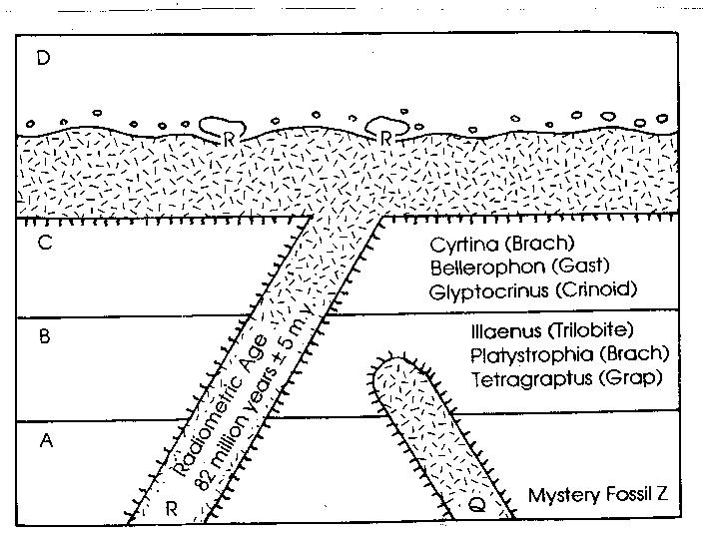

63. List the rock layers in order from Oldest to Youngest on the answer sheet.

64. Using the brachiopod Platystrophia, during which geologic period did layer B form?
a. Cambrian b. Cretaceous c. Ordovician d. Triassic

65. During which geologic period did intrusion R form?
a. Cambrian b. Cretaceous c. Ordovician d. Jurassic

66. What is the relative age of Mystery Fossil Z?
a. It is younger than Igneous Intrusion Q
b. It is older than Igneous Intrusion Q and rock layer B.
c. It is older than 82 million years, but younger than the brachiopod Platystrophia.
d. It is the same age as Igneous Intrusion Q, but older than rock layer C.

STATION 15

The following fossils are all found in the same limestone bedrock in South Dakota.

Fossil Geologic Range
Belemnite (Cephalopod) Mississippian - Cretaceous
Nucula (Clam) Silurian – Recent
Exogyra (Bivalve) Jurassic – Cretaceous
Baculites (Cephalopod) Cretaceous
Turitella (Snail) Cretaceous – Recent

Plot the ranges of the fossils on the form provided. Use arrows or shading to indicate the range of each fossil. Use your completed range chart to answer the questions that follow.

67. What geologic period is indicated by the fossils?

68. Which is the best index fossil? Explain your answer.

School_________________________________ Team # ___________________

Name(s) ______________________________
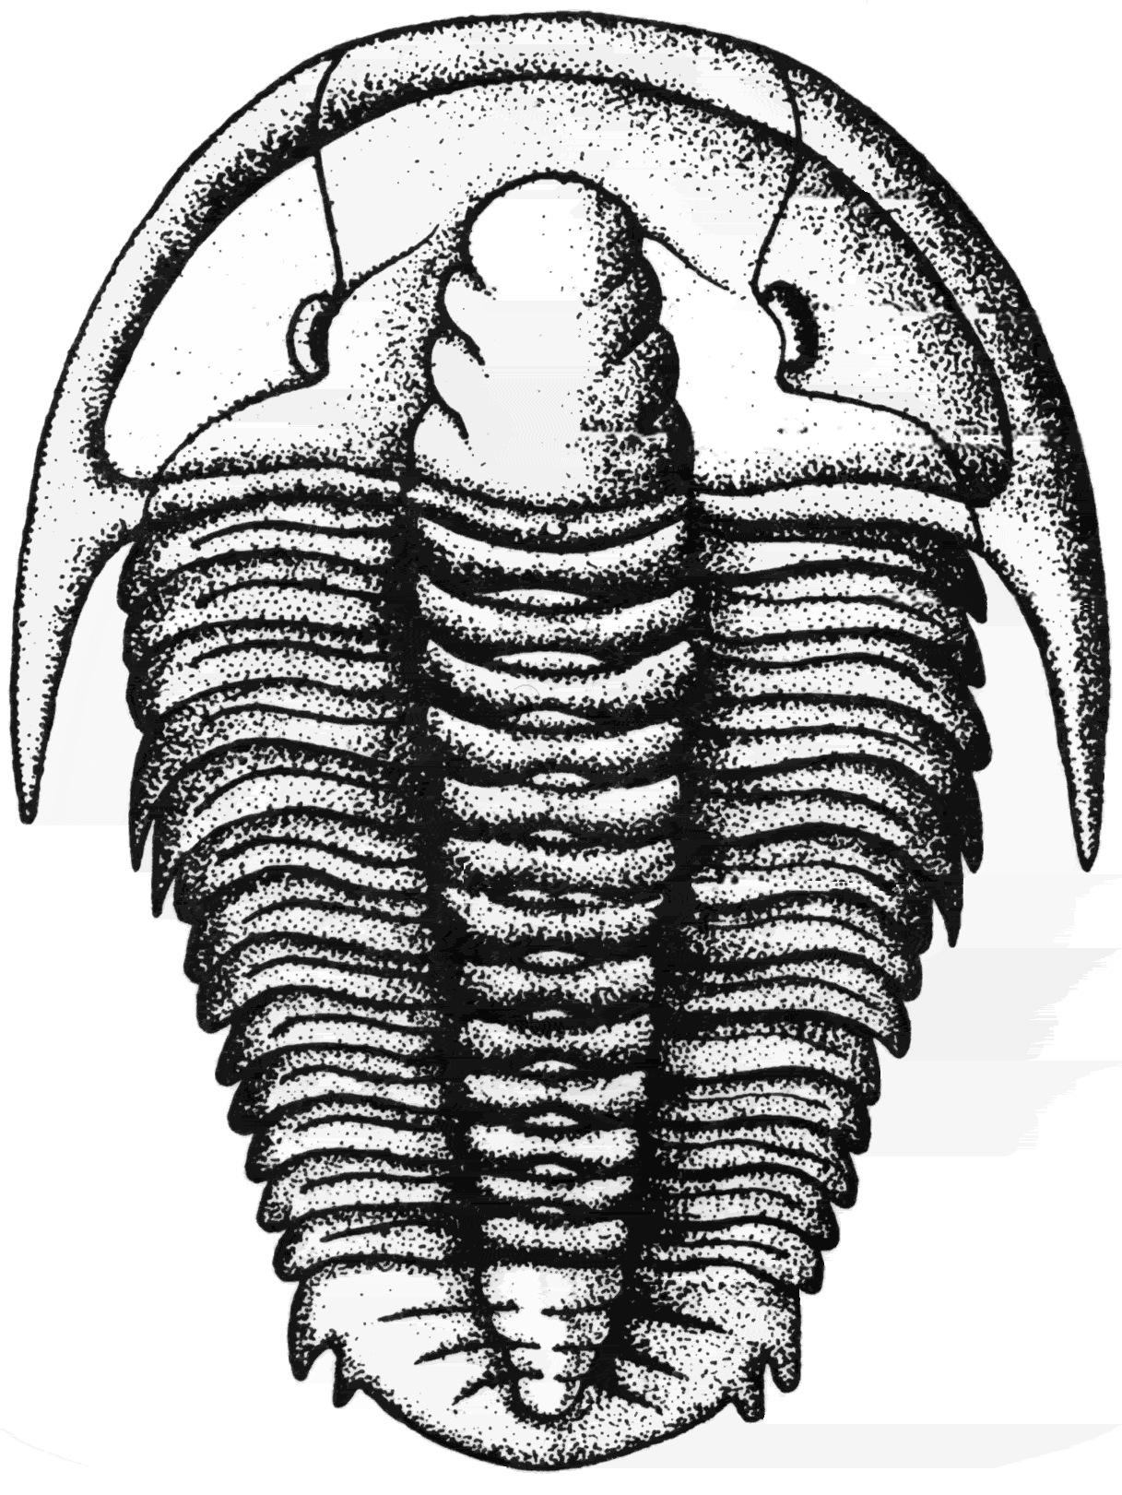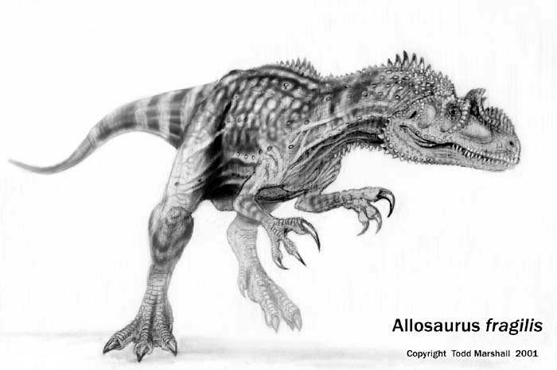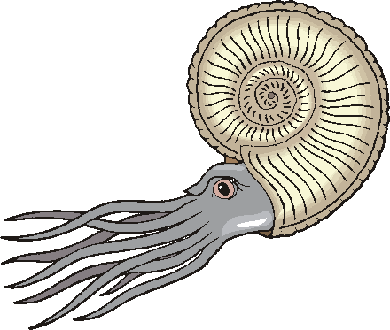

FOSSILS
_______________________________________________________________________________________

STATION 1

1. Phylum__________________________

Fossil (Subgroup) Name Method of Preservation

2. Specimen A.____________________________ _______________________

Specimen B. ____________________________ _______________________

Specimen C. ____________________________ _______________________

Specimen D. ____________________________ _______________________

STATION 2

3. Type of Arthropod: ________________________________

4. . ___________

5. a. Specimen A ___________________________

b. Geologic Period ________________________

6. ___________________________________________________________________________

7. Specimen C & D ___________________________

8. _______________________________

Type of Preservation of C & D _______________ & ________________

STATION 3

9. Specimen A (Common Name) _______________________

10. Specimen B (Genus) _____________________________

11. ________

12. ________

13. ____________________________________________________________________

STATION 4

- Phylum ________________________________

Subgroup Name Method of Feeding

- Specimen A__________________________ ________________________

Specimen B __________________________ ________________________

Specimen C __________________________ ________________________

STATION 5

16 Phylum _________________________________

17. Specimen A__________________________ Specimen D _______________________

Specimen B __________________________ Specimen E ________________________

Specimen C __________________________

18. _______________________________________________________________________________

_______________________________________________________________________________

19. Best Index Fossil is ________________________

20. ____________

TEAM # ____________

STATION 6

- ________

- Specimen A________________________

Specimen B________________________

Specimen C________________________

Specimen D________________________

- ________

- ________

- __________________________________

_____________________________________

_____________________________________

STATION 7

26. _________________________________

27. _________________________________

28. __________________________________

29. __________________________________

________________________________________

________________________________________

30. __________

STATION 8

- _________________________________

- Specimen A________________________

Specimen B________________________

Specimen C________________________

Specimen D________________________

- ________

- ________

- ________

STATION 9

- Specimen A _______________________

Specimen B _______________________

- _________________________________

_________________________________

- ____________________________

- a. _______________________________

b. _______________________________
STATI

STATION 10

42. ________

43. ________

44. ________

45. ________

46. ________

STATION 11

47. ________

48. ________

49. ________

50. ________

21
STATION 12

51. ________

52. ________

53. ________

54. ________

STATION 13

55. _________

56. _________

57. _________

58. _________

TEAM # _____________

STATION 14

59. __________

60. __________

61. __________

62. __________

STATION 15

Plot the ranges of the fossils on the “Plotting Chart” provided in the back of the answer sheet.

63._________

64. ________

STATION 16

- _________

- _________

- a. ________________________________

b. ________________________________

STATION 17

- _________

- _________

- _________

- _________

- _________

SCHOOL ____________________________

STATION 18

- _________

- _________

- _________

- _________

STATION 19

- _________

- _________

- _________

STATION 20

- _________

- _________

- _________

STATION 21

- _________

- _________

- _________

- _________

STATIO

TEAM # _____________ SCHOOL ___________________________

STATION 22 Ancient Environments

- _________

- _________

- __________________________________________________________________

___________________________________________________________________

TEAM # ________________ SCHOOL _______________________

STATION 15

Plotting Chart

Geologic Age Range of Fossils
ERA | GEOLOGIC PERIOD | phacops | mucrospirifer | athyris | fenestella | crinoid | horn coral
CENOZOIC | Recent  (1.6-0 my)
CENOZOIC | Tertiary  (65 -1.6 my)
MESOZOIC | Cretaceous  (142-65 my)
MESOZOIC | Jurassic  (206-142 my)
MESOZOIC | Triassic  (251-206 my)
PALEOZOIC | Permian  (290-206 my)
PALEOZOIC | Carboniferous  (363-290 my)
PALEOZOIC | Devonian  (418-362)
PALEOZOIC | Silurian  (443-418 my)
PALEOZOIC | Ordovician  (490-443 my)
PALEOZOIC | Cambrian  (544-490 my)
FOSSILS

Practice Event

List of Specimens

STATION 1 Mollusca (mollusks)

A. Gastropoda internal mold
B. Gastropoda (Turritella) mineral replacement (silica)
C. Gastropoda (Worthenia) cast
D. Bivalvia (clam) internal mold
E. Cephalopoda mineral replacement (pyrite)
F. Bivalvia (scallop) actual hard parts (shell)

STATION 2 Trilobita (trilobites)

A. Elrathia (Cambrian)
B. enrolled trilobite
C. Cryptolithus mold of head
D. Cryptolithus cast of head

STATION 3 Corals (Cnidaria)

A. Horn Coral (solitary)
B. Hexagonaria (colonial)

STATION 4 Echinodermata (echinoderms)

- crinoidea (stem)
- echinoidea
- blastoid (Pentremites)

STATION 5 Brachiopoda (brachiopods)

- Atrypa
- Mucrospirifer
- Rafinesquina (Ordovician)
- Lingula (inarticulate)
- Juresania (spines)

STATION 6 Cephalopoda (cephalopods)

- Ammonitida (ammonite)
- Ammonitida (ammonite)
- Nautiloida (nautiloid)
- Belemnitida (belemnite) (internal shell; support)

STATION 7 Graptolite (Graptolithina) SHALE/carbonization

STATION 8 Bryozoa

- Rhombopora
- Archimedes

STATION 9 Shark tooth

STATION 10 Dinosaur bone (permineralization; petrifaction)

STATION 11 Brachiosaurus

STATION 12 Tyrannosaurus

STATION 13 Fossil limestone (shallow marine)

Brachiopods, gastropod 1, gastropod 2, bryozoans, trilobite head, trilobite tail

STATION 14 Geologic Cross Section

STATION 15 INDEX FOSSILS

49. Geologic Period _________________________________

50. Index Fossil: _________________________________________________________

_______________________________________________________________________

Geologic Age Range of Fossils
ERA | GEOLOGIC PERIOD | Belemnite | Nucula | Exogyra | Baculites | Turitella
CENOZOIC | Recent  (1.6-0 my)
CENOZOIC | Tertiary  (65 -1.6 my)
MESOZOIC | Cretaceous  (142-65 my)
MESOZOIC | Jurassic  (206-142 my)
MESOZOIC | Triassic  (251-206 my)
PALEOZOIC | Permian  (290-206 my)
PALEOZOIC | Carboniferous  (363-290 my)
PALEOZOIC | Devonian  (418-362)
PALEOZOIC | Silurian  (443-418 my)
PALEOZOIC | Ordovician  (490-443 my)
PALEOZOIC | Cambrian  (544-490 my)

