Remote Sensing Tryout “Quiz” (too short/basic to be a real test =P)

- __________ are used in satellites to detect and record the electromagnetic energy emitted by an object, area, or phenomenon.
  - Cameras
  - Sensors
  - Computers
  - Photographs
  - Solar arrays

- A PDG is an acronym for
  - Position Destination Guide
  - Point Destination Guide
  - Position Determination Grid
  - Point Determination Grid

- The wavelength of ultraviolet light is most nearly
  - 2 micrometers
  - 20 nanometers
  - 200 nanometers
  - 20 micrometers

- TERRA is an example of a satellite in a ____________ orbit.
  - Near polar synchronous
  - Polar asynchronous
  - Polar synchronous
  - Near polar asynchronous
  - Geostationary

- In a(n) ________ sensor, energy is generated within the sensor system and beamed outward.
  - Satellite
  - Passive
  - Electromagnetic
  - Active
  - Microwave

- Changes in ice elevation can be measured by
  - Spectroradiometry
  - The Dvorak technique
  - Radar altimetry
  - Radar interferometry
  - All of the above

- Approximately what percentage of Earth’s surface area is covered by the Pacific Ocean?
  - 28
  - 33
  - 40
  - 45

- Infrared satellites can allow for detection of
  - Water vapor in the atmosphere
  - Air pollution
  - Surface temperature of water
  - Cloud height
  - A, C, and D

- List these greenhouse gases by atmospheric volume, from greatest to least.
  - Water vapor, methane, carbon dioxide, nitrous oxide
  - Methane, nitrous oxide, water vapor, carbon dioxide
  - Carbon dioxide, water vapor, methane, nitrous oxide
  - Water vapor, carbon dioxide, methane, nitrous oxide
  - Carbon dioxide, water vapor, nitrous oxide, methane

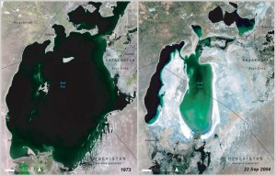

- What body of water are the above before-and-after images of?
  - Red Sea
  - Aral Sea
  - Dead Sea
  - Lake Victoria
  - Caspian Sea

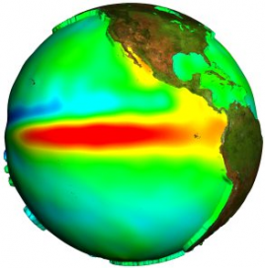
- The above satellite image depicts which phenomenon?
  - Global warming
  - El Niño
  - Depleted ozone layer
  - La Niña
  - Norman ocean currents

- Write the name of the satellite instrument which took each image DIRECTLY BELOW it (acronym is OK). Choose from the instruments listed below.

A. 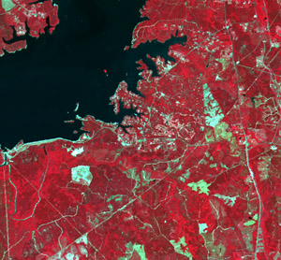 B. 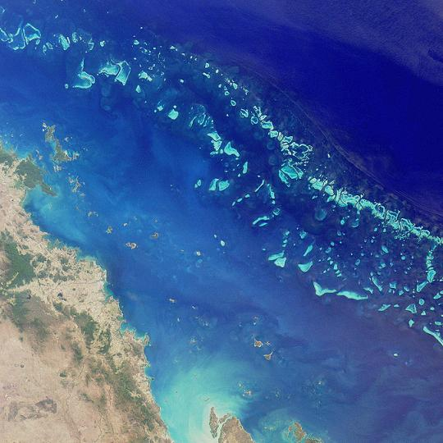 C. 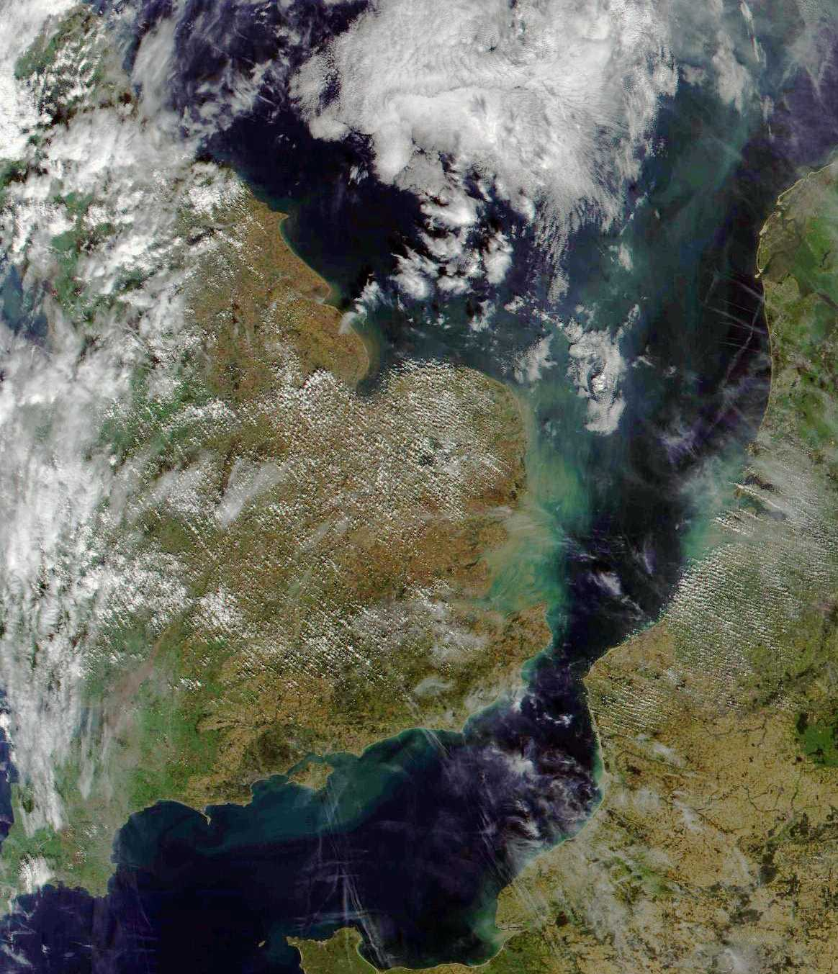

D. 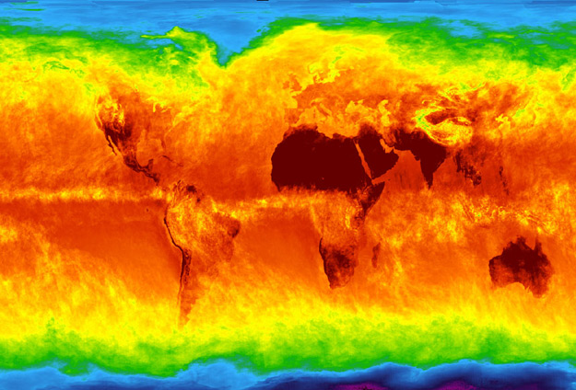 E. 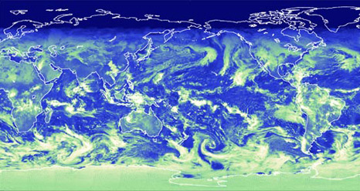

F. 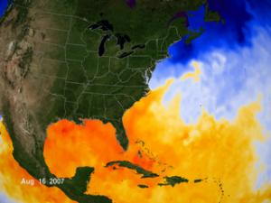
MIRS (Multi-angle Imaging SpectroRadiometer)
MODIS (Moderate Resolution Imaging Spectroradiometer)
ASTER (Advanced Spaceborne Thermal Emission and Reflection Radiometer)
AIRS (Atmospheric Infrared Sounder)
CERES (Clouds and the Earth's Radiant Energy System)
AMSR-E (Advanced Microwave Scanning Radiometer-EOS)

