SCIENCE OLYMPIAD FORESTRY
Practice Test

(.doc version)

Disclaimer/Notice

This test is based on the 2004-2005 rules. The creator of this test is not responsible for anything that happens due to not understanding that rules may change significantly for the 2011-2012 Science Olympiad season.

Please Read the Following:

- Use the corresponding answer sheet (scioly.org).
- The test is timed. For ID questions, you will have 1 minute to identify the tree and 1 minute and 45 seconds to answer questions.
- For automatic timing, use the PowerPoint version of the test.
- For other questions, you will have 15 seconds to answer one question.
- The questions on this test are based on the 2004 National Forestry Specimen List.
- This test may be very time-consuming. Make sure you have at least 20-40 minutes to complete the test although it may not take the full time given to you.
- There will be 12 ID questions and then some basic questions about trees.

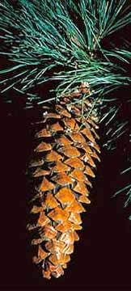

1. Identify this specimen.

A. In which states would you most likely find this tree?
- Minnesota and Wisconsin
- Vermont and Maine
- New Mexico and Arizona
- California and Oregon

B. Which statement is true about this tree?
- It is the tallest pine
- It is the only broadleaf pine tree
- It has no spreading branches
- The tree’s seed itself is larger than the wing of the seed.
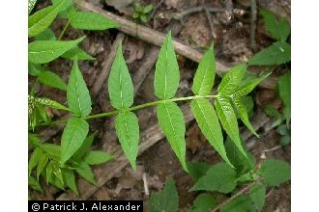

2. Identify this specimen.

A. What is this tree commonly called?
- Poison Sumac
- Tree of Heaven
- The Coffeetree
- Cantaloupe Tree

B. Which statement is true about this tree?
- It grows very slowly compared to other trees.
- It can tolerate pollution better than most trees.
- Its fruit looks similar to an apple.
- Its crown gets wider near the top.

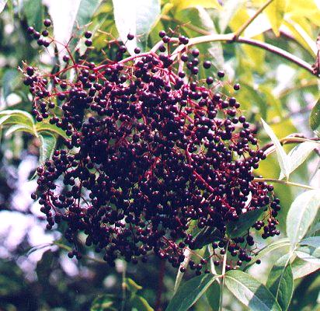

3. Identify this specimen.

A. Which photo (I, II, III, or IV) is a picture of the bark of this plant?
- Left
- Left Center
- Right Center
- Right
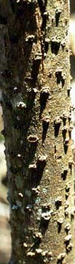
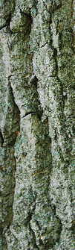
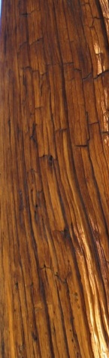
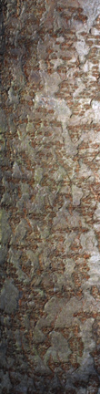

B. Which geographic region (s) is this plant native to?
- Alaska and Northwestern Canada
- Northeastern Canada
- Around the Gulf of Mexico
- The East Coast and the Midwest

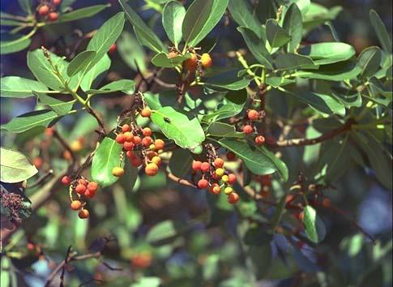

4. Identify this specimen.

A. What type of leaf arrangement does this plant have?
(a) Opposite (b) Whorled
(c) Alternate (d) Simple

B. Which of the photos (I, II, III, IV) are of this plant?
- Top Left
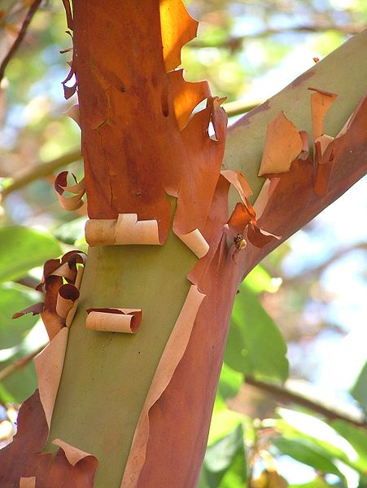
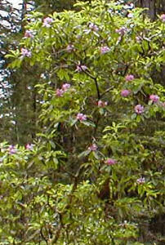
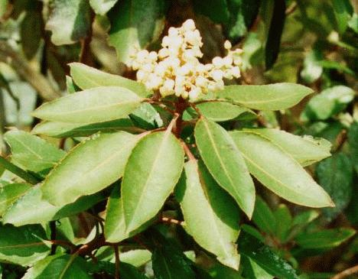
- Top Right
- Bottom Left
- Bottom Right

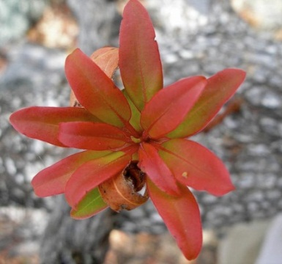

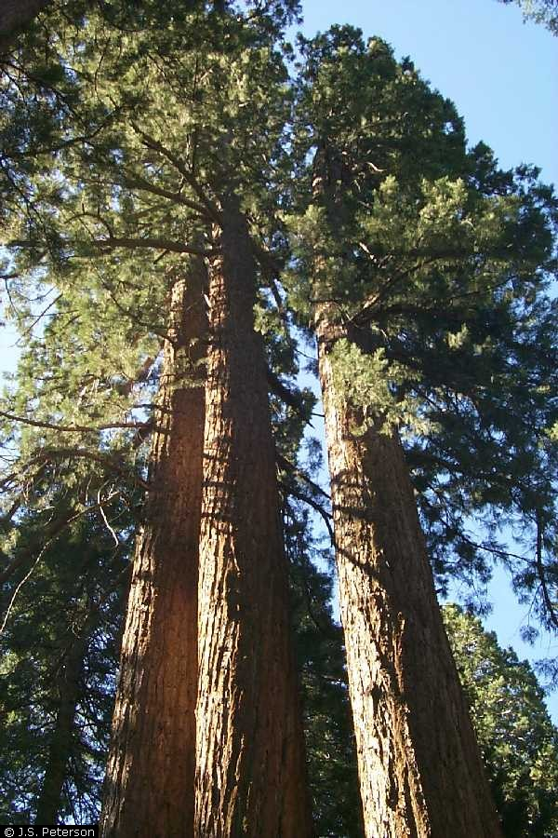
5. Identify this tree.

A. Which photo is a photo of this plant’s leaves?
- Top
- Upper Center
- Lower Center
- Bottom

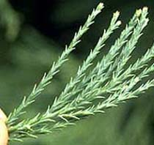

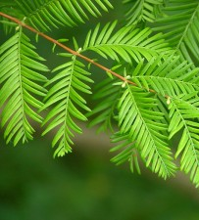

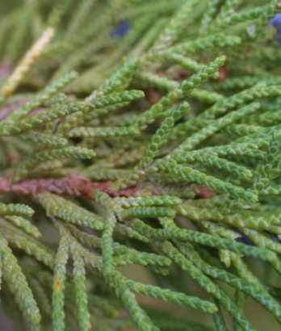
B. What family is this tree from?
- Cypress Family
- Sequoia Family
- Redwood Family
- Pine Family

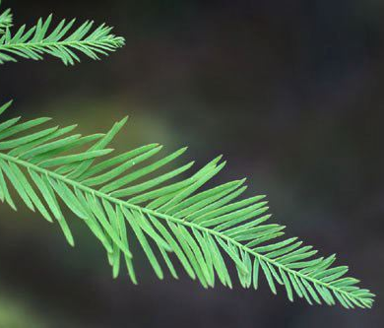
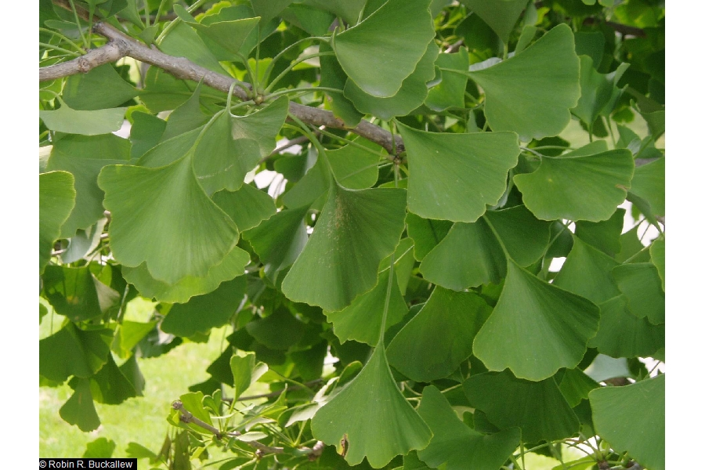
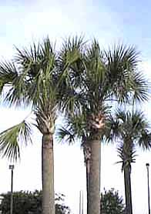

6. Identify the left side tree.

A. Where is this plant mainly found?
- California
- Virginia and Kentucky
- Lesser Antilles
- Florida

B. Which statement is true about this tree?
- Its bark smoothens with age.
- Its fruit was used to make medicine in the early ages.
- Most of the tree’s leaves fall off in the early summer.
- The tree’s is coniferous.

7. Identify the right side tree.

A. What is this plant NOT used for?
- Treating asthma and tinnitus
- Making paper
- Making tea
- Preventing Alzheimer’s Disease

B. What is the conservation status of this species?
- Extinct in the Wild
- Endangered
- Not concerned/Least concern
- Conservation dependent/Near threatened

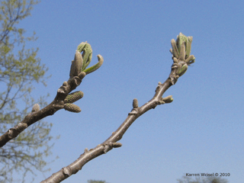
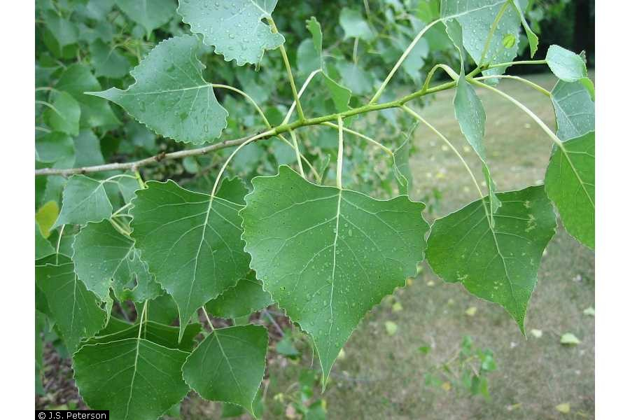

8. Identify the left side tree.

A. Where is this plant found?
- Hudson Bay
- East Coast
- Central USA
- Northwest USA and Canada

B. What problems/disadvantages are there about this tree?
- They can be seriously damaged by wood-boring insects.
- They do not provide good shade.
- Its wood is difficult to cut, split, or bend due to its hardness.
- It grows at a very slow rate.

9. Identify the right side tree.

A. What type of fruit does this plant have?
- An apple-sized purple fruit that tastes bitter.
- This plant has no fruit.
- An oblong husk with a sweet meat inside.
- A grape-sized yellow-brown fruit.

B. Which description of this plant’s leaf fits the best?
- Needles 2-5 inches long.
- Un-toothed circular leaf.
- A long egg-shaped green/yellow leaf.
- A toothed lance-shaped leaf.

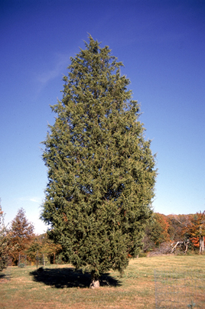
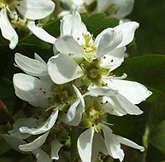

10. Identify the left side specimen.

A. Where is this plant most likely to be found?
- British Columbia
- New York
- Georgia
- Belize

B. Why are the fruits of this plant eaten by animals?
- They are rich in copper and iron.
- They are low in cholesterol.
- They provide nectar.
- They are the only thing that the animals can find.

11. Identify the right side tree.

A. What is this plant’s primary habitat?
- Near the coastline of an ocean or lake.
- Dry or rocky areas, open woods, or fields.
- Temperate rainforests in the northwest.
- Swampy and marshy areas in northern USA and Canada.

B. What type of tree is this?
- Pine
- Juniper
- Walnut
- Magnolia

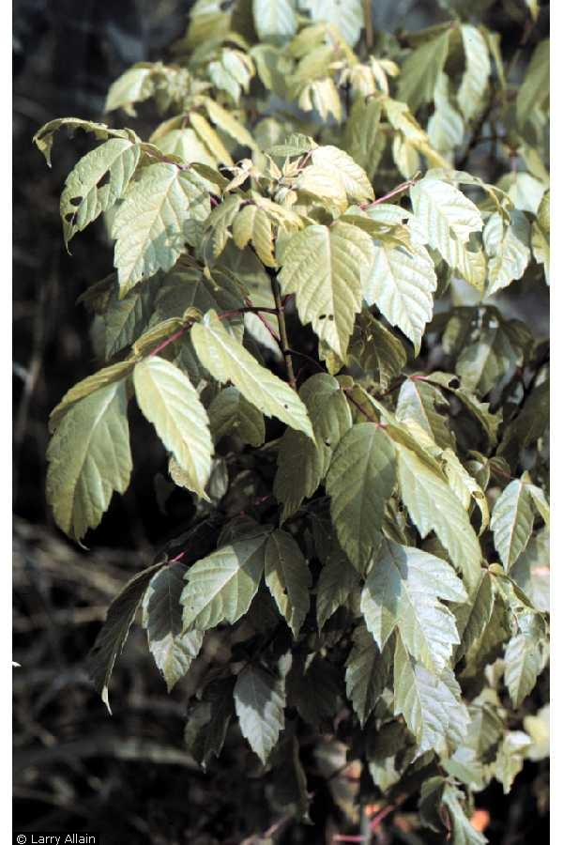
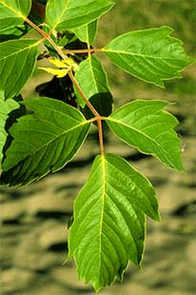

12. Identify this tree.

A. Where is this plant mainly found?
- Coniferous forests.
- Stream banks and floodplains.
- Sandy or rocky desert areas.
- Cold and dry tundra/taiga areas.

B. Name the bug that is attracted by this tree.

13. What feature in a plant cell is not normally found in an animal cell?
- Nucleus
- Deoxyribonucleic acid
- Mitochondrion
- Cell Wall

14. What does photosynthesis mainly help create?
- Light energy
- Adenosine triphosphate (ATP)
- Kinetic energy
- Nutrients in the soil

15. Which picture shows a plant with opposite leaves?
- Left
- Center
- Right
