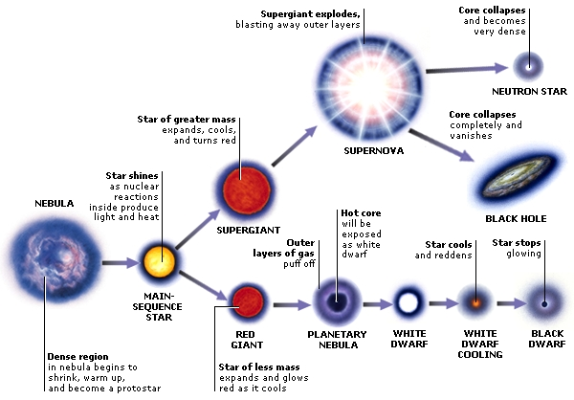
1.
2
3
4
5
6

7
8
9
10

PART 2
B. Identify on your answer sheet the stage in the life cycle of stars, using the diagram above. (1-10) B of Part 2

C. ESSAY : On your answer sheet, discus star clusters, and describe the difference between open and globular star clusters. Discuss their age and why one group can last longer than the other, size, and where they would be located on the HR Diagram. Give an example of each, two of open and one of globular from your list. ( 15 points possible) Looking for good writing!! Look at the grading rubric on cover sheet.

