Dynamic Planet- Division B

Team Number: _______________
Student Names: ______________

Team Points: ______/88
Tie-Breaker (if needed):
Final Rank:
Please read each question carefully and answer as completely as possible. Good Luck!
Earth’s Interior: (9 points total)
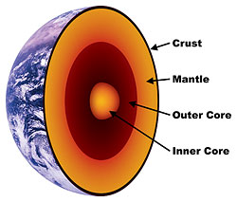
1. Draw and label the layers of the Earth (five main layers). 5 points
Notes: Moho should be labeled between the crust and the mantle

2. Which layer is the thickest? 1 point
Mantle

3. Which layer is the thinnest? 1 point
Crust (or lithosphere)

4. What two metals make up most of the inner core? 2 points
Iron and Nickel

Plate Movement and Boundaries: (23 points total)
5. What are four pieces of evidence commonly used to support the theory of continental drift? (There are more than four, but pick four that are commonly used) 4 points

4 of: fossils, rock formations or types, glacial marks, mountains, shape of continents
6. Draw and label a Convergent-Continental boundary. Make sure you label the type of plates, draw arrows to represent the direction in which they are moving, and include any common landforms/features that occur at this type of boundary. 4 points
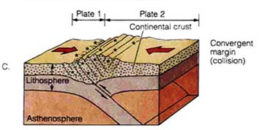

Notes: Common landforms- mountains
Common features- earthquakes

7. Draw and label a Transform-fault boundary. Make sure you label the type of plates, draw arrows to represent the direction in which they are moving, and include any common landforms/features that occur at this type of boundary. 4 points
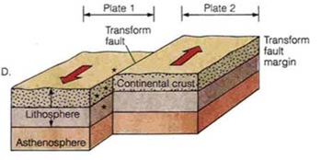
Notes: Common features- earthquakes

8. Draw and label a Convergent-Subduction boundary. Make sure you label the type of plates, draw arrows to represent the direction in which they are moving, and include any common landforms/features that occur at this type of boundary. 4 points
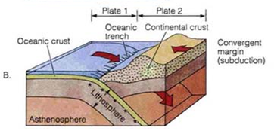
Notes: Volcano should be drawn on the continental plate at the shore line or just in the ocean

9. Draw and label a Divergent boundary. Make sure you label the type of plates, draw arrows to represent the direction in which they are moving, and include any common landforms/features that occur at this type of boundary. 4 points
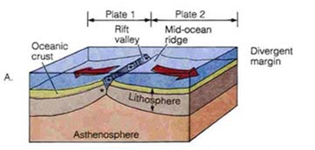
Notes: Plates can be both oceanic OR
both continental.
Rift Valley may be labeled as:
Mid-ocean ridge, rift valley, or rift zone

10. What happens within the Earth that causes the plates to move? 1 point
Convection Currents

11. What is the Ring of Fire? Where is it located? 2 points
It is the area along the edge of the Pacific plate- it is an area with many plates moving in many directions which creates much volcanic and earthquake activity

Volcanoes: (15 points)
12. What is the difference between magma and lava? 1 point
Magma- inside Earth Lava- outside/exposed to air

13. Identify which type of volcano is described in the following statements: 4 points
a.) Steep sides, usually symmetrical, large, explosive eruptions, example- Mt. St. Helens Composite volcano
b.) “Simple” volcanoes, rarely grow over 1,000 feet, single vent, example- Paricutin Cinder cone volcano
c.) Small masses of thick lava, grows mainly from within, example- Katma Volcano Lava dome
d.) Gentle slopes, broad/wide, effusive eruptions, example- Mauna Loa
Shield volcano
14. Which type of volcano usually starts underwater (at hot spots or mid-ocean ridges)? 1 point
Shield volcano
15. Identify which volcano features are described in the following statements: 5 points
a.) Natural fountains of hot water and steam that escape at regular intervals through vents on the Earth’s surface Geysers
b.) Solidified layers of lava that flowed through openings in the crust Lava plateaus
c.) Bowl shaped crater at the top of a volcano Calderas
d.) The result when (c) becomes filled with water Crater lake
e.) Lava that solidified in the pipe of a volcano and is exposed when the outside of the volcano erodes. Volcanic plug
f.) A spot where hot water that gushes from the within the Earth Hot spring

16. Identify which volcano hazards are described in the following statements: 4 points
a.) Fragments of volcanic rock less than 2mm in size Volcanic ash
b.) A mixture of gas, ash, and rock that moves quickly down the slope of a
volcano Pyroclastic flow

c.) “Mudflow” formed from volcanic materials and water that travels down the slope of a volcano Lahar
d.) Carbon Dioxide, Hydrogen Chloride, and Hydrogen Fluoride are some examples Volcanic gases

Earthquakes: (18 points total)
17. What is the difference between a seismometer and a seismogram? 1 point
Seismometer- machine that records seismograph
Seismogram- print out or record of ground shaking
18. What are S waves? How do they travel? 2 points
Secondary or Shear waves; travel in transverse pattern
19. What are P waves? How do they travel? 2 points
Primary waves; travel in compressional pattern

20. Which seismic body wave travels the fastest? 1 point
P waves

21. What is the difference between surface waves and body waves? 2 points
Surface waves- travel on the surface; body waves travel within the Earth

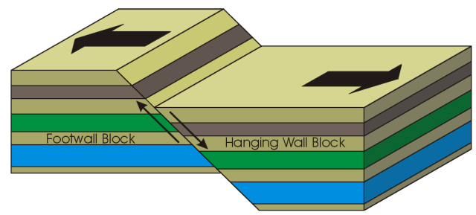
22. Identify the type of fault shown in each picture: 3 points
a.) Normal Fault

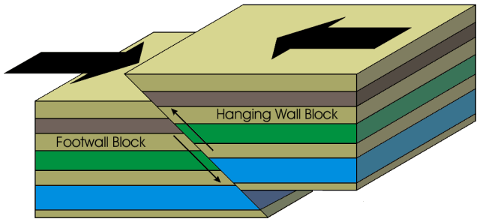
b.) Reverse Fault

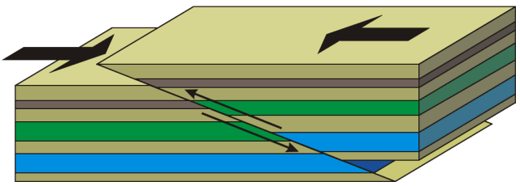
c.) Thrust Fault

23. The _____Richter___________________ scale measures the magnitude of an
earthquake, while the ____________Mercalli___________ scale measures the intensity of ground shaking and damage. 2 points

24. What is the difference between the focus (or hypocenter) and epicenter? 1 point
Focus- starting point of an earthquake, within the Earth; epicenter- spot on the surface directly above the focus
- How do scientists use seismic waves to determine the location an earthquake
began? You may use a picture to help support your written answer. 4 points

The S-P wave interval is used to determine the distance of a seismometer station from the epicenter. This data is triangulated with data from 2 other seismometer stations. For each station a circle is drawn around the location of the station- each circle has a radius equal to its distance from the epicenter. The epicenter is the spot were the 3 circles intersect

Tsunamis: (5 points total)
26. True or False: A tsunami is a tidal wave. 1 point False

27. True or False: A tsunami is a series of waves. 1 point True

28. What are the three possible causes of tsunamis? (there are more than three- you only need to identify three) 3 points
Most common- earthquake, volcano eruption, landslide
Less common (but possible)- underwater explosion, meteorite impact
Emergency Preparedness: (18 points)
29. What items should be in an emergency kit, regardless of the type of disaster possible? List at least five specific items. 5 points Any of (plus other reasonable answers)- first aid supplies, water, canned food, can opener, flashlight, batteries, medicines, copy of personal documents (id, birth certificate, etc), contact information, map, money, duct tape, blanket
30. Identify the following steps as important prior to or during an earthquake,
volcano, or both: 10 points

a.) Evacuate according to authorities Volcano
b.) Have a communication plan in place to get in touch with family members Both
c.) Use a dust mask or damp cloth to cover your mouth and nose Volcano
d.) Find a doorway or study table to stand/sit under Earthquake
e.) Wear goggles to protect your eyes Volcano
f.) Listen to a radio for emergency updates Both
g.) Drop, cover, and hold on Earthquake
h.) If you are outside, find a clear place and drop to the ground Earthquake
i.) If you are outside, get inside the nearest building Volcano
j.) Attach bookcases and other tall furniture to a wall Earthquake

31. If there is a threat of a tsunami, should you… (circle all that apply) 3 points
a.) stay in your home, regardless of its location
b.) go to the highest floor of a tall building Circle
b.) move to the highest ground in your area Circle
c.) head to the beach to watch the tsunami
e.) (if you are already out in a boat) head farther out from shore Circle
f.) (if you are already out in a boat) dock your boat in the harbor and stay there
Tie Breaker- Respond in a paragraph:
What are some of the benefits of volcanoes?
If tie-breaker is needed: one point awarded for each idea- only used to distinguish between two tied teams, does not impact total score!
- Created the atmosphere and hydrosphere
- Renews soil- makes it very fertile
- Can use the heat for geothermal energy
- Creates rich ore deposits
- Allowed us to learn about Ancient Rome (ash “froze” Pompeii)
- Generates tourism (Hawaii)

Resources:
Fault Pictures from: facweb.bhc.edu/.../GEOL101/study/structur.htm
Information on plate boundaries, earthquakes, volcanoes, and tsunamis: www.usgs.gov and http://www.tulane.edu/~sanelson/geol204/index.html
More information on volcanoes: http://library.thinkquest.org/17457/volcanoes/
Preparedness Information: American Red Cross- www.redcross.org

