**Bio Process Lab Practice Test**

*Springs Valley Ohio Invitational by Joseph Norwood*

*In this test there are 4 stations, each one lasts 3 minutes.*

**Station 1**

1. Convert 10 meters to centimeters.
2. What is 3.68 rounded to the nearest tenth?
3. How many centiliters are in a kiloliter?
4. What is the difference between mass and weight?
5. Convert 20 degrees Celsius to Fahrenheit.
6. How do you convert from Celsius to Kelvin?
7. What is the density of water?
8. Which of the following has a density of around .7?
9. Plastic B. Water C. Mercury D. Wood
10. A box has sides of length 8 cm, 9 cm, and 5 cm. What must that mass of the box be for the density to be 5?
11. Rewrite the density formula to show how to find the volume of an object given the mass or density.
12. A more porous material would be ________ than a less porous material. (A. less dense, B. more dense)
13. What is the volume of a cube with side length 8?
14. Write a formula for the volume of a tetrahedron.

**Station 2**

*Michael is doing an experiment on the effects of soda on 100 meter dash times. He uses 50 adults for this study. 10 minutes before running, 10 drink no soda, 10 drink half a can, 10 drink 1 can, 10 drink 2 cans, and 10 drink 3 cans. He records the average 100 meter dash time for each group.*

1. What is the independent variable in this case?
2. What is the dependent variable in this case?
3. What would be an example of a hypothesis for this experiment?
4. Sketch a line graph that would prove the hypothesis you stated for number 3.
5. Sketch a line graph that would disprove the hypothesis you stated for number 3.
6. Identify 3 controlled variables in this case.
7. Name 3 ways to make the results more reliable.

**Station 3**

1. How do you accurately read the measure on a beaker?
2. What is the seemingly curved part of the water in the beaker called?
3. Why is it curved (explain #2)?
4. Accurately read the following:

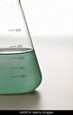

1. How do you measure the mass of a liquid with only a scale, an empty bucket, and a scale with the liquid inside?
2. What is the scientific term for this device, often used in laboratories?

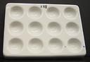

1. What is the pH of water?
2. What does a pH reading of 1 mean? What would the color of the paper look like?
3. What does a pH reading of 12 mean? What would the color of the paper look like?
4. How do you find the pH of a substance using pH paper?
5. How do you accurately use an eyedropper?

**Station 4**

*Answer the following questions using the food label.*

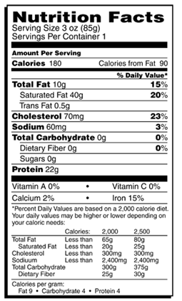

1. What percent of the calories in the substance come from fat?
2. Re-evaluate the percents for the following if the person was following a 2500 calorie diet:
3. Total Fat
4. Saturated Fat
5. Cholestorol
6. Sodium
7. Carbohydrates
8. Dietary Fiber
9. Name 5 foods rich in protein.
10. Name 5 foods rich in fiber.
11. How many servings are in the container?
12. How many calories in this meal come from protein?
13. Judging by the food label, what food is this most likely? Explain your answer.
14. What are the good and bad nutritional parts of this food?