2017-18 SSCS

SCIENCE OLYMPIAD INVITATIONALS

MICROBE MISSION

ANSWER KEY

**Part I: Fill in the blank- write the correct word/phrase on your answer sheet**

1. Proteins
2. Light compound microscope
   1. Purple
   2. Peptidoglycan
   3. Red
3. Upper right
   1. Photoautotrophic
   2. Chemoautotrophic
   3. Lag phase
   4. Exponential growth phase
   5. Stationary phase
   6. Death phase
4. Stereo microscopes
   1. Proteobacteria
   2. Cyanobacteria
5. Golgi apparatus
6. 1. Object magnification
   2. Ocular magnification
7. 1. DNA
   2. Cytoplasm
   3. Cell membrane
   4. Ribosomes
8. 1. Fungi
   2. Cellulose
9. 1. Bacteriophages
   2. Virophages
10. 1. Coccus
    2. Bacillus
    3. Spirillum
11. 1. Lytic
    2. Lysogenic
12. Bacteria
13. 1. Streptococcus
    2. Staphylococcus
    3. Positive
14. Pasteurization
15. Prokaryotes
16. Vectors

**Part II: Diseases- write the corresponding letter on your answer sheet**

**B= bacterial V= viral F= fungal P=protozoan**

1. V
2. B
3. V
4. B
5. F
6. P
7. F
8. V
9. B
10. P
11. F
12. V
13. B
14. V
15. B

**Part III: Labeling- write the correct part of the microscope and its function on your answer sheet**

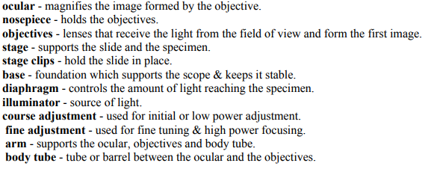

7

2

3

9

4

12

5

6

10

11

8

1