Anatomy and Physiology
2010

By:
ktrujillo52

Skeletal System:

- What type of ossification (intramembranous or endochondreal) does not require cartilage for bone formation?

- What are the 6 types of joints?

- Describe each type of Cartilage and give 1 location for where it may be found

Hyaline-

Fibrocartilage-

Elastic-

- List 4 Characteristics of Cartilage

- Where are red blood cells produced?

True or False

- As you become older, red bone marrow is replaced with yellow bone marrow to store fat.
- Hematopoiesis is the production of bones
- There are 204 bones in the human body

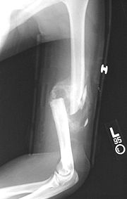
Use the following image to answer questions 9-11

- What type of fracture is this?

- What bone is fractured?

- What joint(s) is/are visible in this x ray?

- Describe the fracture repair process

Use the following image to answer question 13

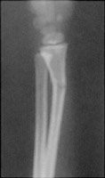
- What kind of fracture is this?

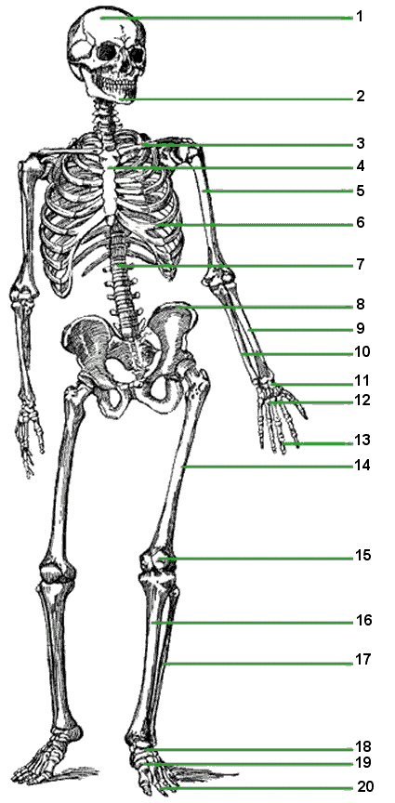
Label
- How many bones are there in the axial skeleton?

- How many bones are there in the appendicular skeleton?

- Draw a long bone and label the epiphysis, metaphysis, diaphysis, compact bone, spongy bone, periosteum, and endosteum.

- Describe the functions of each type of cell

Osteocyte-

Osteoblast-

Osteoclast-

Osteogenic cell-

Bone lining cells-

- The spinal cord consists of individual vertebrae. Are Cervical, Thoracic,and Lumbar. The vertebrae has transverse foramina present, while the vertebrae has rib facets.

- What are the functions of the skeletal system?

- What are the 5 types of bones?

Label

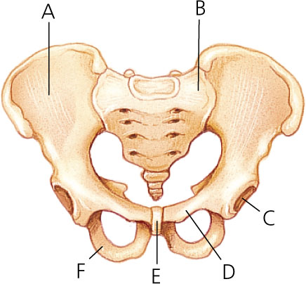

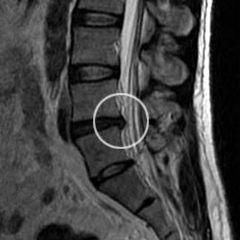

42.Is this an x ray, MRI, or CT scan?

43.What does C T scan stand for?

44.What type of injury is this?

45.How does this injury cause pain?

- In the following image, which ligament has been sprained?

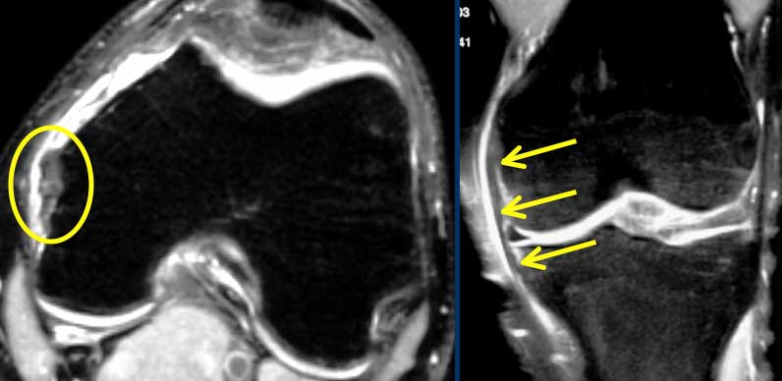
Muscular System

- Please list the functions of the muscular system:

- Describe each characteristic of muscle tissue:

Excitibility-

Contractility-

Extensibility-

Elasticity-

- What type of muscle cell is the following picture of? Skeletal, cardiac, or smooth?
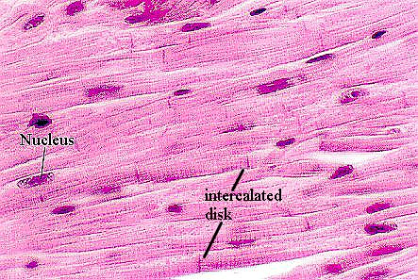

- What are intercalated discs?

- What are striations caused by? In which type(s) of muscle cells are striations present?

- Draw and label a sarcomere

- Define the following terms:

Origin-

Insertion-

- Explain how a muscle contracts. Start with explaining the neuromuscular junction and the neural stimulus and follow to the contraction of a sarcomere.

- Muscles relax when Acetylcholine is broken down by what enzyme?

- Describe each type of injury:

Sprain-

Cramp-

Strain-

- What percent of body heat is produced by muscles?

True or False

- Muscles are connected to bones by Tendons

59. Label
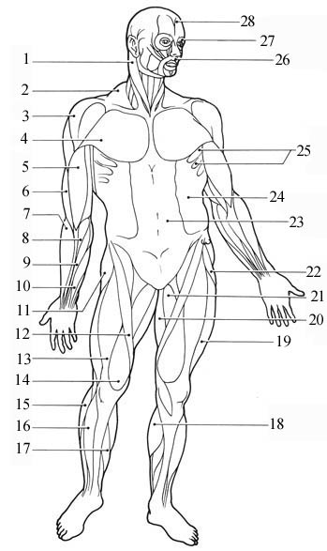

- Label
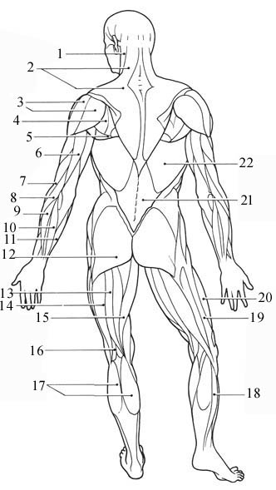

- Which of the following is not one of the 3 ways in which muscles can produce ATP?
A. From creatine phosphate-unique to muscle tissue
B. Anaerobic cellular respiration using glycogen
C. Aerobic cellular respiration using glycogen, fatty acids, and amino acids
D. They all result in production of ATP

Endocrine System

59. Label:

- Why can steroids diffuse through the plasma membrane, unlike amines/proteins? Describe in terms of structure and permeability of a plasma membrane.

61.Define the following terms:
Hypersecretion-
Hyposecretion-

62. Name a disorder that is a result of Hypersecretion

63. Name a disorder that is a result of Hyposecretion

Meet Mr. Wadlow, male with a height of 8'11''. Mr. Wadlow happens to be the world record holder for the tallest man to ever live.

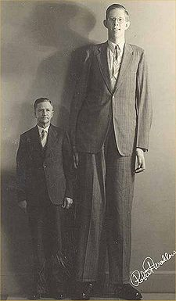
- What hormone causes gigantism?

- What gland secretes this hormone?

- What gland controls other glands?
A. Hypothalamus B. Pituitary
    - Thyroid D. Thymus

- Describe how amine/protein hormones affect their target cell

- Describe how steroid hormones affect their target cell

- What is another name for the posterior pituitary gland?
A.Neurohypophysis B.Postneurotuitary
C. Adenohypophysis D. Hypothalamus

- What is another name for the anterior pituitary gland?
A. Neurohypophysis B. Anteneuropituitary
C. Adenohypophysis D. Anterior Hypothalamus

- What type of hormones are produced by the anterior pituitary gland and target other endocrine glands?
A. Tropic B. Polyurethane
C.Julimonis D. Testicles

- What controls the release of said hormones?

Extra Credit!!!!!!!!!!!!!!

What is the difference between Osteogenic cells and Osteoprogenitor cells?!!?

YOU ARE DONE =D

