Science Olympiad Ladera Vista Names __________________________

Invitational Team # ______

Road Scholar Test School Name _____________________

December 10th, 2016

1. 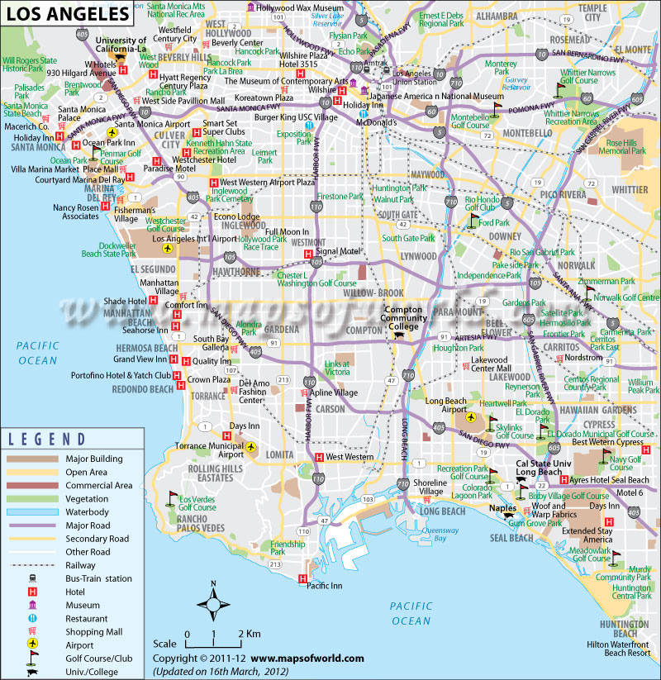Refer to the map section below for questions #1-8.
2. The city of Montebello is bounded by which four freeways? (freeway numbers ONLY please) _______________________
3. Which geographical direction would you follow to fly from Long Beach Airport to Los Angeles International Airport? ______________
4. In a straight line, how many km is it from Lakewood Center Mall to Burger King USC Village? ________
5. What is the name of the closest hotel to Meadowlark Golf Course in Huntington Beach? ______________
6. What is the South Bay Galleria near Gardena? ______________________________________________
7. What is the shortest freeway distance, in km, from the Signal Motel in Westmont to the Hollywood Wax Museum? __________
8. What is the first college you pass while traveling in a northeasterly direction from Rolling Hills Estates? _______________________________________________
9. How many km would you travel if you sailed on a boat from the Pacific Inn to the Huntington Beach Hilton Waterfront Beach Resort? ________________________
10. Refer to the topographic map section below for questions #9-11. In the space below the map, draw a topographic profile of the island terrain, using the A – A’ as a reference for the profile. Include axes for horizontal distance and elevation on the profile.
11. 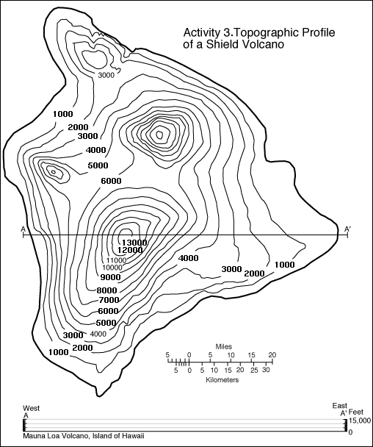How many km are there between points A and A’ on the map? __________________
12. There are four high points on the island. If you walked from the top of each high point to the next, in a straight line between high points, and making a four-sided path that roughly resembles a diamond-shape, how far in miles would you walk? ________________
13. In the previous question, how much TOTAL elevation, in feet, would you gain during your walk across all four high points? ____________
14. Refer to the stream profile below for questions #12-16.

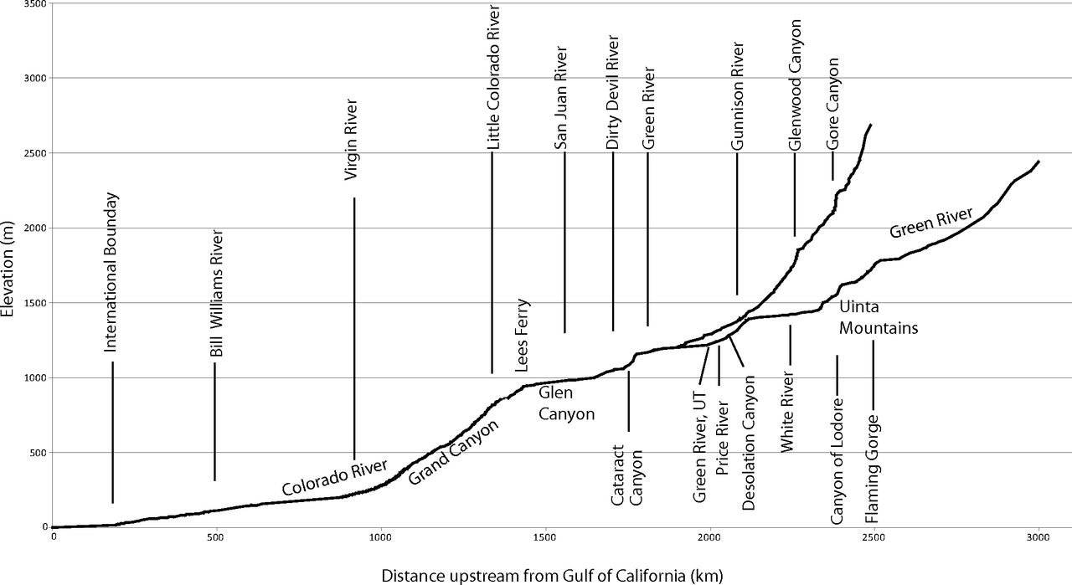

1. What is the APPROXIMATE stream gradient between the San Juan River in Glen Canyon and the International Boundary? Express your answer in terms of thousands of meters per hundreds of km. _______________________________
2. Between which two points does the Colorado River stream gradient seem to be the CLOSEST to vertical? The points must be adjacent to one another. _________________________________________________
3. APPROXIMATELY how far from the end of the Colorado River is the junction of the Colorado and the Green River? Answer in terms of km. _____________________________
4. The Colorado River drains into what body of water? ___________________________________________
5. The upper part of the Colorado River, closer to its origin, seems to be higher than the Uinta Mountains. How can a river flow higher than mountains? _________________________________________________
6. A contour interval indicates the distance between what two map symbols? _________________________
7. Magnetic declination indicates the difference between which measurements? _____________________________________________________________________
8. True or false: a date on a map is an irrelevant piece of information. ______________
9. True or false: a compass rose should always be decorative as a tribute to original maps of centuries ago. ___________
10. True or false: for any given point on the surface of the Earth, magnetic declination can change, as the Magnetic Pole of the Earth moves from

place to place over time. __________

1. Refer to the image below for questions #22-27.

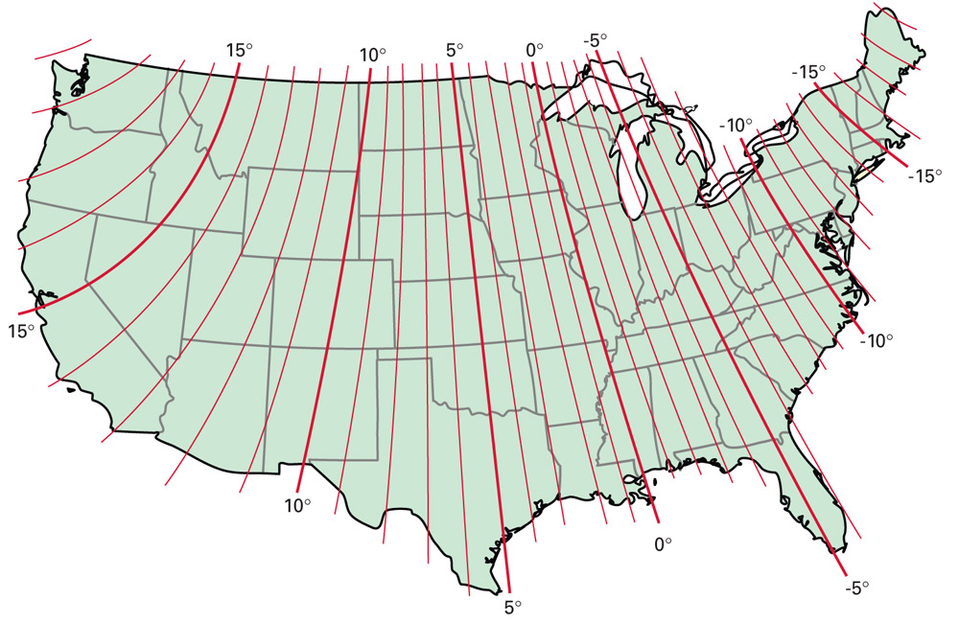

1. The magnetic declination near San Francisco, CA, is about __________________degrees.
2. The magnetic declination for central New Mexico is about __________ degreees.
3. Name three states that have, in part, a magnetic declaration of zero degrees.

______________________________________________________________

1. Knowledge of magnetic declination is VERY useful to __________
2. pilots
3. sailors
4. hikers
5. bakers
6. all of the above
7. a, b, and c, but not d
8. b, c, and d but not a
9. In the space below, name AND draw five STANDARD and useful map symbols.

TIE BREAKERS!!

1. Describe the purpose of a Public Land Survey System (PLSS).
2. What are two other names for a survey control marker?
3. What is the difference between elevation and altitude?