**Water Quality**

By: silentsage

**Section 1: Ecology (1pt. ea. for multiple choice, 2 for word problems)**

1. Biotic factors:
   1. Rock, Tree, Fish
   2. Fish, Insect, Algae
   3. Cow, Rock, Human
   4. Plant, Grass, Water
2. Commensalism:
   1. Barnacles on a whale
   2. Algae eaten by scrapers
   3. A lonely nekton
   4. Cow eating grass
3. Smallest ecological unit:
   1. Community
   2. Ecosystem
   3. Individual
   4. Biosphere
4. Interacting Biotic and Abiotic factors in a region:
   1. Ecosystem
   2. Habitat
   3. Biome
   4. Niche
5. The progression of pollution through an ecosystem is _________________
6. [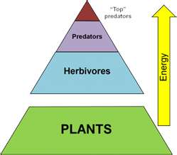](http://www.bing.com/images/search?q=trophic+pyramid&view=detail&id=B5398EAC50536379640EFEDE1A31D97F33D087D7&first=0&qpvt=trophic+pyramid&FORM=IDFRIR)In Fig. 1, if the plants contain 12, 420 J of energy, how much of that energy is contained within the predators? (to the nearest tenth)
7. In Fig. 1, if the predators were to be removed, what would happen to the population of the plants?
8. What is the trophic level of each organism?

Top predators-

Fig. 1

Predators-

Herbivores-

Plants-

**Section 2: Macroinvertebrates (2pts. ea. For identification, 1 for class)**

[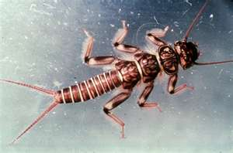](http://www.bing.com/images/search?q=stonefly&view=detail&id=7939ECA781FBAAE09CE94C7DF0880C8FD27C43B6&first=0&FORM=IDFRIR)1.

[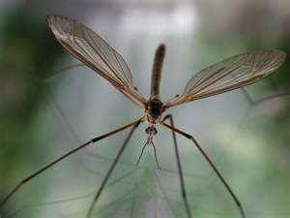](http://www.bing.com/images/search?q=cranefly&view=detail&id=185D666DA83F61F169BB5054911914AFD845BB38&first=0&FORM=IDFRIR)

2.

[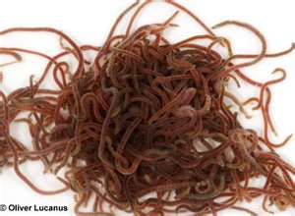](http://www.bing.com/images/search?q=tubifex&view=detail&id=342ABFE9D46D6E1B71B135DCC8F4625528C14EA3&first=0&FORM=IDFRIR)

3.

[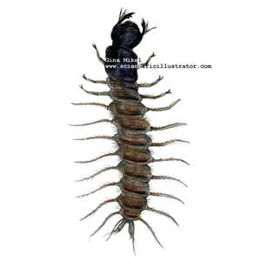](http://www.bing.com/images/search?q=dobsonfly&view=detail&id=DB8235DC9D8D8697B142FE75201E4035D146BE44&first=0&FORM=IDFRIR)

4.

[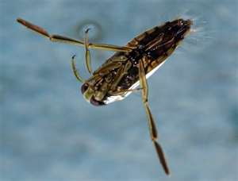](http://www.bing.com/images/search?q=backswimmer&view=detail&id=4058C7DBFAD822FBA04E85E4F7B58527E2B10BD6&first=0&FORM=IDFRIR)5.

[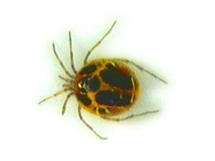](http://www.bing.com/images/search?q=water+mite&view=detail&id=E85206406F8D30D523DCCBBF7ACE37B033100E32&first=0&FORM=IDFRIR)

6.

[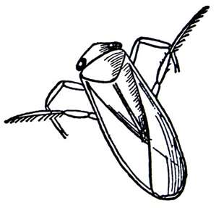](http://www.bing.com/images/search?q=water+boatman&view=detail&id=748AA2B8B25E0F87E3B7EBDF32E393F9D12D8F3C&first=0&FORM=IDFRIR)7.

[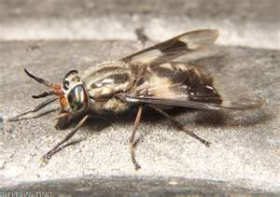](http://www.bing.com/images/search?q=deer+fly&view=detail&id=5060F647AC68B54468075552C67BEC8DD8DB1435&first=0&FORM=IDFRIR)8.

**Section 3: Analysis (1 pt. ea)**

1. DO is dangerous at over what percentage?
2. What disease common in infants is caused by excess nitrates?
3. What does fecal coliform indicate in water?
4. What sewage treatment involves sludge tanks and anaerobic digestion?
5. ph is what?
6. What temperature has a higher oxygen concentration: 18 degrees C or 6 degrees C
7. Nitrates and Phosphates cause what aging process in water environments?
8. Water is densest at what temperature?
9. Total dissolved solids affect what measurement of visibility?
10. What is the unit that the above (answer to 9) is measured in?
11. What is the weighing factor of DO?
12. Alkalinity is the conversion of what substance into toxic forms?
13. Salt concentrations are measured in what unit?
14. Water Quality standards are set by what governmental entity?
15. BOD stands for what?