ENVIRONMENTAL CHEMISTRY
INVITATIONAL EXAM

PATRICK O’NEILL, JAN 2010
peoneill@indiana.edu

SCHOOL NAME: TEAM NO.:
STUDENT NAMES:

Atomic # | Symbol | Element | Atomic Mass
1 | H | Hydrogen | 1.0
6 | C | Carbon | 12.0
7 | N | Nitrogen | 14.0
8 | O | Oxygen | 16.0
11 | Na | Sodium | 23.0
12 | Mg | Magnesium | 24.3
15 | P | Phosphorus | 31.0
16 | S | Sulfur | 32.1
17 | Cl | Chlorine | 35.5
19 | K | Potassium | 39.1
20 | Ca | Calcium | 40.1
29 | Cu | Copper | 63.5

I. SOIL COMPOSITION

Use the following answer choices for this section:

A) Sand B) Silt C) Clay D) Loam

1) A combination of the other three main soil types

2) The most coarse soil type

3) Heaving may occur as a result of freezing and thawing, pushing plants out of the soil

4) Individual particles can only be seen with an electron microscope

5) Composed primarily of quartz and feldspar

6) Has a porosity between 0.51 and 0.58.

SHORT ANSWER

7) Red soil usually derives its color from the presence of a high concentration of this element.

8) An aeolian sediment formed by the accumulation of wind-blown silt and lesser and variable amounts of sand and clay and depicted here:
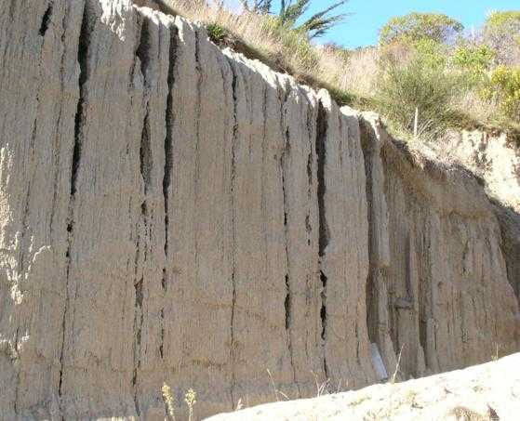

9) The transport of soil material from upper layers of soil to lower levels by downward precipitation of water across soil horizons.

10) The typical soil of coniferous forests, poor for farming, more acidic than usual, possesses an “E horizon” between the A and B horizons.

11) The most highly decomposed of all organic soil material. Has the least amount of plant fiber, the highest bulk density, and the lowest water content at saturation compare to other organic soil materials.

12) These soils form in semi-arid to moist areas and result from weathering processes that leach clay minerals and other constituents out of the surface layer and into the subsoil, where they can hold and supply moisture and nutrients to plants. They formed primarily under forest or mixed vegetative cover and are productive for most crops.
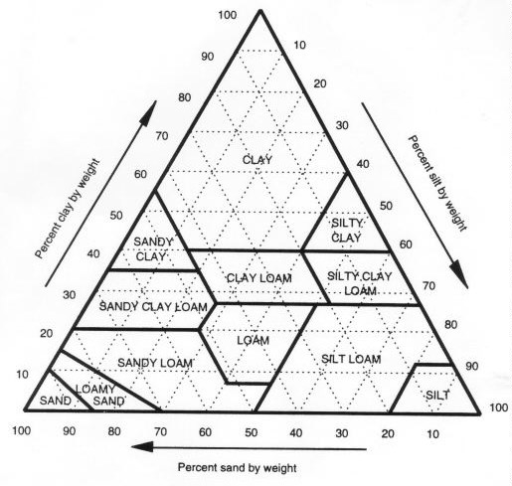
13) What is the percentage of clay, silt, and sand in soil sample A? (2pts)
SOIL SAMPLE A
SOIL SAMPLE B
14) What is the percentage of clay, silt, and sand in soil sample B? (2pts)
15) A soil sample that is 60% clay, 20% silt, and 20% sand would be classified as…?
16) A soil sample that is 30% clay and 70% sand would be classified as…?

II. SOIL TESTING and SOIL POLLUTION

17. To determine the porosity of a soil sample, a volume of 200. cubic centimeters of soil has 200mL of water added to it and it allowed to settle. Excess water is poured off from the top of the soil and measured to be 106mL. What is the porosity of the soil sample? (3pts)

18. If I have an initial solution with a concentration of 40.ppm, how much of this solution would I need to mix with water in order to make a solution of 12ppm with a volume of 1.0L? (3pts)

Use the following answer choices for questions 19-23:

A) Heavy Metals
B) Pesticides
C) Solvents

19. Benzene

20. DDT

21. Mercury

22. Organophosphates

23. The most mobile of the above groups; often create a health hazard by draining into groundwater.

Use the following answer choices for questions 24-30:

A) Heavy Metals
B) Excessive Fertilization
C) Volatile Organic Compounds (VOCs)
D) Persistent Organic Pollutants (POPs)
E) Radioactive Contamination

24. Virtually impossible to remediate

25. Capable of long-range transport to contaminate sites distant from the source

26. Bioaccumulates in human and animal tissues

27. May cause eutrophication in nearby bodies of water

28. “Total BTEX” is the measure used to assess how seriously a site is contaminated by this

29. Will never decay on its own

30. May cause blue baby syndrome

III. PLANT NUTRIENTS

Answer questions 31-40 about plant nutrients.

31. Which of the following is a primary nutrient?
A. Helium B. Oxygen C. Potassium D. Silicon E. Calcium

32. Which of the following is a macronutrient?
A. Iron B. Silicon C. Magnesium D. Manganese E. Chlorine

33. Which of the following is NOT needed by plants?
A. Boron B. Copper C. Nickel D. Chromium E. Molybdenum

34. Which element plays an important role in aiding plant growth hormones?
A. Nickel B. Chromium C. Copper D. Zinc E. Chlorine

35. There is some debate as to whether or not there are 16 or 17 essential plant nutrients because of…
A. Silicon B. Phosphorus C. Chlorine D. Molybdenum E. Vanadium

36. A deficiency of which macronutrient may result in the purpling of leaves?
A. Nitrogen B. Phosphorus C. Potassium D. Zinc E. Nickel

37. Which of the following is least likely to be sufficiently available in an acidic soil?
A. Nitrogen B. Phosphorus C. Potassium D. Zinc E. Nickel

38. Acid rain commonly discharges a great deal of this nutrient:
A. Hydrogen B. Chlorine C. Nitrogen D. Phosphorus E. Sulfur

39. Excess will yield all leaf and stem growth, with little fruit, and darkened foliage that is more vulnerable to insect attack than usual.
A. Iron B. Potassium C. Nitrogen D. Phosphorus E. Sulfur

40. Excess is well tolerated by the plant, although it is likely to interfere with calcium (and possibly potassium) uptake.
A. Iron B. Magnesium C. Nitrogen D. Sulfur E. Nickel
Answer questions 41-45 about the nitrogen cycle. They are worth 2 points each.

41) Nitrogen fixation occurs due to a symbiotic relationship between bacteria and…

A) True Grasses (Poaceae)
B) Legumes (Fabaceae)
C) Crucifers (Brassicaceae)
D) Nightshades (Solanaceae)
E) Sedges (Juncaceae)

42) Nitrogen fixation can also occur due to lightning. What reaction is occurring?

A) N₂ + O₂ → NO₃
B) N₂ + O₂ → NO₂
C) N₂ + O₂ → NO
D) NH₄ + O₂ → NO₂ + H₂O
E) NH₃ + O₂ → NO₂ + H₂O

43) Nitrification refers to…

A) The oxidation of ammonia to nitrate
B) The reduction of ammonia to nitrate
C) The oxidation of nitrate to ammonia
D) The reduction of nitrate to ammonia
E) The reduction of ammonia to nitrite

44) Which of the following is NOT true of mineralization?

A) Requires glu dehydrogenase (GDH)
B) Is the major source of nitrogen available in the soil
C) Primarily conducted by bacteria and fungi
D) Creates inorganic nitrogen sources from organic ones
E) Results in the release of free nitrate ions into the soil

45) The biological process that directly converts nitrite and ammonium into dinitrogen gas is…
A) Ammonification
B) Mineralization
C) Anammox
D) Nitrogen Fixation
E) Aromatization
Answer questions 46-48 about fertilizer.

46. If 20-10-5 fertilizer is applied at a rate of 100.kg/acre, what mass of each of the three primary nutrients is delivered to the soil? (3pts)

47. A farmer needs to apply 100.kg/acre fertilizer to his field but receives his fertilizer in pounds and has no access to a metric scale. How many lbs/acre should the farmer apply? (1kg = 2.20lbs) (2pts)

48. How many atoms of phosphorus are present in 50.lbs of 10-10-10 fertilizer? (5pts)

IV. REMEDIATION TECHNIQUES

49. Briefly describe how LTTD (aka “soil roasting” or “thermal stripping”) works. (4pts)

50. What type of pollutants are targeted by LTTD? (4pts)

51. What does LTTD stand for? (1pt)

Use the following answer choices for questions 52-57:

A. Aeration
B. Electrochemical Remediation
C. Phytoremediation
D. In Situ Oxidation
E. Solidification and Stabilization

52. Falling out of favorability due to the CO₂ emissions from the large amount of concrete it requires.

53. Only applicable to heavy metal pollution.

54. May result in significant air pollution.

55. The most widespread remediation technique for managing heavy metals, with numerous successful endeavors.

56. There is some risk that this technique will not provide a permanent solution and that groundwater may become contaminated if the technique is unsuccessful or cannot be sustained over time.

57. The injection of chemicals as hydrogen peroxide, ozone gas, potassium permanganate or persulfates is used.

V. Gas Chromatography / Mass Spectroscopy
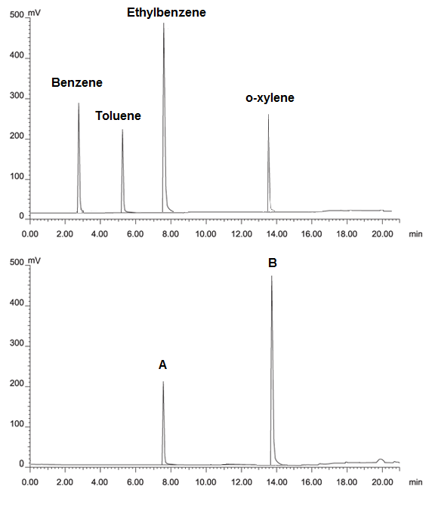
GC #1: Known mixture

Column: 004-CW 30m x 42mm I.D.x1.0µm
Temperature: 50°C
Detection: FID, 250°C
Injector: 250°C
Carrier Gas: He 40.0cm/sec

GC #2: Unknown mixture

58. What is the retention time of toluene? (2pts)
59. What is the maximum signal intensity of peak A (see lower graph)? (2pts)
60. What is the identity of peak A? (2pts)
61. What is the identity of peak B? (2pts)
62. What does it mean that peak B and ethylbenzene have the same height? (2pts)
63. What was the length of the column used for this analysis? (2pts)
64. What feature of this column is 1.0µm? (2pts)
65. What detection method was used with this analysis? (2pts)
66. What is the most important characteristic of a carrier gas to make it appropriate for this analysis (hint: think about the detector). (2pts)
67. Why are the units of the y-axis mV? (2pts)
For #s 68 -72 use the following answer choices:
A. All retention times would increase
B. All retention times would decrease
C. All signal intensities would increase
D. All signal intensities would decrease
E. Some retention times would increase, some retention times would decrease

68. A longer column is used.
69. A higher temperature is used.
70. The carrier gas is sped to a higher velocity.
71. A thinner column is used.
72. A different carrier gas is used.

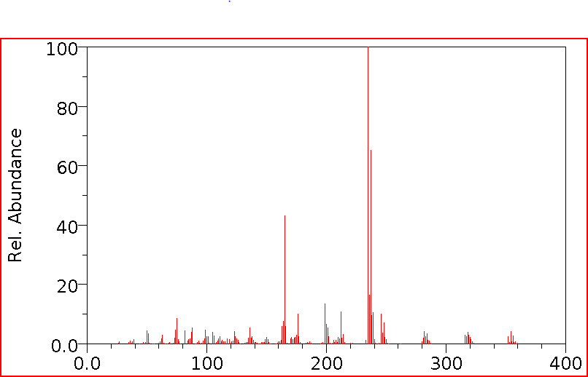
73. The mass spectrograph above is most plausibly of… (2pts)
A. Carbon B. Carbon Dioxide C. Octane D. Petroleum E. DDT

74. What does the term “molecular peak” mean? (3pts)

75. Do you believe the molecular peak is present in the above spectrogram? Why or why not? (5pts)

