Name: _____________________________

School: _____________________________

Team Number: _____________________________

2017-18 SSCS

SCIENCE OLYMPIAD INVITATIONALS

MICROBE MISSION TEST

**Part I: Fill in the blank- write the correct word/phrase on your answer sheet**

1. Prions are infectious __________ that are responsible for a class of diseases known as the Transmissible Spongiform Encephalopathies.
2. The ___________ is the most commonly used microscope.
3. Gram-positive bacteria are stained __________ and have a thick wall of __________. Gram-negative bacteria are stained __________.
4. An organism viewed under a microscope appears to be moving to the lower left. The organism is actually moving to the __________.
5. Bacteria may be **__________**, where they utilize photosynthesis to produce food and oxygen. They may also be __________, where they make food using the energy from chemical reactions.
6. The four phases of a microbial growth curve are__________, __________, __________, and __________.
7. __________ microscopes provide 3-D views of the specimen and are highly useful in observing opaque objects.
8. The endosymbiotic theory holds that mitochondria and chloroplasts in eukaryotic cells originated specifically from __________ and __________, respectively.
9. In a cell, the __________ is responsible for the final modification of proteins and packing them into vesicles to be secreted.
10. To calculate the total magnification under a microscope, you should multiply the __________ by the ___________.
11. The organelles that are present in both eukaryotes and prokaryotes are the __________, __________, __________, and __________.
12. __________ have cell walls composed of chitin, while plants have cell walls composed of ___________.
13. __________ are viruses that infect bacteria, and ___________ are viruses that infect other viruses.
14. Bacteria come in three shapes: __________, __________, and __________.
15. The two types of infections that viruses can cause are __________ and __________.
16. This type of microbe is capable of nitrogen fixation: __________.
17. __________ bacteria are found in chains and __________ bacteria found in grape-like clusters. Both are gram-__________ bacteria.
18. __________ is a process that kills microbes in foods and liquids- such as milk- by heating them to specific temperatures.
19. Between viruses, proteins, eukaryotes, and prokaryotes, __________ are the second largest in size.
20. ___________ are living organisms that can transmit infectious diseases.

**Part II: Diseases- write the corresponding letter on your answer sheet**

**B= bacterial V= viral F= fungal P=protozoan**

1. Measles ­- _________
2. Cholera - _________
3. Norovirus- _________
4. Anthrax- _________
5. Athlete’s foot- _________
6. Giardiasis- _________
7. Thrush- _________
8. Polio- _________
9. Strep throat- _________
10. Malaria- _________
11. Histoplasmosis- _________
12. Yellow Fever- _________
13. Pertussis- _________
14. Zika- _________
15. MRSA- _________

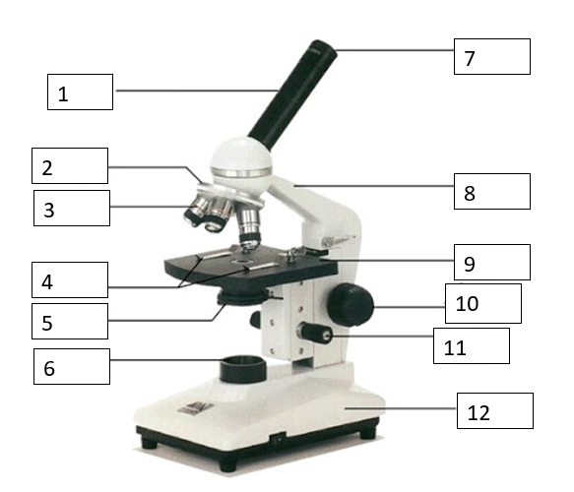**Part III: Labeling- write the correct part of the microscope and its function on your answer sheet**