Remote Sensing (C)
Nebraska Science Olympiad
Regional Competition
Henry Doorly Zoo
Saturday, February 27th 2010

96 points total

Please answer all questions with complete sentences with the exception of problems 2, 4, 9, 14 & 16.

- Radar imagery is a common tool used by scientists, foresters, and other relevant policymakers involved in monitoring deforestation. Why would images from radar be more useful in monitoring short-term changes in deforestation over traditional satellite sensors using reflectance in the visible and infrared wavebands (i.e. LandSat, MODIS)? (6pts)

- The Normalized Difference Vegetation Index (NDVI) is used as a measure of identifying vegetation. Table 1 is a numeric grid containing values determined by NDVI. Circle four major land cover types on the image, identify what major cover types (i.e. vegetation, soil, etc.) are in each group, and indicate the approximate NDVI value for that land cover type. (HINT: groups may be nested inside another group.) (6pts)

Table 1: NDVI values: Values in table are close to land cover types identified in Holben, 1986
0.712 | 0.723 | 0.813 | 0.726 | 0.626 | 0.771 | 0.783
0.752 | 0.794 | 0.783 | 0.679 | 0.006 | 0.637 | 0.723
0.717 | 0.753 | 0.681 | 0.003 | 0.002 | 0.643 | 0.779
0.756 | 0.724 | 0.005 | 0.001 | 0.005 | 0.064 | 0.670
0.743 | 0.797 | 0.681 | 0.002 | 0.005 | 0.653 | 0.789
0.783 | 0.800 | 0.750 | 0.630 | 0.681 | 0.891 | 0.861
0.025 | 0.040 | -0.210 | -0.168 | 0.621 | 0.902 | 0.637
0.020 | 0.030 | -0.351 | -0.161 | 0.798 | 0.736 | 0.716
0.035 | -0.230 | -0.191 | -0.132 | 0.676 | 0.637 | 0.816
0.043 | 0.035 | 0.792 | 0.952 | 0.686 | 0.763 | 0.762

Land Cover Type 1: ________________________________ Approximate NDVI: _________
Land Cover Type 2: ________________________________ Approximate NDVI: _________
Land Cover Type 3: ________________________________ Approximate NDVI: _________
Land Cover Type 4: ________________________________ Approximate NDVI: _________

- Using Figure 1, describe the overall change in forest cover in Massachusetts from 1830-1985. What is the likely cause for this change? (6 pts)

Figure 1: Land Use Change in the state of Massachusetts from a) 1830 to b) 1985 (taken from Foster et al., 1998)
a)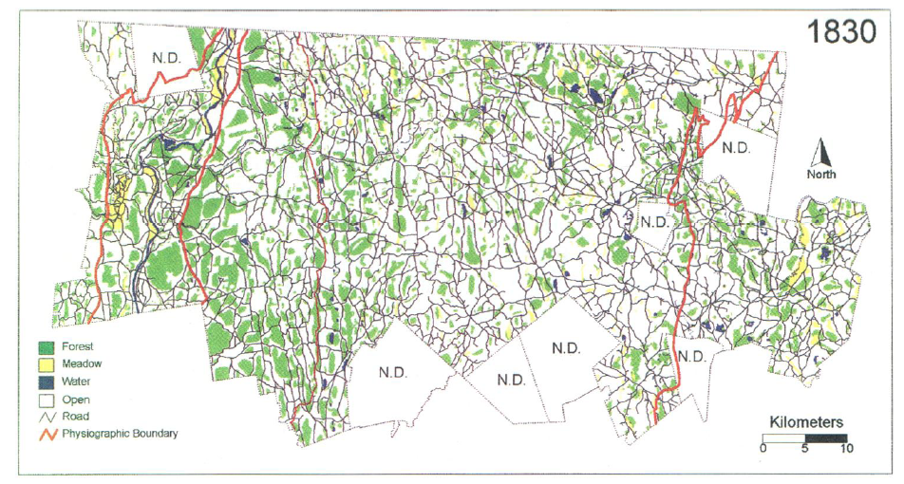
b)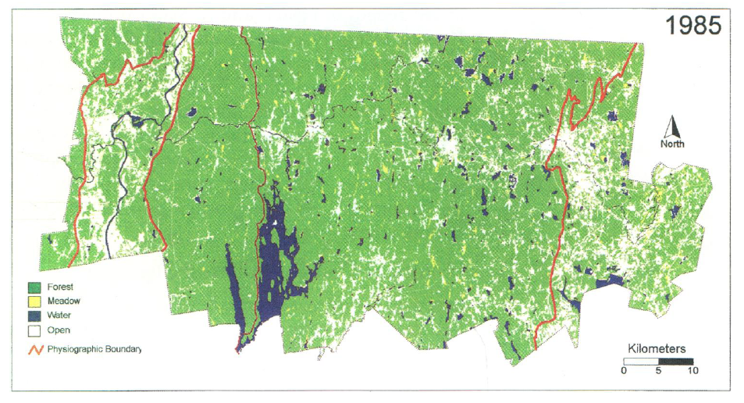

- The green chlorophyll index (CIgreen) (Gitelson and Merzlyak, 1994) was developed to assist in quantifying chlorophyll concentrations in maple and chestnut trees and is represented by the following equation:
CIgreen = (Near Infrared Band /Green Band) - 1
Calculate CIgreen for the following pixel from Landsat 7. Please show your work, circle your answer, and use the correct number of significant figures. (NOTE: Part of this question will be used as a tie breaker.) (6pts)
Band Number | Wavelength Interval (μm) | Reflectance
1 | 0.45-0.52 | 0.025
2 | 0.52-0.60 | 0.043
3 | 0.63-0.69 | 0.024
4 | 0.76-0.90 | 0.719
5 | 1.55-1.75 | 0.725
7 | 2.08-2.35 | 0.716

- Name five sources of greenhouse gases. At least one example must be from a non-anthropogenic source. (6pts)

- Using Figure 2, a map of forest cover change in a region of India, please summarize the overall land management in terms of maintaining the amount of forest from 1996 to 2002. Can forest managers increase the density of forest located in the green areas from the 2002 densities? (6pts)

Figure 2: (taken from Roy, 2003) Map of forest change. Values are in percent forest cover 1) >80% 2) 61-80%, 3) 41-60%, 4) 21-40%, 5) <20%, 6) No Forest. Colors correspond to a change from forest coverage ‘x’ to ‘y’. Four examples are displayed within the figure.
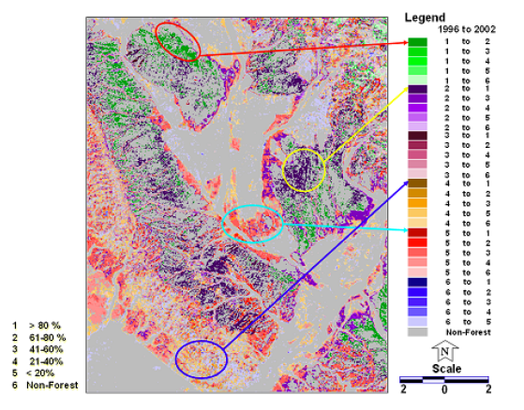

- Describe the patterns in Figure 3 and provide an explanation/source for this pattern. (6pts)

Figure 3: Global carbon levels in July 2008 produced from Atmospheric Infrared Sounder (AIRS)
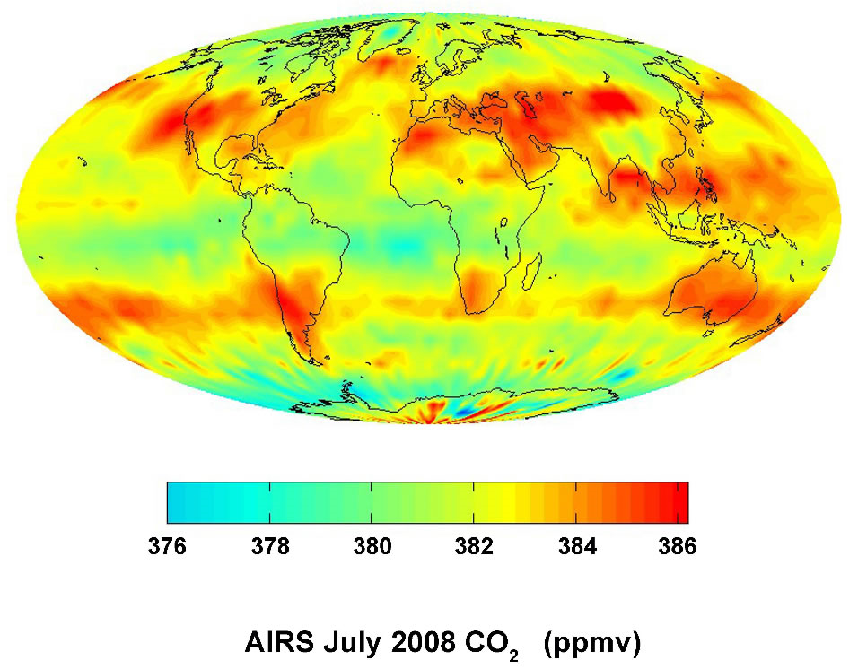

- Describe the differences in the two images in Figure 4 using scientific terminology. How can remote sensing scientists produce these images from a satellite-based sensor such as LandSat? Why might remote sensing scientists want to create both types of images? (8pts)

Figure 4: LandSat images taken of Chesapeake Bay, USA on August 23rd, 2004. Both images were taken concurrently.
a) 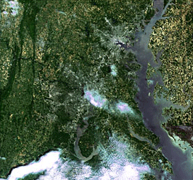 b)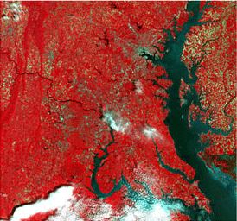

- The mean annual radian energy and heat balance of the earth was estimated by Houghton et al. (1996) and summarized in Figure 5. Assuming the atmospheric window does not change, if an increase in greenhouse gases causes approximately 94.29% of the remaining surface radiation (surface radiation- atmospheric window) to be returned as back radiation, what is the total radiation absorbed by the surface of the earth in W/m²? Show your work, circle your answer, and use the correct number of significant figures. (8pts)

Figure 5: Mean annual radian energy and heat balance of the earth (Houghton et al., 1996).
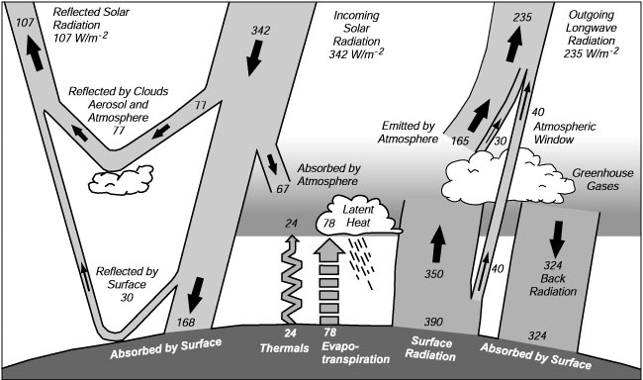

- Figure 6 displays the amount of energy from the top of the atmosphere to the earth’s surface. Explain why there is a difference between these two lines. Using this figure, give an explanation as to why humans might have developed eyesight in the ‘visible’ range of the electromagnetic spectrum. (6pts)

Figure 6: Solar radiation curve expressed in energy reaching the atmosphere and surface of the earth.
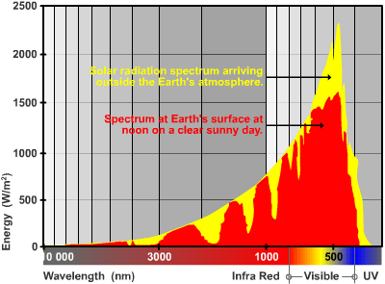

- Describe how remote sensing can be used to monitor human interactions with forest biomes. Provide at least 3 examples. (6pts)

- Lidar is a relatively new remote sensing platform that uses lasers to determine elevation. Provide at least one advantage and disadvantage Lidar has compared to traditional reflectance-based sensors (i.e. LandSat, MODIS). How might scientists interpret information from canopy height and ground elevation acquired from the Lidar data transect presented in Figure 7? (6pts)

Figure 7: Sample Lidar data acquired from Dubayah and Drake (2000).
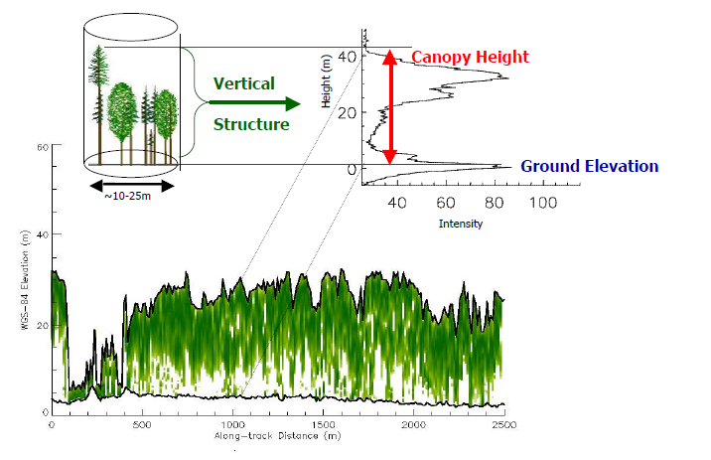

- When measuring productivity of plant systems, many scientists determine the total amount of photosynthetically active radiation (PAR). In what region of the electromagnetic spectrum is PAR located? You may use wavelengths or descriptors; however, if you use descriptors, you must include all regions. In the northern hemisphere, what month will have the greatest incoming PAR values, assuming cloud-free conditions? (6pts)

- The enhanced vegetation index (EVI) is another index used to estimate vegetation and is represented by the following equation:

EVI = 2.5 * (NIR – RED)_____
(NIR + C1 * RED – C2 * Blue + L)

When applied to MODIS images, the following coefficients are used: L=1.0, C1=6.0, C2= 0.5. Find EVI for the following MODIS pixel. Be sure to show your work, circle your answer, and use the correct number of significant figures. (6pts)

Band | Reflectance
Blue | 0.02
Green | 0.04
Red | 0.02
NIR | 0.61

- Typically, how do forests contribute to the carbon cycle? (4pts)

- Assuming 100% consumption in the fire, if a 1 ha stand of oak trees with a dry biomass of 20.32 mg/ha and an average age of 53 years is cut down and burned, what is the net release of carbon dioxide into the atmosphere for the life of the stand of trees? Be sure to show your work, circle your answer, and use the correct number of significant figures. (4 pts)

