**Disease Detective Kraemer Middle School Scrimmage**

**Science Olympiad Tryouts**

(Questions 1-4), Use the passage below from from an article on the CDC website Morbidity and Mortality Weekly Report published on September 9, 2017.

*Notes from the Field*: *Clostridium perfringens* Outbreak at a Catered Lunch — Connecticut, September 2016 *Weekly* / September 8, 2017 / 66(35);940–941

Vivian H. Leung, MD1,2; Quyen Phan, MPH2; Cynthia E. Costa2; Christina Nishimura, MPH2; Kelly Pung3; Liz Horn3; Lynn Sosa, MD2

In September 2016, the Connecticut Department of Public Health was notified of a cluster of gastrointestinal illnesses among persons who shared a catered lunch. Information about symptoms and foods eaten was gathered using an online survey. A case was defined as the onset of abdominal pain or diarrhea in a lunch attendee <24 hours after the lunch. Risk ratios (RRs), 95% confidence intervals (CIs), and Fisher’s exact p-values were calculated for all food consumed. Associations of food exposures with illness were considered statistically significant at p<0.05.

Among approximately 50 attendees, 30 (60%) completed the survey; 19 (63%) respondents met the case definition. The majority of commonly reported symptoms included diarrhea (17 of 18), abdominal pain (15 of 16), and headache (7 of 15). The median interval from lunch to illness onset was 5.3 hours (range = 0.4–15.5 hours) for any symptom and 7 hours (range = 2.5–13 hours) for diarrhea. Analysis of food exposures reported by 16 ill and 10 well respondents found illness to be associated with the beef dish 16 ill respondents reported eating the beef.

The caterer had begun preparing all dishes the day before the lunch. Meats were partially cooked and then marinated in the refrigerator overnight. In the morning, they were sautéed 2 hours before lunch. Inspection of the facility found the limited refrigerator space to be full of stacked containers that were completely filled with cooked food, disposable gloves that appeared to have been washed for reuse, and a porous wooden chopping block.

1. The first sentence refers to a cluster of gastrointestinal illness. What defines a cluster?

2. What were three criteria met for establishing a case definition in this outbreak?

3. What factors in food preparation and storage may have played a role in a food borne illness developing?

4. Clostridium perfringens was determined to be the etiology of the outbreak. Was the timeframe of onset of illness typical or atypical of this organism?

(QUESTIONS 5-8) What type of bias is described by the following situations? Each answer used only once.

1. Observer
2. Recall
3. Selection
4. Information

5. Doctors know which patients in a drug study are receiving the experimental drug itself and which are receiving placebo. ______

6. A study pays college students $50 each to participate as a control ______

7. More likely in a retrospective study of people who got ill eating at Chipotle______

8. Some patients in a study were incorrectly identified as being HIV+­ ______

(Questions 9-12) Use the table below

|  |  |  |  |
| --- | --- | --- | --- |
|  | **DISEASE** | **NO DISEASE** | **TOTAL** |
| **EXPOSED** | 135 | 65 | 200 |
| **UNEXPOSED** | 38 | 62 | 100 |

9. Calculate the relative risk?

10. Is there a correlation between exposure and disease?

11. In the above 2 x 2 table, what would the odds ratio be if 10% of the people who thought they were exposed were actually not exposed:

12. In the above 2 x 2 table, what would the odds ratio be if 20% of the people forgot that they were exposed:

(Questions 13-20) Match the following adult patient interviews with the most likely offending food-borne illness organism (each choice will be used only once):

**Salmonella Rotavirus Listeria Giardia**

**Shigella Norovirus E. Coli Campylobacter**

13.“I’ve been having diarrhea, belching, and feel like I’ve been having greasy stools. I drank water from a mountain stream last weekend”

_____________________

14. “I got sick after eating grilled chicken at a barbecue 3 days ago”

_____________________

15. “I’ve been having bad cramping with my diarrhea which feels like lots of water coming out”

_____________________

16. “I started having bad diarrhea after playing with my pet snakes, frogs and turtles”

_____________________

17. “I have a fever, muscle aches and a stiff neck.”

_____________________

18. “I have vomiting, diarrhea, and I lost my sense of taste for a few days”

_____________________

19.“I’ve had severe stomach cramps and diarrhea that was at first watery but now bloody”

_____________________

20.“I had only a mild diarrhea and stayed home from school for only two days” –

_____________________

(Questions 21-22) In evaluating a study for a new test that screens people for disease what terms define the following:

21. Having sick people incorrectly identified as healthy: _____________________

22. Having healthy people incorrectly identified as sick: ____________________

(QUESTION 23-26) Use the figure below to answer the question. Each answer is used only once.

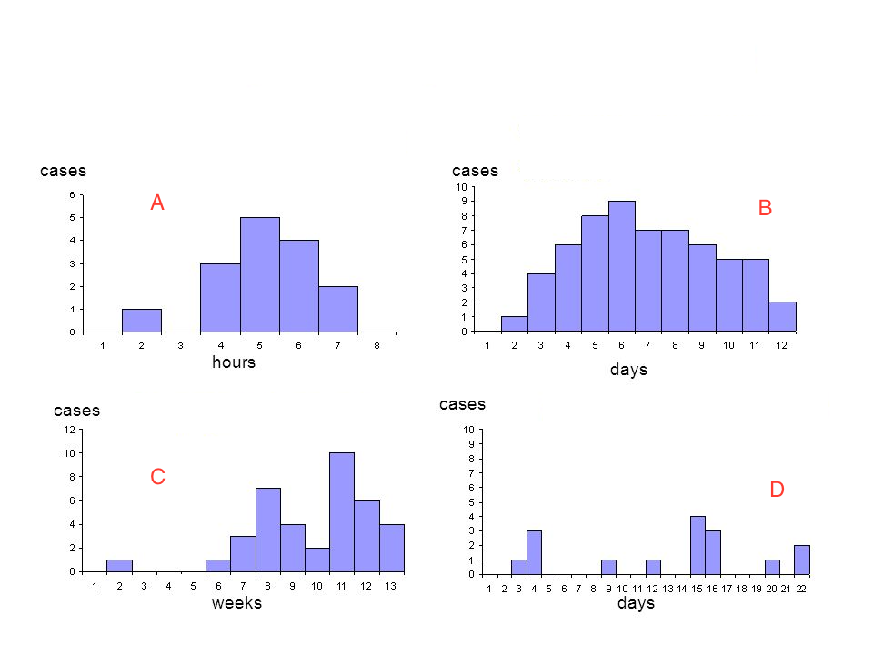

What type of outbreak is represented by each of the above epidemic curves?

23. ______

24. ______

25. ______

26. ______

A Common Point Source

B, Common Persistent Source

D. Propagated Source

E. Common Intermittent Source

(Questions 27-28) Use the table below

|  |  |
| --- | --- |
|  | **Control** |
| **Case** | |  |  |  | | --- | --- | --- | |  | Exposed | Not Exposed | | Exposed | 30 | 60 | | Not Exposed | 20 | 10 | |

27. Calculate the matched odds ratio:

28. Create a new 2 x 2 table with this information to calculate the unmatched odds ratio:

(Questions 29-30) You attend a conference reporting results of a new screening test. The investigators report there was a 97% probability that a person with negative test does not have the disease.

29. What statistical term is used to describe this finding?

30. They report that while their specificity was very high, their sensitivity was a bit lower. Is this a problem when considering implementing a new type of screening test? Why or why not?

(Questions 31-33) Indicate the best type of study design for the following scenarios.

31. Study the possible factors associated with developing Creutzfeldt-Jakob Disease

32. Study the rate of gastrointestinal illness after exposure to eating a rare and hard to find caviar

### 33. Study the prevalence of rotavirus in Fullerton primary schools

### (Questions 34-37) Indicate the type of prevention (primary, secondary, tertiary, quaternary) in the following scenarios.

### 34. Vaccination of people traveling to Africa on safari for hepatitis A ___________

### 35. Teach people with a history of tapeworm infection how to cook and clean meat properly____________

### 36. Educate people in a remote village to not treat their cholera with herbs provided by the local nurse ____________

### 37. Treating a patient diagnosed with Campylobacter infection with antibiotics______________

(Questions 38- 43) Answer the following questions about cholera.

38. How would you diagnose cholera infection in the local population?

### 39. Which serogroup or subtype of cholera are you most concerned with?

### 40. Why is it important to diagnose cholera versus other types of watery diarrhea?

### 41. What is the cornerstone of treatment for cholera?

### 42. How is the cholera vaccine administered (intravenous, intramuscular, subcutaneously, oral, rectal,)?

### 43. List three measures to help prevent future outbreaks of cholera:

### (Questions 44- 47) You have run a cholera test on a local population. Use the table below to answer the following question

|  |  |  |  |
| --- | --- | --- | --- |
| RESULTS | CHOLERA | NO CHOLERA | TOTAL |
| CULTURE TEST POSITIVE | 40 | 50 | 90 |
| CULTURE TEST NEGATIVE | 10 | 400 | 410 |
| TOTAL | 50 | 450 | 500 |

### 44.What is the sensitivity of the cholera test that you ran?

### 45. What is the specificity of the cholera test that you ran?

### 46.The precision of a particular test is influenced by (random or measurement) error?

### 47. The accuracy of a particular test is influenced by (random or measurement) error?

(Questions 48-52) Match the organisms to the historical outbreak. Each answer can be used only once

48. 1985 Jalisco Cheese (142 ill, 28 deaths) ______

49. 2015 Chipotle Mexican Grill (55 ill, 0 deaths) ______

50. 2013 Foster Farm Chicken (634 ill, 0 deaths) ______

51. 2015 Home Canned Potatoes (29 ill, 0 deaths) ______

52. 2003 Chi Chi’s Salsa, Chile con Queso (55 ill, 0 deaths) ______

A. Hepatitis A

B. Listeria

C. C botulinum

D. Salmonella

E. E. Coli

### (Questions 53-55)You are an epidemiologist who is tasked to studying diarrhea in a town in rural West Africa .

### 53. What two pieces of data would you need to gather to determine the prevalence of Hepatitis A in a town in rural West Africa in the last year?

### 54. What two pieces of data would you need to determine the incidence of Hepatitis A in the last month

### 55. What two pieces of data would you need to determine the incidence proportion