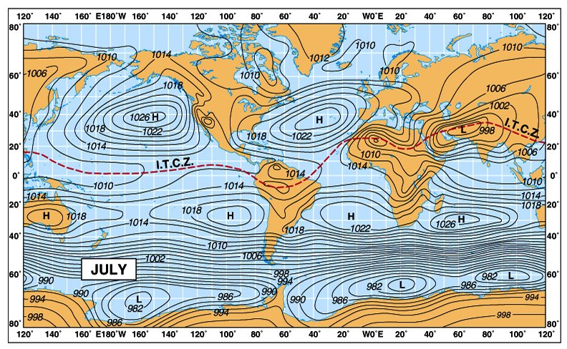Composition: N-78.08%, O-20.95%, Ar-0.93%, CO2-0.038%, H2O-1%.

Evolution: 1st atmos- H & He, then dissipated b/c heat; 4.4 byr: 2nd atmos- CO2, O, N, may H; 3rd atmos. now.

GH gases and contrib. : H2O 36–70%, CO2 36–70%, CH4  4–9%, N2O, O3 3–7%

Eff. Volcanic ash: SO2 + OH-/H2O = stratospheric sulfur aerosols = no sunlight = “global dimming”

CO2 has long term effects almost irreversible (1000 yr)

Weather- dad to day measurements, Climate “average weather”/long term weather

Solar Radiation/Earth’s energy balance

Albedo: ratio of reflected radiation from the surface to incident radiation upon it

Daisy World Model: World of black and white daisies, Black ones raise temp, White decrease.

Solar Weather: 2 types of solar storms. 1. Solar flares, sudden release of Electro-Magnetic

Radiation above the Sun's normal output (covers whole spectrum) caused by magnetic energy releasing.

2. Coronal mass ejection, burst of plasma

Sunspots: Parts of cooler spots on photosphere, b/c of intense magnetism, prevent convection

Solar atmosphere: Photosphere, where light originates, Chromosphere, thin layer, Corona, plasma atmosphere

Insolation: measure of solar radiation received on a surface during a given time.

Solar minimums and maximums: 11 year cycle, solar max more sunspots etc. solar min. calm.

Köppen – vegetation, Thornwaite – precipitation

Köppen Climate Classification-

GROUP A: Tropical/megathermal climates- Tropical rain forest climate (Af), Tropical monsoon climate (Am), Tropical wet and dry or savanna climate (Aw)

GROUP B: Dry (arid and semiarid) (climate’s precipitation is less than potential evapotranspiration)- Subtropical desert (Bwh), Subtropical steppe (Bsh), Mid-Latitude desert (Bwk), Mid-Latitude Steppe (Bsk)

GROUP C: Temperate/mesothermal climates- Mediterranean climates (Csa, Csb), Humid subtropical climates (Cfa, Cwa), Maritime Temperate climates or Oceanic climates (Cfb, Cwb, Cfc), temperate climate with dry winters (Cwb), Maritime Subarctic climates or Subpolar Oceanic climates (Cfc)

GROUP D: Continental/microthermal climate- Hot Summer Continental climates (Dfa, Dwa, Dsa), Warm Summer Continental or Hemiboreal climates (Dfb, Dwb, Dsb), Continental Subarctic or Boreal (taiga) climates (Dfc, Dwc, Dsc)

GROUP E: Polar climates- Tundra climate (ET), Ice Cap climate (EF)

GROUP H: Highland climates, in which altitude plays a role in determining climate classification

1: A - Moist Tropical Climates are known for their high temperatures year round and for their large amount of year round rain.

B - Dry Climates are characterized by little rain and a huge daily temperature range. Two subgroups, S - semiarid or steppe, and W - arid or desert, are used with the B climates.

C - In Humid Middle Latitude Climates land/water differences play a large part. These climates have warm,dry summers and cool, wet winters.

D - Continental Climates can be found in the interior regions of large land masses. Total precipitation is not very high and seasonal temperatures vary widely.

E - Cold Climates describe this climate type perfectly. These climates are part of areas where permanent ice and tundra are always present. Only about four months of the year have above freezing temperatures.

2: f - Moist with adequate precipitation in all months and no dry season. This letter usually accompanies the A, C, and D climates.

m - Rainforest climate in spite of short, dry season in monsoon type cycle. This letter only applies to A climates.

s - There is a dry season in the summer of the respective hemisphere (high-sun season).

w - There is a dry season in the winter of the respective hemisphere (low-sun season).

3: a - Hot summers where the warmest month is over 22°C (72°F). These can be found in C and D climates.

b - Warm summer with the warmest month below 22°C (72°F). These can also be found in C and D climates.

c - Cool, short summers with less than four months over 10°C (50°F) in the C and D climates.

d - Very cold winters with the coldest month below -38°C (-36°F) in the D climate only.

h - Dry-hot with a mean annual temperature over 18°C (64°F) in B climates only.

k - Dry-cold with a mean annual temperature under 18°C (64°F) in B climates only.

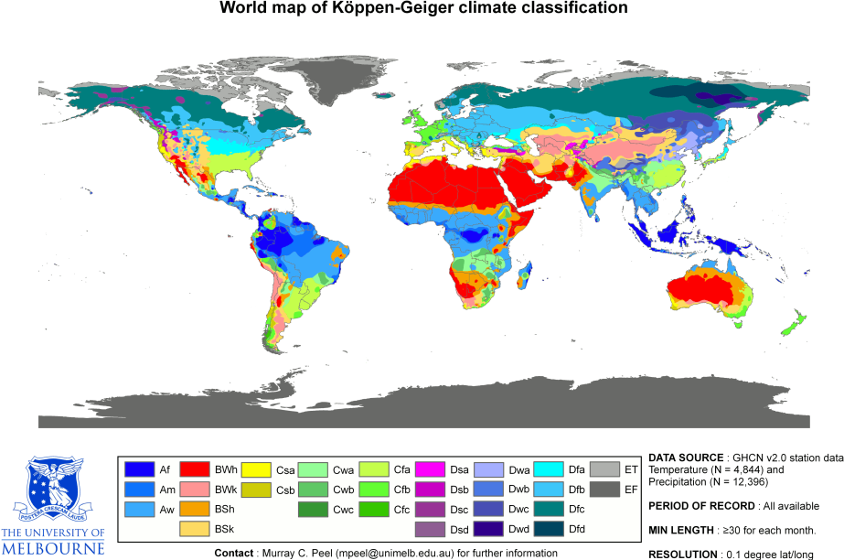Hadley, Ferrel, and Polar Cells

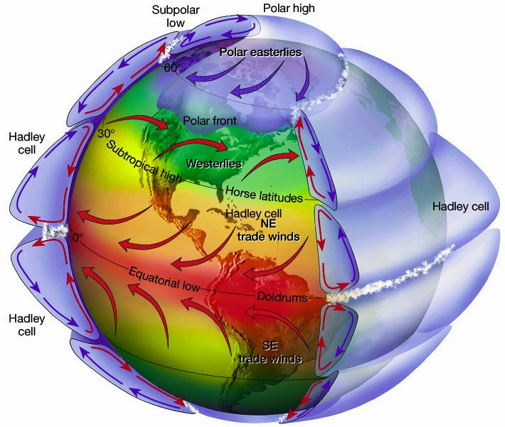

Thornthwaite climate classification- divides climates by vegetation characteristic, the vegetation being determined by Precipitation Effectiveness (P total monthly precipitation, E total monthly evaporation) The sum of the monthly P/E values gives the P/E index, which is used to define five humidity provinces, with associated vegetation. A P/E index >127 (wet) rain forest; 64–127 (humid) forest; 32–63 (subhumid) grassland; 16–31 (semi-arid) steppe; <16 (arid) desert. Microthermal climate, between 0 °C (32 °F) & 14 °C (57 °F)short summers, potential evaporation between 14 cm (5.5 in) & 43 cm (17 in). Mesothermal , potential evaporation between 57 cm (22 in) and 114 cm (45 in). Megathermal climate persistent high temp, abundant rainfall, potential annual evaporation in excess of 114 cm (45 in)

Plate tectonics: move 3 cm/yr, alter ocean currents and heat transport, volcanic eruptions

Cryosphere – ice on earth

El Niño and La Niña: They are a warming or cooling of at least 0.5 °C (0.9 °F) averaged over the east-central tropical Pacific Ocean. Typically, this anomaly happens at irregular intervals of 2–7 years and lasts nine months to two years.

El Niño: Strong Equatorial Counter-Current, Wetter than Average Winter over Florida, Pronounced Ridge in Polar Jet over Western North America, Drier than Average over Indonesia and Australia, Large-Scale Warming of Pacific

La Niña: Strong Peruvian Current, Higher Sea Level in the West Pacific, Stronger than Normal Subtropical Highs in Pacific, Increased Snowfall in the North Western U.S. , Oceanic Cooling of the Pacific Southern Oscillation – alt. btw. El and La

Walker Circulation: (El Niño) trade winds blows moist surface air west, rains, become dry air blown back to the east. Opposite for La Niña.

Thermohaline Circulation - The adjective thermohaline derives from "thermo-", referring to temperature, and "-haline", referring to salt content. Salt and determines the density of sea water.

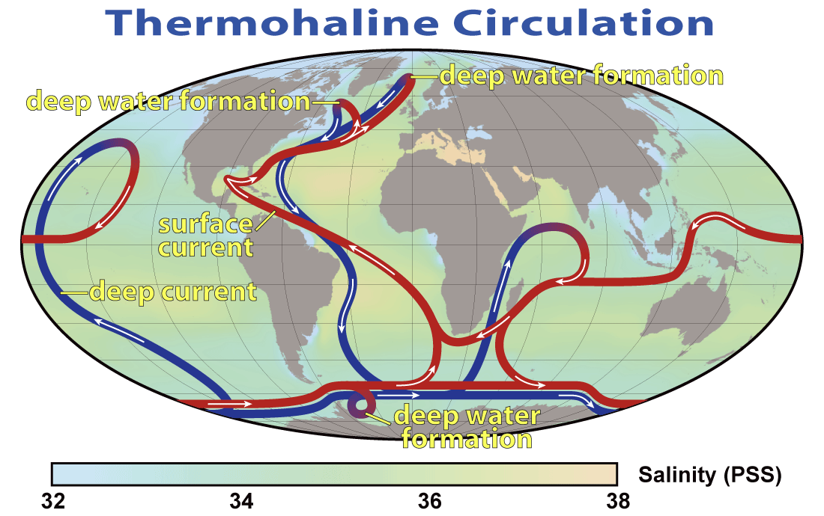Impact on Earth's Climate – If disappear, will affect energy transport and solids, dissolved substances and gases, so marine life

Milankovitch Cycles: **Eccentricity**: Change in Earth’s orbit. Orbit vary almost circular low eccentricity (0.005) to mildly elliptical (high ecc. 0.058) mean ecc. of 0.028 (0.017 current) Closest to the sun (perihelion, Jan.3 91.4 mil mi) farthest (aphelion Jul.4, 94.5 mil mi ).

**Axial Tilt**: aka Obliquity 42,000 yr cycle, 22.1° to 24.5°, current 23.45° Less angle than current = less temp. diff. **Precession**: Axis point change from North Star or Polaris to Vega, 26,000 yr cycle, summer in Dec. then.

Pleistocene Ice Age: 2.58 Ma to present, made ice sheets in Antarctica and poss. Greenland. Erosion, mod. river systems, create mil’s lakes, changes sea level, crust shift, and abnormal winds. It affected oceans bio. The ice sheets raise albedo - cool.

Younger Dryas Cold Period: (stadial – cold period in warm period) aka Big Freeze, occ. 12,800 & 11,500 yr ago. Last 1,300 ± 70 yr. Caused by reduction or shutdown of the North Atlantic conveyer. Maybe sudden influx of fresh water from Lake Agassiz from deglaciation, or jet stream shift North bring more rain from melting N. American ice sheet to slow circulation.

Medieval Warm Period: AD 950 -1250, 300 yr. N. Atlantic. Ice melt, Viking travel

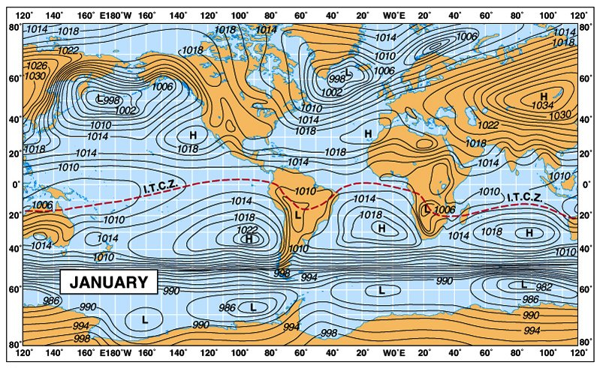Little Ice Age: 1550 AD - 1850 AD, 3 particularly cold period, 1650, ~1770, 1850 sep. by int. of slight warming. Maybe causes: less sunlight, volcanic activity, conveyer slow, reforestation b/c less humans.



Paleoproxies: Loess- accumulated wind blown silt, Speleothems- caves formation, Geomorphic features- landforms, Lacustrine sediments- lake sediments, Dendrochronology- tree rings

Corals build calcium carbonate skeletons over many years and are sensitive to water temperatures and other environmental factors. Their skeletons record annual information on past climate and ocean circulation.

Ozone depletion: Caused by CFCs and other halocarbons, like Cl + O3 → ClO + O2 , and ClO + O3 → Cl + 2 O2. Effects: more UV – skin cancer, cataracts, more ground-level ozone 🡨 bad b/c toxic, make Vit. D, sunburn animals, kill cyanobacteria which helps plants retention of N.

Urban heat island effect: Urban hot, because concrete/asphalt radiate heat at night.

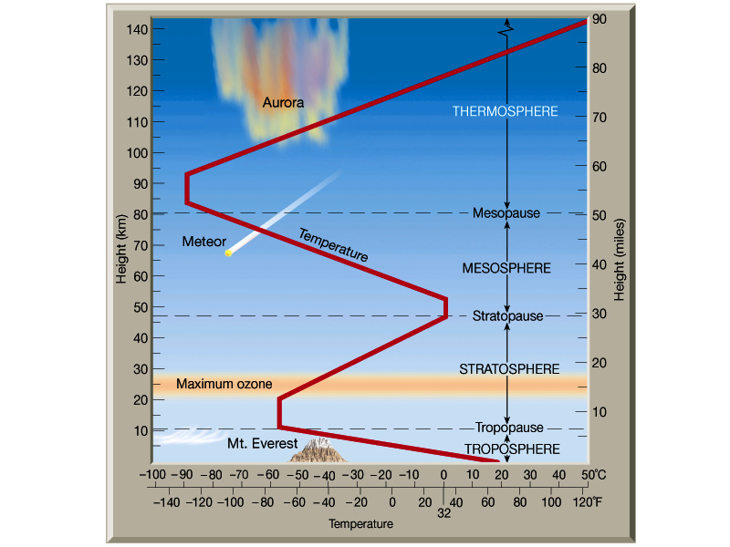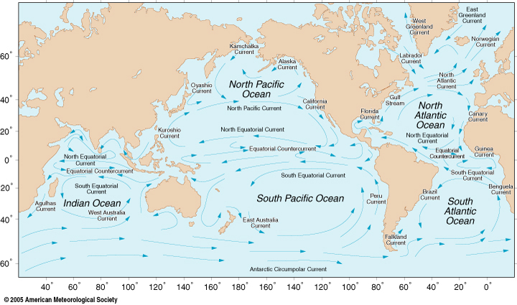Structure of Atmosphere: Troposphere 0-12 km, 80% of atmosphere’s mass, -6.5°C/km up, Tropopausejet stream near (strong winds eastward) Stratosphere 12-50 km, ozone layer, weather balloons, commercial airplanesMesosphere 50-80 km, coldest region −100 °C, meteors burn, Thermosphere 80 km-600km, hot, 2000°C, space shuttles, space station, satellites. Ionosphere in lower part of thermosphere, aurora, radio communication Exosphere 600km-190,000km