**Note to SciOly users:** This is a homemade test.Microbe Mission is a completely event and I think it will return next year. This is based on 2010-2011’s rules, even though if it returns next year, the rules are likely to be similar. Also, **THIS DOES NOT COVER ALL OF THE TOPICS FOR MICROBE MISSION 2010-2011**. This was made for my partner and we split up the studying.

**MICROBE MISSION MICROSCOPY PRACTICE TEST**

**DIVISION B 2011**

Names: _______________________________ _________________________________

Team Number: ___________

**STATION A**

**MICROBIAL GROWTH CURVE**

1. What happens to the microbes during the lag phase?
2. What happens to the microbes during the exponential phase?
3. What is the stationary phase?
4. What happens during the death phase?

**STATION B**

**FOOD PRODUCTION AND INDUSTRIAL USES**

1. Which type of microbe is used to make petroleum?
2. What are two ways that microbes are an aid in food production?

**STATION C**

**MICROBIAL ECOLOGY**

1. Which microbes are decomposers?
2. Why can algal blooms be dangerous aquatic environments?

**STATION D**

**TYPES OF MICROSCOPES**

1. What is the most widely used microscope?
2. Which microscope includes a UV radiation source and forms a colored image against a black field?

**STATION E**

**PARTS OF A LIGHT MICROSCOPE**

1. 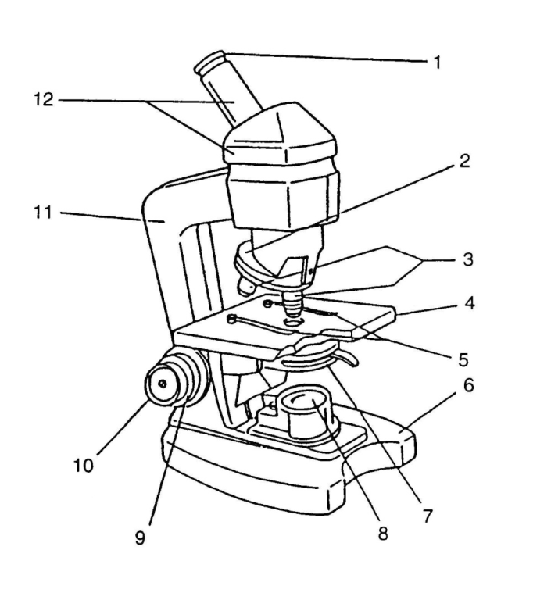Name the parts of the microscope shown here.

1. __________________

21

2. __________________

1

3. __________________

321

4. __________________

54321

5. __________________

4321

6. __________________

6

7. __________________

109

8. __________________

8

9. __________________

10. _________________

12

11. _________________

9

11109

7

12. _________________

1. What type of microscope is the one shown in the diagram?

**STATION F**

**PRINCIPLES OF MICROSCOPY**

1. If an object appears to be moving up and left, in which direction is it actually moving?
2. When changing objectives from low power to high power, what happens to the size of the field of view?
3. When changing objectives from low power to high power, what happens to the size of the image?

Put in the missing number in the table for each question.

|  |  |  |  |
| --- | --- | --- | --- |
|  | **Ocular** | **Objectives** | **Total magnification** |
| 16. | 10X | 45X |  |
| 17. |  | 43X | 516X |
| 18. | 10X | 5X |  |
| 19. | 12X |  | 144X |

1. If a capital “**L**” was placed on the stage in its normal position, what would it appear to look like when seen through the microscope?
2. When changing objectives from 10x to 40x with a 10x ocular, how many times more magnified would the image be with the 40x objective instead of the 10x objective?

**ANSWER KEY**

**STATION A – Microbial Growth Curve**

1. They produce the materials they need to reproduce

2. Rapid growth of cells

3. Same number of cells die as are being produced

4. Rapid death of cells

**STATION B – Food Production and Industrial Uses**

5. Algae

6. -Milk into yogurt, buttermilk, sour cream, cheese

-Aid in production of chocolate, bread products, wine, beer, tea

-Pickling process to make pikles from cucumbers and sauerkraut from cabbage

**STATION C – Microbial Ecology**

7. Bacteria and fungi

8. They can use up too much oxygen and kill fish

**STATION D – Types of Microscopes**

9. Light compound microscope

10. Flourescence microscope

**STATION E – Parts of a Light Microscope**

11.

1. Body Tube

2. Ocular

3. Nosepiece

4. Objectives

5. Arm

6. Stage

7. Illuminator

8. Base

9. Coarse adjustment

10. Stage clips

11. Diaphraghm

12. Fine adjustment

12. Light compound microscope

**STATION F – Principles of Microscopy**

13. Down and right

14. Field of view decreases

15. Size of the image increases

16-19.

|  |  |  |  |
| --- | --- | --- | --- |
|  | **Ocular** | **Objectives** | **Total magnification** |
| 16. | 10X | 45X | **450X** |
| 17. | **12X** | 43X | 516X |
| 18. | 10X | 5X | **50X** |
| 19. | 12X | **12X** | 144X |

20.

21. 16 times