School Name ________________________ Team #____
International Academy East Meteorology Test
Graphs, Pictures, and Diagrams
Diagram #1
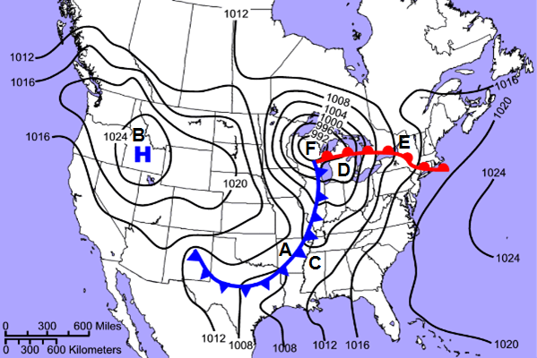
Use the map above, and the locations marked A-F, to answer the following questions.
- The center of a low pressure system would be found at which location? ________
- At which location(s) would you expect to see precipitation? __________
- What is atmospheric pressure at location A? _____________
- What is the atmospheric pressure at location B?___________
- What is the proper name for the contour lines on the map?_________________
- Which two locations would you expect to have the warmest temperatures? __________
- Which location would you expect to have the lowest temperatures?__________
- Which location would be most likely to experience the highest wind speeds?_________
How do you know?

- What type of weather would you expect to have at location B?

- What type of weather would you expect to have at location F?

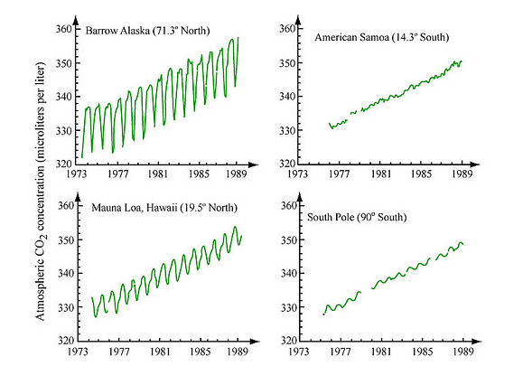
Diagram #2

- ______ What is a possible explanation for the general upward trend seen in the graphs above?
  - Increasing plant populations
  - Global warming
  - Deforestation
  - Carbon emissions from humans
- ______ What is responsible for the annual variations causing the peaks and troughs in the graph?
  - Cold temperatures making air more dense
  - Annual volcanic eruptions
  - Seasonal variations in photosynthesis
  - The use of natural gas heaters in the winter
- ______ Why are there greater difference between annual highs and lows in CO₂ concentration in Barrow, Alaska than in Mauna Loa, Hawai’i?
  - Mauna Loa is surrounded by water and Barrow is surrounded my mostly water, which buffers the variations in carbon dioxide.
  - The greater difference in seasonal temperatures causes photosynthesis to be prevalent in summer, and cellular respiration to be prevalent in winter.
  - Barrow Alaska is further north than Mauna Loa, and the colder temperatures cause CO₂ to enter the atmosphere more quickly in the winter.
  - Mauna Loa is a volcano, which stores and releases carbon dioxide.
- ______ Why isn’t there a significance difference between annual high and lows in CO₂ concentration at the South Pole?
  - The South Pole is too cold for the composition of the air to change much.
  - There is not significant plant life at the South Pole that will photosynthesize.
  - The South Pole is surrounded by water, in the form of water.
  - All of the above factors influence the variability of carbon dioxide in the atmosphere.

Diagram #3
Label each of the following
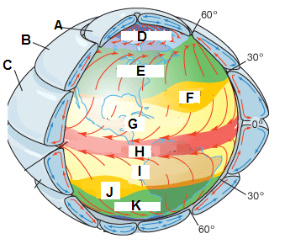
- The cell labeled A:__________________________
- The cell labeled B:__________________________
- The cell labeled C:__________________________
- The pressure zone labeled D:__________________
- The winds at D:_____________________________
- The winds labeled E:_________________________
- The pressure zone labeled F:___________________
- The winds at G:_____________________________
- Windless region at H:_________________________
- The zone at H:______________________________

Diagram #4
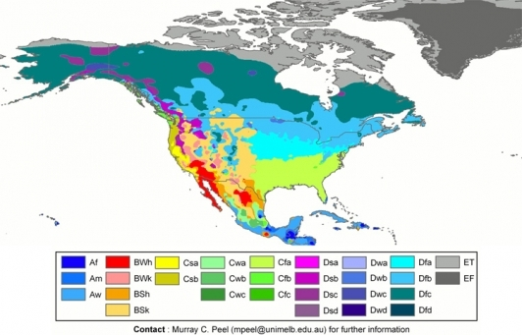
Above is an image of North America color-coded according to the Köppen Climate Classification System. Use it to answer the following questions.
- What two factors are the climate classifications determined by?

- What are the five major categories in the Köppen Climate Classification System, indicated by the capital A-E
  - _________________________
  - _________________________
  - _________________________
  - _________________________
  - _________________________
- According to the map, what would the climate of northern Canada and Alaska be like?

- According to the classification, what would the climate of Florida be like?

- What are the three types of climates that fall into category A? Match them with the two letter code on the key and briefly describe them.

- What are the two types of climates that fall into category E? Match them with the two letter code on the key and briefly describe them.

Diagram #5
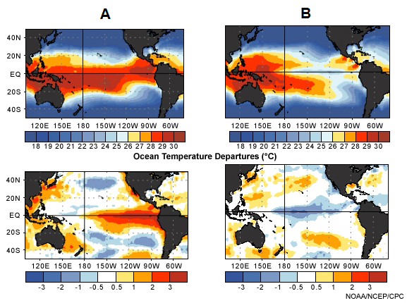
- What is the official name for the climate pattern and conditions shown in image A?

- What is the official name for the climate patterns and conditions shown in image B?

Describe whether the following are conditions associated with El Niño or La Niña, or both.
- Heavy rain and flooding in Bolivia, Ecuador, and Northern Peru.______________
- An increase in hurricanes in Hawai’i. _______________
- Increase in precipitation in Australia. ________________
- Drought in southern Africa and India._______________
- Mild winters in the northern United States and Canada. ______________
- Warmer winters in the southeast of the United States. _______________
- Large scale changes in sea surface temperatures. _______________
- Occur every 3-7 years. _______________
- Stronger than usual trade winds.______________
- Fewer than usual hurricanes in the Atlantic. ______________
- Occurred in 2004-2005 ________________

Multiple Choice
- ______ Which describes the effects of earth’s movements upon its climate?
  - Precession
  - Southern Oscillation
  - Milankovitch Cycles
  - Albedo
- ______ What is another word for axial tilt?
  - Obliquity
  - Precession
  - Insolation
  - Eccentricity
- ______ In the Daisy World Model, what two types of species live on the planet?
  - Red and blue daisies
  - Striped and spotted daisies
  - Black and white daisies
  - Green and orange daisies

- ______ How do mountains effect precipitation?
  - With a prevailing wind, warm moist air is forced to cool, condense, and precipitate on one side, creating a rain shadow on the leeward side.
  - Snow cover on mountains sublimate and cause increase precipitation
  - The mountain blocks the sunshine, causing the leeward side to be cooler and less water evaporates, leading to less precipitation all around the mountain.
  - A rain shadow forms on the windward side of a mountain, causing an increase in precipitation on both sides.
- ______ Sea and land breezes over a large region that change direction with the seasons are called:
  - Windwards
  - Steppes
  - Monsoons
  - Microclimates
- ______ Which of the following are not possible climate effects of volcanic eruptions:
  - A cooling of the earth due to heat being absorbed by cooling lava
  - A cooling of the earth due to suspended particulate blocking out sunlight
  - A warming of the earth due to greenhouse gas emission in the eruption process
  - The depletion of ozone due to a reaction with hydrochloric acid.
- ______ An air mass is a body of air with:
  - Equal density throughout
  - Similar values of temperature and moisture in the horizontal
  - Very high pressure everywhere
  - At least two frontal zones
- ______ Why are maritime air masses from the north Atlantic of only limited concern for weather in the U.S.?
  - They never cause severe storms
  - Prevailing winds move them away from the U.S.
  - Temperatures are usually mild over this region
  - Polar fronts block these air masses from the U.S.
- _______ Which of the following is not a factor that influences temperature?
  - Latitude
  - Distance from large bodies of water
  - Ocean currents
  - All of these are factors that influence temperature
- ______ The definition of a variable gas is a gas that varies significantly from time to time and place to place. The most significant variable gas by volume in the planetary boundary layer in the atmosphere is:
  - Ozone
  - Water vapor
  - Oxygen
  - Carbon dioxide
- ______ The seasons of spring, summer, winter, and fall are a direct result of which phenomenon?
  - The sun's energy output and the Earth's proximity to the sun
  - Shifting of ocean currents
  - The 23.5 ° tilt of the Earth from vertical
  - The jet stream

- ______ Which of the following has the highest albedo and thus more reflected solar radiation?
  - Fresh snow
  - Water
  - Grass
  - Blacktop
- ______ Which of the following have an effect on climate?
  - Altitude
  - Latitude
  - Weather
  - Ocean currents
- ______ Why are thunderstorms less common in California than Florida?
  - The directional shear is smaller throughout the year in California
  - Fronts do not move through California except in the summer. Florida has fronts year round.
  - The jet stream is stronger over Florida
  - Florida has warmer ocean waters surrounding it. This results in higher dewpoints, instability and thus more thunderstorms.
- ______ The _______was a short cold period that is sometimes referred to as the Big Freeze. The period only lasted 1300 years between 12,800 and 11,500 years ago. The period is sandwiched between the end of the Pleistocene and the beginning of the Holocene.
  - Ice Age
  - Little Ice Age
  - Younger Dryas Period
  - Medieval Period

Short Response/Fill in the Blank
- Not including water vapor, what are the four most common gases in Earth’s atmosphere, from greatest to least?
1)______________________, 2)_______________________,
3)______________________, 4)_______________________
- What star will the North Pole point to in 12,900 years?

- What star will the North Pole point to in 25,800 years?

- What is the range of the earth’s axial tilt?

- What are the four different types of fronts? Do fronts influence climate?

- What is the difference between weather and climate?

- What are three negative consequences of deforestation?

