SHOCK VALUE TEST
- 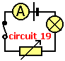Circuit 19 shows a switch closed, battery, bulb and a variable resistor wired in a complete series circuit. Which statement about the operation of the circuit is TRUE?
  - ? if the resistance is increased less current flows and the bulb is dimmer
  - ? if the resistance is decreased, less current flows and the bulb is brighter
  - ? the variable resistor cannot be used as a switch
  - ? if the cell or battery connections are swapped around, the bulb goes out

2.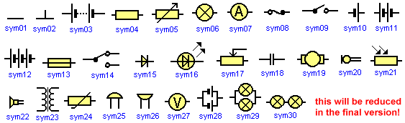
Which of the circuit symbols means a 'two way switch'?
  - ? sym18
  - ? sym23
  - ? sym14
  - ? sym02
3.
Which of the following symbols means a 'fuse'? [7j-28]
  - ? sym21
  - ? sym04
  - ? sym05
  - ? sym13
4.
Which of the circuit symbols means a 'meter for measuring potential difference'? [7j-2]
  - ? sym27
  - ? sym07
  - ? sym19
  - ? sym06
5.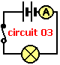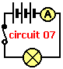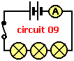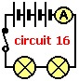From the four circuits shown, which will have 'the brightest lit lamp or lamps'? Note that the bulbs are identical and the batteries identical. [7j-17]
  - ? circuit 09
  - ? circuit 07
  - ? circuit 16
  - ? circuit 03
6.The ratings for four typical domestic appliance fuses are 3A, 5A, 8A and 13A. Which fuse wires will melt if a current of 4A is passed through them? [7j-69]
  - ? 3A only
  - ? 3A, 5A, 8A and 13A
  - ? 3A and 5A only
  - ? 3A, 5A and 8A only
7.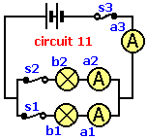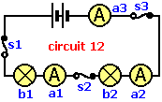Which of the following is TRUE when comparing the two circuits 11 and 12? Note that the bulbs are identical and the batteries identical. [7j-29]
  - ? the bulbs are dimmer in circuit 11 than the bulbs in circuit 12
  - ? the bulbs are brighter in circuit 12 than the bulbs in circuit 11
  - ? in circuit 11 the bulbs are wired in parallel, but not so in circuit 12
  - ? if switch s2 is opened in both circuits, all the bulbs go out
8.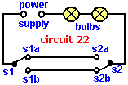The Circuit 22 shows two, two way switches, s1 and s2, connected to a power supply and lamp. Which conditions ensure the lamp is OFF in Circuit 22? [7j-74]
  - ? s1a open (down) and s2b closed (down)
  - ? s1b open (up) and s2a closed (up)
  - ? s1b open (up) and s2a open (down)
  - ? s1a closed (up) and s2b open (up)
9.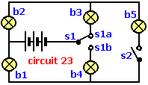The Circuit 23 shows a two way switch s1 and a simple switch s2, connected to a power supply and five lamps (b1 to b5). Which lamps will be ON when switches s1b and s2 are closed? [7j-80]
  - ? b1, b2, b4 and b5
  - ? b1 and b4
  - ? b2 and b3
  - ? b1, b2, b3 and b5
10.The ratings for four typical domestic appliance fuses are given below. Which is the safest fuse to use for an appliance with a normal operating current of 6A? [7j-67]
  - ? 5A
  - ? 3A
  - ? 13A
  - ? 8A
11.
Which of the circuit symbols means 'two cells or batteries in series'? [7j-4]
  - ? sym14
  - ? sym18
  - ? sym10
  - ? sym11
- The Circuit 22 shows two, two way switches, s1 and s2, connected to a power supply and lamp. Which conditions ensure the lamp is ON in Circuit 22? [7j-73]
  - ? s1b open (up) and s2a open (down)
  - ? s1a open (down) and s2a closed (up)
  - ? s1b closed (down) and s2b open (up)
  - ? s1a closed (up) and s2b open (up)

