Science Olympiad
2012 Camas High School Invitational
Dynamic Planet
Key

Name the type of glacier shown in each picture:

- This glacier can be classified as two types, name each one:
____Piedmont____ & _____Tidewater________

- This series of photos shows a glacier over 30 years. What type of glacier is this? _____________Retreating_______________________

- What type of glacier is this? __________Cirque_______________________

- What type of glacier is this? _____________Hanging___________________

- This is one of the only land masses that has these: _____Ice Sheets______

- This is what type of glacier? ________Ice Shelf________________

- This is what type if glacier? ______Valley____________

Name the glacier feature in each picture:

- This is what glacier feature? __________Terminus__________

- This is what glacier feature? _______Ice Cave_________

- This climber is currently in what glacier feature? ___Crevasse______

- This is what glacial feature? ______Ogives__________

- This image illustrates the formation of what glacial feature? __Medial Moraine_________

- The sides of this glacier show what glacial feature? _____Lateral Moraine________

- This is what glacial landform? _______Erratic__________

- This is what glacial landform? ______Arête________

- Name the glacial feature as well as this famous mountain: ______Horn & Matterhorn_______

- Name this glacial feature: ________Drumlin_____________

- Name this glacial feature: __________Trough__________________

- Name each of the glacial features on this diagram:
A: Hanging Valley
B: Arête
C: Horn
D: Tarn
E: Pater Noster Lakes
F: Cirques
G: Glacial Trough

Name this glacial feature: _______Tarn__________

Name this glacial feature: _________Kettle Lake__________

Name the glacial feature in the center of this picture: ______Kame_____

Answer each question directly on this test:

- The degree of ellipticity of Earth’s orbit around the sun is called:
- Precession
- Eccentricity
- Ellipticality
- Tilt

- If a glacier is moving quickly over a short period of time then it is a ______________________ glacier
- Rock
- Valley
- Falling
- Surging

- What feature forms when two glaciers merge together?
- Crevasse
- Horns
- Medial Moraine
- Arêtes

- Glaciers contain how much of the Earth’s freshwater?
- 30%
- 36%
- 25%
- 33%

Fill in the blank space with the correct answer

- In the ____zone of accumulation____ snowfall is occurring all year round.

- In the _____zone of ablation____ snowfall rarely occurs.

- The _______Snow line__________________ separates the answer to question 19 and the answer to question 20.

- All the material dropped by a glacier is called _____drift____

- Glaciers erode the landscape by ___abrasion__ & __plucking__

- The stages from snow to ice are:
Snow
____Granular ice______
____Firn______
Glacial Ice

- The present epoch we are in now is __Holocene__ and the one before the present epoch is the ___Pleistocene___ epoch.

- In the epoch that lasted from the beginning of the Quarternary Period to the end of the last glaciation there were 4 different major ice ages. Name them: __________Nebraskan___________, ________Kansan__________________, _________Illinoian_______________, & _________Wisconsin______________

- Concerning the previous question, the oldest of these ice ages was the ________Nebraskan_______________ ice age and the latest one was the ________Wisconsin_____________ ice age.

- The snow line at the equator is approximately __5,000__ meters

Match each of these glacial features to the type of glacier that forms it:

- Arêtes: ___B___
- Truncated Spurs: ___B___
- Continental Glaciers

- Valley Glaciers

- Both Valley and Glaciers
- Kettles: ___A___
- Eskers: ___A___
- Drumlins: __A____
- Kames: ___A___
- Cirques: ___B___
- Horns: __B____
- Hanging Valleys: ___B___
- Glacial Trough: ___B___
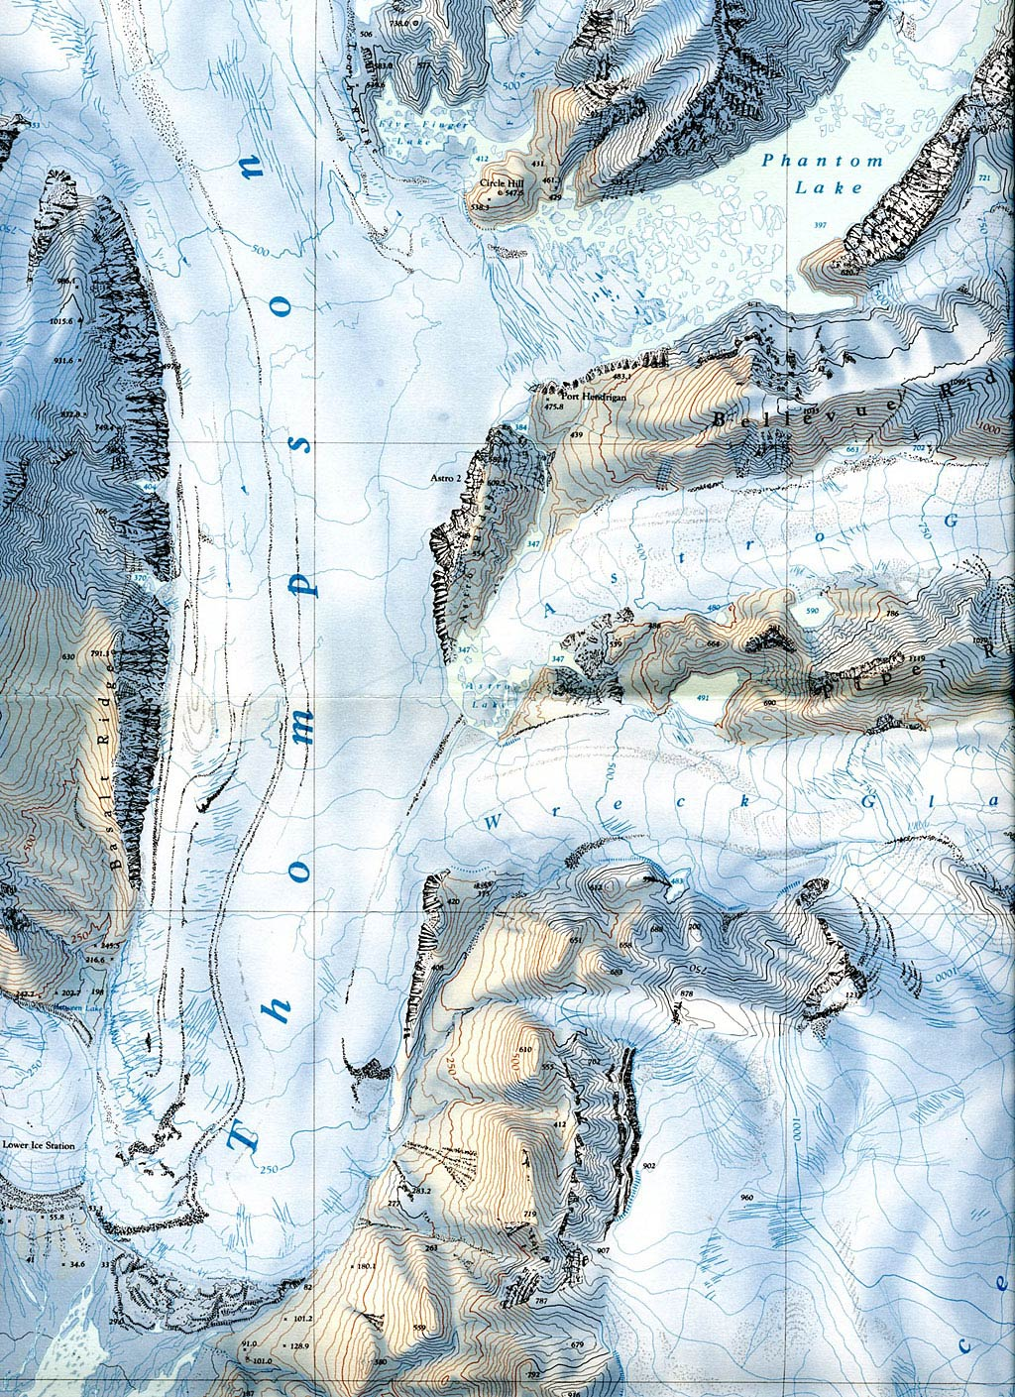
C
B
Topographic Map
A
Answer the following questions:

- Referring to the Topographic Map, what type of glacier is the Thompson glacier? ____________Valley Glacier__________________

- On the topographic map there is a circle with a letter A next to it. What glacial feature is in this circle? ___________ Arêtes_________

- On the topographic map there is a circle with a letter B next to it. What glacial feature is in this circle? _______Cirque__________

- When the Wreck Glacier and the Thompson Glacier meet what will be formed in the middle? _________Medial Moraine_____________

- What is the contour interval of this topographic map? ____25____ feet

- On the topographic map there is a circle with a letter C next to it. What type of glacier is in this circle? _____Hanging Glacier (Ice Apron)_______

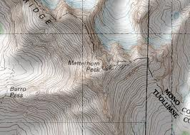
B
A

- Where is this famous mountain located? _________Border of Switzerland and Italy or Western Alps_________

- On this topographic map there is a circle with a letter A next to it. What glacier feature is in this circle? _____Tarn_______

- What is the glacier feature in circle B? ____Horn____

- What is this diagram of? _______Lake Vostok________
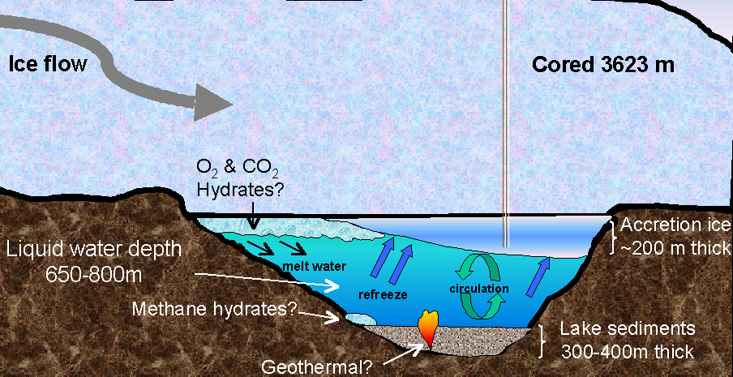
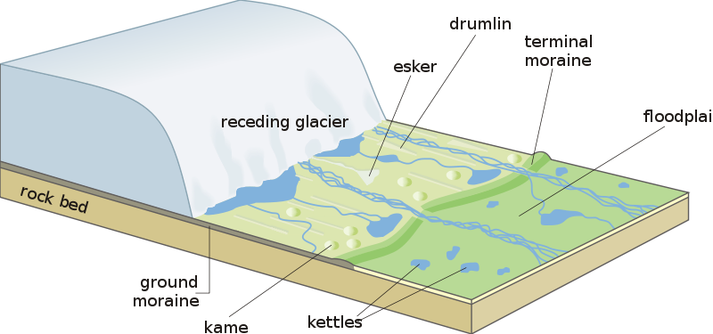
G
F
E
D
C
B
A

- Identify each of the glacial features in the above diagram.
A: Esker
B: Drumlin
C: Terminal Moraine
D: Floodplain
E: Ground Moraine
F: Kame
G: Kettles

