DYNAMIC PLANET
TECTONICS
Massachusetts State Science Olympiad, B Division
March 3, 2018

ANSWER KEY

STATION ONE: IN THE NICK OF TIME

1. PHANEROZOIC 5. H

2. CENOZOIC 6. I

3. PALEOPROTEROZOIC 7. Circle: Rock 1 Rock 2

4. DEVONIAN 8. B

STATION TWO: ANYBODY HAVE A MAP?

1. H 5. E

2. Circle: East West 6. W

3. ANTICLINE 7. Circle: East West

4. Circle: Fault 1 Fault 2 No 8. Circle: Fault 1 Fault 2 No

STATION THREE: A CUT ABOVE

1. Circle: True False 5. ANTICLINE

2. Circle: True False 6. F

3. PENARTH GROUP 7. 3

4. SILURIAN VOLCANICS 8. REVERSE FAULT

STATION FOUR: HISTORY HAS ITS EYES ON YOU

1. STENO 4. HESS

2. WEGENER 5. ROCKY MOUNTAINS

3. THARP 6. APPALACHIAN MOUNTAINS

7. YELLOWSTONE HOTSPOT

8. SWITCHING FROM AN EAST DIPPING TO WEST DIPPING SUBDUCTION ZONE

STATION FIVE: (M)ORE, PLEASE

1. 3 5. A

2. 4 6. C

3. 3 7. B

4. 1 8. C

STATION SIX: LAYERS, LIKE ONIONS AND OGRES

1. BECAUSE OF ISOSTASY; THE LAND IS RISING FASTER THAN THE LAND POST-GLACIAL

PERIOD (full credit for “land is rising faster than ocean due to rebound/isostasy”)

2. INCREASE IN RAIN = DESTABILIZING SLOPE = INCREASE IN MASS WASTING

KEY IDEA: INCREASE IN WASTING (full credit for this)

3. E 6. C

4. D 7. 3

5. F 8. Deepest: C Shallowest: D (1/2 point each)

STATION SEVEN: CROSSING A (PLATE) BOUNDARY

1. DIVERGENT 5. REVERSE

2. 2a: D 2b: CONVERGENT (1/2 point each) 6. A

3. Circle: Increase Decrease Stay the Same 7. TENSION

4. Circle: Increase Decrease Stay the Same 8. 1/5 or 0.2

STATION EIGHT: DROP THE BASIN

1. WEDGE TOP 5. C

2. FOREDEEP 6. A

3. FOREBULGE 7. B

4. BACKBULGE 8. BASE ISOLATION

STATION NINE: ALL OVER THE MAP

1. H 5. ~13.5

2. E 6. Circle: Brittle Ductile

3. E 7. Fold A: ANTICLINE

4. MID-OCEAN RIDGE Fold B: SYNCLINE (1/2 point each)
8. SOMETHING ABOUT TWO PLATES/TERRANES/ETC. SMASHING TOGETHER

STATION TEN: BACK TO THE DRAWING BOARD
3.
1.
North
D
A
C

D
D
D
C
B
B
B
A
A
A
B
A
B
A
D
C
B
West
East
West
East
North
2.
4.
PART 2: EARTH, WIND & FIRE
Part 2 of this exam, the Short Answer section, is divided into four questions. Each question focuses on a different period in Earth history, looking at the implications of geologic events on the ocean, the climate, and the biosphere.

1: NEOPROTEROZOIC.
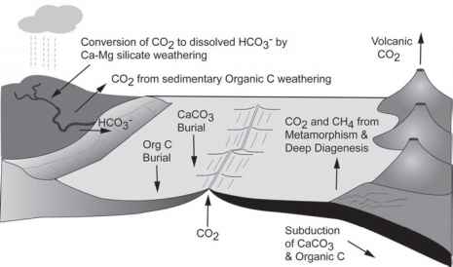
During the Neoproterozoic, the Earth was covered in glaciers from the poles to the equator. Twice. (They occurred ~710 and ~640 million years ago.) Sedimentary deposits provide strong evidence for these “Snowball Earth” events, though exactly what caused them to start and stop is still up for discussion.

One leading hypothesis for how the Earth exited its “snowball state” relates to the interplay between volcanism, glaciation, and the geologic carbon cycle. (As a helpful guide, a diagram of the geologic carbon cycle is on the right.)

Explain how glaciation could affect volcanism, and how this—through effects on the carbon cycle—led to the warming of the planet and the end of Snowball Earth. (4 points)

Glaciers put pressure on magma chambers, increasing the likelihood of volcanic eruptions (1 point)

Volcanoes release carbon dioxide into the atmosphere (1 point)

Because of ice coverage, there is no weathering to remove and bury carbon dioxide (1 point)

Which leads to a buildup of carbon dioxide in the atmosphere, warming the climate (1 point)
- (1/2 point) for only “carbon dioxide warms atmosphere” (the key idea here is the buildup)
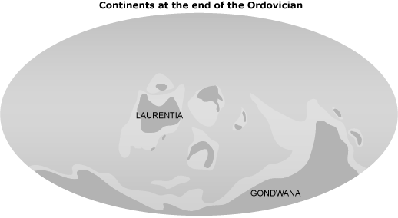
2: PALEOZOIC, ORDOVICIAN.
The Phanerozoic is punctuated by five big mass extinctions, and the first of these extinctions was the Late Ordovician Mass Extinction. The leading hypothesis for the cause of this mass extinction is glaciation, which led to sea level fall, global cooling, and habitat loss.

Explain how the continent configuration at the end of the Ordovician (shown to the right) contributed to the onset of a global cooling. Consider the location of Gondwana. (2 points)

Gondwana was at the South Pole (1 point)

Ice could easily form on continent at south pole without floating away, allowing ice to build up and form quickly (1 point)

3: CENOZOIC, OLIGOCENE.
Around 10-20 million years ago, the Isthmus of Panama formed, connecting the continents of North and South America. The closure of the seaway that used to flow between the Atlantic and the Pacific had drastic effects on life, the ocean and climate.

Explain how the formation of the Isthmus of Panama affected (a) the mammals in North America, (b) the climate in present-day England, and (c) the onset of Northern Hemisphere glaciation. (4 points)

A: Many South American mammals, such as the opossum, migrated to North America and have been here since (1 point)

B: Redirection of ocean circulation brought warm water up to the northwest Atlantic (1 point)

B: This warmer water = warmer atmosphere = warmer England (1/2 point)

C: This warmer water moving northward = More evaporation = More precipitation (1 point)

D: More precipitation = More snow = More glaciers (1/2 point)

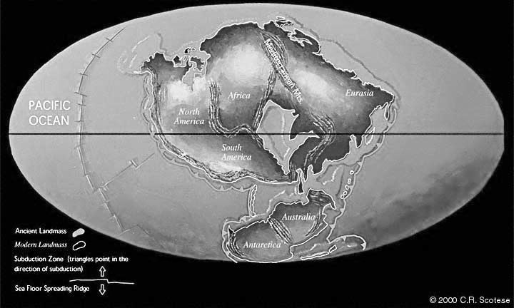
4: THE FUTURE.
It’s always hard to predict the future, but that doesn’t stop people from trying. To the right is one hypothesis of what people think continental configuration might look like in 250 million years. Note how a supercontinent has formed near the equator.

Considering this continent configuration, let’s try and predict what the global climate might be like. (Let’s assume humans are extinct by then, the Anthropocene has ended, and the effects of human-induced climate change are over.)

Compared to the current continental configuration, would the temperature at the equator be warmer or cooler than it is now? What about at the North Pole? Why? (3 points)
Equator: Cooler (1/2 point)

Because of higher albedo of continents v. ocean; etc. (1 point)

Poles: Warmer (1/2 point)

Because of lower albedo of ocean v. continent; no place for ice to form/accumulate; circulation of warmer water (1 point)

Consider the location marked by the circle near the center of the supercontinent. What would you expect the temperature and precipitation to be like at this location? (2 points)

Hot (1/2 point)

Dry (1/2 point)

Because of the continental interior not getting the moisture/precipitation from the ocean, so it’s dryer (1/2 point)

Also right on the equator, so relatively warm (1/2 point)

