MICROBE MISSION PRACTICE TEST (2010-2011)

NAME 1:
NAME 2:
TEAM NUMBER: |  | SCHOOL:

Note: This is a practice test based on the 2010-2011 rules for Microbe Mission.
All answers will be written in the test. There is no answer sheet for this test.
The answer key is separated from this test and is not included in this file.

STATION 1: TYPES AND PARTS OF A MICROSCOPE

1. What is the source of illumination in a light compound microscope?
______________________________________________________________________________

2. What is the source of illumination in a confocal microscope?
______________________________________________________________________________

3. Name one type of microscope in which electron beams form the image of the specimen.
______________________________________________________________________________

4. Which part of a light compound microscope is used for controlling the amount of light that reaches the specimen?
______________________________________________________________________________

5. What is the purpose of the ocular in a light compound microscope?
______________________________________________________________________________

STATION 2: PRINCIPLES OF MICROSCOPY

6. How is the total magnification of a microscope determined?
______________________________________________________________________________

7. What happens to the size of the field of view when changing objectives from high power to low power?
______________________________________________________________________________

8. How many micrometers is 1.32 millimeters?
______________________________________________________________________________

9. If an organism viewed through a microscope appears to be moving , in which direction is it actually moving?
A.  B.  C.  D. 
10. What is the highest total magnification by a microscope equipped with a 12x ocular, and three objectives; 5x scanning, 10x low, and 43x high?
______________________________________________________________________________

STATION 3: MICROBIAL DISEASES

Name the type of microbe that causes each disease.

Disease | Microbe
11. Histoplasmosis
12. Mad Cow Disease (bovine spongiform encephalopathy)
13. Anthrax
14. Rabies
15. Acquired immune deficiency syndrome (AIDS)

STATION 4: PROKARYOTIC/EUKARYOTIC CELLS AND CELL PARTS

16. Give an example of a prokaryotic cell and a eukaryotic cell.
______________________________________________________________________________

17. Where does the final modification of proteins take place in a eukaryotic cell?
______________________________________________________________________________

18. What type of cell does not have membrane bound organelles (prokaryotic/eukaryotic)?
______________________________________________________________________________

19. What is the storage place in a eukaryotic cell called?
______________________________________________________________________________

20. What part of a plant cell is used for protection and support but not is found in an animal cell?
______________________________________________________________________________
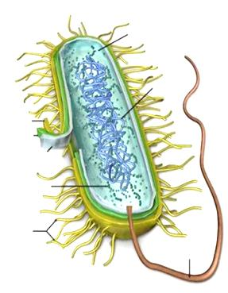

21. Is the microbe shown above right prokaryotic or eukaryotic?
______________________________________________________________________________
STATION 5: BACTERIA, ARCHAEA, VIRUSES, ALGAE, PROTOZOA, PRIONS, VIRUSES, ETC.

22. Name two types of prokaryotic microbes.
______________________________________________________________________________

23. How do algal blooms harm other organisms in the water such as fish?
______________________________________________________________________________

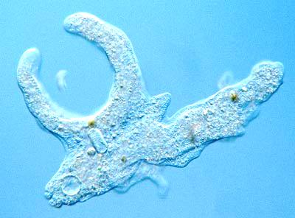

24. What type of microbe is in the picture shown above?
______________________________________________________________________________

25. Fungi are single-celled as _______________________ and are in multicellular clusters as _______________________ .

26. About how many cells of fungi are found in a teaspoon of topsoil?
A. 200,000 B. 6,000,000 C. 1800 D. 120,000

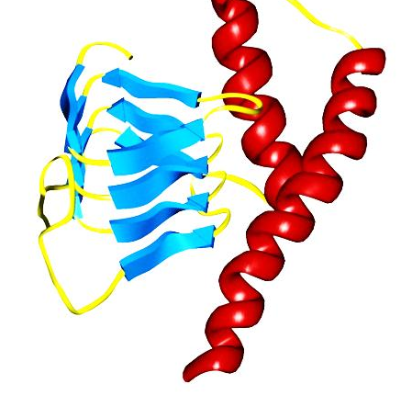

27. What type of microbe is the one shown above?
______________________________________________________________________________

28. Name one disease that it causes in humans.
______________________________________________________________________________

29. Name one disease that it causes in other animals.
______________________________________________________________________________
STATION 6: MICROBIAL GROWTH CURVE

30. In which phase is the number of nonviable cells increasing?
______________________________________________________________________________

31. In which phase is the number of viable cells increasing?
______________________________________________________________________________

32. What is happening during the stationary phase?
______________________________________________________________________________

33. What is the name for the phase in which there are few or no cells?
______________________________________________________________________________

STATION 7: DICHOTOMOUS KEY

Identify each specimen using the dichotomous key on the next page.
34. Specimen A
35. Specimen B
36. Specimen C
37. Specimen D
38. Specimen E
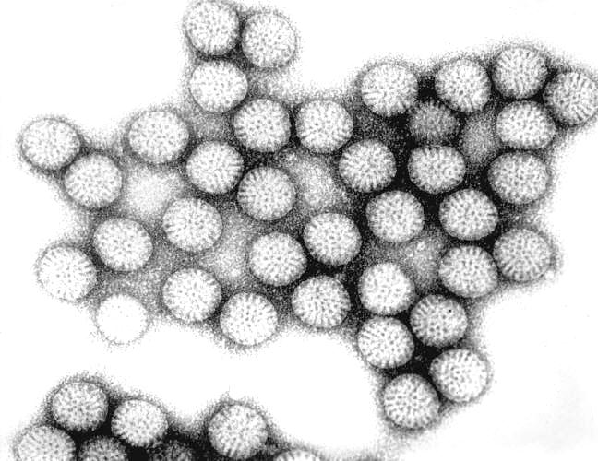
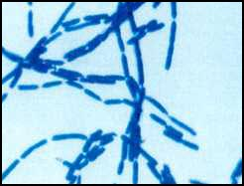
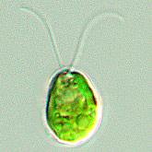
A > B > C >

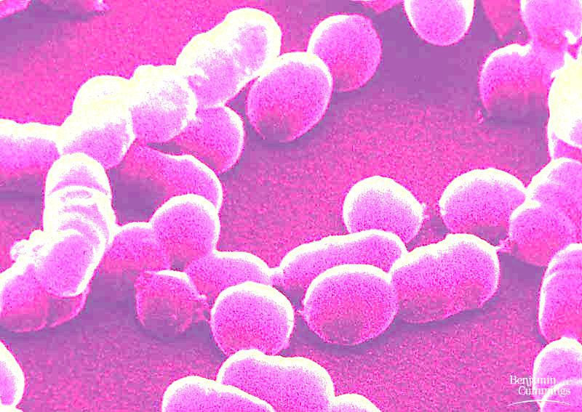
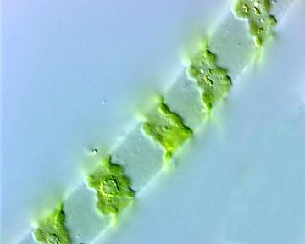
D > E >

Photos are not to scale.
DICHOTOMOUS KEY FOR STATION 7

1. Is spherical or elliptical in shape . . . . . . . . . . . . . . . . . . . . . . . . . . . . . . . . . . . . 2
1. Is not spherical or elliptical in shape . . . . . . . . . . . . . . . . . . . . . . . . . . . . . . . . . 3

2. Rod-shaped . . . . . . . . . . . . . . . . . . . . . . . . . . . . . . . . . . . . . . . . . . . . . . . . . . bacillus bacteria
2. Spiral-shaped filaments . . . . . . . . . . . . . . . . . . . . . . . . . . . . . . . . . . . . . . . . . spirogyra

3. Has chlorophyll and flagella . . . . . . . . . . . . . . . . . . . . . . . . . . . . . . . . . . . . . Clamydomonas
3. Does not have chlorophyll . . . . . . . . . . . . . . . . . . . . . . . . . . . . . . . . . . . . . . . 4

4. Long chain-like clusters . . . . . . . . . . . . . . . . . . . . . . . . . . . . . . . . . . . . . . . . . coccus bacteria
4. Non chain-like and irregularly shaped clusters . . . . . . . . . . . . . . . . . . . . . . . . rotavirus

STATION 8: MICROBES IN DAILY LIFE

39. What type of microbe causes mold?
______________________________________________________________________________

40. What type of microbe ferments milk into products such as yogurt?
______________________________________________________________________________

41. What is the name of the process in which food, usually a liquid such as milk, is heated to destroy disease-producing microbes?
______________________________________________________________________________

