Cell Biology Event Practice Exam
Most of the information on this test can be found on http://scioly.org/wiki/index.php/Cell_Biology.
For questions 1-5, state whether the structures make up the primary structure, secondary structure, tertiary structure or quaternary structure of proteins.
- Beta pleats and alpha helixes
- Multiple polypeptide chains
- Unique shape of protein
- A sequence of amino acids
- Interactions between side chains

- What are four functions of enzymes?

- Name three constituents of the cell membrane.

- What is the function of cholesterol in the cell membrane?

- Which of the following have a 9+2 arrangement?

  - Ovum
  - Cholesterol
  - Cilia
  - Enzymes
  - Phospholipids

- Which of the following maintains shape and prevents damage for the cell membrane?

  - Integral proteins
  - Peripheral proteins
  - Cytoskeleton
  - Amphipathic phospholipids
  - Flagella

- Which of the following is considered passive transport?

  - Sodium-potassium pump
  - Pinocytosis
  - Phagocytosis
  - Exocytosis
  - Facilitated diffusion

- The passive transport of water down its concentration gradient is

  - Facilitated diffusion
  - Pinocytosis
  - Exocytosis
  - Diffusion
  - Osmosis

- What is the ratio of potassium to sodium in a sodium-potassium pump?

  - 1:1
  - 1:2
  - 2:1
  - 3:2
  - 2:3

- When an animal is placed into a hypotonic environment, explain what happens to the cell.

Circle the best answer choices below:
- A [ plant cell / animal cell ] becomes flaccid when it is placed in a(n) [ hypertonic / isotonic / hypotonic ] environment.
- The ideal environment for a plant cell is [ hypertonic / isotonic / hypotonic ].
- The pump that removes excess water from a plant is called the [ osmotic pump / cytosolic pump / contractile vacuole ].

- Fill in the following diagram with the steps of the cell cycle in proper order. G1, G2, M, S.

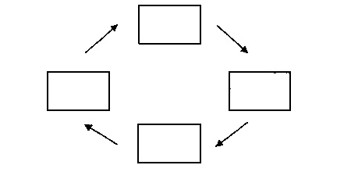
M

- During which stage of the cell cycle does the DNA replicate?

- What is the function of cyclins in the cell cycle?

The following images were drawn of a cell as it underwent mitosis. State the name of the phase represented in each photo.
- __________________________________________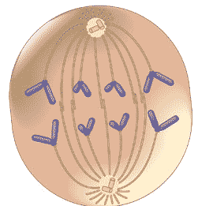
- __________________________________________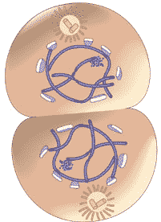
- __________________________________________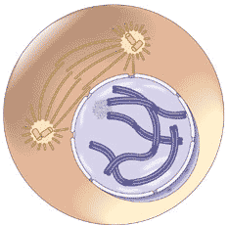
- __________________________________________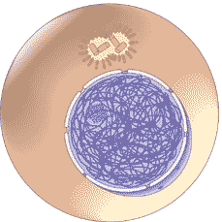
- __________________________________________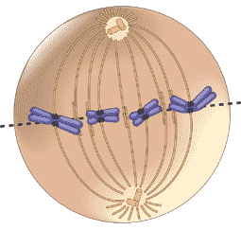
- What is the correct sequence of photos above?

- What is the name of the structure being formed in the cell below?

  - Cleavage furrow
  - Cell plate
  - Cell wall
  - Contractile ring
  - Cell ring

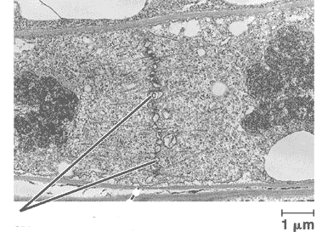
- True/False: Pyrimidines contain a single ring structure.

- Which two nitrogenous bases are considered to be purines?

- If a strand of DNA contains 30% guanine, what is the percentage of cytosine present in the strand?

- If a strand of DNA contains 22% adenine, what is the percentage of guanine present in the strand?

- What is the function of histones in chromosomes?

For the following statements, write the organelle being described.

- Ribosomes are produced here
- Bound ribosomes are found here
- Most cellular metabolism occurs here
- Packaging of macromolecules for transport
- Sac of hydrolytic enzymes necessary for cell digestion
- Protects the cell from its production of hydrogen peroxide
- Energy center
- Site of protein synthesis
- Stores nutrients and waste products, very large in plant cells
- Rigid surrounding of a plant cell made of cellulose
- Site of photosynthesis

- Put into order from largest (1) to smallest (4) in diameter.
_______ Actin filaments
_______ Mitochondria
_______ Intermediate filaments
_______ Microtubules
- Which of the following would you not find in a prokaryotic cell?

  - Cell membrane
  - Cell wall
  - Cytoplasm
  - Mitochondria
  - Vacuole

- Compare and contrast the DNA in a prokaryotic and eukaryotic cell.

47-50. Fill in the diagram below.
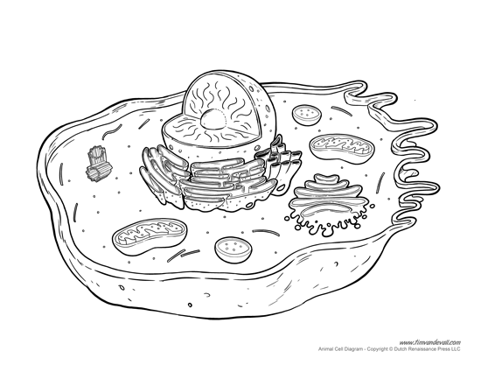
50. ____________________
49. ____________________
48. ____________________
47. ____________________
When you are finished with this packet, answer the questions on the following links:
This test was made as a refresher, and is probably much simpler than the actual event. The following links are made much harder than this exam: (Remember: Answer ALL questions).
http://scioly.org/wiki/images/9/95/FIXED_reefownage_Cell_Biology_test.pdf
http://scioly.org/wiki/images/1/16/SSSS_Cell_Bio_Test_by_Maples6.pdf
Answer Key
- (1) Secondary
- (1) Quaternary
- (1) Tertiary
- (1) Primary
- (1) Tertiary
- (3) NOT LIMITED TO THE ANSWERS PROVIDED
Provide energy to cells
Build new cells
Aid in digestion
Break down complex molecules (“substrate” = reactant)
Catalysts (speed up chemical reactions without being used up or altered)
- (2) NOT LIMITED TO THE ANSWERS PROVIDED
Phospholipids, cholesterol, proteins (integral, peripheral), hydrocarbon tails, glycerol
- (1) Temperature regulation
- (1) C
- (1) C
- (1) E
- (1) E
- (1) E
- (1) It will explode/lyse.
- (1) Plant cell, isotonic
- (1) Hypotonic
- (1) Contractile vacuole
- (1) M -> G1 (right) -> S (bottom) -> G2 (left)
- (1) S
- (1) NOT LIMITED TO ANSWERS PROVIDED There are enzymes in the cell called cyclin-dependent kinases that are present at all times but need a specific cyclin to bind to them before they become active. When they are activated by a cyclin they push the cell into the next phase of the cell cycle by modifying other enzymes. The cyclins are specific to different cell cycle checkpoints.
- (1) anaphase
- (1) telophase
- (1) prophase
- (1) interphase
- (1) metaphase
- (1) 24, 23, 25, 21, 22 OR interphase, prophase, metaphase, anaphase, telophase
- (1) B
- (1) true
- (1) adenine and guanine (acceptable: A and G)
- (1) 30
- (1) 28
- (1) keep chromosome shape
- (1) nucleolus
- (1) rough ER (ER accepted)
- (1) cytosol OR cytoplasm
- (1) golgi body
- (1) lysosome
- (1) peroxiosome
- (1) mitochondria
- (1) ribsome
- (1) vacuole
- (1) cell wall
- (1) chloroplast
- (1) actin filaments -> intermediate filaments -> microtubules -> mitochondria
- (1) D
- (1) ANSWERS NOT LIMITED TO THOSE LISTED
Prokaryote – one long ring structure, nucleoid region
Eukaryotic – many strands, nucleus
- (1) ER, smooth ER, rough ER, bound ribosome OR ribosome
- (1) plasma membrane, cell membrane, phospholipid, protein, etc.
- (1) mitochondria, cristae, matrix, ribosome, free ribosome
- (1) golgi body, trans face, cis face

