Earth’s Fresh Waters test answer sheet
By the way limnology is SOMETIMES considered the study of freshwater. In reality it isn’t exactly and is actually the study of inland waters. This especially includes lakes, ponds, rivers, springs, streams, wetlands. Also, when you don’t know the answer use common sense (some of the pictures are hard, but at least make educated guesses (in earth science it is complete common sense minus the laws, fill in pictures, etc.) . My personal recommendation is to do two things: look at as much random info in your memory as possible and link it to water (have fun with it) and to look at websites other than Wikipedia. I have to admit Wikipedia is good, but it seems to be a weakness in which getting info. from multiple sources makes the test more diverse (JD’s tests for example with the waterfalls). By the way for certain questions that you did guess I did actually give half to a quarter credit meaning you would do better if you gave decent guesses that applied to the question.
Label both the black and white boxes:
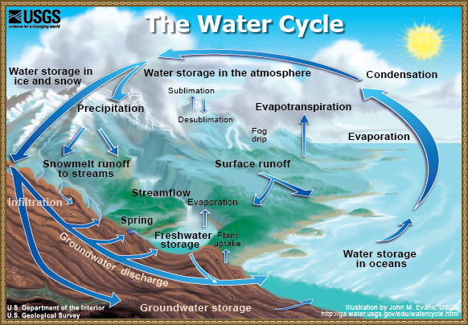
- Compare Hard and Soft water. Such answers include, but are not limited to: Hard water consists of concentrations of Ca²⁺ and Mg²⁺. Soft water involves the removal of hardness ions, sometimes with distillation. Hard water has certain positive effects like getting calcium or magnesium. It is also negative because it can lead to the consumption of toxic metals or heavy metals.
- By adding this element to water tooth decay can occur. Such answers include, but are not limited to: Fluoride or sugar.

- What does USGS stand for and when was it founded? The United States Geologic Survey, founded in 1879
- How does water play a role in the creation of Death Valley? Answers include, but are not limited to: The salt beds indicate the presence of water. Also it was a lake filled with water from the ice age. It turned into a desert probably towards the end of the ice age and also the fact that the rocks are made of limestone and sandstone indicate the presence of a shallow sea.
- Assuming within a time range of 100 years, 65 floods occur. What is the recurrence interval and probability? 100/65=1.54 the probability would be 1/1.54=.65 or 65% chance.
- What type of pollution was produced from the Love canal? What did this pollution affect? Nonpoint source pollution affected Niagara Falls.
- What could be the problem with getting one’s water supply from groundwater? Bacteria could have infested the ground water or the fact that it goes through dirt infested with various organisms could be a problem. Chemicals could also seep into the ground.
- In 2009 how much water came from the Catskill/Delaware area? 100%
- What two falls is Niagara Falls split into? Horseshoe Falls and American Falls.
- What is the main function behind a canal like Erie Canal and what was the purpose of Erie Canal? What is the city where the canal may have been? Answers include, but are not limited to: The canal’s main function was to control the height of the water and transport goods from all across the Delaware River or Mississippi river. It was almost in New Orleans.
- How can lead get into drinking water? It can get into drinking water from pipes, batteries, various metallic objects, glass or paint, etc.
- Why did Dutch farmers perform clamming in New York City? Near what canal was made this
made (Hint: it was not the Erie Canal)? Salt water went into large tides that were ideal for bivalves and made clams come to shore. It was made near Gowanus Canal.
- What is a riprap? Rock or other material used to armor shorelines. It helps in erosion control.
- Draw four types of deltas and describe each (there are many types).
Arcuate (fan-shaped) delta - e.g., Nile River. Has many active, short distributaries taking sediment to their mouths. The receiving (ambient) waters are rather shallow and have relatively even wave action arriving perpendicular to the shore with minimal longshore current. As the sediment exits the many distributary mouths, the waves push it back, so the coastline is rather smooth. 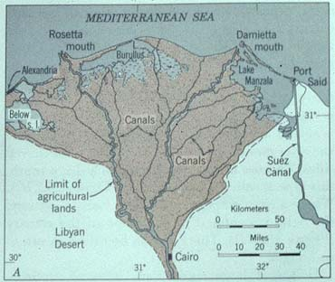
* Bird-foot (shaped like a bird foot) delta - e.g., Mississippi River. Tend to have one or a very few major distributaries near their mouths. The receiving basin has currents that carry the sediment away as it exits the distributary mouth. There is a broad, shallow shelf that deepens abruptly, so the trend is to grow long and thin like a bird's toe. 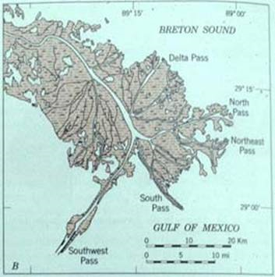
3. Cuspate (tooth-shaped) delta - e.g., Tiber River of Italy. Usually has one distributary emptying into a flat coastline with wave action hitting it head-on. This tends to push the sediment back on both sides of the mouth, with a "tooth" growing out onto the shelf. 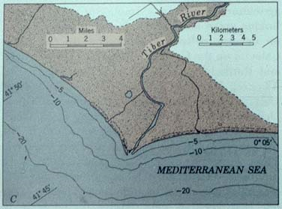
4. Estuarine delta - e.g., Seine River of France. This type of delta has a river that empties into a long, narrow estuary that eventually becomes filled with sediment (inside the coastline).
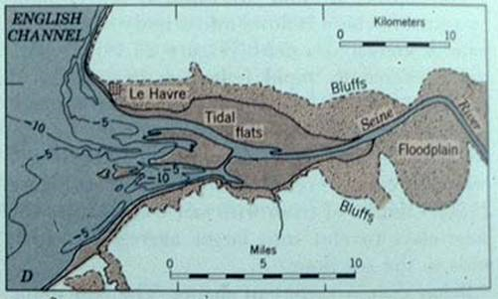

Inland deltas
Okavango Delta

In rare cases the river delta is located inside a large valley and is called an inverted river delta. Sometimes a river will divide into multiple branches in an inland area, only to rejoin and continue to the sea; such an area is known as an inland delta, and often occur on former lake beds. The Inner Niger Delta is the most notable example. The Amazon has also an inland delta before the island of Marajó.

In some cases a river flowing into a flat arid area splits into channels which then evaporates as it progresses into the desert. Okavango Delta in Botswana is one well-known example.
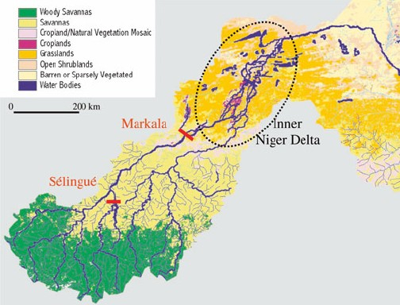
Wave-dominated deltas

In wave dominated deltas, wave erosion controls the shape of the delta, although deposition still outweighs the amount of erosion and the delta is able to advance into the sea. Deltas of this form, such as the Nile Delta, tend to have a characteristic Greek-capital-delta shape \left(\Delta\right).
The Ganges Delta in India and Bangladesh is the largest delta in the world and it is also one of the most fertile regions in the world.
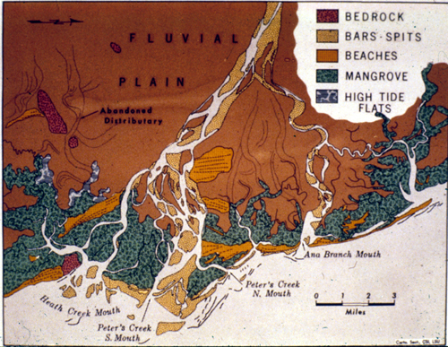
Tide-dominated deltas

Erosion is also an important control in tide dominated deltas, such as the Ganges Delta, which may be mainly submarine, with prominent sand bars and ridges. This tends to produce a "dendritic" structure. Tidal deltas behave differently from river- and wave-dominated deltas, which tend to have a few main distributaries. Once a wave- or river- distributary silts up, it is abandoned, and a new channel forms elsewhere. In a tidal delta, new distributaries are formed during times when there's a lot of water around - such as floods or storm surges. These distributaries slowly silt up at a pretty constant rate until they fizzle out. 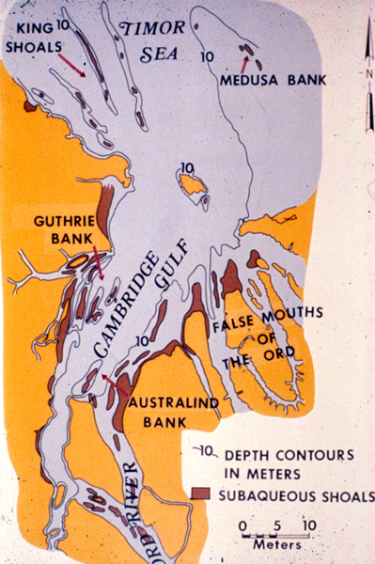

Gilbert deltas

A Gilbert delta (named after Grove Karl Gilbert) is a specific type of delta that is formed by coarse sediments, as opposed to gently-sloping muddy deltas such as that of the Mississippi. For example, a mountain river depositing sediment into a freshwater lake would form this kind of delta. While some authors describe both lacustrine and marine locations of Gilbert deltas, others note that their formation is more characteristic of the freshwater lakes, where it is easier for the river water to mix with the lakewater faster (as opposed to the case of a river falling into the sea or a salt lake, where less dense fresh water brought by the river stays on top longer).

G.K. Gilbert himself first described this type of delta on Lake Bonneville in 1885. Elsewhere, similar structures can be found e.g. at the mouths of several creeks flowing into Okanagan Lake in British Columbia and forming prominent peninsulas at Naramata (49°35′30″N 119°35′30″W﻿ / ﻿49.59167°N 119.59167°W﻿ / 49.59167; -119.59167), Summerland (49°34′23″N 119°37′45″W﻿ / ﻿49.57306°N 119.62917°W﻿ / 49.57306; -119.62917), or Peachland (49°47′00″N 119°42′45″W﻿ / ﻿49.7833333°N 119.7125°W﻿ / 49.7833333; -119.7125)

- How do stream drainage patterns occur? These include annular, parallel, trellis, rectangular, dendritic, radial, centripetal and deranged. Draw each one
Stream drainage patterns occur from differences in sediment structure.
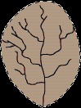A dendritic drainage pattern is the most common form and looks like the branching pattern of tree roots. It develops in regions underlain by homogeneous material. That is, the subsurface geology has a similar resistance to weathering so there is no apparent control over the direction the tributaries take. Tributaries joining larger streams at acute angle (less than 90 degrees).
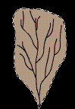Parallel drainage patterns form where there is a pronounced slope to the surface. A parallel pattern also develops in regions of parallel, elongate landforms like outcropping resistant rock bands. Tributary streams tend to stretch out in a parallel-like fashion following the slope of the surface. A parallel pattern sometimes indicates the presence of a major fault that cuts across an area of steeply folded bedrock. All forms of transitions can occur between parallel, dendritic, and trellis patterns.
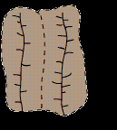Trellis drainage patterns look similar to their namesake, the common garden trellis. Trellis drainage develops in folded topography like that found in the Appalachian Mountains of North America. Down-turned folds called synclines form valleys in which resides the main channel of the stream. Short tributary streams enter the main channel at sharp angles as they run down sides of parallel ridges called anticlines. Tributaries join the main stream at nearly right angles.
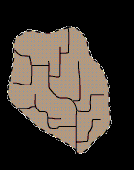The rectangular drainage pattern is found in regions that have undergone faulting. Streams follow the path of least resistance and thus are concentrated in places were exposed rock is the weakest. Movement of the surface due to faulting off-sets the direction of the stream. As a result, the tributary streams make shape bends and enter the main stream at high angles.
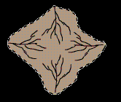The radial drainage pattern develops around a central elevated point. This pattern is common to such conically shaped features as volcanoes. The tributary streams extend the headward reaches upslope toward the top of the volcano.
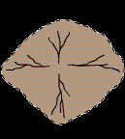The centripetal drainage pattern is just the opposite of the radial as streams flow toward a central depression. This pattern is typical in the western and southwestern portions of the United States where basins exhibit interior drainage. During wetter portions of the year, these streams feed ephemeral lakes, which evaporate away during dry periods. Salt flats are created in these dry lake beds as salt dissolved in the lake water precipitates out of solution and is left behind when the water evaporates away.

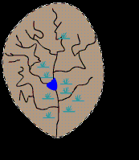Deranged or contorted patterns develop from the disruption of a pre-existing drainage pattern. Figure 18.11 began as a dendritic pattern but was altered when overrun by glacier. After receding, the glacier left behind fine grain material that form wetlands and deposits that dammed the stream to impound a small lake. The tributary streams appear significantly more contorted than they were prior to glaciation.
An annular drainage pattern forms when layers of rock are uplifted into a dome or down-warped into a basin, and the stream channels preferentially follow the weakest concentric beds of rock.
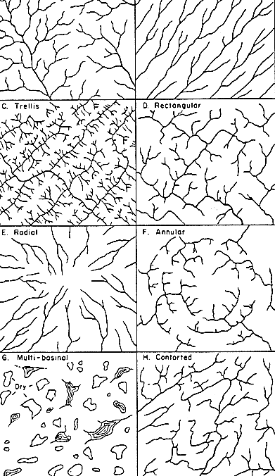

- Compare lateral and vertical accretion. The digging away of material at the outer bank of a meandering stream and the simultaneous building up to the water level by deposition of material brought there by pushing and rolling along the stream bottom. To sum it up quickly the opposite. (actually I like your picture too)
- What is the world’s largest source of frozen fresh water? Glaciers
- What is a dry lake bed called? Playa
- What are most lakes in New York made from? Glaciers
- What is the world’s smallest river and what lake does it drain into? D river into Devils lake or the Roe river
- What are the four largest rivers in the world? Nile, Amazon, Yangtze, Mississippi
- What classification of water is the world’s largest drainage basin? Second and third? Atlantic Arctic and Pacific Oceans
- What type of pollution is present in the picture below? Nonpoint source pollution
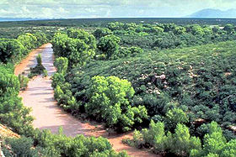
- In this picture? Point source pollution
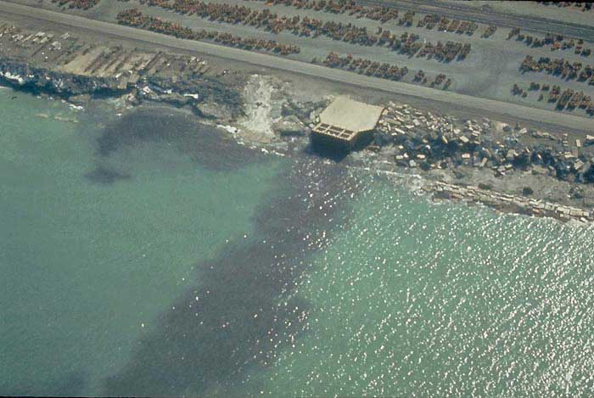
- What type of lake is Yellowstone Lake? What are characteristics of these lakes? Crater lakes and they are acidic and atop volcanoes or mountains
- What does the secchi disk involve? What is the formula for it? Takes into account the transparency of a body of water. Formula: 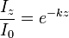
- Fertilizer being dumped into various types of water is what type of pollution? It promotes the growth of what type of organism? What type of lake do these organisms thrive in?
- What is Le Chatalier’s principle? If a chemical system at equilibrium experiences a change in concentration, temperature, volume, or partial pressure, then the equilibrium shifts to counteract the imposed change and a new equilibrium is established. The principle is used to manipulate the outcomes of reversible reactions, often to increase the yield of reactions. CO + 2 H2 ⇌ CH3OH
- Primarily, acid rain is caused from what two emissions? Sulfur dioxide and nitrogen oxides.
- Discuss wet vs. dry deposition. Dry deposition includes gravitational sedimentation, impaction, diffusion or Brownian motion and turbulence. These consist of molecules hitting each other or essentially being physically moved by some force other than water or water like substances. Wet deposition comes from any deposition caused by water including precipitation, snow or clouds.
- What gas additive was used around the 1970’s-1990’s to reduce air pollution? Why was it banned (Hint: its chemical formula is C₅H₁₂O)? What other gas additive in the early 1900’s caused an even worse problem? Methyl tert-butyl ether and lead
- During the Vietnam War these herbicides were extremely deadly to civilians and veterans. It was also able to contaminate waters. What was the name of the group of these herbicides? Rainbow herbicides.
- The Bhopal disaster of 1984 in India produced what type of pollution into water? What were some of the substances that poisoned many? Nonpoint source pollution. phosgene, hydrogen cyanide, carbon monoxide, hydrogen chloride, oxides of nitrogen, monomethyl amine (MMA) and carbon dioxide, either produced in the storage tank or in the atmosphere.
- What famous river in Great Britain was extremely polluted? What type of river is it? What type of pollution was this river affected by? River Thames is a tidal river and was affected by nonpoint source pollution (sewage).
- What type of delta(s) is/are present in the Mississippi river? Bird’s foot delta and stream dominated 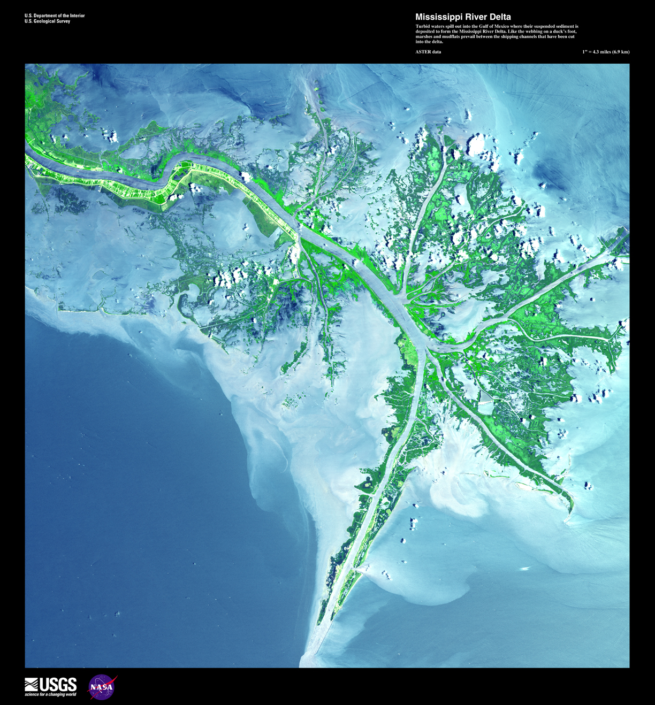

- Only 2.8% of all the water on Earth is fresh water. However, about 74% of this fresh water is frozen in glaciers and ice caps, and 99% of the liquid water is what? Groundwater
- Which of the following processes describes water seeping into the ground? Percolation/infiltration
- Precipitation that falls onto the Earth’s surface first (1) infiltrates into the regolith, then (2) percolates downwards through the (3)unsaturated zone into the (4) the water table
- All water on earth moves from one storage or transportation system to another, forming a hydrologic cycle. These storage or transportation systems are called (1) reservoirs and the amount of time that a water molecule spends in any one of them is (2) called the residence time.
- Which reservoir typically has the longest residence time for water molecules? Ice sheets/oceans
- Which reservoirs have the shortest residence time for water molecules? Living organisms (humans/animals). A few answers could be accepted, but this is true mainly because it is the smallest regularly (I guess one could count puddles, but that is debatable).
- Name an example of a feature not produced by alluvium. Rock slides
- Name a feature not associated with floodplains. Distributaries
- Deltas get their name from the Greek letter, Δ. What is the only type of delta that really has this triangular shape when viewed from above? Wave-dominated
- If you are standing in an arid or semi-arid region looking at the features around you produced by running water, what features might you see? Braided streams, bars, bajadas, alluvial fans
- What is this a map of, label it (you may label either map you prefer):

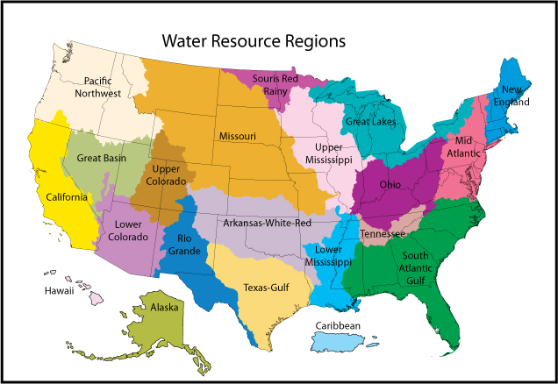

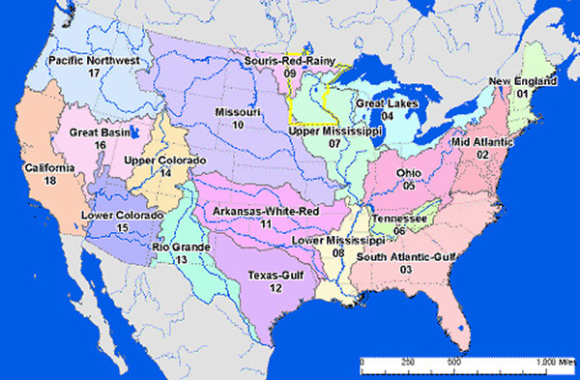

Concentrations of constituents in each of the aquifers on long island are minimal. Still, what substances are more concentrated and what are less concentrated? (least to greatest)Nitrate, magnesium, potassium, iron, calcium, chloride, sodium, sulfate, bicarbonate
- 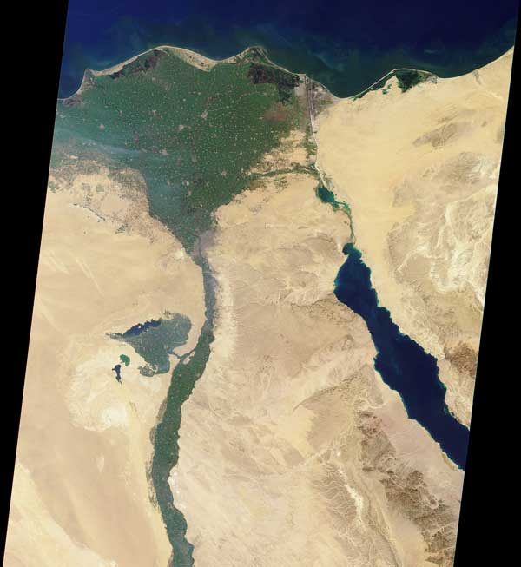What is this a picture of and what type of delta is present? Nile river’s arcuate delta
- In this movie one of the characters only drinks rainwater or grain alcohol. What substance being added to water does he think is an evil plot by communists? Name three substances he thinks they were trying to add this substance to other than water. Is the fact that he only drinks rainwater or grain alcohol a positive or a negative? If he drank water with this substance what would be some positive or negative effects (Hint: if you saw the movie he was trying to protect his precious bodily fluids)? Bonus: What was the name of this character? Dr. Strangelove or how I learned to love the bomb. Fluoride. Flour, ice cream, fruit juices, soup, sugar, milk, salt. He only drinks extremely freshwater and doesn’t get many other nutrients. He also probably doesn’t too sick from his water as long as it is purified and whatnot. Teeth decay…teeth strengthening. General Jack D. Ripper (ok admittedly half or ¾ of the question is useless, but some of it was basically just where you get your water from which does have to do with freshwater).
- This river that runs through France has Atlantic salmon and a pH level of 8.46. Does this indicate good or bad water quality? If not what could improve the river and if so explain. Bonus: Name random facts about the river if you want. In addition what type of pollution has been present in this river? Seine. It is a good quality. Although, it does have sewage which could be gotten rid of. This is nonpoint source pollution. (a little general, but for more info. about the seine river you can google it because there is an abundance of websites on it).
- List five types of point and nonpoint source pollution. Describe the major effect of point and nonpoint source pollution. Are there some any advantages at all to “pollution”? Point: Water pollution from an oil refinery wastewater discharge outlet Noise pollution from a jet engine Disruptive seismic vibration from a localized seismic study Light pollution from an intrusive street light
Thermal pollution from an industrial process outfall Radio emissions from an interference-producing electrical device. Nonpoint: sediment, nutrients, heavy metals, toxic chemicals, pathogens, acids and salts. This can be controlled and can help like with irrigation.
- TI Chl P SD
<30—400 0—2.6 0—12 >8—4
40—50 2.6—20 12—24 4—2
50—70 20—56 24—96 2—0.5
70—100+ 56—155+ 96—384+ 0.5—<0.25
What is this chart above detailing? List what each level of statistics is and explain the organisms that thrive in each. Compare different types of algae or organisms. Remember to name each of the abbreviations. Trophic index of lakes. From top to bottom it explains oligotrophic, mesotrophic, eutrophic and hypereutrophic. Trophic Index (TI), chlorophyll (Chl), phosphorus (P, both micrograms per litre), Secchi depth (SD, metres), and Trophic Class. More nutrition creates more life. Algal growths sometimes occur killing off other life. Periphyton can live in contaminated or polluted waters.
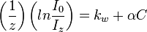 where z = the depth at which the disk disappears,
I0 is the intensity of light striking the water's surface,
Iz is about 10% of I0 and is considered a constant,
kw is a coefficient for the attenuation of light by water and dissolved substances,
α is treated as a constant with the units of square meters per milligram and
C is the concentration of particulate matter in units for milligrams per cubic meter.
- Where do alluvial fans form and why? An alluvial fan is a fan-shaped deposit formed where a fast flowing stream flattens, slows, and spreads typically at the exit of a canyon onto a flatter plain.
- What is stream capture? Stream capture, river capture, or stream piracy is a geomorphological phenomenon occurring when a stream or river drainage system or watershed is diverted from its own bed, and flows instead down the bed of a neighbouring stream. This can happen for several reasons, including: Tectonic earth movements, where the slope of the land changes, and the stream is tipped out of its former course. Natural damming, such as by a landslide or ice sheet. Erosion, either Headward erosion of one stream valley upwards into another, or Lateral erosion of a meander through the higher ground dividing the adjacent streams. Within an area of karst topography, where streams may sink, or flow underground (a sinking or losing stream) and then reappear in a nearby stream valley.
- Explain why natural levees build up along the banks of streams the flood often. By building levees up you are able to "funnel" more water downstream to a point that has not been built up! This will cause more water to over flow the river banks creating a worse flood condition! Banks of coarse river load and other material that has been transported down river, that are made when the river floods and bedload is carried out wider then before and desposited. It is left with the river recedes creating a higher banks
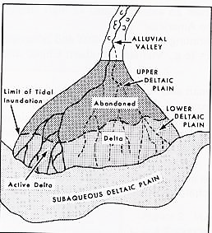
- Label and describe what this is a picture of:

- The pictures below were taken from which website? Label them for each arrow, each white box and the sediment for the second picture. For the third picture describe what it is a graph of, label the axes and show the order of the variable on the right axes (basically just label everything you possibly can + a description). Describe each sediment layer on the second/first picture. What are the main differences and which would deposited first. On the third picture what sediment would be eroded at .01 cm/s and what would be eroded and 1000 cm/s.
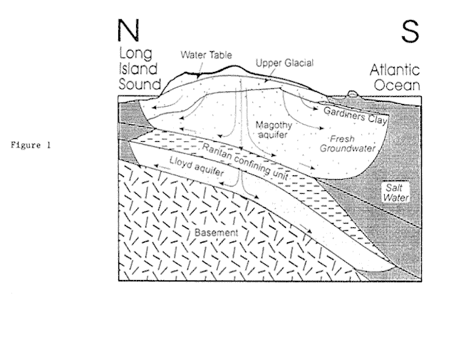

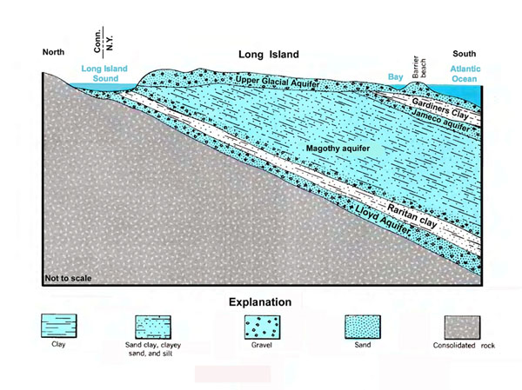

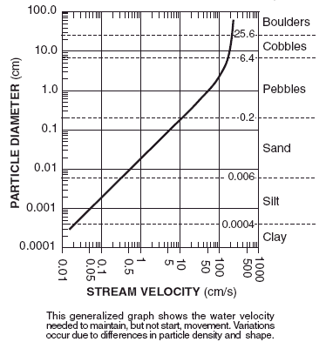

- Define and if only told the overlying background to the word then list the following terms (also a few terms will be in French, for a bonus name the literal translation of each, try and spot them all). ? If you want you can add extra info. For extra points:
Arroyo- An arroyo, a Spanish word translated as brook, and also called a wash is usually a dry river, creek or stream bed—gulch that temporarily or seasonally fills and flows after sufficient rain.
aits or eyots- An ait (or eyot) is a small island. It is especially used to refer to islands found on the River Thames and its tributaries in England.
Cuesta- In structural geology and geomorphology, a cuesta (from Spanish: "slope") is a ridge formed by gently tilted sedimentary rock strata in a homoclinal structure.[1][2] Cuestas have a steep slope, where the rock layers are exposed on their edges, called an escarpment or, if more steep, a cliff. Usually an erosion-resistant rock layer also has a more gentle slope on the other side of the ridge called a dip slope. The steeper slopes face inside anticlinals and outside eroded sinclinals.
Backswamps- is the section of a floodplain where deposits of fine silts and clays settle after a flood. Backswamps usually lie behind a stream's natural levees.
Bayous- is a body of water typically found in flat, low-lying areas, and can refer either to an extremely slow-moving stream or river (often with a poorly defined shoreline), or to a marshy lake or wetland.
Bluffs- a steep promontory, bank, or cliff, esp one formed by river erosion on the outside bend of a meander. A cliff
Benches- a bench or benchland is a long, relatively narrow strip of relatively level or gently inclined land that is bounded by distinctly steeper slopes above and below it. Benches can be of different origins and created by very different geomorphic processes.
Billabongs- Billabong is an Australian English word meaning a small lake, specifically an oxbow lake, a section of still water adjacent to a river, cut off by a change in the watercourse.
Caves- Solutional caves are the most frequently occurring caves and such caves form in rock that is soluble, such as limestone, but can also form in other rocks, including chalk, dolomite, marble, salt, and gypsum. Rock is dissolved by natural acid in groundwater that seeps through bedding-planes, faults, joints etc. Over geological epochs cracks expand to become caves or cave systems. Some caves are formed at the same time as the surrounding rock. These are sometimes called primary caves. Lava tubes are formed through volcanic activity and are the most common 'primary' caves. The lava flows downhill and the surface cools and solidifies. Sea caves are found along coasts around the world. A special case is littoral caves, which are formed by wave action in zones of weakness in sea cliffs. Often these weaknesses are faults, but they may also be dykes or bedding-plane contacts. Corrasional or erosional caves are those that form entirely by erosion by flowing streams carrying rocks and other sediments. These can form in any type of rock, including hard rocks such as granite. Glacier caves occur in ice and under glaciers and are formed by melting. They are also influenced by the very slow flow of the ice, which tends to close the caves again. Fracture caves are formed when layers of more soluble minerals, such as gypsum, dissolve out from between layers of less soluble rock. Talus caves are the openings between rocks that have fallen down into a pile, often at the bases of cliffs. Anchihaline caves are caves, usually coastal, containing a mixture of freshwater and saline water (usually sea water).
Chines- A chine is a steep-sided river valley where the river flows through coastal cliffs to the sea. Typically these are soft eroding cliffs such as sandstone or clays. The word chine originates from the Saxon "Cinan” meaning a gap or yawn.
Crevasse splays- A crevasse splay is a sedimentary feature which forms when an overloaded stream breaks a natural or artificial levee and deposits sediment on a floodplain. This breach can cause large deposits that spread in a pattern similar to that of a river delta.
Crevices vs. crevasses-a crevice occurs in rock from water while a crevasse occurs in an ice sheet nearly vertically from melting or other features.
Coulee- is applied rather loosely to different landforms, all of which refer to a kind of valley or drainage zone. The word coulee comes from the Canadian French coulée, from French word couler meaning "to flow".
Flumes- A flume is an open artificial water channel, in the form of a gravity chute that leads water from a diversion dam or weir completely aside a natural flow.
Debouch- a debouch is a place where a body of water pours forth from a narrow opening. Some examples are: where a river or stream emerges from a narrow constraining landform, such as a defile, into open country or a wider space; a creek joins a river; or a stream flows into a lake. It is also a military term.
Vegas-A crater of some sort (unsure)
Gulches- A small ravine, especially one cut by a torrent.
Gullies- A gully is a landform created by running water, eroding sharply into soil, typically on a hillside. Gullies resemble large ditches or small valleys, but are metres to tens of metres in depth and width.
Lacustrine deltas- A lacustrine delta is an accumulation of alluvium laid down where rivers flow into lakes. In moving from a river to a lake water movement slows, and with it the water's lowered capacity to carry sediments creates a river delta.
Lacustrine plains- Some lakes get filled up by the sediments brought down by the rivers and turn into plains in the course of time. Such plains are called lacustrine plains( or lake plains). The water may have disappeared by natural drainage, evaporation or other geophysical processes.
Atolls- is an island (or islands) of coral that encircles a lagoon partially or completely.
Hoodoos-(can be associated with voodoo) A hoodoo (also called a tent rock, fairy chimney, and earth pyramid) is a tall, thin spire of rock that protrudes from the bottom of an arid drainage basin or badland. Hoodoos consist of soft sedimentary rock topped by harder, less easily-eroded stone that protects each column from the elements.
Badlands- A badlands (also badland) is a type of dry terrain where softer sedimentary rocks and clay-rich soils have been extensively eroded by wind and water. It can resemble malpaís, a terrain of volcanic rock. Canyons, ravines, gullies, hoodoos and other such geological forms are common in badlands. They are often difficult to navigate by foot. Badlands often have a spectacular color display that alternates from dark black/blue coal stria to bright clays to red scoria. Death valley maybe an example.
limans- Liman is a name for a lake, bay, or estuary formed at the mouth of a river where flow is blocked by a bar of sediments. Liman can be maritime (the bar being created by the current of a sea) or fluvial (the bar being created by the flow of a bigger river at the confluence).
linns-In Scotland and northern England a Linn is a geographical water feature. In Scotland it describes where a watercourse has cut through a shelf of hard rock creating a narrow (usually), steep-sided cut though which the watercourse runs.
Ravines- A ravine is narrower than a canyon and is often the product of streamcutting erosion. Ravines are typically classified as larger in scale than gullies, although smaller than valleys.
Plunge pools- A plunge pool (or plunge basin or waterfall lake) can be a natural hydrologic fluvial landform feature or a constructed recreational garden feature. It is a stream pool, lake, or pond that is small in diameter, but deep.
The strahler number- In mathematics, the Strahler number or Horton–Strahler number of a mathematical tree is a numerical measure of its branching complexity. These numbers were first developed in hydrology by Robert E. Horton (1945) and Arthur Newell Strahler (1952, 1957); in this application, they are referred to as the Strahler stream order and are used to define stream size based on a hierarchy of tributaries.
Glens- A glen is a valley, typically one that is long, deep, and often glacially U-shaped; or one with a watercourse running through such a valley.
Shoals- A shoal, sandbar (or just bar in context), or gravelbar is a somewhat linear landform within or extending into a body of water, typically composed of sand, silt or small pebbles. A spit or sandspit is a type of shoal. Shoals are characteristically long and narrow (linear) and develop where a stream or ocean current promotes deposition of granular material, resulting in localized shallowing (shoaling) of the water. Shoals can appear in the sea, in a lake, or in a river. Alternatively a bar may separate a lake from the sea, as in the case of an ayre. They are typically composed of sand, although could be of any granular matter that the moving water has access to and is capable of shifting around (for example, soil, silt, gravel, cobble, shingle, or even boulders). The grain size of the material comprising a bar is related to the size of the waves or the strength of the currents moving the material, but the availability of material to be worked by waves and currents is also important.
Thalwegs- In hydrological and fluvial landforms, the thalweg is a line drawn to join the lowest points along the entire length of a stream bed or valley in its downward slope, defining its deepest channel. The thalweg thus marks the natural direction (the profile) of a watercourse. The thalweg is almost always the line of fastest flow in any river.
tinaja- Tinaja is a term used in the American Southwest for water pockets formed in bedrock depressions that occur below waterfalls or are carved out by spring flow or seepage. Tinajas are important sources of surface water storage in these arid environments. These relatively rare landforms are important ecologically because they support unique plant communities and provide important services to terrestrial wildlife.
wadi/vadi- Wadi (Arabic: وادي‎ wādī; also: Vadi) is the Arabic term traditionally referring to a valley. In some cases, it may refer to a dry (ephemeral) riverbed that contains water only during times of heavy rain or simply an intermittent stream.
Yazoo streams- A yazoo stream is a hydrologic term for any tributary stream that runs parallel to, and within the floodplain of, a larger river which the stream eventually joins. Where the two meet is known as a belated confluence or deferred junction. This is especially the characteristic when such a stream is forced to flow along the base of the main river's natural levee. The name comes from the Yazoo River, which runs parallel to the Mississippi River for 280 km (175 miles) before converging, constrained from doing so by the river's levees.
Moraines- Moraines are glacially formed accumulations of unconsolidated debris which occur in formerly and currently glaciated areas. These come from either frost wedging, rocks picked off valley floors or landslides. Lateral moraines are parallel ridges of debris and stand high. Ground moraines are till covered areas with irregular topography and no ridges. These can be turned into drumlins with overriding ice. Rogen or ribbed moraines are types of basal moraines that form a series of ribs perpendicular to ice flow in an ice sheet. End moraines or terminal moraines are ridges of unconsolidated debris deposited at the snout or end of glaciers. They reflect the shape of a glacier terminus (end of glacier). Recessional moraines are transverse ridges running across a valley behind a terminal moraine forming perpendicular to lateral moraines that they reside between and are composed of unconsolidated debris deposited by the glacier. Medial moraines are ridges of moraines that run down the center of valley floors. Supraglacial moraines are created by debris accumulated on top of the glacial ice. Washboard moraines are due to a low amplitude geomorphic feature caused by glaciers and resemble washboards. Veiki moraines are kinds of hummocky moraines that form irregular landscapes of ponds and plateaus surrounded by banks when irregular melting of ice covered with thick layer of debris occurs. They come from the peasant French word to describe alluvial embankments and rims found near the margins of glaciers in the French Alps. In modern geology, the term is used more broadly, and is applied to a series of formations, all of which are composed of till.
Glacial horns-are mountaintops that have been modified by ice during glaciation and frost weathering (erosional). This involves cirque glaciers which have rotational sliding that abrades the floor of the basin but not the edge and that causes the bowl shape to form and also contributes to the creation of morainal or rock thresholds that separate them from downvalley slopes along with creating glacial lakes called tarns. Essentially this is taken to the extreme at a near vertical slope creating an almost vertical side to a mountain from complete glacial abrasion
Roche moutonnée- come from the passing of a glacier that erodes down bedrock and form eardrop shaped hills that appear in the up ice direction. These were named because the rocks resembled wigs that were smoothed over with mutton fat (moutonée). This happens with a combination of erosional forces of the glacier and frost action after it melts and it is the opposite of a drumlin. (literally rock sheep or rock mutton)
Trim lines- are clear lines on the side of glacial valleys and show the highest extent of a glacier. This is visible in color changes of rock.
Hanging valleys- A hanging valley is a tributary valley with the floor at a higher relief than the main channel into which it flows. They are most commonly associated with U-shaped valleys when a tributary glacier flows into a glacier of larger volume.
Eskers - Most eskers are believed to form in ice-walled tunnels by streams which flowed within (englacial) and under (subglacial) glaciers. They tended to form around the time of the glacial maximum when the glacier was slow and sluggish. After the retaining ice walls melted away, stream deposits remained as long winding ridges. (Water can flow uphill if it is under pressure in an enclosed pipe, such as a natural tunnel in ice.)
Kames- A kame is a geological feature, an irregularly shaped hill or mound composed of sand, gravel and till that accumulates in a depression on a retreating glacier, and is then deposited on the land surface with further melting of the glacier. Kames are often associated with kettles, and this is referred to as kame and kettle topography.
Basal sliding- is when ice acts as a lubricant and a glacier moves down a slope. Glacial erratics are depositional occurrences where large rocks are moved large distances.
Moulins-meaning mill, A moulin or glacier mill is a narrow, tubular chute, hole or crevasse through which water enters a glacier from the surface.
Fjords- is a long, narrow inlet with steep sides or cliffs, created in a valley carved by glacial activity. Fjords are formed when a glacier cuts a U-shaped valley by abrasion of the surrounding bedrock. Glacial melting is accompanied by rebound of Earth's crust as the ice load and eroded sediment is removed (also called isostasy or glacial rebound).
Arête-Meaning stop or ridge, An arête is a thin, almost knife-like, ridge of rock which is typically formed when two glaciers erode parallel U-shaped valleys. The arête is a thin ridge of rock that is left separating the two valleys. Arêtes can also form when two glacial cirques erode headwards towards one another, although frequently this results in a saddle-shaped pass, called a col. The edge is then sharpened by freeze-thaw weathering.
Outwash fans- is where a body of fan shaped sediments is deposited by braided streams from melting glaciers.
Ablations- is removal of material from the surface of an object by vaporization, chippings or other erosive processes. Glacial starvation is the retreating or melting of a glacier from precipitation where it falls into the ablation zone. Glacial surge is where a glacier reaches critical mass or it simply meets a force that creates extreme movement thousands of times faster than normal glaciers and the same for the receding force.
Cirques-Meaning circle or circus is an amphitheatre-like valley head, formed at the head of a valley glacier by erosion. The concave amphitheatre shape is open on the downhill side corresponding to the flatter area of the stage, while the cupped seating section is generally steep cliff-like slopes down which ice and glaciated debris combine and converge from the three or more higher sides.
Séracs- Meaning a ricotta like whey cheese or a block of ice. is a block or column of ice formed by intersecting crevasses on a glacier. Often house-sized or larger, they are dangerous to mountaineers since they may topple with little warning. Even when stabilized by persistent cold weather, they can be an impediment to glacier travel.
Glacier comes from French and latin and roughly means what? Glacia or ice is a block or column of ice formed by intersecting crevasses on a glacier. Often house-sized or larger, they are dangerous to mountaineers since they may topple with little warning. Even when stabilized by persistent cold weather, they can be an impediment to glacier travel.

- What is the driving force behind all erosion or deposition? Gravity
- Compare alluvial features to fluvial features in relation. What is their relationship? Fluvial features are carved out by rivers and alluvial features come from when rivers go into lakes and when river sediment is deposited.
Here are the lyrics to yellow submarine by the Beatles :
In the town where I was born,
Lived a man who sailed to sea,
And he told us of his life,
In the land of submarines,
So we sailed on to the sun,
Till we found the sea green,
And we lived beneath the waves,
In our yellow submarine,
We all live in yellow submarine,
…And our friends are all aboard,
Many more of them live next door,
And the band begins to play.
We all live in yellow submarine,
…(Full speed ahead, Mr. Barkley, full speed ahead!
Full speed over here, sir!
All together! All together!
Aye, aye, sir, fire!
Captain! Captain!)
As we live a life of ease(life of ease)
Every one of us(every one of us) has all we need,(has all we need)
Sky of blue,(sky of blue) and sea green,(sea of green)
In our yellow(In our yellow) submarine.(submarine) ( Haha! )
We all live in yellow submarine…
Is it possible to have the sea green? What would cause it to be this way? Would the sea being green be from a positive, negative effect or neither? Why? Yes, some possible causes include sewage or algae. This would usually be a negative effect unless it was caused by overlying plants in a swamp. This is because sewage acts as a killing pollutant and algae can kill off much of the ecosystem in a lake if over algal growths occur. Algae make the green lake for an obvious reason, but sewage can be shown making green water in this picture. 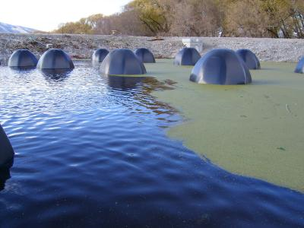
- Name the top five countries with the fewest total renewable water resources per capita (info on Dominica, Timor-Leste, Grenada, St. Lucia, St. Vincent and the grenadines, Samoa, Seychelles or Tonga was apparently not available from the source, http://www.sporcle.com/games/worldwaterresources_fewest.php ). Why do these countries have the least water resources? What could be done and if nothing can be done explain. Now answer these same questions but applying to the countries with the most water resources. Least:Kuwait, UAE, Bahamas, Qatar and Maldives. These countries are either hit by earthquakes are in a desert of extreme temps., are inland etc. Most: Iceland, Guyana, Suriname, Republic of the Congo and Papau New Guinea. They have the most because of closeness to ocean/rivers/glaciers and other major water resources.
- The Pokémon squirtle is based after what real life animal? Is freshwater important to this animal? Not really as turtles live in the ocean. Technically this was a joke question and there are both fresh and salt water turtles I think so I felt like making a giveaway.
- Does holy water come from fresh water? Is this water actually healthy to drink? If there is or isn’t a problem explain. It can, but not always. It is not always healthy because many bacteria can grow after many people put their hands in it. Even if it is from freshwater usually it is used continuously so it depends on the church. It really does depend.
- Describe the qualities of water and what the common water quality parameters are. Is there any less common way to observe the quality of water? Most aren’t less common because it is good to test all ways. They are tested for levels of alkalinity, color, pH, taste and odor, dissolved metals and salts, microorganisms, dissolved metalloids, dissolved organics, radon, heavy metals, hormones, pharmaceuticals, dissolved oxygen, nitrate, salinity, pesticides, chemical or biochemical oxygen demand, temperature and turbidity.
- The recent problems in the Gulf of Mexico (oil spill, etc.) include what type of pollution? What organism is sometimes a problem in the gulf coast? What is a dead zone? Why has it happened in the Gulf of Mexico? Point source pollution. Red algae. When there are absolutely no organisms in the vicinity of space. Happens because of many toxins seeping into ocean waters.
- What can happen if people don’t drink freshwater? List an example of a recent country that has had its water supplies depleted. List 3 or more ways that can cause problems with freshwater. Explain the mechanisms with in a filter and within cleaning water. They usually die unless they are used to non-freshwater. Haiti. Earthquakes, tsunamis or hurricanes. Can use a sieve or other methods like sun filtering/heat killing. Without water for about 3 days one usually dies.
- Why do freshwater fish have to live in freshwater? If humans were fish would we be more likely to be freshwater or saltwater, explain. They need a balance in salt and pH levels. Freshwater…
- What is the world’s largest freshwater lake? How about the most voluminous freshwater lake? What is another known fact about this second lake and where is it located? Largest freshwater fish? Are any oceans freshwater? Why? Lake Michigan. Lake Baikal. Deepest in Siberia. Giant Mekong catfish.
- What is the source water of the Hudson River? What are the two waterways that lead from the source of water that actually feed into the Hudson? The Tear of the Clouds Lake in the Adirondacks, going into Feldspar Brook and Opalescent River along with the Delaware river sort of.
- What types of microorganisms live in the Hudson River? Why? Cryptosporidium and giardia from pipes or simply not monitoring water. There have been many leaks in the Hudson river.
- How much pollution has the Hudson been exposed to? What organisms are most affected by this and what types of pollutions are being put into the river? It also has sediment. What nuclear company and hydroelectric company contributed to these problems?
A lot to an extent (I know this is stupid, but it is true). It has both nonpoint and point source pollution from sediment to heavy metals to sewage to pesticides and other chemicals (what happens when a river is near a city). Consolidated Edison (Con Ed) and Indian Point Energy Center. They were stopped because of the Waterkeeper alliance and the clean water act.
- Which are more common freshwater lakes or rivers? Fresh water Lakes because lakes usually connect to the oceans eventually.
- Ephemeros is the Greek meaning what? How does this apply to water? Lasting only one day. An ephemeral waterbody is a wetland, spring, stream, river, pond or lake that only exists for a short period following precipitation or snowmelt. They are not the same as intermittent or seasonal waterbodies, which exist for longer periods, but not all year round…Ephemerals.
- Define Karst topography. What are three major rocks affected within karst features? Why? Karst topography is a landscape shaped by the dissolution of a layer or layers of soluble bedrock usually carbonate rock such as limestone or dolomite. These are usually made of organic materials that can easily be decomposed through chemical weathering and acids.
- Describe the chemical processes within karst features. Carbonic acid: H₂O + CO₂ → H₂CO₃
CaCO₃ → Ca²⁺ + CO₃^{2–}
CO₃^{2–} + H₂CO₃ → 2 HCO₃–
CaCO₃ + H₂CO₃ → Ca²⁺ + 2 HCO₃–
Sulfide oxidation: H₂S + 2 O₂ → H₂SO₄ (sulfide oxidation)
H₂SO₄ + 2 H₂O → SO₄^{2–} + 2 H₃O⁺ (sulfuric acid dissociation)
CaCO₃ + 2 H₃O⁺ → Ca²⁺ + H₂CO₃ + 2 H₂O (calcium carbonate dissolution)
CaCO₃ + H₂SO₄ → CaSO₄ + H₂CO₃ (global reaction leading to calcium sulfate)
CaSO₄ + 2 H₂O → CaSO₄ · 2 H₂O (hydration and gypsum formation)
- Can farming be done in karst areas? Within karst features why is water not usually present? Yes. Careful consideration of water usage must be thought about, though. Water is not present from sinkholes or simply the water being turned into an acid
- What is the world’s largest river delta? What type of delta is it? Where is this river delta located? Ganges delta is an arcuate delta in Bangladesh, India and Bhutan (also Tibet)
- Is there freshwater on other planets? Explain if yes or no and if yes also name how many places may have extraterrestrial water. Yes. On Mars, Venus and the Moon. Icecaps and stored water (on moon)…
- Explain Playfair’s law. Is an empirical relationship that relates the size of a stream to the valley it runs through. The role of the flow regiment requires subject attention; the relation acts fundamentally similar to the functionality of a glacial trough. Since the relationship is case specific, it is a misleading description of the morphology of fluvial junctions and is better defined as a theory rather than law. is the is erosion (or incision), and is therefore equal to the incision rate
is an erosion parameter (see below)
is the area drained by the stream
is the local gradient of the channel
stream parameters (see below)

- Explain Hack’s law. Hack's law is an empirical relationship between the length of streams and the area of their basins. If L is the length of the longest stream in a basin, and A is the area of the basin, then Hack's law may be written asor some constant C where the exponent h is slightly less than 0.6 in most basins. Note that h varies slightly from region to region, and also slightly decreases for larger basins (>8,000 mi², or 20,720 km²). A theoretical value h = 4/7 ≈ 0.571 for the exponent has been derived (Birnir, 2008).
- Explain Baer’s law. In geology, Baer's law, named after Karl Ernst von Baer, says that, because of the rotation of the earth, in the Northern Hemisphere, erosion occurs mostly on the right banks of rivers and in the Southern Hemisphere on the left banks. In 1926, Albert Einstein wrote a paper explaining the causes of the phenomenon. Although it is possible that an aggregate measurement of all rivers would lead to a correlation, the Coriolis force is orders of magnitude weaker than the local forces on the river channel from its flow. Therefore, this is unlikely to be important in any given river.
- Explain what a blackwater river is. What are the differences between white and black water rivers? A blackwater river is a river with a deep, slow-moving channel that flows through forested swamps and wetlands. As vegetation decays in the water, tannins are leached out, resulting in transparent, acidic water that is darkly stained, resembling tea or coffee. Most major blackwater rivers are in the Amazon River system and the Southern United States. The term "blackwater" here is an agreed-upon technical one in fluvial studies, geology, geography and ecology/biology. Not all dark-colored rivers are true blackwater rivers in the technical sense. Some rivers in temperate regions, which drain or flow through areas of dark black loam, are colored black due to the color of the soil. These types of rivers can be referred to as black mud rivers; there are also black mud estuaries (see link above to rivers officially named Blackwater River.) Whitewater is formed in a rapid, when a river's gradient increases enough to disturb its laminar flow and create turbulence, i.e. form a bubbly, or aerated and unstable current; the frothy water appears white. The term is also used loosely to refer to less-turbulent but still agitated flows. There are different ionic conecentrations where black water has lower nutrients than white water and ionic concentrations slightly higher than rainwater. Blackwater can refer to contaminated water.
- What is the river continuum concept? The River Continuum Concept (RCC) is a model for classifying and describing flowing water, in addition to the classification of individual sections of waters after the occurrence of indicator organisms. The theory is based on the concept of dynamic equilibrium in which stream forms balance between physical parameters, such as width, depth, velocity, and sediment load, also taking into account biological factors. It offers the introduction to map out pure living communities, but also an explanation for their sequence in individual sections of water. This allows the structure of the river to be more predictable as to the biological properties of the water. The concept was first developed in 1980 by Robin L. Vannote, with fellow researchers at the Stroud Water Research Center.
- Explain Archimedes’ principle and how it can be used with water. Can it be used to solve certain problems with freshwater? Explain if yes or no. Buoyancy
It can be used for major filtration processes. It can be used to remove oil due to differences in density or general contaminants or absorption of oil and contaminants through certain materials.
- Explain the law of multiple proportions. The law of multiple proportions is one of the fundamental laws of stoichiometry and was first discovered by the English chemist John Dalton in 1803. The law states that when chemical elements combine, they do so in a ratio of small whole numbers. For example, carbon and oxygen react to form carbon monoxide (CO) or carbon dioxide (CO2), but not CO1.3. Further, it states that if two elements form more than one compound between them, the ratios of the masses of the second element to a mass of the first element will also be in small whole numbers. It consists of the Law of conservation of mass, mass relationships during chemical reactions, Law of definite proportions, multiple mass ratio, and the law of multiple proportions.
- What is stoichiometry? Stoichiometry (pronounced /ˌstɔɪkiˈɒmɨtri/, STOY-kee-AHM-ə-tree) is a branch of chemistry that deals with the quantitative relationships that exist between the reactants and products in chemical reactions. In a balanced chemical reaction, the relations among quantities of reactants and products typically form a ratio of whole numbers. For example, in a reaction that forms ammonia (NH3), exactly one molecule of nitrogen (N2) reacts with three molecules of hydrogen (H2) to produce two molecules of NH3: N2 + 3H2 → 2NH3
Stoichiometry can be used to calculate quantities such as the amount of products that can be produced with given reactants and percent yield (the percentage of the given reactant that is made into the product). Stoichiometry calculations can predict how elements and components diluted in a standard solution react in experimental conditions. Stoichiometry is founded on the law of conservation of mass: the mass of the reactants equals the mass of the products.
- Explain Darcy’s law. Darcy’s law describes the flow of a fluid through a porous medium (like water through sand) and involves permeability. Darcy's law is the relationship between the instantaneous discharge rate through a porous medium, the viscosity of the fluid and the pressure drop over a given distance. 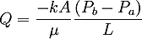 The total discharge, Q (units of volume per time, e.g., cm³/s) is equal to the product of the permeability of the medium, k, the cross-sectional area to flow, A, and the pressure drop, all divided by the viscosity, μ and the length the pressure drop is taking place over. The negative sign is needed because fluids flows from high pressure to low pressure. So if the change in pressure is negative (in the z direction) then the flow will be positive (in the x direction). Dividing both sides of the equation by the area and using more general notation leads to 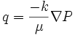 where q is the flux (discharge per unit area, with units of length per time, m/s) and is the dimensionless pressure gradient vector. This value of flux, often referred to as the Darcy flux, is not the velocity which the water traveling through the pores is experiencing. The pore velocity (v) is related to the Darcy flux (q) by the porosity (n). The flux is divided by porosity to account for the fact that only a fraction of the total formation volume is available for flow. The pore velocity would be the velocity a conservative tracer would experience if carried by the fluid through the formation. 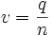Darcy's law is a simple mathematical statement which neatly summarizes several familiar properties that groundwater flowing in aquifers exhibits, including: if there is no pressure gradient over a distance), no flow occurs (this is hydrostatic conditions), if there is a pressure gradient, flow will occur from high pressure towards low pressure (opposite the direction of increasing gradient - hence the negative sign in Darcy's law), the greater the pressure gradient (through the same formation material), the greater the discharge rate, and the discharge rate of fluid will be often be different — through different formation materials (or even through the same material, in a different direction) — even if the same pressure gradient exists in both cases.
- Name three major organizations involved with water. Name the founding of each organization and explain what each organization has done to aid in spreading information about water. EPA has created many acts and was founded in 1970 by Nixon (watersense and safe drinking water act). USGS founded in 1879 has created infinite maps about water and water resources and help with defining troubled areas along with keeping an amazing database about water and things one can do to help. The Water Environment Federation in 1928 for water quality.
- What is the Hagen-Poiseuille equation and what is its application for? In fluid dynamics, the Hagen–Poiseuille equation is a physical law that gives the pressure drop in a fluid flowing through a long cylindrical pipe. The assumptions of the equation are that the flow is laminar viscous and incompressible and the flow is through a constant circular cross-section that is substantially longer than its diameter. The equation is also known as the Hagen–Poiseuille law, Poiseuille law and Poiseuille equation. The fluid flow will be turbulent for velocities and pipe diameters above a threshold, leading to larger pressure drops than would be expected according to the Hagen–Poiseuille equation. 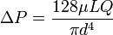 ΔP is the pressure drop
L is the length of pipe
μ is the dynamic viscosity
Q is the volumetric flow rate
r is the radius
d is the diameter
π is the mathematical constant
- Describe the Young-Laplace equation and its application. In physics, the Young–Laplace equation is a nonlinear partial differential equation that describes the capillary pressure difference sustained across the interface between two static fluids, such as water and air, due to the phenomenon of surface tension. It relates the pressure difference to the shape of the surface and it is fundamentally important in the study of static capillary surfaces. It is a statement of normal stress balance for static fluids meeting at an interface, where the interface is treated as a surface (zero thickness): 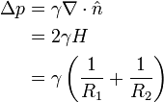where Δp is the pressure difference across the fluid interface, γ is the surface tension, is a unit normal to the surface, H is the mean curvature, and R₁ and R₂ are the principal radii of curvature. (Some authors refer inappropriately to the factor 2H as the total curvature.) Note that only normal stress is considered, this is because it can be shown that a static interface is possible only in the absence of tangential stress. The equation is named after Thomas Young, who developed the qualitative theory of surface tension in 1805, and Pierre-Simon Laplace who completed the mathematical description in the following year. It is sometimes also called the Young–Laplace–Gauss equation, as Gauss unified the work of Young and Laplace in 1830, deriving both the differential equation and boundary conditions using Johann Bernoulli's virtual work principles.
- What is the Herschel-Bulkley fluid? The Herschel–Bulkley fluid is a generalized model of a non-Newtonian fluid, in which the stress experienced by the fluid is related to the strain in a complicated, non-linear way. Three parameters characterize this relationship: the consistency k, the flow index n, and the yield shear stress τ0. The consistency is a simple constant of proportionality, while the flow index measures the degree to which the fluid is shear-thinning or shear-thickening. Ordinary paint is one example of a shear-thinning fluid, while oobleck provides one realization of a shear-thickening fluid. Finally, the yield stress quantifies the amount of stress that the fluid may experience before it yields and begins to flow. 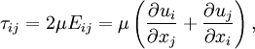 This equation is also commonly written as τ = τ0 + Kγn where τ is the shear stress, γ the shear rate, τ0 the yield stress, and K and n are regarded as model factors.
- What are the Navier-Stokes equations? In physics the Navier–Stokes equations, named after Claude-Louis Navier and George Gabriel Stokes, describe the motion of fluid substances. These equations arise from applying Newton's second law to fluid motion, together with the assumption that the fluid stress is the sum of a diffusing viscous term (proportional to the gradient of velocity), plus a pressure term. The equations are useful because they describe the physics of many things of academic and economic interest. They may be used to model the weather, ocean currents, water flow in a pipe and air flow around a wing. The Navier–Stokes equations in their full and simplified forms help with the design of aircraft and cars, the study of blood flow, the design of power stations, the analysis of pollution, and many other things. Coupled with Maxwell's equations they can be used to model and study magnetohydrodynamics. 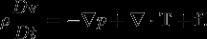

- Explain Bernoulli’s principle in relation to fluid dynamics. In fluid dynamics, Bernoulli's principle states that for an inviscid flow, an increase in the speed of the fluid occurs simultaneously with a decrease in pressure or a decrease in the fluid's potential energy. Bernoulli's principle is named after the Dutch-Swiss mathematician Daniel Bernoulli who published his principle in his book Hydrodynamica in 1738. Bernoulli's principle can be applied to various types of fluid flow, resulting in what is loosely denoted as Bernoulli's equation. In fact, there are different forms of the Bernoulli equation for different types of flow. The simple form of Bernoulli's principle is valid for incompressible flows (e.g. most liquid flows) and also for compressible flows (e.g. gases) moving at low Mach numbers. More advanced forms may in some cases be applied to compressible flows at higher Mach numbers (see the derivations of the Bernoulli equation). 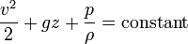
Where: is the fluid flow speed at a point on a streamline, is the acceleration due to gravity, is the elevation of the point above a reference plane, with the positive z-direction pointing upward – so in the direction opposite to the gravitational acceleration, is the pressure at the chosen point, and is the density of the fluid at all points in the fluid. For conservative force fields, Bernoulli's equation can be generalized as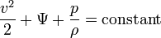where Ψ is the force potential at the point considered on the streamline. E.g. for the Earth's gravity Ψ = gz. The following two assumptions must be met for this Bernoulli equation to apply: the fluid must be incompressible – even though pressure varies, the density must remain constant along a streamline; friction by viscous forces has to be negligible.
By multiplying with the fluid density ρ, equation (A) can be rewritten as:or: where:
is dynamic pressure,
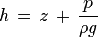is the piezometric head or hydraulic head (the sum of the elevation z and the pressure head)^{[6][7]} and
is the total pressure (the sum of the static pressure p and dynamic pressure q).^{[8]}
The constant in the Bernoulli equation can be normalised. A common approach is in terms of total head or energy head H: 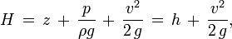The above equations suggest there is a flow speed at which pressure is zero, and at even higher speeds the pressure is negative. Most often, gases and liquids are not capable of negative absolute pressure, or even zero pressure, so clearly Bernoulli's equation ceases to be valid before zero pressure is reached. In liquids – when the pressure becomes too low – cavitation occurs. The above equations use a linear relationship between flow speed squared and pressure. At higher flow speeds in gases, or for sound waves in liquid, the changes in mass density become significant so that the assumption of constant density is invalid. Simplified form In many applications of Bernoulli's equation, the change in the ρ g z term along the streamline is so small compared with the other terms it can be ignored. For example, in the case of aircraft in flight, the change in height z along a streamline is so small the ρ g z term can be omitted. This allows the above equation to be presented in the following simplified form: where p₀ is called total pressure, and q is dynamic pressure.^{[9]} Many authors refer to the pressure p as static pressure to distinguish it from total pressure p₀ and dynamic pressure q. In Aerodynamics, L.J. Clancy writes: "To distinguish it from the total and dynamic pressures, the actual pressure of the fluid, which is associated not with its motion but with its state, is often referred to as the static pressure, but where the term pressure alone is used it refers to this static pressure. “The simplified form of Bernoulli's equation can be summarized in the following memorable word equation: static pressure + dynamic pressure = total pressure Every point in a steadily flowing fluid, regardless of the fluid speed at that point, has its own unique static pressure p and dynamic pressure q. Their sum p + q is defined to be the total pressure p₀. The significance of Bernoulli's principle can now be summarized as total pressure is constant along a streamline. If the fluid flow is irrotational, the total pressure on every streamline is the same and Bernoulli's principle can be summarized as total pressure is constant everywhere in the fluid flow.^{[11]} It is reasonable to assume that irrotational flow exists in any situation where a large body of fluid is flowing past a solid body. Examples are aircraft in flight, and ships moving in open bodies of water. However, it is important to remember that Bernoulli's principle does not apply in the boundary layer or in fluid flow through long pipes. If the fluid flow at some point along a stream line is brought to rest, this point is called a stagnation point, and at this point the total pressure is equal to the stagnation pressure.
- What is secondary flow? In fluid dynamics, a secondary flow is a relatively minor flow superimposed on the primary flow, where the primary flow usually matches very closely the flow pattern predicted using simple analytical techniques and assuming the fluid is inviscid. (An inviscid fluid is a theoretical fluid having zero viscosity.) The primary flow of a fluid, particularly in the majority of the flow field remote from solid surfaces immersed in the fluid, is usually very similar to what would be predicted using the basic principles of physics, and assuming the fluid is inviscid. However, in real flow situations, there are regions in the flow field where the flow is significantly different in both speed and direction to what is predicted for an inviscid fluid using simple analytical techniques. The flow in these regions is the secondary flow. These regions are usually in the vicinity of the boundary of the fluid adjacent to solid surfaces where viscous forces are at work, such as in the boundary layer.
- Why is the speed of sound faster in saltwater than freshwater? Is it at all? Explain. It is slightly faster for the factor of salt, but so minimal it usually is counted (approximately 3-.003 seconds faster or something)
- Why do humans drink freshwater or filtered saltwater instead of salt water? Salt water essentially changes the whole molecular structure of water and therefore is not usually drinkable.
- What is more dense saline or freshwater? Why? Salt water has a higher density because it has more solutes.
- What is the ghyben-herzberg relation? 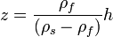 The thickness of the freshwater zone above sea level is represented as h and that below sea level is represented as z. The two thicknesses h and z, are related by ρ_{f} and ρ_{s} where ρ_{f} is the density of freshwater and ρ_{s} is the density of saltwater. Freshwater has a density of about 1.000 grams per cubic centimeter (g/cm³) at 20 °C, whereas that of seawater is about 1.025 g/cm³. The equation can be simplified to. The Ghyben-Herzberg ratio states, for every foot of fresh water in an unconfined aquifer above sea level, there will be forty feet of fresh water in the aquifer below sea level. In the 20th century the higher computing power allowed the use of numerical methods (usually finite differences or finite elements) that need fewer assumptions and can be applied more generally.
- What is the difference between an aquifer and an aquitard? An aquifer is a wet underground layer of water-bearing permeable rock or unconsolidated materials (gravel, sand, silt, or clay) from which groundwater can be usefully extracted using water well. The study of water flow in aquifers and the characterization of aquifers is called hydrogeology. Related terms include aquitard, which is a bed of low permeability along an aquifer, and aquiclude (or aquifuge), which is a solid, impermeable area underlying or overlying an aquifer. If the impermeable area overlies the aquifer pressure could cause it to become a confined aquifer.
- What is the difference between saturated and unsaturated zones? Groundwater can be found at nearly every point in the Earth's shallow subsurface, to some degree; although aquifers do not necessarily contain fresh water. The Earth's crust can be divided into two regions: the saturated zone or phreatic zone (e.g., aquifers, aquitards, etc.), where all available spaces are filled with water, and the unsaturated zone (also called the vadose zone), where there are still pockets of air with some water, but can be filled with more water. Saturated means the pressure head of the water is greater than atmospheric pressure (it has a gauge pressure > 0). The definition of the water table is surface where the pressure head is equal to atmospheric pressure (where gauge pressure =0). Unsaturated conditions occur above the water table where the pressure head is negative (absolute pressure can never be negative, but gauge pressure can) and the water that incompletely fills the pores of the aquifer material is under suction. The water content Unsaturated means the zone is held in place by surface adhesive forces and it rises above the water table (the zero gauge pressure isobar) by capillary action to saturate a small zone above the phreatic surface (the capillary fringe) at less than atmospheric pressure. This is termed tension saturation and is not the same as saturation on a water content basis. Water content in a capillary fringe decreases with increasing distance from the phreatic surface. The capillary head depends on soil pore size. In sandy soils with larger pores, the head will be less than in clay soils with very small pores. The normal capillary rise in a clayey soil is less than 1.80 m (six feet) but can range between 0.3 and 10 m (1 and 30 ft). The capillary rise of water in a small diameter tube is this same physical process. The water table is the level to which water will rise in a large-diameter pipe (e.g., a well) that goes down into the aquifer and is open to the atmosphere.
- What is the difference between confined and unconfined aquifers? Confined versus unconfined There are two end members in the spectrum of types of aquifers; confined and unconfined (with semi-confined being in between). Unconfined aquifers are sometimes also called water table or phreatic aquifers, because their upper boundary is the water table or phreatic surface. (See Biscayne Aquifer.) Typically (but not always) the shallowest aquifer at a given location is unconfined, meaning it does not have a confining layer (an aquitard or aquiclude) between it and the surface. The term "perched" refers to ground water accumulating above a low-permeability unit or strata, such as a clay layer. This term is generally used to refer to a small local area of ground water that occurs at an elevation higher than a regionally-extensive aquifer. The difference between perched and unconfined aquifers is their size (perched is smaller). If the distinction between confined and unconfined is not clear geologically (i.e., if it is not known if a clear confining layer exists, or if the geology is more complex, e.g., a fractured bedrock aquifer), the value of storativity returned from an aquifer test can be used to determine it (although aquifer tests in unconfined aquifers should be interpreted differently than confined ones). Confined aquifers have very low storativity values (much less than 0.01, and as little as 10−5), which means that the aquifer is storing water using the mechanisms of aquifer matrix expansion and the compressibility of water, which typically are both quite small quantities. Unconfined aquifers have storativities (typically then called specific yield) greater than 0.01 (1% of bulk volume); they release water from storage by the mechanism of actually draining the pores of the aquifer, releasing relatively large amounts of water (up to the drainable porosity of the aquifer material, or the minimum volumetric water content).
- What is the difference between isotropic and anisotropic aquifers? In isotropic aquifers or aquifer layers the hydraulic conductivity (K) is equal for flow in all directions, while in anisotropic conditions it differs, notably in horizontal (Kh) and vertical (Kv) sense. Semi-confined aquifers with one or more aquitards work as an anisotropic system, even when the separate layers are isotropic, because the compound Kh and Kv values are different (see hydraulic transmissivity and hydraulic resistance). When calculating flow to drains or flow to wells in an aquifer, the anisotropy is to be taken into account lest the resulting design of the drainage system may be faulty.
- What causes saltwater intrusions? Salt water intrusion can happen from fissures, dissolution, human impact, cation exchange and more.
- What is an artesian aquifer? An artesian aquifer is a confined aquifer containing groundwater that will flow upward through a well, called an artesian well, without the need for pumping. Water may even reach the ground surface if the natural pressure is high enough, in which case the well is called a flowing artesian well. An aquifer is a layer of soft rock, like limestone or sandstone that absorbs water from an inlet path. Porous stone is confined between impermeable rocks or clay. This keeps the pressure high, so when the water finds an outlet, it overcomes gravity and goes up instead of down. The recharging of aquifers happens when the water table at its recharge zone is at a higher elevation than the head of the well. Fossil water aquifers can also be artesian if they are under sufficient pressure from the surrounding rocks. This is similar to how many newly tapped oil wells are pressurized.
- What is a cistern? A cistern (Middle English cisterne, from Latin cisterna, from cista, box, from Greek kistê, basket) is a waterproof receptacle for holding liquids, usually water. Often cisterns are built to catch and store rainwater. Cisterns are distinguished from wells by their waterproof linings. Modern cisterns range in capacity from a few litres to thousands of cubic metres, effectively forming covered reservoirs.
- What is the difference between stalactites and stalagmites? A stalactite (UK /ˈstæləktaɪt/, US /stəˈlæktaɪt/; from the Greek stalasso, (σταλάσσω), "to drip" and meaning "that which drips") is a type of speleothem (secondary mineral) that hangs from the ceiling of limestone caves. It is a type of dripstone. Stalactites are formed by the deposition of calcium carbonate and other minerals, which is precipitated from mineralized water solutions. Limestone is the chief form of calcium carbonate rock which is dissolved by water that contains carbon dioxide, forming a calcium bicarbonate solution in underground caverns. The chemical formula for this reaction is: CaCO3(s) + H2O(l) + CO2(aq) → Ca(HCO3)2(aq) This solution travels through the rock until it reaches an edge and if this is on the roof of a cave it will drip down. When the solution comes into contact with air the chemical reaction that created it is reversed and particles of calcium carbonate are deposited. The reversed reaction is: Ca(HCO3)2(aq) → CaCO3(s) + H2O(l) + CO2(aq) An average growth rate is 0.13 mm (0.005 inches) a year. The quickest growing stalactites are those formed by fast-flowing water rich in calcium carbonate and carbon dioxide, these can grow at 3 mm (0.12 inches) per year.
A stalagmite (UK: /ˈstæləɡmaɪt/, US: /stəˈlæɡmaɪt/; from the Greek Σταλαγμίτης stalagmitês), "drop" or "drip") is a type of speleothem that rises from the floor of a limestone cave due to the dripping of mineralized solutions and the deposition of calcium carbonate. This stalagmite formation occurs only under certain pH conditions within the underground cavern.[1] The corresponding formation on the ceiling of a cave is known as a stalactite. If these formations grow together, the result is known as a column.
- Describe the riffle-pool sequence. In a flowing stream, a riffle-pool sequence (also known as a pool-riffle sequence) develops as a stream's hydrological flow structure alternates from areas of relatively shallow to deeper water. This sequence is present only in streams carrying gravel or coarser sediments. Riffles are formed in shallow areas by coarser materials such as gravel deposits over which water flows. Pools are deeper and calmer areas whose bed load (in general) is made up of finer material such as silt. Streams with only sand or silt laden beds do not develop the feature. The sequence within a stream bed commonly occurs at intervals of from 5 to 7 stream widths. Meandering streams with relatively coarse bed load tend to develop a riffle-pool sequence with pools in the outsides of the bends and riffles in the crossovers between one meander to the next on the opposite margin of the stream. The pools are areas of active erosion and the material eroded tends to be deposited in the riffle area between.

- What is helicoidal flow? Helicoidal flow is the cork-screw-like flow of water in a meander. It is one example of a secondary flow. Helicoidal flow is a contributing factor to the formation of slip-off slopes and river cliffs in a meandering section of the river. The helicoidal motion of the flow aids the processes of hydraulic action and corrasion on the outside of the meander, and sweeps sediment across the floor of the meander towards the inside of the meander.
- What weather phenomenon exhibits a meander too? Jetstream
What is the Exner equation? The Exner equation is a statement of conservation of mass that applies to sediment in a fluvial system such as a river. It was developed by the Austrian meteorologist and sedimentologist Felix Maria Exner, from whom it derives its name. The equation states that the change in bed elevation, η, over time, t, is equal to one over the grain packing density, , times the negative divergence of sediment flux, q_{s}. 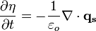Note that can also be expressed as (1 − λ_{p}), where λ_{p} equals the bed porosity. Good values of for natural systems range from 0.45 to 0.75. A typical good value for spherical grains is 0.64, as given by random close packing. An upper bound for close-packed spherical grains is 0.74048. (See sphere packing for more details); this degree of packing is extremely improbable in natural systems, making random close packing the more realistic upper bound on grain packing density. Often, for reasons of computational convenience and/or lack of data, the Exner equation is used in its one-dimensional form. This is generally done with respect to the down-stream direction x, as one is typically interested in the down-stream distribution of erosion and deposition though a river reach.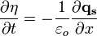
- What is the difference between aggradation, degradation, progradation and transgression in a stream? Aggradation=sediment builds up. Degradation=deteriation of environment. Progradation=Normal stream flow. Transgression=Stream recession
- What is an antidune? An antidune is a bedform found in fluvial environments. It occurs where there is supercritical flow, meaning that the Froude number is greater than 1.0 or the flow velocity exceeds the wave velocity; this is also known as upper flow regime. In antidunes, sediment is deposited on the stoss (upstream) side and eroded from the lee (downstream) side, opposite lower flow regime bedforms. As a result, antidunes migrate in an upstream direction, counter to the current flow. Antidunes are called in-phase bedforms, meaning that water surface elevation mimics the bed elevation; this is due to the supercritical flow regime. Antidune bedforms evolve rapidly, growing in amplitude as they migrate upstream. The resultant wave at the water's surface also increases in amplitude. When that wave becomes unstable, breaks and washes downstream, most of the antidune bedform is destroyed.
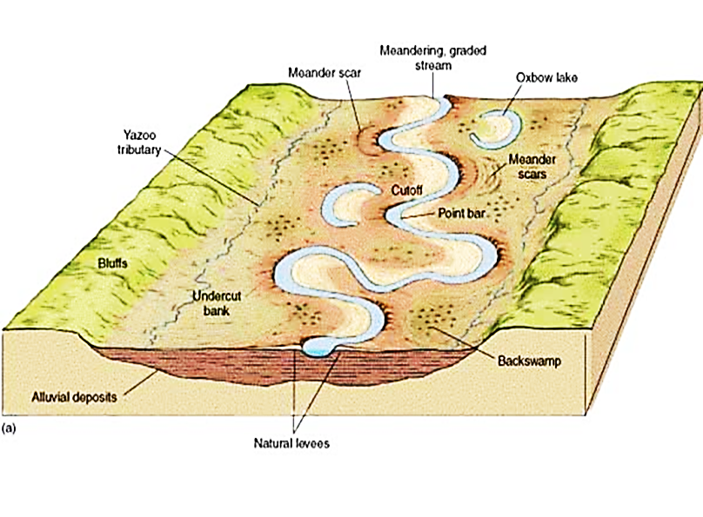
- Label the picture below/ at the right.

