Earth’s Fresh Waters test
1. Identify this waterfall (just kidding)
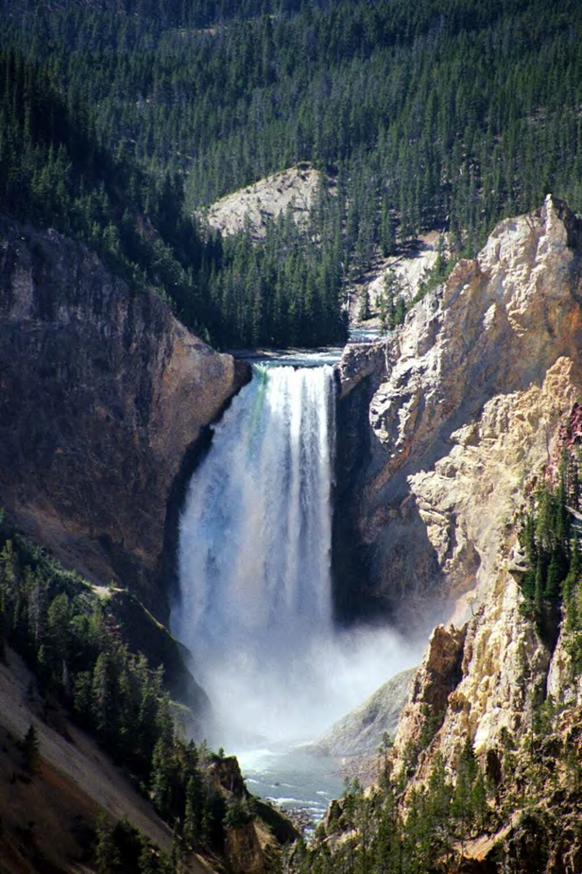

NOTE: Throughout the test you may complete a few bonuses if you would like. ONLY view the last page of the test when you have completely finished the rest of the test. The last page has some websites and a picture which can act as a slight hint for a few questions. For all “explain” or other general questions list as much info as possible (if enough is written you may get a few extra points). YOU CAN DRAW PICTURES TO HELP IN EXPLANATIONS FOR CERTAIN QUESTIONS, BUT IF YOU INCORRECTLY LABEL THE PICTURE YOU LOSE POINTS. If you have any questions just ask. Please at the 50 minute mark circle the question you are at if you have not finished so I can grade how well you would do within the proper time limit. At the end of the test please circle the ratings (good luck). If you don’t have enough room for a question write an arrow implying the back of the paper and write the number on the back of the paper.

- Label both the black and white boxes:
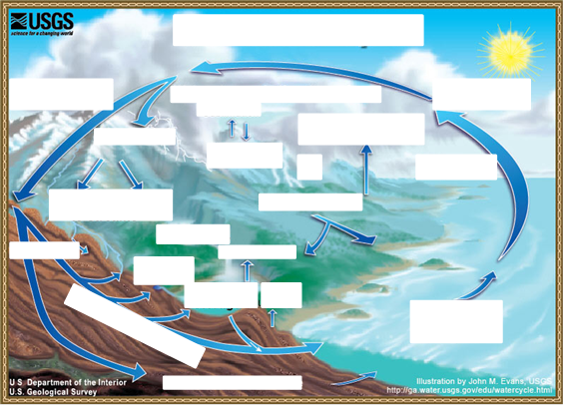
- Compare Hard and Soft water.

- By adding this element to water tooth decay can occur in children.

- What does USGS stand for and when was it founded?

- How does water play a role in the creation of Death Valley?

- Assuming within a time range of 100 years, 65 floods occur. What is the recurrence interval, probability?
- What type of pollution was produced from the Love canal? What did this pollution affect?

- What could be the problem with getting one’s water supply from groundwater?

- In 2009 how much water came from the Catskill/Delaware area?
- What two falls is Niagara Falls split into?
- What is the main function behind a canal like Erie Canal and what was the purpose of Erie Canal? What is the city where the canal may have been?

- How can lead get into drinking water?

- Why did Dutch farmers perform clamming in New York City? Near what canal was made this made (Hint: it was not the Erie Canal)?

- What is a riprap?
- Draw four or more types of deltas and describe each.

- How do stream drainage patterns occur? These include annular, parallel, trellis, rectangular, dendritic, radial, centripetal and deranged. Draw each one

- Compare lateral and vertical accretion.

- What is the world’s largest source of frozen fresh water?
- What is a dry lake bed called?
- What are most lakes in New York made from?
- What is the world’s smallest river and what lake does it drain into?
- What are the four largest rivers in the world?
- What classification of water is the world’s largest drainage basin? Second and third?

- What type of pollution is present in the picture below?
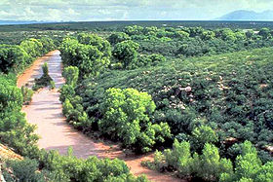
- In this picture?
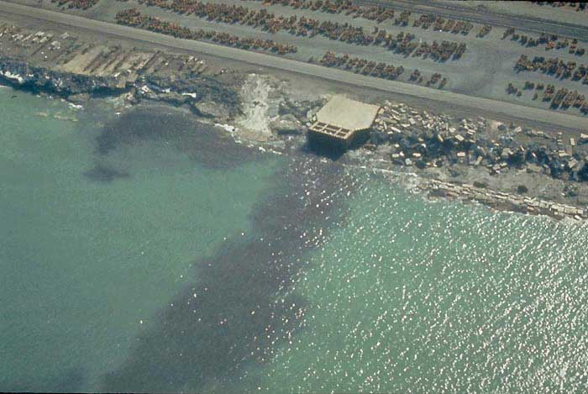
- What type of lake is Yellowstone Lake? What are characteristics of these lakes?

- What does the secchi disk involve? What is the formula for it?

- Fertilizer being dumped into various types of water is what type of pollution? It promotes the growth of what type of organism? What type of lake do these organisms thrive in?

- What is Le Chatalier’s principle?

- Primarily, acid rain is caused from what two emissions?
- Discuss wet vs. dry deposition.

- What gas additive was used around the 1970’s-1990’s to reduce air pollution? Why was it banned (Hint: its chemical formula is C₅H₁₂O)? What other gas additive in the early 1900’s caused an even worse problem?

- During the Vietnam War these herbicides were extremely deadly to civilians and veterans. It was also able to contaminate waters. What was the name of the group of these herbicides?

- The Bhopal disaster of 1984 in India produced what type of pollution into water? What were some of the substances that poisoned many?

- What famous river in Great Britain was extremely polluted? What type of river is it? What type of pollution was this river affected by?

- What type of delta(s) is/are present in the Mississippi river?
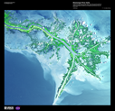

- Only 2.8% of all the water on Earth is fresh water. However, about 74% of this fresh water is frozen in glaciers and ice caps, and 99% of the liquid water is what?
- Which of the following processes describes water seeping into the ground?
- Precipitation that falls onto the Earth’s surface first (1) ________ into the regolith, then (2) _______ downwards through the (3) _________ into the (4)
- All water on earth moves from one storage or transportation system to another, forming a hydrologic cycle. These storage or transportation systems are called (1)________ and the amount of time that a water molecule spends in any one of them is (2)________.
- Which reservoir typically has the longest residence time for water molecules?
- Which reservoirs have the shortest residence time for water molecules?
- Name an example of a feature not produced by alluvium.
- Name a feature not associated with floodplains.
- Deltas get their name from the Greek letter, Δ. What is the only type of delta that really has this triangular shape when viewed from above?
- If you are standing in an arid or semi-arid region looking at the features around you produced by running water, what features might you see?
- What is this a map of, label it (you may label either map you prefer):

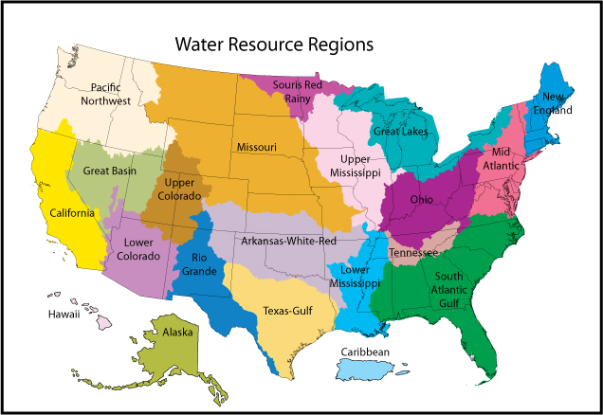

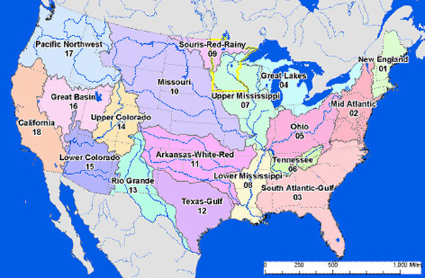

Concentrations of constituents in each of the aquifers on long island are minimal. Still, what substances are more concentrated and what are less concentrated?

- 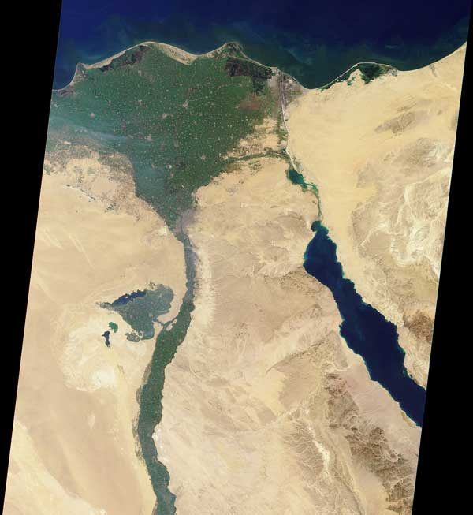What is this a picture of and what type of delta is present?
- In this movie one of the characters only drinks rainwater or grain alcohol. What substance being added to water does he think is an evil plot by communists? Name three substances he thinks they were trying to add this substance to other than water. Is the fact that he only drinks rainwater or grain alcohol a positive or a negative? If he drank water with this substance what would be some positive or negative effects (Hint: if you saw the movie he was trying to protect his precious bodily fluids)? Bonus: What was the name of this character?

- This river that runs through France has Atlantic salmon and a pH level of 8.46. Does this indicate good or bad water quality? If not what could improve the river and if so explain. In addition what type of pollution has been present in this river? Bonus: Name random facts about the river if you want.

- List five types of point and nonpoint source pollution. Describe the major effect of point and nonpoint source pollution. Are there some any advantages at all to “pollution”?

- TI Chl P SD
<30—400 0—2.6 0—12 >8—4
40—50 2.6—20 12—24 4—2
50—70 20—56 24—96 2—0.5
70—100+ 56—155+ 96—384+ 0.5—<0.25
What is this chart above detailing? List what each level of statistics is and explain the organisms that thrive in each. Compare different types of algae or organisms. Remember to name each of the abbreviations.

- Where do alluvial fans form and why?

- What is stream capture?

- Explain why natural levees build up along the banks of streams the flood often.

- Label and describe what this is a picture of:

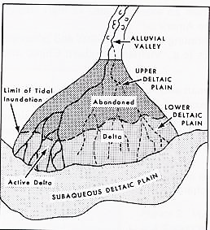

- The pictures below were taken from which website? Label them for each arrow, each white box and the sediment for the second picture. For the third picture describe what it is a graph of, label the axes and show the order of the variable on the right axes (basically just label everything you possibly can + a description). Describe each sediment layer on the second/first picture. What are the main differences and which would deposited first.

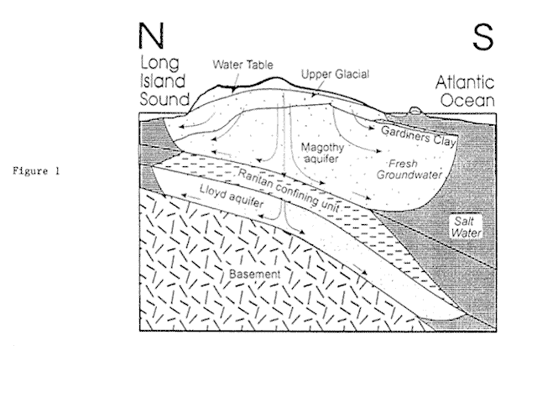

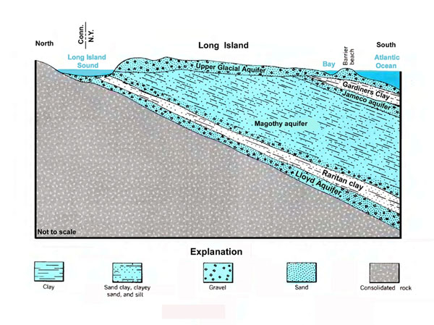

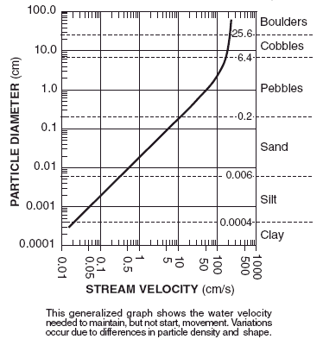

- Define and if only told the overlying background to the word then list the following terms (also a few terms will be in French, for a bonus name the literal translation of each, try and spot them all). If you want you can add extra info for extra points. arroyo, aits or eyots, cuesta, backswamps, bayous, bluffs, benches, billabongs, approximately the 8 different types of caves, chines, crevasse splays, crevices vs. crevasses, coulee, flumes, debouch, vegas, gulches, gullies, lacustrine deltas, lacustrine plains, atolls, hoodoos, badlands, limans, linns, ravines, plunge pools, the strahler number, glens, shoals, thalwegs, tinaja, wadi/vadi, yazoo streams, moraines, glacial horns, roche moutonnée, trim lines, moraines, hanging valleys, eskers, kames, basal sliding, moulins, fjords, arête, outwash fans, ablations, cirques and séracs. Glacier comes from French and latin and roughly means what?

Use space for definitions

- What is the driving force behind all erosion or deposition?
- Compare alluvial features to fluvial features in relation. What is their relationship?

Here are the lyrics to yellow submarine by the beatles :
In the town where I was born,
Lived a man who sailed to sea,
And he told us of his life,
In the land of submarines,
So we sailed on to the sun,
Till we found the sea green,
And we lived beneath the waves,
In our yellow submarine,
We all live in yellow submarine,
…And our friends are all aboard,
Many more of them live next door,
And the band begins to play.
We all live in yellow submarine,
…(Full speed ahead, Mr. Barkley, full speed ahead!
Full speed over here, sir!
All together! All together!
Aye, aye, sir, fire!
Captain! Captain!)
As we live a life of ease(life of ease)
Every one of us(every one of us) has all we need,(has all we need)
Sky of blue,(sky of blue) and sea green,(sea of green)
In our yellow(In our yellow) submarine.(submarine) ( Haha! )
We all live in yellow submarine…
Is it possible to have the sea green? What would cause it to be this way? Would the sea being green be from a positive, negative effect or neither? Why?

- Name the top five countries with the fewest total renewable water resources per capita (info on Dominica, Timor-Leste, Grenada, St. Lucia, St. Vincent and the grenadines, Samoa, Seychelles or Tonga was apparently not available from the source, http://www.sporcle.com/games/worldwaterresources_fewest.php ). Why do these countries have the least water resources? What could be done and if nothing can be done explain. Now answer these same questions but applying to the countries with the most water resources.

- The Pokémon squirtle is based after what real life animal? Is freshwater important to this animal?

- Does holy water come from fresh water? Is this water actually healthy to drink? If there is or isn’t a problem explain.

- Describe the qualities of water and what the common water quality parameters are. Are there any less common way to observe the quality of water?

- The recent problems in the Gulf of Mexico (oil spill, etc.) include what type of pollution? What organism is sometimes a problem in the gulf coast? What is a dead zone? Why has it happened in the Gulf of Mexico?

- What can happen if people don’t drink freshwater? List an example of a recent country that has had its water supplies depleted. List 3 or more ways that can cause problems with freshwater. Explain the mechanisms with in a filter and within cleaning water.

- Why do freshwater fish have to live in freshwater? If humans were fish would we be more likely to be freshwater or saltwater, explain.

- What is the world’s largest freshwater lake? How about the most voluminous freshwater lake? What is another known fact about this second lake and where is it located? Largest freshwater fish? Are any oceans freshwater? Why?

- What is the source water of the Hudson River? What are the two waterways that lead from the source of water that actually feed into the Hudson?

- What types of microorganisms live in the Hudson River? Why?

- How much pollution has the Hudson been exposed to? What organisms are most affected by this and what types of pollutions are being put into the river?

- Which are more common freshwater lakes or rivers?
- Ephemeros is the Greek meaning what? How does this apply to water?

- Define Karst topography. What are three major rocks affected within karst features? Why?

- Describe the chemical processes within karst features.

- Can farming be done in karst areas? Within karst features why is water not usually present?

- What is the world’s largest river delta? What type of delta is it? Where is this river delta located?
- Is there freshwater on other planets? Explain if yes or no and if yes also name how many places may have extraterrestrial water.

- Explain Playfair’s law

- Explain Hack’s law.

- Explain Baer’s law

- Explain what a blackwater river is. What are the differences between white and black water rivers?

- What is the river continuum concept?

- Explain Archimedes’ principle and how it can be used with water. Can it be used to solve certain problems with freshwater? Explain if yes or no.

- Explain the law of multiple proportions.

- What is stoichiometry?

- Explain Darcy’s law

- Name three major organizations involved with water. Name the founding of each organization and explain what each organization has done to aid in spreading information about water.

- What is the Hagen-Poiseuille equation and what is its application for?

- Describe the Young-Laplace equation and its application.

- What is the Herschel-Bulkley fluid?

- What are the Navier-Stokes equations?

- Explain Bernoulli’s principle

- What is secondary flow?

- Why is the speed of sound faster in saltwater than freshwater? Is it at all? Explain.

- Why do humans drink freshwater or filtered saltwater instead of salt water?

- What is more dense saline or freshwater? Why?

- What is the ghyben-herzberg relation?

