Awesome Aquifers for the Less Experienced
Compliments of silentsage (with the help of the Noob, Dalish Elf)
Station 1
Completion Questions (5pt. ea.):
- An extended period with little or no precipitation.

- Openings in geologic material that can contain air and/or water.

- A bored, drilled, or driven shaft, or a dughole, whose depth is greater than the largest surface dimension and whose purpose is to reach underground water supplies to inject, extract, or monitor water.

- Treatment of contaminated groundwater.

- Water above the land surface.

Multiple Choice (2pt. ea.):
- Overwithdrawal:
- Withdrawing over
- A large rock
- Groundwater taken in large quantities from an aquifer
- Withdrawal that exceeds the recharge rate.
- Point-Source Pollution:
- Pollution on a point.
- Pollution from a specific location.
- Pollution from a nonspecific location.
- Nasty stuff in the sewer.
- Unsaturated Zone:
- Vadose zone.
- Aeration zone.
- Answers a. and b.
- None of the above.

- Artesian well:
- Wells made by artisans.
- A brick well
- Wells that don’t require pumps.
- Wells that use natural pressure to eject water.
- Aquitard:
- One who knows nothing about aquifers
- The answer above.
- A layer of geologic material that almost or completely restricts groundwater movement.
- The answer above.

Station 2
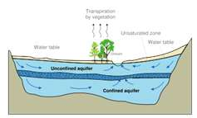
Answer questions about the above (5 pt. ea.):
- If a well was placed to the left of the trees and entered the unconfined aquifer, how could it affect the stream?

- What do the blue arrows represent? What are names for this term?

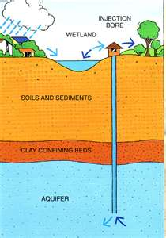
Answer questions about the above (5 pt. ea.):
- What type of well is this?

- What is this well used for?

Station 4
Build an aquifer based on these topics (50 pt.)
-confined/unconfined aquifer
-Nonpoint-source pollution
-wells
-porosity (at least 2 diff. materials)
-percolation

Score(x/100)
Station 1 /30
Station 2 /20
Station 4 /50
Total /100

